

Selenium Initial Guide
Dive into the World of Auomation

Version <1.0>

<September> <2012>

This document applies to Phresco Selenium Initial Guide 1.0 and to all subsequent releases.
Specifications contained herein are subject to change and these changes will be reported in subsequent release notes or new editions.
© Copyright Photon Infotech Pvt Ltd 2012.
All rights reserved.
The name Phresco and/or all Photon product names are either trademarks or registered trademarks of Photon. Other company and product names mentioned herein may be trademarks of their respective owners.

TABLE OF CONTENTS
1 About This Guide 2
Document Conventions 2

- About This Guide

The purpose of this guide.

Document Conventions
Convention | Description
Blue | Identifies elements on a screen
Brown | Identifies tabs on a screen
 | Note
Green | Phresco UI Navigation (Breadcrumbs)
Italic | Code structure
“Yellow” | Important

- Selenium Introduction
Selenium is an open source automation testing tool for web based applications. Its easy to use,strong and is very flexible. You can work on many operating systems using selenium and you can code in any one of the following languages when using selenium.

Languages supported by Selenium
- Java
- C#
- Ruby
- Pyton
- PHP
- Pearl

Browsers supported by Selenium
- Mozilla(till latest version)
- IE 6,7,8
- Google chrome
- Opera8,9,10

The language which you use is independent of the language in which your application is made. Fox example if your application is made in C#, then you can use selenium with any languages mentioned above to test it. You need to know atleast one programming languages mentioned above in order to learn selenium.

Operating systems Supported by Selenium include windows, mac, linux, unix and many more.

Components of Selenium
- Selenium IDE: Installs as an addon in Mozilla.Only runs in Mozilla. Its got a strong feature of record and run. You can also extend IDE functionality with the help of user extensions. It supports regular extensions, loops, if statements and many other features. You can also parameterize your test cases using IDE. Click here to view 4 hours of Selenium IDE video tutorial.
- Selenium RC: This is the older version of selenium. It works on multiple browsers. RC can be implemented in any one of the programming languages mentioned abve. Click here to view a tutrial covering selenium RC installation and Selenium Tests.
- Webdriver: Webdriver is the new version of selenium. It also works on multiple browsers. Its removed many drawbacks and issues in Selenium RC. It also supports Android and Iphone Testing. Click here to view a tutorial on Webdriver installation and writing Selenium tests.
- Grid: Grid is used to run test cases parallely on multiple machines and browsers.

Certain Features which make it a strong tool to use are:
- Open source
- Works on multiple browsers and multiple operating systems as compared to other tools in market.
- You can develop selenium code and make it run parallely on multiple machines using different browsers.
- Support for Android and Iphone Testing.
- Selenium IDE is a simple tool which comes as an addon in firefox and is easy to use. It has the record and run feature which is very strong.
- You can also extend the functionality/scope of IDE with the help of many plugins available
- You can also create your own Selenium IDE plugins
- Selenium RC is the older version of selenium and is supporting all the languages mentioned above
- Webdriver is the latest version of selenium and is very strong. Its removed lots of drawbacks in RC and introduced many more features in selenium. - Selenium when used with Hudson can be used for Continuous integration.
- Object oriented datadriven or hybrid testing framework can be made very easily.
- You can use open source frameworks such as junit, testng, nuint etc and can write selenium test cases in them

Selenium Introduction is provided in the base document: https://insight.photoninfotech.com/sf/go/doc70114?nav=1

- Selenium IDE
You can use selenium IDE for,
- Record and playback – Converting into scripts
- Identifying element ID’s
In below screen shot - you can see that you need to do recording in main firefox window.
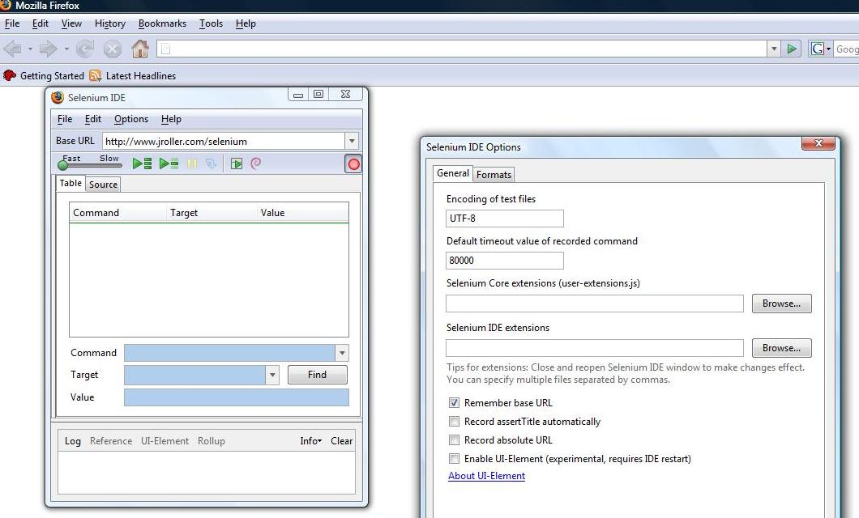

- Selenium Installation
Pre Requisites
- Install Firefox
- Install Java jdk: Download jdk (not JRE) .
Main TOOLS Installation:
- Install Selenium IDE from the direct link : http://release.seleniumhq.org/selenium-ide/1.9.0/selenium-ide-1.9.0.xpi
After installation - you should see selenium ide option in firefox which is added as a plugin.
Download Selenium Webdriver JAR file:
Download latest Webdriver JAR file from: http://selenium.googlecode.com/files/selenium-server-standalone-2.25.0.jar
- Maven Integration for eclipse
Add eclipse plugin for Maven integration so that the user can build and develop maven projects
[Note: Look through detailed document on Maven integration for eclipse at the below link]
Download document from: https://insight.photoninfotech.com/sf/go/doc72916?nav=1
- Writing automation test scripts
Once the above mentioned setup is made the environment is now ready to develop automation test scripts.
Follow detailed steps mentioned in the doc: https://insight.photoninfotech.com/sf/go/doc72701?nav=1

- Selenium Tips and Tricks
* Assert vs verify: If you use seleniums verify command - then the test suite/case - will still run - and fail at the end. Hence in most cases you should use assert command which will cause the test to stop.
* Sometimes selenium IDE may use "click" instead of "clickAndWait" for some
"submit" button cases resulting in your next page's assert/verify to fail. Hence
you should change it manually or add waitForPageToLoad with some timeout.
* If the recording is not working - then go to firefox and click on "Tools->Add on -> Selenium IDE " .First disable it and then enable it and restart the browser. Sometimes clicking on Selenium IDEs
Options->HTML Format helps.
* If web site does not allow itself to be frameable then use -multiwidow option(instead of -interactive) with selenium rc.
* To eliminate certificate warning(and work cross domains ) use chrome/iehta modes -
which is now default(as compared with rc beta1 version)
http://selenium-rc.openqa.org/experimental.html
*If you check selenium rc options eg "java -jar selenium-server.jar -h"
then you will find that it has a "timeout" option. But that timeout is for the overall
run(and not for individual "clickAndWait" ) . Hence you may be advised to use "setTimeOut" via your
java program or in case of HTML use -Selenium IDE open test case-> Add Insert new command
-> setTimeout with value(not Target) of say 240000 (ms)

* Selneium has this cool - captureEntirePageScreenShot command which works
well with IDE/HTML . Consider using it at critical points(to debug
issues, if you schedule your test cases).
But with programming language like java - it may not work(try
using the experimental - captureScreenshot .

* Consider writing a wrapper for your TestCase/TestSuite in .net/jsp
so that you can maintain your testcase/test suite in HTML.

* Sometimes the browsers or the java process may not get killed after the test is run.. So you may need to manually
kill it(you can try to use some automated tools like Pskill on Windows ).
* When your client java test (using RC) finishes with error - then it does not give clear error -you just the line number of the failed assert in stack trace - Hence you may need to trap all exceptions and - print the last body test
* If you are testing with page where the id dynamically changes - then You may need to use lots of xpath in your test . In that case install firebug and use "Inspect element" by right clicking on the element -> Copy XPath by right click on bottom-> Add "/" in front of value you got in your clipboard-> paste this as a "target" in Selenium IDE for your "clickAndWait" command. You can check the validility by - click on find button in Selenium IDE to ensure that your XPath is correct(assuming that page is open) . You may find more tip on xpath using firebug/xpather here

* If you are using Selenium HTML test case - then one way to remove hard coded values
in your selenium test is to have simple JSP(or asp/php) that converts CSV file to HTML file.
Then you just need to invoke that JSP page (for particular CSV) - and call various "store" values
and replace hard coded values in your test with "get" values .
That way you can just change your test/data by just replacing the CSV file.
* Do use (minor) javascript in HTML test case. You would need javascript to access stored values anyway.
eg store 1 abc (store on one page)
, type id javascript{storedVars['abc'].toUpperCase()} (extract or evaluate it on another page)
* If you are running selenium rc test with IE a site which already has invalid certificate -
then IE will give a warning for "invalid certificate". You can have selenium
automatically click on "Continue" link in it(which has ID of overridelink) by adding
below command in your IE specific test case.
<tr>
<td>clickAndWait</td>
<td>//a[@id='overridelink'] </td>
<td></td>
</tr>
With firefox 3 - you can permanently store the exception. However selenium -rc starts
new firefox profile every time(probably to get around lock issues) - hence you may
need to start firefox with same/particular profile.

You may also consider changing IE options to be strict (eg Tool->Internet Options->Advanced->Display
For whatever reasons (firefox does not expose its model)- the above scripts(or autoit) does not help in Firefox dialog boxes(but you dont need it anyway as in chrome mode - selenium automatically gets rids of dialog boxes)
However if you are trying to get rid of basic authentication dialog - you can directly pass user/pass in URL.(however for IE you would need to add some registery settings)
* if you read above mentioned tips you will realize selenium has limitation in IE with certain dialog box(eg upload file, basic auth). You can get around some of the limitation with autoit script or the Selenium 2/Webdriver

