Topic 1: Basic Linux Commands
- Pwd ~ Display the current working directory
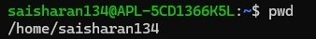

- Clear ~ clear the terminal screen

- History ~ displays previously executed commands
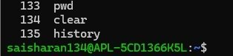

- Whoami ~ display the current logged-in username
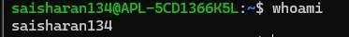

- Date ~ display the current system date and time
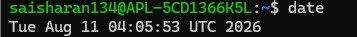

- Hostname ~ Display the system hostname

- Uname -a ~ Display operating system operation

- Exit ~ exit the terminal

TOPIC 2 ~ DIRECTORY MANAGEMENT

- Ls ~ list files and directories
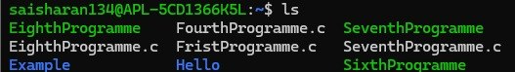

- Ls -a ~ display detailed file information
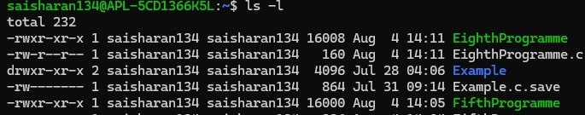

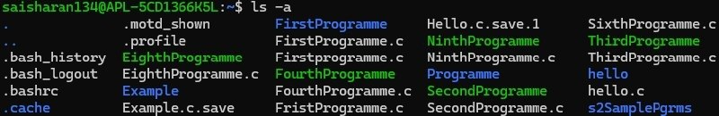

- Cd ~ change the current directory
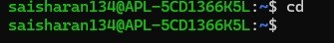

- Cd ..~ move to parent directory

- mkdir ~ create a new directory

- rmdir ~ remove a directory

- find FileName.c ~ search for files and directories

- locate ~ Quickly locate files

3.FILE MANAGEMENT

1.touch ~ Create new empty file

2. cat ~ display file contents
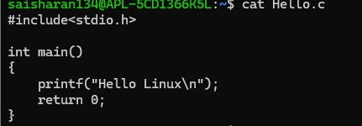

3. cp ~ copy files or directories

4. mv ~ move or rename files

5. rm ~ remove file

6. head ~ display first lines of a file
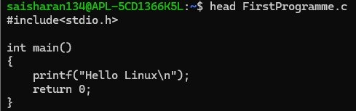

7. tail ~ display last lines of the file
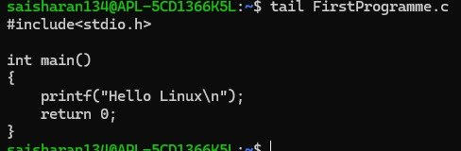

8.more ~ view a file page by page
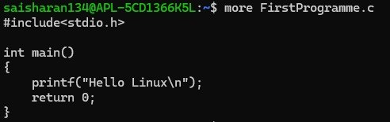

9.less ~ Scroll through a file
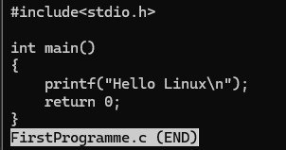

10.wc ~ count lines, words and characters

11.diff ~ compare two files
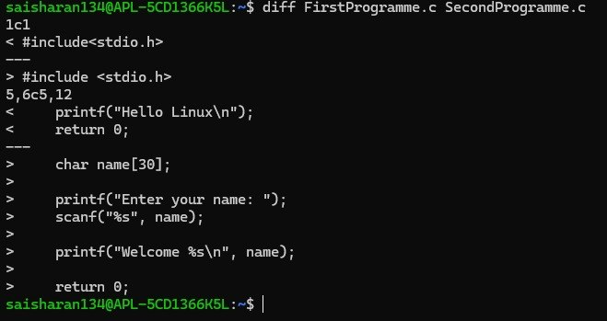

12.sort ~ sort file contents
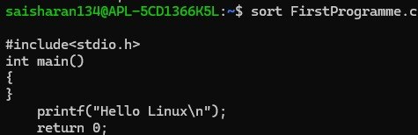

13.uniq ~ remove duplicate files
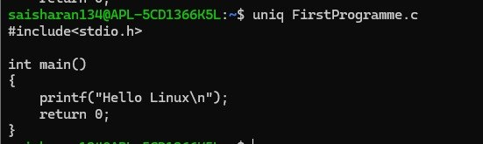
14.grep ~ search for text inside a file

