“Placement Hub”

Data Structures and Algorithms -3 (25CS2103E)

in

DEPARTMENT OF COMPUTER SCIENCE ENGINEERING

by

R C SAI SHARAN : 2520030128

KOMPELLI SAANVI : 2520030083

S KETANA SINDHU : 2520030487

Team Number : 21
Section : 6

Under the Guidance of

Dr. V. Sireesha
Professor
Department of Computer Science and Engineering





2026-27

DEPARTMENT OF COMPUTER SCIENCE ENGINEERING

Declaration

The Project Report entitled “Placement Hub” is a record of Bonafide work of R.C. Sai Sharan– 2520030128, Kompelli Saanvi– 2520030083, S. Ketana Sindhu – 2520030487 submitted in partial fulfillment for the award of B. Tech in Computer Science and Engineering. The results embodied in this report have not been copied from any other departments/University/Institute.

R C Sai Sharan – 2520030128
Kompelli Saanvi – 2520030083
S Ketana Sindhu – 2520030487

DEPARTMENT OF COMPUTER SCIENCE ENGINEERING

CERTIFICATE

This is certify that the mini project based report entitled “Placement Hub” is a bonafide work done and submitted by R.C. Sai Sharan– 2520030128, Kompelli Saanvi– 2520030083, S. Ketana Sindhu – 2520030487 in partial fulfillment of the requirements for the award of the degree of BACHELOR OF TECHNOLOGY in Department of Computer Science Engineering, during the academic year 2026-27.

Signature of the Guide Signature of the HOD
(Dr. S. Vinay Kumar)

Signature of the External Examiner
ACKNOWLEDGEMENT

Description in Times New Roman font 12 size with two to three paragraphs thanking guide Dr. S. Vinay Kumar, Associate Professor, Dept. of CSE and Dr. P. Venkateshwara Rao, Associate Professor, HOD CSE

R C Sai Sharan – 2520030128
Kompelli Saanvi – 2520030083
S Ketana Sindh

Abstract

The global travel and tourism sector is experiencing rapid growth, but planning a trip remains complex, forcing travellers to use multiple different apps for flights, trains, and hotels. This fragmented approach causes delays, confusion, and a poor user experience. To tackle this, our project focuses on the Design and Development of an Integrated Tourism Platform for Flights, Trains, Hotels, and Hidden Destinations. Our core aim was to successfully implement a unified, single-window website that dramatically simplifies the entire travel process for the modern global traveller.

The platform is structured around four primary, fully interconnected modules. It offers seamless booking for Flights (with real-time fares and availability, including the critical function to compare and sort packages from cheapest to highest) and Hotels (with a vast inventory, user reviews, and similar pricing comparison tools). Crucially, the platform includes a comprehensive Train Ticket Module with essential functionalities like live running status and PNR checks, addressing the high demand for rail travel information within the region.

The most innovative feature is the dedicated Hidden Destinations Discovery Module. This system uses smart recommendations to suggest off-beat, lesser-known, and culturally rich locations globally. By promoting these hidden gems, we are not only enriching the user's journey but also supporting local communities and encouraging more sustainable and diversified tourism. The system is built using robust, modern web technologies and is fully responsive across all devices. In summary, this project delivers a complete, reliable, and user-friendly digital solution that significantly enhances the experience of planning, booking, and exploring travel worldwide.
Table of Contents

 |  |  | Page No.
 | Acknowledgement
 | Abstract
 | Table of Contents
 | List of Figures
1 | Introduction | 1.1 Overview  1.2 Problem statement  1.3 Scope of the project  1.4 Objectives | 8-9
2 | System Requirements | 2.1 Functional Requirements  2.2 Non-Functional Requirements | 10
3 | System Design | 3.1 High-level Architecture Diagram  3.2 Description of each layer | 11-12
4 | Implementation | 4.1 Module-wise implementation  4.2 Front-end logic (UI rendering, state management)  4.3 API integration  4.4 ……. | 13-15
5 | Results |  | 16-19
6 | Challenges & Limitations | 6.1 Issues faced during development  6.2 Solutions applied  6.3 Limitations of the System | 20
7 | Conclusion & Future Work | 7.1 Conclusion  7.2 Future Work  7.3 Skills learned during development | 21
 | References | - Books, tutorials, APIs, documentation sites used | 22

CHAPTER 1: INTRODUCTION

1.1 Overview
PlacementHub is a web-based placement management system developed as part of the Data Structures and Algorithms–3 (DSA-3) course. The primary objective of this project is to simplify the placement process by providing a centralized platform where students can explore job opportunities, search for suitable positions, check eligibility and manage their job applications. The system also helps organize company information and recruitment details.
Traditional placement processes often require students to search through multiple sources to identify suitable job opportunities. Manually comparing eligibility criteria, technical skills, academic performance and job requirements can be time-consuming. PlacementHub addresses these difficulties by integrating job searching, eligibility checking and student–job matching into one platform.
The project uses HTML, CSS and JavaScript for the frontend, Java for the backend, and MySQL for persistent data storage. JDBC is used to connect Java with the database. The major focus is the application of DSA concepts, including string pattern matching, fuzzy searching, sorting and job-matching algorithms.

1.2 Problem Statement
Students often face difficulties finding relevant placement opportunities because job information and eligibility criteria may be distributed across different sources. Manual searching and comparison can lead to unnecessary effort and missed opportunities. Therefore, a system is required to organize placement information and efficiently identify jobs that match students' qualifications and skills.

1.3 Scope of the Project
PlacementHub provides student registration and login, job listings, company information, job searching, eligibility checking, job recommendations and application tracking. It demonstrates the practical application of data structures and algorithms in a real-world placement scenario. The project focuses on local web application functionality and does not claim integration with external recruitment portals.

1.4 Objectives
- Develop a simple and user-friendly placement management website.
- Maintain student, company, job and application information.
- Implement efficient job searching and sorting techniques.
- Support fuzzy searching to accommodate spelling mistakes.
- Match students with jobs based on eligibility and skills.
- Demonstrate the practical use of DSA concepts in software development.

CHAPTER 2: SYSTEM REQUIREMENTS

2.1 Functional Requirements
The functional requirements describe the operations performed by PlacementHub.
- Student Registration and Login: Students can register with their details and log in using their credentials.
- Job Management: Students can view available job opportunities and their requirements.
- Company Information: The system displays company details associated with recruitment opportunities.
- Job Search: Students can search for jobs using keywords, job roles and skills.
- Fuzzy Search: The system can support searches involving minor spelling mistakes.
- Eligibility Checking: Student qualifications are compared with job requirements, including CGPA, branch and backlog limits.
- Job Recommendations: Suitable opportunities are identified using student information and job requirements.
- Application Management: Students can submit applications and view their application status.

2.2 Non-Functional Requirements
- Usability: The interface should be simple and easy to navigate.
- Performance: Searching, sorting and matching should process available records efficiently.
- Reliability: The system should validate inputs and handle errors appropriately.
- Maintainability: The API, DAO, service, model and DSA components are separated to simplify maintenance.
- Data Integrity: Database constraints and validation should help prevent invalid or duplicate records.
- Compatibility: The frontend should operate in a modern web browser.

2.3 Hardware and Software Requirements
Hardware: A computer with a modern processor, at least 4 GB RAM recommended, sufficient storage and a network interface for local development.
Software: Windows or another supported operating system, Java Development Kit (JDK), Visual Studio Code, Apache Maven, MySQL Server, MySQL Workbench, and a modern web browser. The frontend uses HTML, CSS and JavaScript, while the backend uses Java, JDBC and the built-in Java HTTP server.

CHAPTER 3: SYSTEM DESIGN

3.1 High-Level Architecture
PlacementHub follows a layered architecture that separates the user interface, API handling, business logic, data access and persistent storage. This separation makes the application easier to understand, test and maintain.
Fig. 3.1: High-Level Architecture of PlacementHub
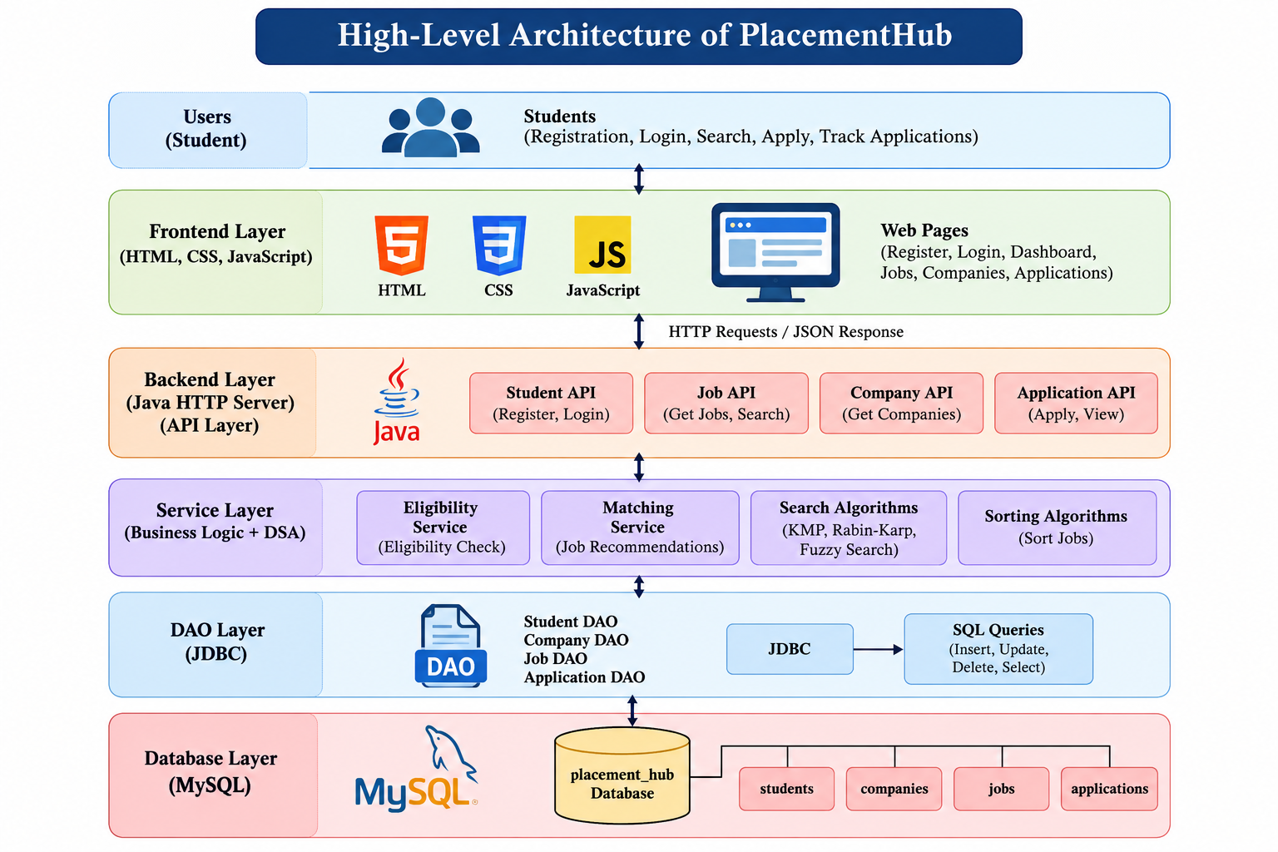

3.2 Description of Each Layer
Frontend Layer: HTML defines the pages and forms, CSS provides styling, and JavaScript handles user interactions, validation and API requests.
API Layer: Java HTTP server endpoints process requests for registration, login, jobs, companies and applications. CORS configuration permits communication between the locally hosted frontend and backend.

Service and DSA Layer: Service classes handle eligibility checking and job matching. DSA classes provide searching, fuzzy matching and sorting functionality.

DAO Layer: Data Access Objects execute database operations using JDBC. Separate DAO classes handle students, jobs, companies and applications.

Database Layer: MySQL stores the project's persistent records in the placement_hub database.
The layered architecture helps isolate errors and allows individual components to be updated without unnecessarily modifying the entire system.

CHAPTER 4: IMPLEMENTATION

4.1 Module-Wise Implementation
The project is implemented using Java, HTML, CSS, JavaScript and MySQL. The frontend communicates with the Java backend through HTTP API endpoints.
The student module supports registration and login. The job module retrieves job information and provides search functionality. The company module displays company details. The application module supports submitting applications and retrieving application records. The service layer handles eligibility checking and student–job matching.
The DAO layer uses JDBC to execute database queries, while model classes represent students, jobs, companies and applications.

4.2 Data Structures and Algorithms
The project applies the following DSA concepts:
- KMP (Knuth–Morris–Pratt): Uses a prefix table to avoid unnecessary comparisons while searching for a pattern.
- Rabin–Karp: Uses rolling-hash comparisons to locate patterns in text.
- Fuzzy Search: Uses string similarity or edit-distance concepts to accommodate spelling variations.
- Sorting Algorithms: Organize job listings according to relevant attributes such as package, job role or eligibility criteria.
- Job-Matching Algorithm: Compares student details with job requirements to identify potentially suitable opportunities.
- Application List: Organizes application records using an appropriate list-based structure.

4.3 Pseudocode
Algorithm 4.1: Student–Job Eligibility Checking
INPUT: Student S, Job J

IF S.CGPA < J.minimumCGPA
RETURN Not Eligible
END IF

IF S.branch is not allowed for J
RETURN Not Eligible
END IF

IF S.backlogs > J.maximumBacklogs
RETURN Not Eligible
END IF

RETURN Eligible
Algorithm 4.2: Job Search
INPUT: List of jobs, search keyword

Create an empty result list

FOR each job in the list
Search the job role, skills and description
using the selected search algorithm
IF a match is found
Add the job to the result list
END IF
END FOR
RETURN result list
These algorithms illustrate how DSA concepts support placement-related operations. The exact algorithm selected depends on the search mode and implementation.

4.4 API Integration
JavaScript sends HTTP requests to the Java backend. The API layer processes requests, invokes the appropriate service or DAO, and returns responses in JSON format. The frontend uses these responses to display job listings, company details and application information.

CHAPTER 5: RESULTS

5.1 Expected System Outcomes
PlacementHub is designed to provide a centralized interface for student placement activities. The principal expected outcomes are summarized below.
Test case | Expected outcome
Student registration | Valid student details are stored successfully
Student login | Valid credentials authenticate the student
View jobs | Available job records are displayed
Search jobs | Matching job records are returned
Fuzzy search | Relevant results can be found despite minor spelling mistakes
Eligibility check | Students are assessed against job criteria
Job recommendations | Potentially suitable jobs are identified
Apply for job | An application record is created
View applications | The student's application records are displayed
Fig. 5.1: General Workflow of PlacementHub 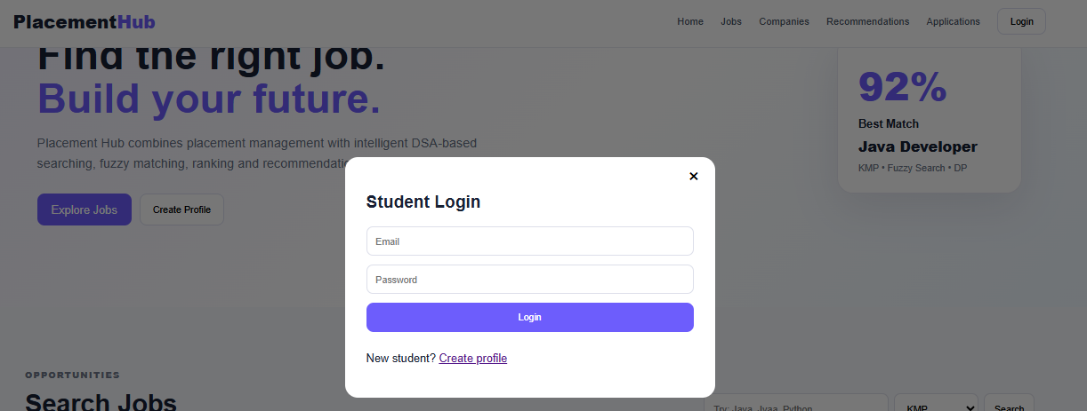
Login

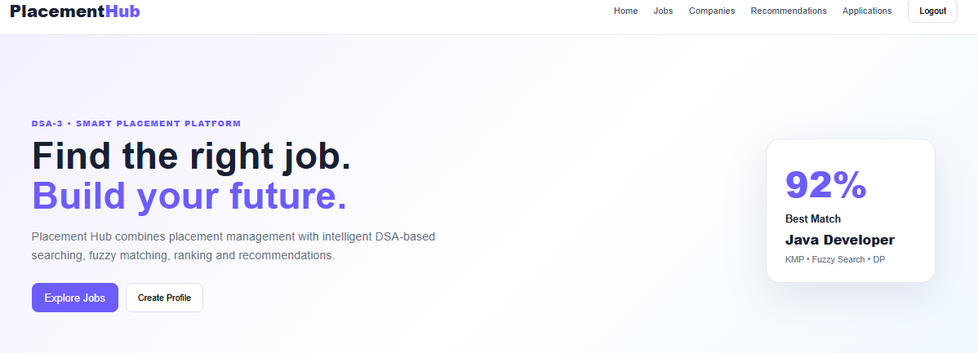
Open Dashboard
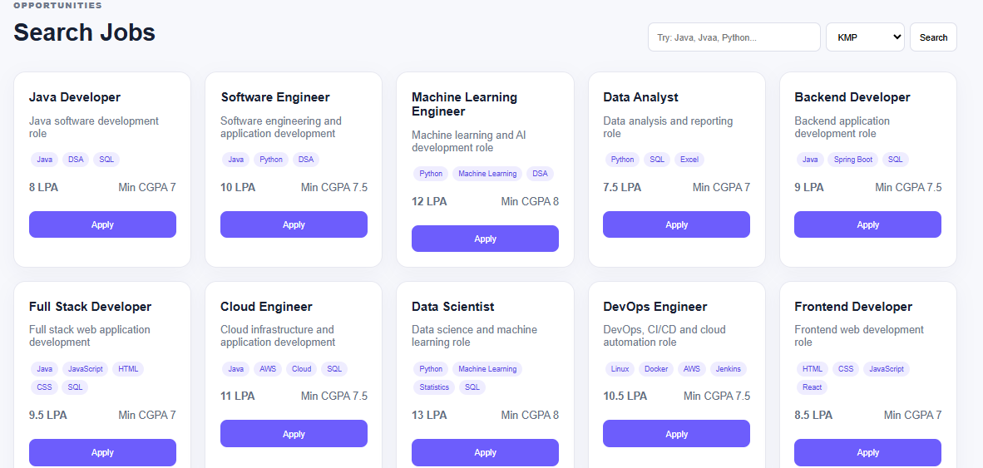
Select Jobs / Search
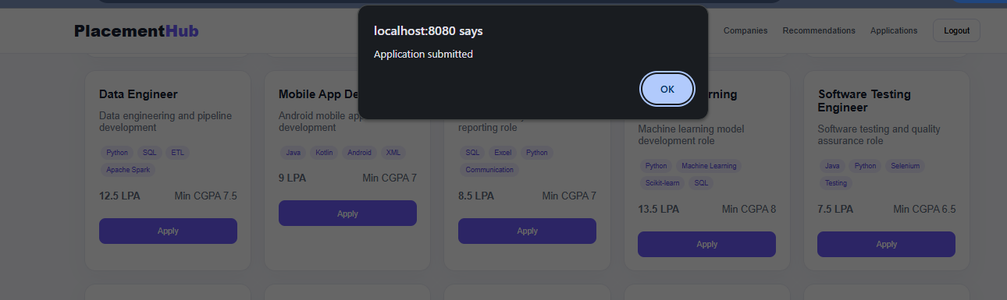
Apply for a Job
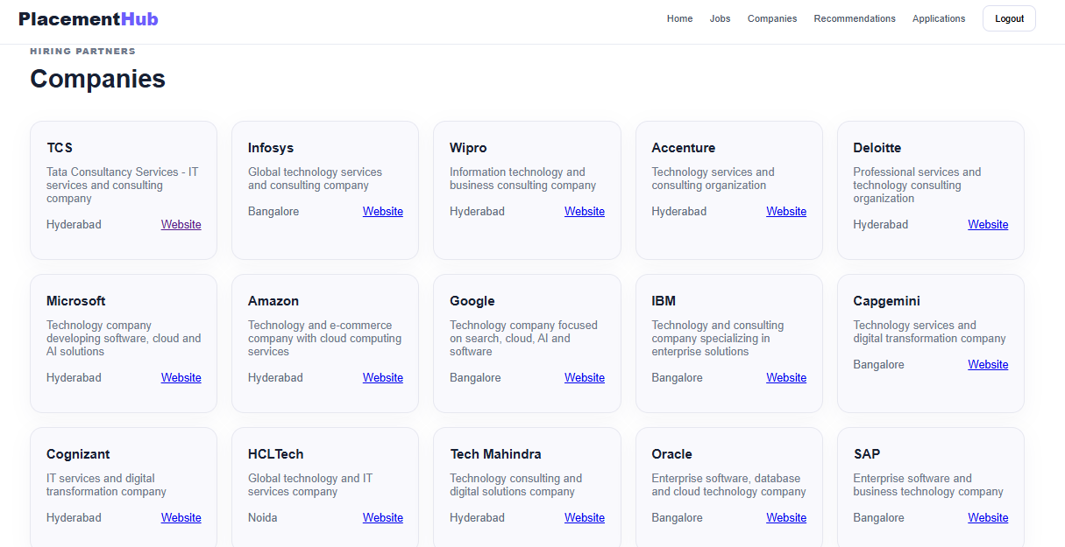
Companies
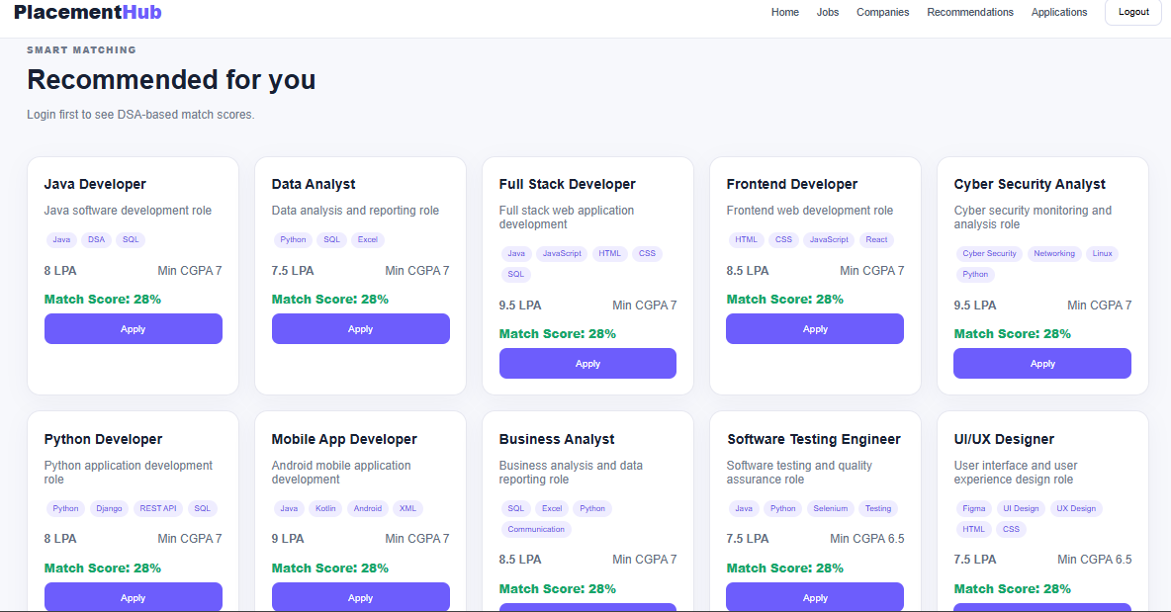
Recommended jobs
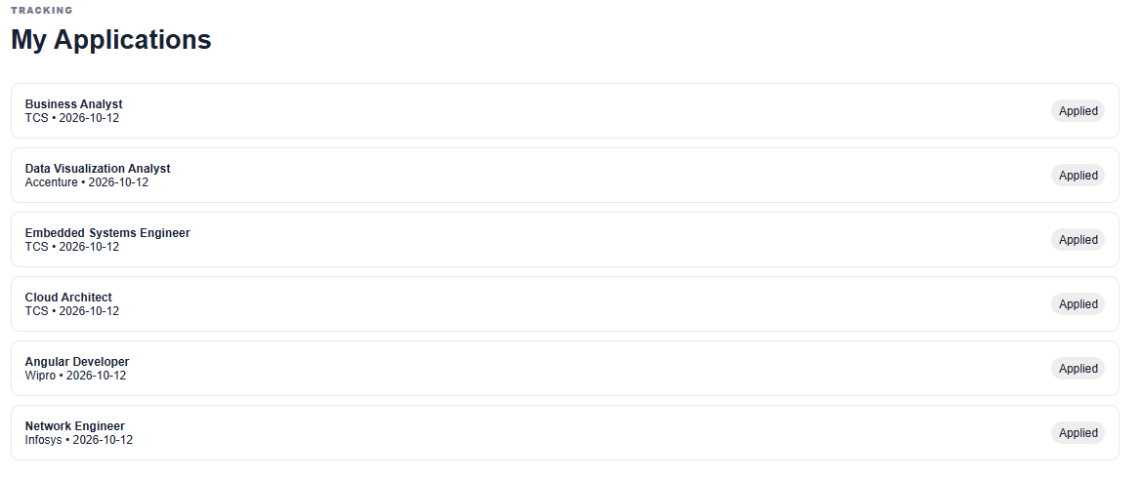
Applied jobs
Logout…..
The system's success should be assessed by executing the test cases and confirming that each operation produces the expected response. Actual test results, screenshots and any observed errors should be added after testing the final running version. No numerical performance improvement is claimed without measured results.

CHAPTER 6: CHALLENGES AND LIMITATIONS

6.1 Issues Faced During Development
One of the challenges in developing PlacementHub was integrating the frontend with the Java backend. The frontend and backend run on different local ports, which requires appropriate Cross-Origin Resource Sharing (CORS) configuration. Another challenge was ensuring that the API methods, model fields and DAO operations use consistent names and data types.
Database connectivity also required attention because JDBC depends on the correct database configuration, available drivers and valid SQL queries. Implementing string-matching algorithms required careful handling of keywords, case differences and spelling variations. Finally, connecting eligibility checking, job matching and application management required coordination between multiple software layers.

6.2 Solutions Applied
The application was organized into API, DAO, service, model and DSA packages to improve modularity. A separate database connection class was used for JDBC connectivity. CORS handling was introduced to allow frontend requests. API responses were structured as JSON, and individual endpoints could be tested independently. Searching and matching logic was separated into dedicated classes to make the algorithms easier to understand and maintain.

6.3 Limitations of the System
The current project is a local academic prototype. Its operation depends on the availability of the Java server and MySQL database. Job information depends on the records maintained in the database; automatic synchronization with external recruitment websites is not included. The matching algorithm may not fully capture a student's practical abilities or every employer's requirements. Security improvements, stronger authentication, password protection, administrative authorization, large-scale performance testing and deployment would be necessary before production use.

CHAPTER 7: CONCLUSION AND FUTURE WORK

7.1 Conclusion
PlacementHub demonstrates how data structures and algorithms can be applied to a practical placement management problem. It combines student registration, job listings, company information, job searching, eligibility checking, recommendations and application tracking within a single web application.
The project integrates a frontend developed using HTML, CSS and JavaScript with a Java backend and MySQL database. JDBC provides database connectivity, while the API, DAO, service and model layers organize the application into manageable components.
The most important academic contribution is the application of pattern matching, fuzzy searching, sorting and job-matching concepts to recruitment-related data. The project also provides practical experience in frontend development, backend programming, database integration and debugging.

7.2 Future Work
Possible future enhancements include:
- Adding secure password hashing and stronger authentication.
- Developing a dedicated administrator dashboard for managing recruitment drives.
- Improving recommendations using weighted skill similarity and additional eligibility factors.
- Supporting resume uploads and automated skill extraction.
- Introducing pagination and indexing for larger datasets.
- Adding automated unit and integration tests.
- Deploying the application to a hosted environment with appropriate security controls.
- Measuring the execution time of searching and sorting algorithms on different dataset sizes.

7.3 Skills Learned During Development
The project provides practical experience with Java programming, HTML, CSS, JavaScript, JDBC, MySQL, Maven, HTTP APIs, database operations, string pattern matching, fuzzy searching, sorting, algorithm design, debugging and software modularity.

REFERENCES
[1] T. H. Cormen, C. E. Leiserson, R. L. Rivest and C. Stein, Introduction to Algorithms, 4th ed., MIT Press, 2022.
[2] D. E. Knuth, J. H. Morris and V. R. Pratt, “Fast Pattern Matching in Strings,” SIAM Journal on Computing, vol. 6, no. 2, pp. 323–350, 1977.
[3] R. M. Karp and M. O. Rabin, “Efficient Randomized Pattern-Matching Algorithms,” IBM Journal of Research and Development, vol. 31, no. 2, pp. 249–260, 1987.
[4] V. I. Levenshtein, “Binary Codes Capable of Correcting Deletions, Insertions, and Reversals,” Soviet Physics Doklady, vol. 10, pp. 707–710, 1966.
[5] Oracle, “Java Platform Documentation.” https://docs.oracle.com/en/java/
[6] Oracle, “Java Database Connectivity (JDBC) Documentation.” https://docs.oracle.com/javase/tutorial/jdbc/
[7] MySQL, “MySQL Reference Manual.” https://dev.mysql.com/doc/
[8] Mozilla, “Fetch API.” https://developer.mozilla.org/en-US/docs/Web/API/Fetch_API

