Infosys Springboard Virtual Internship 6.0 Completion Report

Team Details <Do not mention any personally identifiable information like email ID, institute details, mobile phone number etc.>

Batch Number: 13 - WellBot Global Wellness Assistant Chatbot
Start date : 02-02-2026
Names: 1. Sai Shashank
2. Sai Srujana
3. Sri Charan Tej
4. Krishnendu Anil

Internship Duration: 40 days

1. Project Title
WellBot – Global Wellness Assistant Chatbot

2. Project Objective
WellBot is an AI-powered wellness chatbot designed to provide users with basic health guidance and wellness recommendations through a conversational interface. The system uses Natural Language Processing (NLP) and Large Language Models (LLM) to understand user queries related to health symptoms, lifestyle habits, and wellness concerns.
The objective of WellBot is to help users receive quick, reliable, and structured health guidance based on WHO wellness recommendations such as sleep hygiene, hydration, nutrition, and physical activity. The chatbot also encourages users to consult healthcare professionals when serious symptoms are detected.
The system includes multilingual support, making it accessible to users who speak different languages. Additionally, an admin dashboard is implemented to monitor user activity, chat history, recovery plans, and reports uploaded by users.
Overall, WellBot aims to promote preventive healthcare awareness and healthy lifestyle habits through an intelligent conversational AI system.

3. Project description in detail
WellBot is an AI-based health and wellness chatbot developed to provide users with instant wellness guidance and health awareness. The system allows users to interact with a chatbot interface where they can ask questions about symptoms, lifestyle habits, mental health concerns, and general wellness.
The chatbot processes the user’s input using Natural Language Processing (NLP) techniques to understand the intent and context of the query. The request is then analyzed by an LLM-based AI model that generates structured responses based on predefined wellness guidelines and knowledge sources.
The architecture of the system consists of three main components:
Frontend Application:
The user interacts with the chatbot through a web interface developed using React.js. The interface provides a chat window where users can type their symptoms or wellness questions. It also includes a dashboard for administrators to monitor user activities.
Backend System:The backend is developed using Python Flask, which processes user requests, communicates with the AI model, and manages application logic. The backend also handles user authentication, chat history storage, and API communication.
Database Management:The system uses MySQL database to store user information, chat logs, recovery plans, and reports uploaded by users.
One of the important features of WellBot is multilingual support, allowing the chatbot to respond in different languages. This feature improves accessibility for users from diverse linguistic backgrounds.
Another major component is the Admin Dashboard, which allows administrators to track:
- Total registered users
- Active users
- Chat history
- Recovery plan usage
- Uploaded medical reports
The system also integrates WHO-based wellness recommendations such as:
- 7–9 hours of sleep daily
- Proper hydration
- Balanced nutrition
- Regular physical activity
- Hygiene practices
- Mental health awareness
If the system detects potentially serious symptoms, it recommends users to consult a medical professional, ensuring responsible AI usage.
Overall, WellBot combines AI technology, full-stack web development, and healthcare awareness to create a smart digital wellness assistant.

4. Timeline Overview

Week | Activities Planned | Activities Completed
Week 1 | Requirement gathering and project planning | Defined project scope and identified chatbot features
Week 2 | Research on NLP and LLM models | Selected NLP techniques and AI model for chatbot
Week 3 | Database design | Designed MySQL database for user data and chat history
Week 4 | Backend development | Implemented Flask APIs and chatbot logic
Week 5 | Frontend development | Developed chatbot UI using React
Week 6 | Dashboard implementation | Created admin dashboard for monitoring users and chats
Week 7 | Integration and testing | Integrated frontend, backend, and AI model
Week 8 | Testing and documentation | Final debugging, documentation, and deployment

5a. Key Milestones
Milestone | Description | Date Achieved
Project Kickoff | Defined project objectives and system architecture | 2 Feb 2026
Prototype/First Draft | Built initial chatbot interface and backend APIs | 10 Feb 2026
Mid-Term Review | Evaluated progress and improved chatbot response logic | 17 Feb 2026
Final Submission | Completed WellBot chatbot with full functionality | 23 Feb 2026
Presentation | Demonstrated project features and working system | 28 Feb 2026

5b. Project execution details

• Requirement Analysis – Identified user needs and defined chatbot features.
• Technology Selection – Selected Python Flask, React.js, MySQL, NLP and LLM models.
• System Design – Designed system architecture and database schema.
• Backend Development – Implemented APIs for chatbot processing and user management.
• Frontend Development – Built chatbot interface and admin dashboard.
• Multilingual Support – Implemented multi-language response system.
• Database Integration – Stored user data, chat history, and recovery plans.
• Testing & Debugging – Conducted functional testing and resolved system issues.
• Deployment – Prepared final system and documentation.

6. Snapshots / Screenshots

Step 1 : Go to Github and clone the Repository in your system then open in VS Code to do the execution

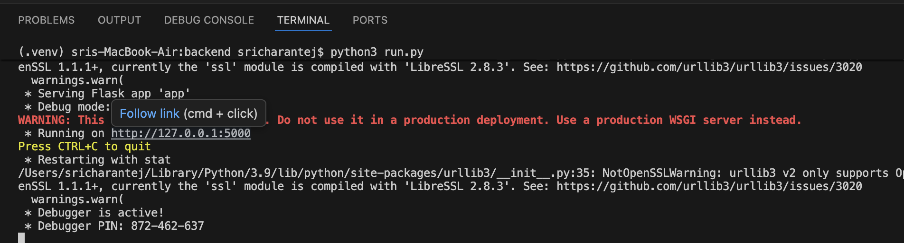
Step 2 : Navigate to the backend folder and start the application using the command: python run.py

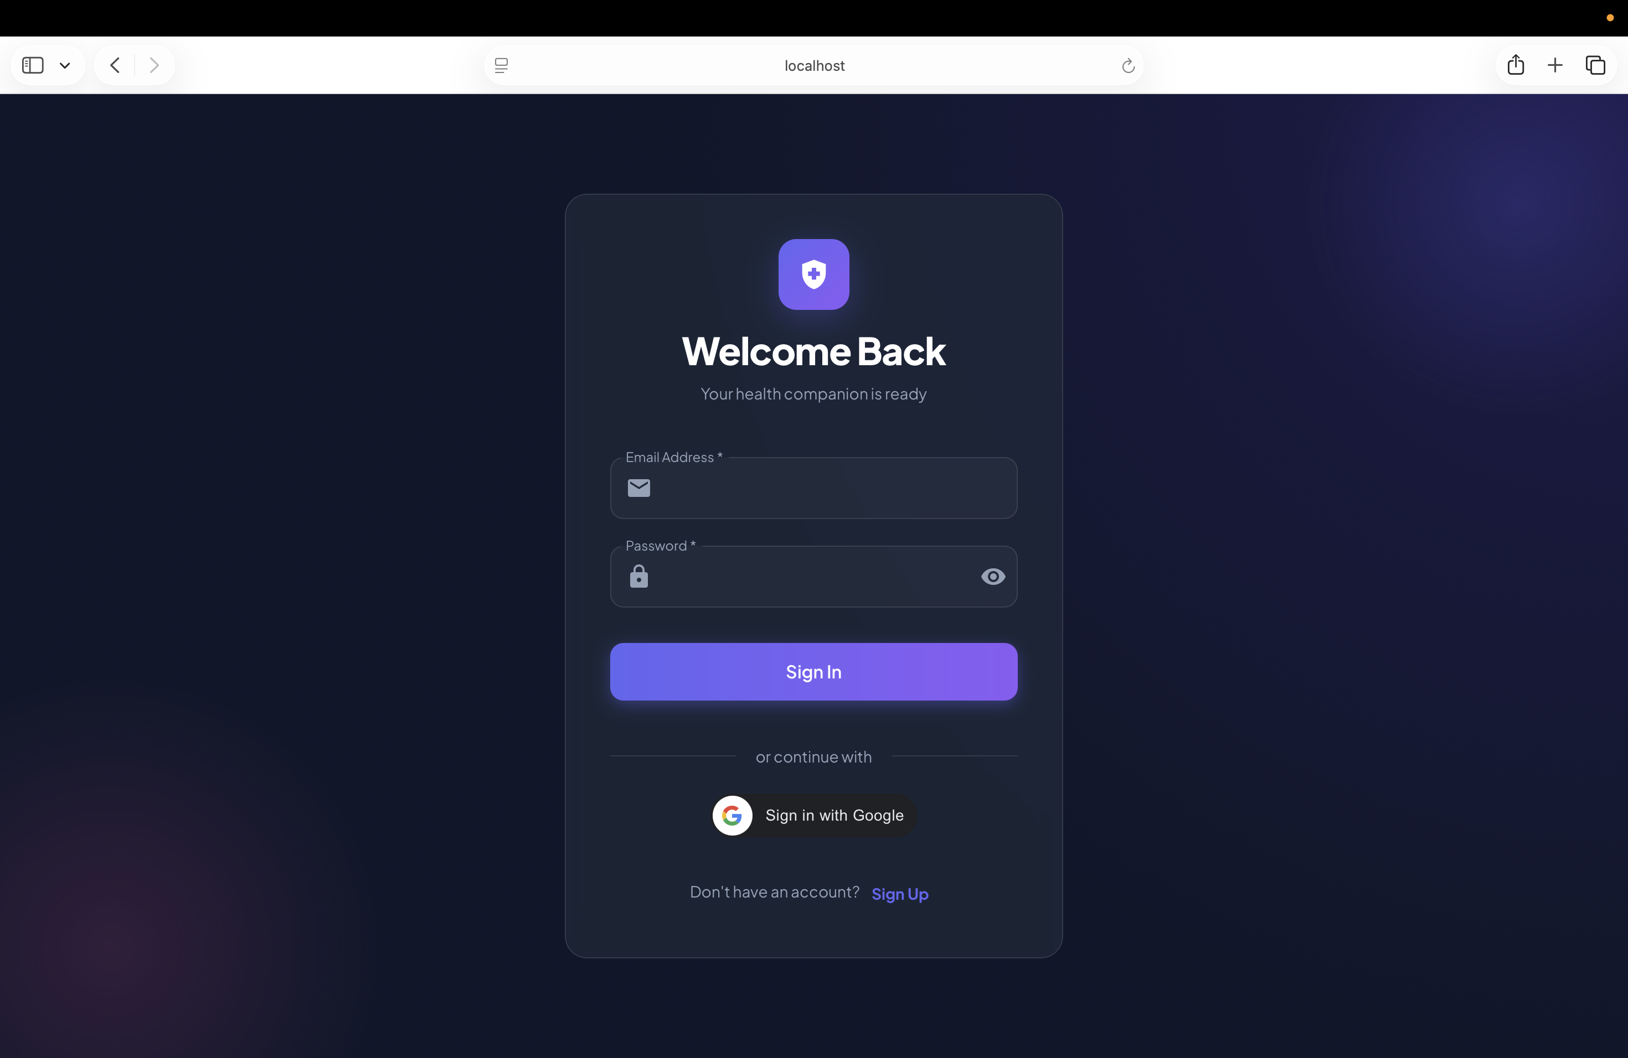
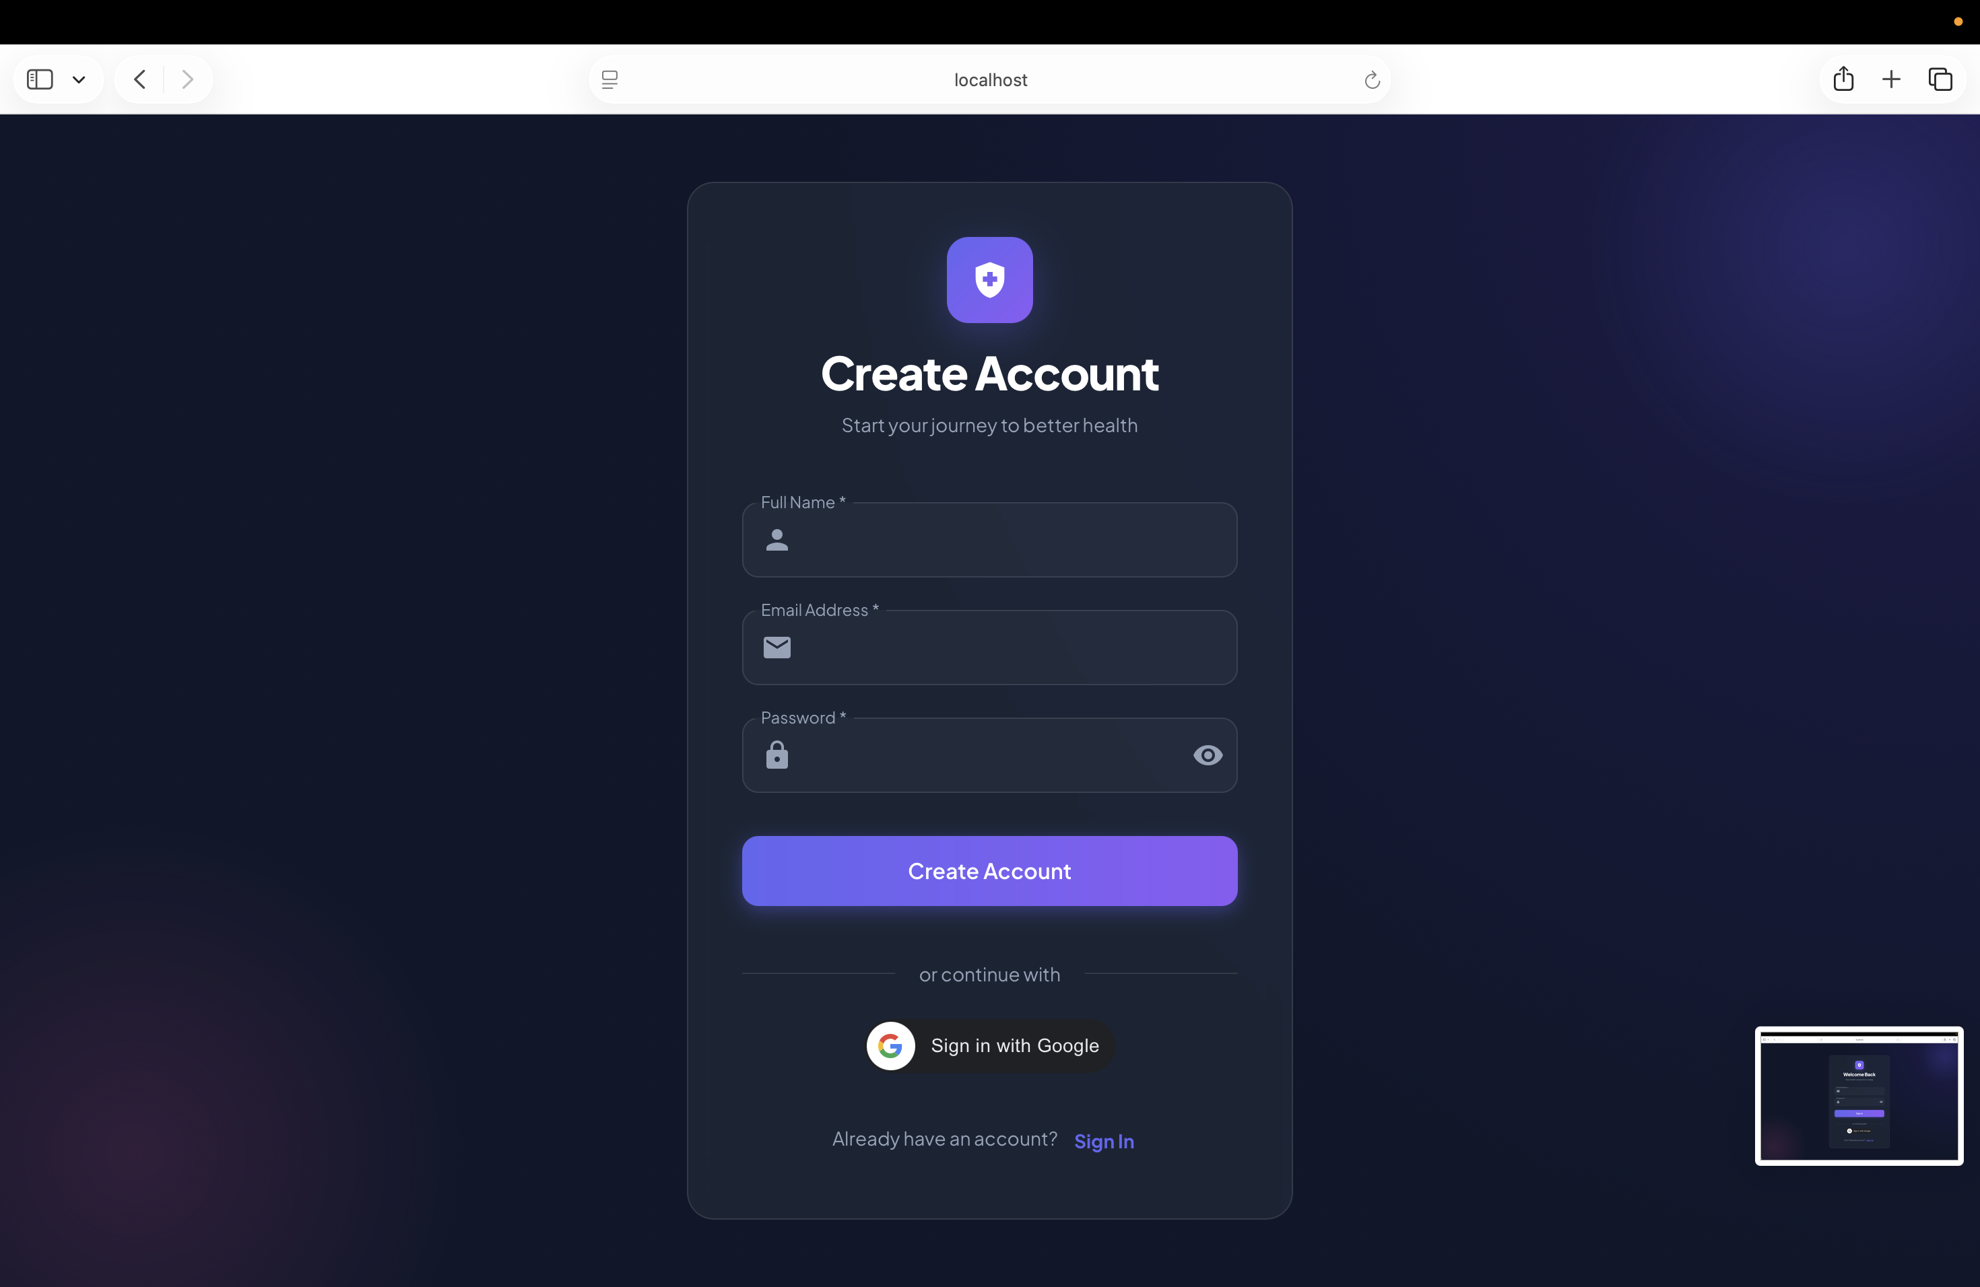
Step 3: After clicking on Login / Signup, the user must register and log in to access the chatbot and other system features.

Step 4: After login, the user is redirected to the WellBot Dashboard showing health intelligence information.

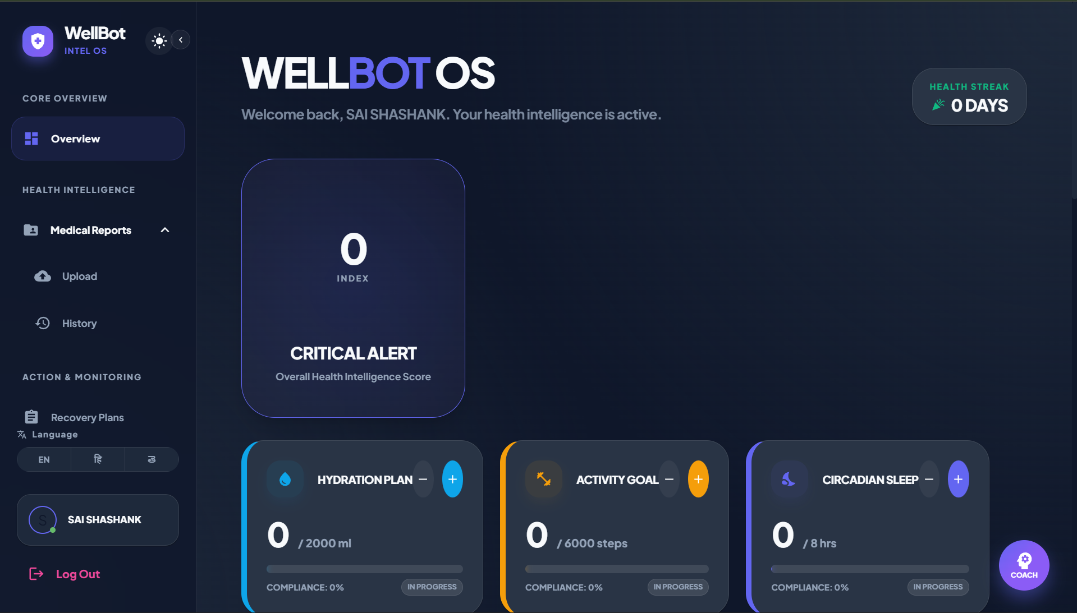

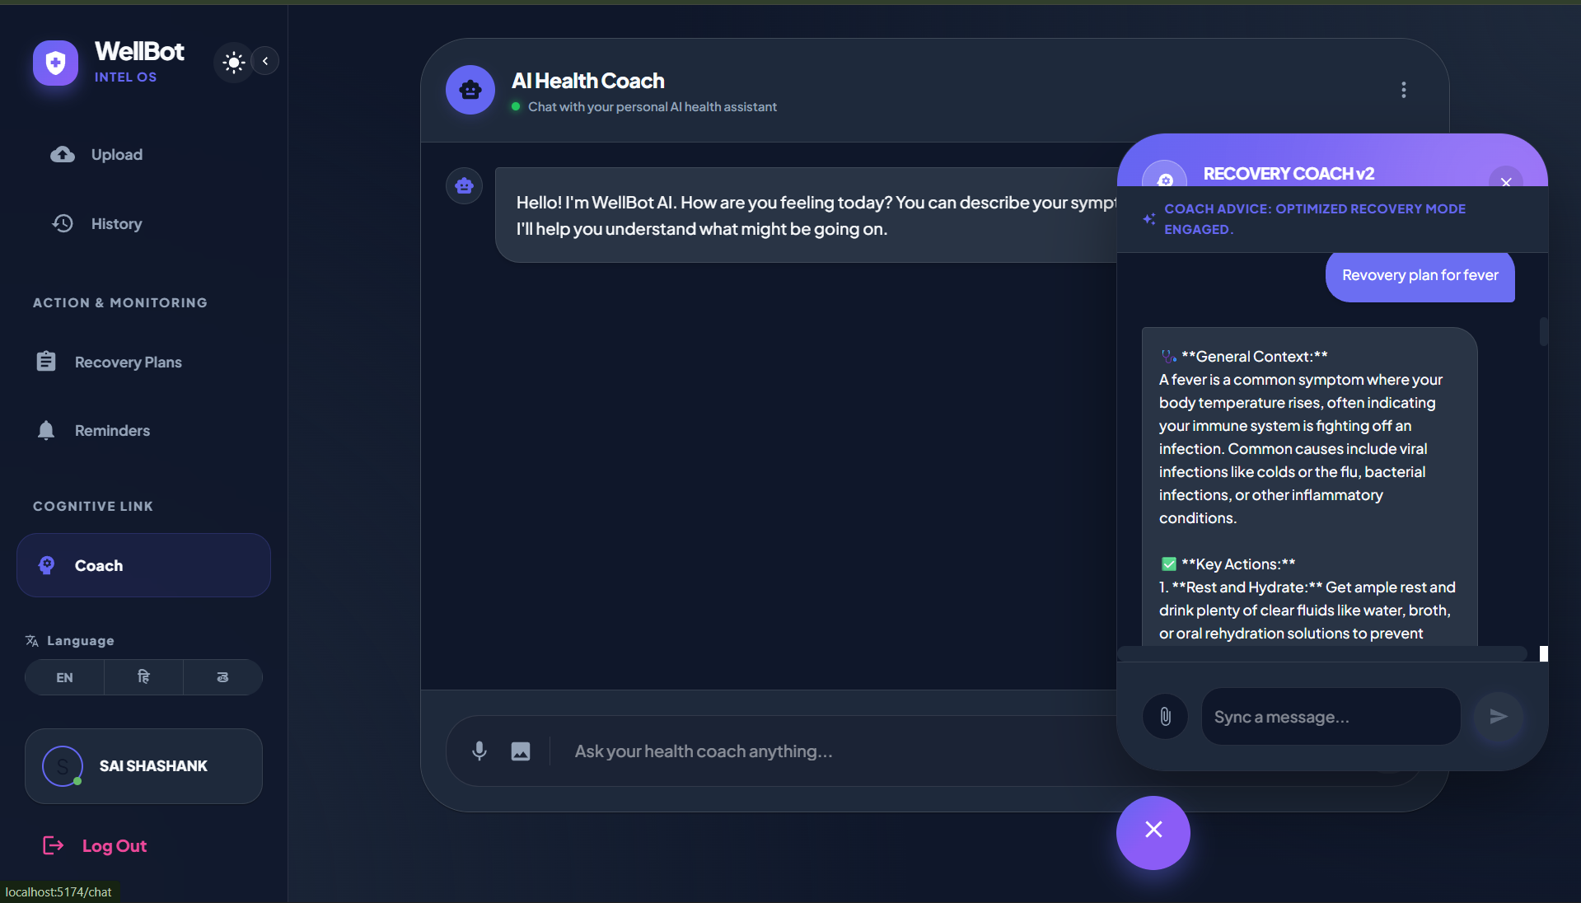
Step 5: Once logged in, users can enter their health symptoms or wellness queries in the chatbot interface to receive AI-based health guidance.

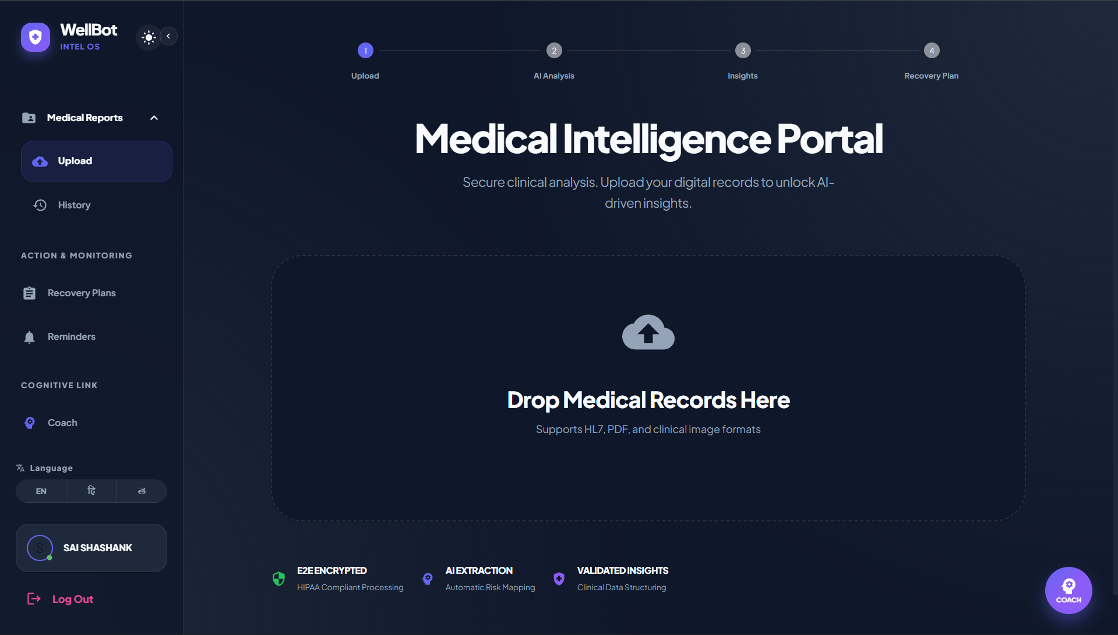
Step 6: Users can upload their medical reports in formats such as PDF or clinical images.

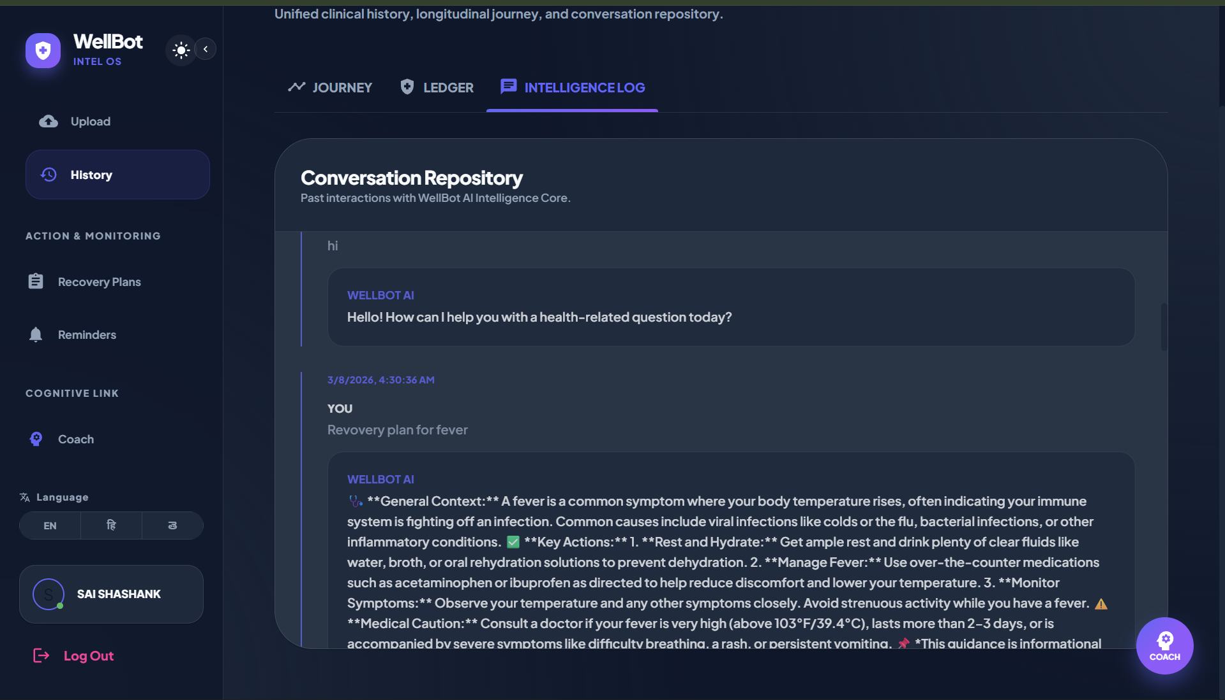
Step 7: Users can view their conversation history with the chatbot in the Conversation Repository.
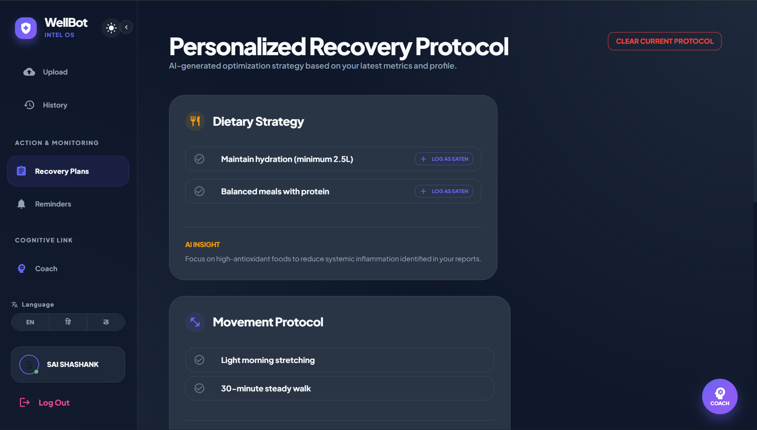
Step 8: The system generates a personalized recovery protocol based on the user’s health data.
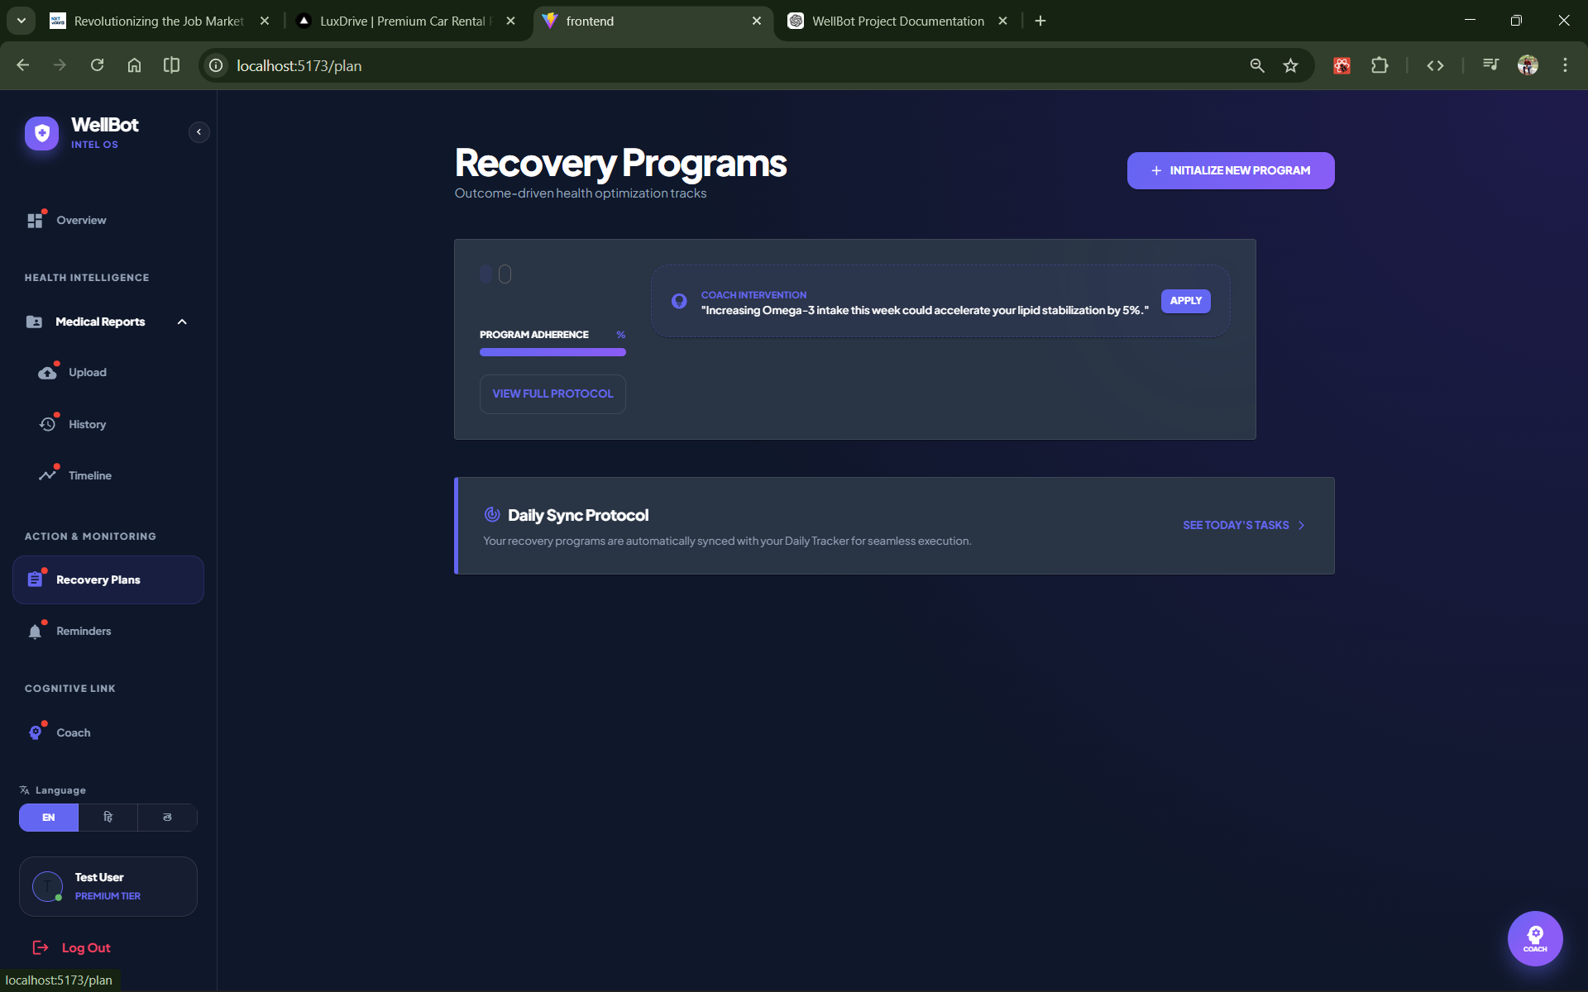
Step 9: Users can access Recovery Programs that provide health optimization strategies
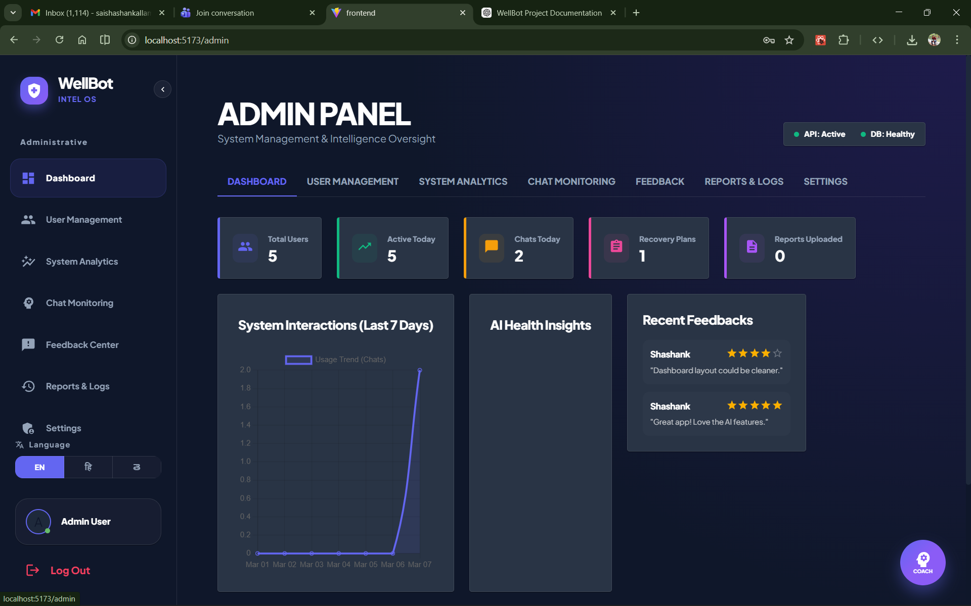
Step 10: The Admin Panel allows administrators to monitor users, chats, recovery plans, and uploaded reports

7. Challenges Faced
• Understanding user queries accurately using NLP
• Integrating AI model with backend system
• Implementing multilingual chatbot responses
• Designing a simple but functional admin dashboard
• Handling chat history storage efficiently
• Testing chatbot responses for different user queries

8. Learnings & Skills Acquired
• Practical knowledge of Natural Language Processing (NLP)
• Understanding of Large Language Models (LLM)
• Full-stack development using React and Flask
• Database management using MySQL
• API development and integration
• Chatbot system design and architecture
• Debugging and testing web applications
• Team collaboration and project management

9. Testimonials from team
Team Member - Sai Shashank : “This project helped me understand how AI chatbots work and how NLP can be applied in real-world applications.”
Team Member - Saisrujana : “I gained hands-on experience in building full-stack applications and integrating AI models.”
Team Member - Sri charan tej : “Working on WellBot improved my knowledge of chatbot architecture and user interface development.”
Team Member - Krishnendu anil : “This project strengthened my problem-solving skills and teamwork in developing AI-based systems.”

10. Conclusion
The WellBot project successfully developed an AI-powered wellness chatbot that provides users with health-related guidance and lifestyle recommendations. By combining AI technologies, NLP, and full-stack web development, the system delivers an interactive and intelligent health assistance platform. The project improved technical knowledge in AI development, web technologies, and system integration while promoting awareness about healthy living.

11. Acknowledgements
We would like to express our sincere gratitude to Infosys Springboard for providing the opportunity to work on the WellBot project and gain valuable experience in AI and full-stack development.
We extend our heartfelt thanks to, our mentor Miss Shakthi Gopalakrishnan, for her invaluable guidance, constructive feedback, and consistent encouragement throughout every milestone. Her support was instrumental in shaping both our technical approach and professional outlook
Finally, we are grateful to our faculty, peers, and families for their motivation and support throughout this journey.

