CIVICPULSE
SMART CIVIC ISSUE REPORTING AND COMMUNITY RESPONSE PLATFORM

  - A PROJECT REPORT
Submitted in partial fulfillment of the requirements for the award of the degree of
BACHELOR OF TECHNOLOGY
IN COMPUTER SCIENCE AND ENGINEERING
Submitted by
STUDENT NAME | STUDENT ID
A. Shashank | 2420030254
T. Mukhesh | 2420030278
K. Shruthik | 2420030247

Under the guidance of
Dr. N. Sunanda
Associate Professor, Department of CSE

K L (DEEMED TO BE) UNIVERSITY
K L H Bachupally Campus, Hyderabad, Telangana
Academic Year 2026–2027 | Odd Semester
FINAL CHECK REQUIRED The source document contains conflicting student IDs for A. Shashank and K. Shruthik. Confirm all three IDs before submission; placeholders are intentionally used here rather than guessing.

CHAPTER
DECLARATION
We hereby declare that the project report entitled “CivicPulse – Smart Civic Issue Reporting and Community Response Platform” is a record of the work carried out by our team as part of the academic requirements for the Bachelor of Technology degree in Computer Science and Engineering at K L (Deemed to be) University during the academic year 2026–2027.
We further declare that the material presented in this report is prepared for academic purposes. Wherever external documentation, standards, tools or resources have been referred to, they are acknowledged in the references section.

STUDENT | SIGNATURE
A. Shashank
T. Mukhesh
K. Shruthik

CHAPTER
CERTIFICATE
This is to certify that the project report entitled “CivicPulse – Smart Civic Issue Reporting and Community Response Platform” is a bona fide record of the project work carried out by A. Shashank, T. Mukhesh and K. Shruthik, students of the Department of Computer Science and Engineering, K L (Deemed to be) University, during the academic year 2026–2027, under the prescribed academic requirements.
The work presented in this report has been reviewed for academic submission. The project title and student particulars should be verified against the department records before the final signed copy is submitted.

GUIDE | COURSE COORDINATOR | HEAD OF DEPARTMENT
Dr. N. Sunanda  Associate Professor, CSE | Dr. N. Sunanda  Department of CSE | Dr. P. Venkateswara Rao  Department of CSE

CHAPTER
ACKNOWLEDGEMENT
We express our sincere gratitude to our project guide, Dr. N. Sunanda, Associate Professor, Department of Computer Science and Engineering, for her guidance, encouragement and valuable suggestions throughout the development of CivicPulse.
We also thank the course coordinator, Dr. N. Sunanda, the Head of the Department, Dr. P. Venkateswara Rao, and all faculty members of the Department of CSE for providing the academic environment and support required to carry out this project.
We are grateful to our friends, classmates, and the teaching and non-teaching staff who offered assistance and feedback during the preparation of the project. Finally, we thank our parents and families for their continued encouragement and cooperation.
A. Shashank | T. Mukhesh | K. Shruthik

CHAPTER
ABSTRACT
CivicPulse is a web-based civic issue reporting and community response platform intended to provide residents with a structured channel for communicating local public-infrastructure and service-related concerns. Examples include damaged roads, potholes, overflowing waste, sanitation problems, drainage blockages, streetlight failures and water-supply complaints. The central objective is to bring issue submission, administrative review and progress tracking into a single, organized workflow.
The platform is designed around two principal user groups: citizens, who submit and monitor reports, and authorized administrators, who review submitted information, categorize and assign issues, and update their status. A typical report contains a description, an issue category and location information. A report progresses through defined states such as Pending, In Progress and Resolved, allowing the reporting citizen to understand the current stage of handling.
The supplied project material includes a Flask application run/output snapshot, interface mock-up imagery, a feature workflow and a sample results summary. These materials indicate the intended user journey and demonstrate complaint registration, login, complaint submission, database interaction and status update outputs. The precise database engine, deployment configuration and external integrations are not conclusively identified in the source material; they are therefore described as implementation details requiring confirmation rather than asserted as completed functionality.
CivicPulse aims to improve the visibility, traceability and organization of civic complaints. The report documents the problem context, requirements, system design, modules, feature workflow, testing approach, observed outputs, limitations and possible future enhancements.

Keywords
Civic issue reporting, complaint management, Flask, web application, administration dashboard, status tracking, community response.

CHAPTER
TABLE OF CONTENTS
SECTION | CONTENTS
Preliminary Pages | Declaration, Certificate, Acknowledgement, Abstract
1 | Introduction
2 | System Requirements and Feasibility
3 | System Analysis and Design
4 | Implementation and Modules
5 | Features and User Workflow
6 | Testing and Validation
7 | Results and Output Analysis
8 | Challenges, Limitations and Future Enhancements
9 | Conclusion
References | Technical documentation and supporting resources
Appendices | User guide, test checklist and submission verification

Note: Page numbers are intentionally omitted from this contents list because pagination can change when the final student IDs, screenshots and department-approved formatting are inserted. Update the contents page after the final document layout is approved.

CHAPTER 1
INTRODUCTION

1.1 Background of the Project
Civic infrastructure and public services have a direct influence on the quality of life in a community. Residents regularly encounter issues such as damaged roads, blocked drains, irregular waste collection, malfunctioning streetlights and interruptions in water supply. Timely identification of these issues is important because unresolved problems may affect public safety, hygiene, accessibility and the efficient use of local resources.
In many settings, a complaint may be communicated through an informal conversation, a phone call, a paper form or a separate online channel. When reports are scattered across different channels, citizens may find it difficult to know whether a complaint has been received or acted upon. Staff may also face difficulty organizing incoming reports, identifying duplicates and communicating progress.
CivicPulse proposes a centralized digital workflow in which a citizen can submit a structured report and later review its status. Administrators can use a consolidated view to examine reports, classify them, route them to the appropriate team and record progress updates. The system is intended to support clearer communication and a more traceable complaint-handling process.

1.2 Problem Statement
The core problem addressed by CivicPulse is the absence of a simple, organized and transparent mechanism through which residents can report civic issues and monitor their progress. A reporting process without consistent categories, location details, ownership and status updates can make it difficult to prioritize and follow up on complaints.
The project therefore focuses on a web-based system that captures essential complaint information, stores it in a structured manner, provides administrative management functions and presents status information to the citizen.

1.3 Aim
To design and develop a web-based platform that organizes civic issue reporting and supports complaint review, assignment and status tracking through a citizen-facing interface and an administrative interface.

1.4 Objectives
- Provide a clear interface for registering civic complaints.
- Capture a complaint description, category and location details in a consistent format.
- Organize submitted complaints so that administrators can review and manage them.
- Support status progression through Pending, In Progress and Resolved states.
- Allow citizens to view the latest available status of their submitted complaints.
- Present complaint information in a dashboard-oriented format for administrative monitoring.
- Create a foundation that can be extended with maps, evidence uploads and notifications.

1.5 Scope of the Project
The project scope covers citizen registration or login, complaint submission, complaint listing, administrative review, complaint categorization, department assignment and status updates. The report also considers dashboard summaries and the storage and retrieval of complaint information.
Features such as map-based location selection, image attachments, automated notifications, analytics and integration with municipal systems are treated as optional or future enhancements unless verified in the final running application. The project is an academic prototype and should not be represented as an officially connected municipal grievance system.

1.6 Target Users
USER GROUP | RESPONSIBILITIES / NEEDS
Citizens / Residents | Create an account or sign in, submit issue details, provide location information and monitor the status of submitted complaints.
Administrators | Review incoming reports, validate details, categorize issues, assign responsibility and update complaint progress.
Civic / Department Teams | Receive or act on assigned issues and provide progress information to the administrator, where the workflow supports this role.
Project Evaluators | Review the system objectives, architecture, implementation evidence and test results.

1.7 Importance of the Application
A structured reporting platform can improve the quality of information collected at the point of submission. Categorization makes reports easier to sort, location information helps identify where an issue exists, and status history can reduce uncertainty about progress. A consolidated administrative view can also support workload visibility and basic operational review.

1.8 Organization of the Report
Chapter 1 introduces the project. Chapter 2 describes requirements and feasibility. Chapter 3 explains the system analysis and design. Chapter 4 documents the major implementation modules. Chapter 5 describes the features and workflow. Chapter 6 presents the testing approach and test cases. Chapter 7 summarizes the outputs evidenced in the supplied material. Chapter 8 discusses challenges, limitations and future enhancements. Chapter 9 concludes the report.

CHAPTER 2
SYSTEM REQUIREMENTS AND FEASIBILITY

2.1 Hardware Requirements
COMPONENT | RECOMMENDED / REQUIRED PURPOSE
Laptop or desktop computer | Development, execution, debugging and report preparation.
Processor | A modern multi-core processor suitable for running a local web server and browser.
Memory | Sufficient RAM to run the code editor, local server, browser and database tools together.
Storage | Space for source code, dependencies, database files, screenshots and backups.
Network connection | Required when installing packages, accessing online documentation or using hosted services.
Smartphone / mobile browser | Useful for checking responsive layouts if mobile support is part of the delivered interface.

2.2 Software Requirements
SOFTWARE | ROLE IN THE PROJECT
Operating system: Windows / Linux / macOS | Provides the development and execution environment.
Python | Runtime language indicated by the supplied Flask application evidence.
Flask | Python web framework referenced in the project materials and execution snapshot.
HTML, CSS and JavaScript | Suitable technologies for constructing the browser-based user interface; confirm exact files used.
Database engine | Stores user and complaint records. The exact engine must be confirmed from the project configuration.
Visual Studio Code | Source-code editing and project development.
Web browser | Accessing the application and inspecting the user interface.
Git / GitHub | Version control and collaborative source-code management, if used by the team.

2.3 Development Tools and Frameworks
The source material names Flask and Python documentation and includes an application execution image that refers to a Flask application. It also lists HTML, CSS, JavaScript, Bootstrap, Font Awesome and mapping services among the technologies or resources considered. The final report should list only the libraries and services that appear in the delivered source code and dependency files.

2.4 Functional Requirements
- The system should allow a citizen to access the complaint submission workflow.
- The system should collect the details required to describe a civic issue.
- The system should associate a complaint with a category and location information.
- The system should store submitted complaint records for later retrieval.
- The administrator should be able to review complaint records.
- The administrator should be able to update a complaint status.
- The citizen should be able to view complaint details and the latest available status.
- The system should provide a dashboard or organized listing for complaint monitoring.

2.5 Non-Functional Requirements
ATTRIBUTE | EXPECTED QUALITY
Usability | Forms, labels and status information should be understandable to users with different levels of technical experience.
Reliability | Valid complaint records should be stored and retrieved consistently.
Security | Access to administrative actions should be restricted to authorized users. Inputs should be validated.
Performance | Common pages and complaint operations should respond within a reasonable time under normal prototype usage.
Maintainability | Modules, routes and data operations should be organized so that future changes can be made safely.
Compatibility | The interface should work in commonly used modern web browsers.
Scalability | The design should allow additional categories, users and complaint records to be supported as the project evolves.

2.6 Feasibility Study

2.6.1 Technical Feasibility
A web application built with a lightweight Python framework such as Flask is suitable for an academic prototype because it can expose routes, process form submissions and connect to a data store. The supplied material includes Flask execution evidence. The exact database and hosting arrangement must be confirmed from the implementation.

2.6.2 Operational Feasibility
The intended workflow follows familiar actions: sign in, submit an issue, review a report and check its status. This makes the concept practical to demonstrate. Clear instructions and simple form validation are important to reduce incomplete submissions.

2.6.3 Economic Feasibility
The prototype can be developed using commonly available development tools and open-source frameworks. Any future hosting, mapping, messaging or storage services may introduce operational costs and should be assessed before deployment.

2.7 Assumptions and Dependencies
- Users have access to a supported web browser and a network connection when the application is hosted.
- Administrators are responsible for reviewing reports and maintaining accurate status information.
- The application has access to a configured data store.
- Any map, email or notification service requires valid configuration and credentials before it can be used.

CHAPTER 3
SYSTEM ANALYSIS AND DESIGN

3.1 Overview of the Proposed System
CivicPulse is organized as a layered web application. The citizen interface collects complaint information. The application layer validates requests and applies complaint-management rules. The data layer stores records. The administrative interface provides tools to review and update complaints. This separation helps keep presentation, processing and storage responsibilities distinct.

3.2 High-Level Architecture
LAYER | MAIN RESPONSIBILITY | EXAMPLE OPERATIONS
Presentation layer | Citizen pages and administrator dashboard | Login, complaint form, report list, status view
Application layer | Request handling and business rules | Input validation, authentication checks, category and status handling
Data layer | Persistent information storage | Create, retrieve and update user and complaint records
Administration layer | Operational review and monitoring | Review reports, assign responsibility, update status and inspect summaries

The conceptual request flow is: Citizen Interface → Application Layer → Data Store → Administrative Review → Status Update → Citizen Tracking.

3.3 User Roles and Access
ROLE | PERMITTED ACTIVITIES (INTENDED)
Citizen | Register or sign in; create a complaint; view own complaint records; track status.
Administrator | Access the management view; inspect submitted complaints; update complaint details and status; manage assignment.
Department representative | View assigned items and provide progress updates, if this role is implemented.

3.4 Data Entities
The following entities describe the information required by the CivicPulse workflow. They are a logical data model, not a claim about the exact table names or schema in the delivered database.
ENTITY | IMPORTANT ATTRIBUTES | PURPOSE
User | User ID, name, email or username, password hash, role | Identifies citizens and administrators.
Complaint | Complaint ID, user ID, category, description, location, created date, status | Stores the civic issue submitted by a citizen.
Category | Category ID, category name, description | Maintains consistent issue classification.
Assignment | Assignment ID, complaint ID, responsible department or staff, assigned date | Records responsibility for handling a complaint, if supported.
Status History | History ID, complaint ID, previous status, new status, update time, remarks | Maintains a trace of complaint progress, if implemented.

3.5 Complaint Status Model
STATUS | MEANING | EXPECTED ACTION
Pending | The complaint has been received and awaits review or action. | Administrator reviews details and determines the next step.
In Progress | The complaint is being handled. | Responsible staff or administrator records progress.
Resolved | The reported issue has been addressed according to the recorded update. | The final status is shown to the citizen.

3.6 Input Validation and Data Integrity
The complaint form should reject empty or malformed mandatory values, enforce reasonable length limits and ensure that a selected category is valid. Location details should be captured in a consistent format. Server-side validation is essential even when browser-side checks are present, because client-side validation can be bypassed.

3.7 Security Considerations
- Store passwords using a suitable one-way password-hashing mechanism; never store plaintext passwords.
- Check authorization on the server before allowing administrative operations.
- Validate and normalize user input before database operations.
- Use parameterized database queries or a safe data-access layer to reduce injection risk.
- Avoid exposing sensitive configuration values in source control.
- Use HTTPS when the application is deployed beyond a local development environment.
- Restrict access to personal information and retain only information needed for complaint handling.

3.8 Interface Design Principles
- Use clear labels and concise instructions on every form.
- Keep the complaint category and location fields easy to identify.
- Use consistent status labels and visual cues.
- Provide confirmation after a complaint is submitted or updated.
- Make navigation predictable across citizen and administrator pages.
- Ensure that text and controls remain readable on smaller screens.
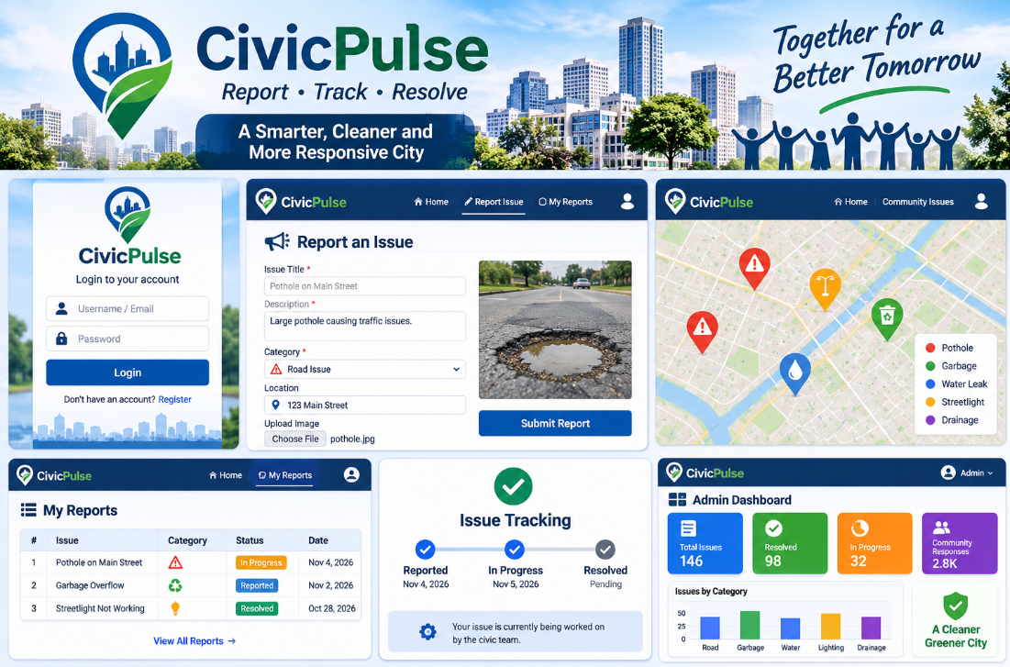
Figure 3.1: CivicPulse interface concept showing login, complaint submission, map view, report tracking and administration dashboard.

CHAPTER 4
IMPLEMENTATION AND MODULES

4.1 Implementation Overview
The supplied report identifies a Flask application and includes a run/output snapshot. It also describes a browser interface, complaint registration, login, complaint submission, database storage and status update. The sections below document these modules at a functional level. Exact route names, source filenames, database engine and library versions should be copied from the final source repository before submission.

4.2 Citizen Registration and Login Module
The authentication module provides an entry point for users. A registration flow, where enabled, collects the required account details and creates a user record. The login flow verifies submitted credentials and establishes an authenticated session. The interface should provide clear feedback for invalid credentials and should not reveal whether a particular account exists.

4.3 Complaint Registration Module
The complaint registration module allows a citizen to submit a new civic issue. The form is expected to collect a short title or description, a category and location details. A well-designed form should explain what information is required and should validate the submission before it is stored.

4.4 Complaint Management Module
The complaint management module presents stored reports in an organized list or dashboard. Administrators can inspect the description, category, location and current status. The module supports a consistent record of each complaint and provides the basis for filtering or prioritizing work.

4.5 Department Assignment Module
The project workflow includes department assignment as a feature. In a complete implementation, the category and location can help an administrator select the responsible department or team. Assignment should be recorded against the complaint so that responsibility is visible. The final implementation should be checked to determine whether assignment is fully functional or represented only in the design.

4.6 Complaint Status Tracking Module
The status-tracking module displays the latest recorded state of a complaint. The supplied material identifies Pending, In Progress and Resolved as the status values. When an administrator changes a status, the updated value should be saved and made visible in the citizen-facing report view.

4.7 Administrator Dashboard
The administrator dashboard is intended to provide a consolidated view of complaints and basic operational information. Useful dashboard indicators include total reports, pending reports, reports in progress and resolved reports. Category-wise summaries can help identify recurring issue types. These indicators should be calculated from actual stored records rather than hard-coded sample values.

4.8 Data Storage and Database Connectivity
Complaint information must persist beyond a single browser session. The application therefore uses a data store to create, retrieve and update records. The supplied material references database storage and includes SQLite documentation in the bibliography, but it does not conclusively establish the exact database engine. Confirm the connection configuration, schema and database file or server before naming the engine in the final version.

4.9 Optional Integrations
INTEGRATION | POTENTIAL USE | STATUS IN THIS REPORT
Map / location service | Show issue locations and support location selection. | Listed as optional; confirm implementation.
Image upload | Attach visual evidence of the reported issue. | Listed as optional; confirm implementation.
Email / in-app notification | Notify users when complaint status changes. | Listed as optional; confirm implementation.
Analytics and reporting | Summarize categories, pending items and resolution trends. | Feature concept described; verify actual calculations.

4.10 Application Execution
The supplied results image shows a Flask application being run from a development environment and includes terminal output associated with application execution and complaint operations. For reproducibility, the final submission should include the actual startup command, dependency installation steps, configuration instructions and database initialization procedure from the delivered project.
IMPLEMENTATION ACCURACY Do not retain alternative technologies such as Django, Node.js, MySQL or MongoDB in the final “technology used” list unless they are actually present in the source code. The original report listed several alternatives without identifying the selected stack.

CHAPTER 5
FEATURES AND USER WORKFLOW

5.1 Main Features
FEATURE | DESCRIPTION
Citizen complaint registration | Allows a resident to submit a report about a public issue such as road damage, sanitation, drainage, water supply or streetlight failure.
Complaint categorization | Groups reports by issue type to support consistent review and filtering.
Location information | Captures where the reported issue is occurring so that it can be identified and routed.
Complaint listing and tracking | Allows a citizen to view submitted complaints and inspect the latest available status.
Administrative review | Provides authorized personnel with a consolidated view of incoming reports.
Department assignment | Supports routing a complaint to a responsible department or team, where implemented.
Status management | Uses Pending, In Progress and Resolved states to communicate progress.
Dashboard summaries | Presents complaint information in an organized administrative view.
Authentication | Separates citizen access from administrative functions, subject to the implemented role controls.

5.2 Citizen Workflow
- Open the CivicPulse application in a supported browser.
- Register or sign in, if authentication is enabled for the session.
- Open the complaint submission page.
- Enter the issue description, choose the relevant category and provide location information.
- Review the entered details and submit the complaint.
- Receive a confirmation or validation message.
- Open the complaint list or tracking page to view the submitted report.
- Return later to review any status update recorded by the administrator.

5.3 Administrator Workflow
- Sign in using an authorized administrator account.
- Open the complaint management dashboard.
- Review newly submitted complaints and check that the information is usable.
- Categorize or prioritize the complaint where required.
- Assign the complaint to the appropriate team or department if assignment is supported.
- Update the status as work progresses.
- Add a meaningful remark or progress note where the application provides that facility.
- Verify that the updated status is visible in the relevant complaint view.

5.4 Overall Feature Workflow
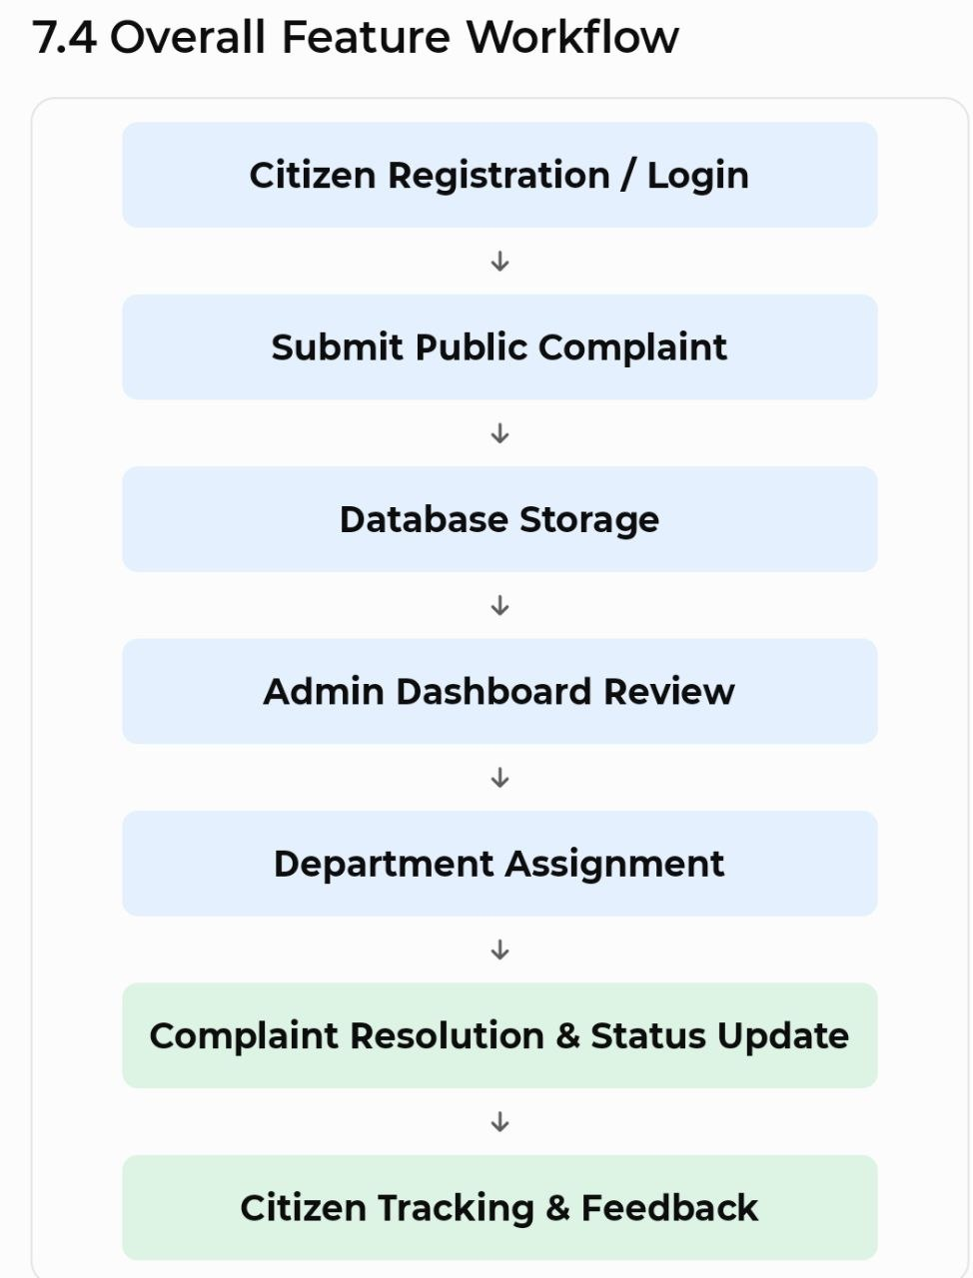
Figure 5.1: Workflow supplied with the original project report, from citizen registration and complaint submission through administrative review, department assignment, resolution and citizen tracking.

5.5 Benefits to Stakeholders
STAKEHOLDER | EXPECTED BENEFIT
Citizens | A consistent channel to submit issues and check recorded progress.
Administrators | A centralized view of incoming complaints and their current states.
Civic teams | Clearer issue descriptions and location details to support follow-up.
Community | Better visibility of reported issues and the actions recorded against them.

CHAPTER 6
TESTING AND VALIDATION

6.1 Purpose of Testing
Testing checks whether the application behaves according to its intended requirements. For CivicPulse, the most important flows are authentication, complaint submission, data persistence, complaint retrieval and status updates. Testing should include valid inputs, invalid inputs, unauthorized access attempts and end-to-end workflows.

6.2 Testing Approach
TEST LEVEL | FOCUS | EXAMPLE
Unit testing | Individual validation functions or data operations. | Check that a missing complaint description is rejected.
Integration testing | Communication between routes, application logic and the data store. | Submit a complaint and confirm it can be retrieved.
System testing | Complete user journeys across the application. | Citizen submits a complaint; administrator updates its status.
Usability testing | Clarity and ease of use of forms and navigation. | Ask a user to submit a report without assistance.
Security testing | Authentication, authorization and input handling. | Attempt to access an administrator action as a citizen.

6.3 Test Cases
ID | TEST | PRECONDITION | EXPECTED RESULT | EXECUTION
TC-01 | Open application home page | Application is running | Home page loads without an error | Verify on local/hosted instance
TC-02 | Submit login with valid credentials | Valid test account exists | User is authenticated and redirected appropriately | Verify with test account
TC-03 | Submit login with invalid credentials | Login page is available | Access is denied with a safe error message | Verify
TC-04 | Submit complaint with required fields | Citizen is authenticated | Complaint is saved and confirmation is displayed | Verify record in data store
TC-05 | Submit complaint with missing required field | Complaint form is available | Validation message is shown; invalid record is not saved | Verify
TC-06 | View complaint list | At least one complaint exists | Relevant complaint records are displayed | Verify
TC-07 | Update complaint status | Administrator is authenticated | Status is saved and latest value is displayed | Verify
TC-08 | Access admin action as citizen | Citizen account is available | Unauthorized action is blocked | Verify
TC-09 | Refresh complaint tracking page | Complaint exists | Saved complaint data remains available | Verify persistence
TC-10 | Check layout on narrow screen | Mobile browser or responsive mode | Content remains readable without horizontal overlap | Verify

6.4 Evidence Available in the Supplied Material
The original report contains a results/output image showing application execution and sample outputs for modules such as registration, login, complaint submission and status update. It also includes a summary stating that complaint data is stored and retrieved from the database. These are useful demonstration artifacts, but they do not replace a complete test log with test date, input data, actual result and pass/fail status.

6.6 Validation Checklist
- All mandatory form fields are validated on the server.
- A complaint is not duplicated because of repeated submission without user feedback.
- Only authorized users can access administrative operations.
- A status update is persisted and remains visible after page refresh.
- Dashboard totals match the records stored in the database.
- Error messages are understandable and do not expose internal stack traces.
- The interface does not overlap or clip at common desktop and mobile widths.

CHAPTER 7
RESULTS AND OUTPUT ANALYSIS

7.1 Introduction
The supplied project material presents CivicPulse as a web-based complaint management application. The included output snapshot describes user registration and login, complaint submission, database storage and retrieval, and complaint status updates. The interface concept image also illustrates a citizen login view, report form, map-oriented view, report list, tracking panel and administrator dashboard.

7.2 Functional Results Reported
MODULE | RESULT DESCRIBED IN THE SOURCE MATERIAL
User registration and login | Registration and login are reported as implemented.
Complaint creation | Citizens can submit complaints with details and location information.
Complaint management | Administrators can view, manage and update complaint status.
Complaint tracking | Citizens can track the progress of submitted complaints.
Database operations | Complaint data is described as being stored and retrieved from a database.

7.3 Interface Evidence
Figure 7.1: Interface overview image included in the supplied report. It depicts the intended CivicPulse screens and dashboard arrangement.

7.4 Execution and Sample Output Evidence
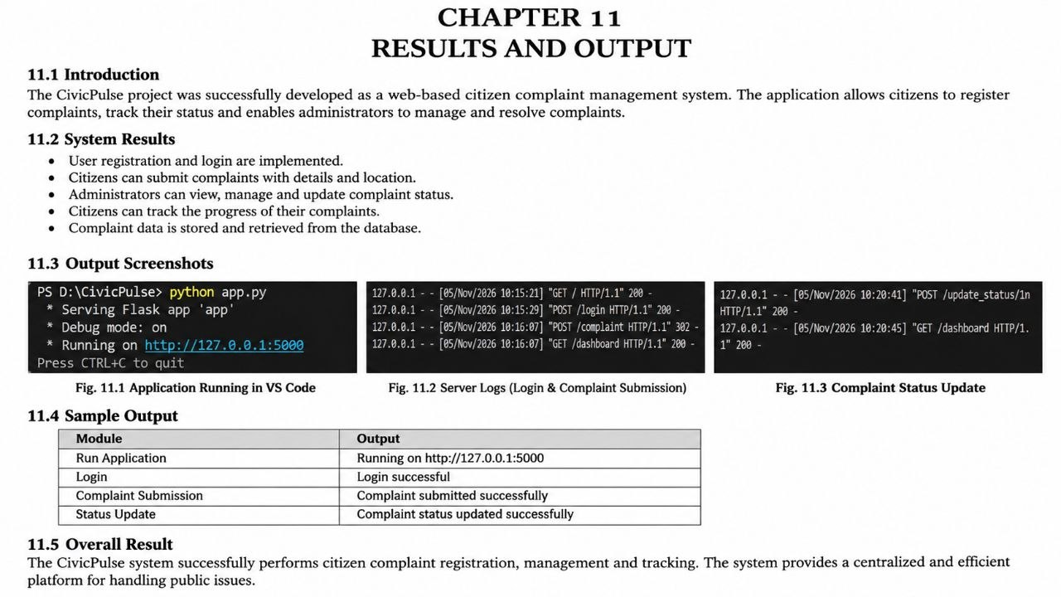
Figure 7.2: Results and output snapshot supplied with the original document. The image contains a brief results description, application/server output screenshots and a sample module-output table.

7.5 Interpretation
The available evidence supports the conclusion that the project team prepared a working demonstration of the core complaint-management flow. The strongest documented elements are the Flask application execution snapshot and the stated operations for registration, login, complaint submission and status update. The screenshots should be replaced or supplemented with clear, high-resolution captures taken from the final running version so that evaluators can read the interface and terminal output.

7.6 Metrics Recommended for Future Evaluation
The current source material does not provide measured performance or service-quality metrics. A future evaluation could record the number of reports submitted, percentage of reports with complete location details, average time to first administrative review, average time to resolution, number of pending reports and user satisfaction feedback. These values should be calculated from real test or operational data and should not be estimated for the report.

CHAPTER 8
CHALLENGES, LIMITATIONS AND FUTURE ENHANCEMENTS

8.1 Challenges
The project materials identify several development concerns: keeping complaint tracking synchronized between the interface and application logic, presenting complaint statistics in an organized dashboard and designing a simple interface for users with different levels of technical familiarity.

8.2 Solutions Described in the Project Material
- Centralized complaint management: use a common data store to organize complaint records.
- Input validation: validate submitted information before processing it.
- Complaint categorization: use predefined categories to make reports easier to organize.
- Database integration: support storing, retrieving and updating complaint information.
- Status management: use consistent status values to communicate progress.
- Administrative dashboard: provide a consolidated view for monitoring complaints.
- User-friendly interface: use clear navigation and recognizable actions.

8.3 Current Limitations
- The exact database engine and final technology versions are not specified consistently in the source report.
- The report does not include a complete database schema or detailed API/route documentation.
- The supplied test evidence does not provide a dated pass/fail test log.
- Map services, image uploads and notifications are mentioned as optional integrations and must be verified before being described as operational.
- The report does not provide measured performance, security or usability evaluation results.
- The platform is an academic prototype; no official municipal integration or production service-level commitment is documented.

8.4 Future Enhancements
ENHANCEMENT | DESCRIPTION / VALUE
Map-based issue location | Allow users to select a location on a map and help administrators identify clusters of reports.
Image evidence | Allow citizens to attach photographs to support issue verification.
Notifications | Send email or in-app notifications when a complaint is received or its status changes.
Duplicate detection | Identify reports with similar categories and nearby locations to reduce duplicate work.
Advanced search and filters | Filter complaints by category, date, status, location or assigned team.
Analytics dashboard | Show trends, resolution time and category distribution using actual complaint records.
Accessibility improvements | Improve keyboard navigation, contrast, labels and screen-reader support.
Security hardening | Add stronger session management, rate limiting, audit logs and secure deployment configuration.
Municipal integration | Explore authorized APIs or data exchange with relevant civic departments, subject to approvals.
Progress feedback | Allow citizens to provide feedback after a complaint is marked resolved.

8.5 Sustainability and Community Impact
A civic reporting platform can support the broader objective of making communities safer, cleaner and more inclusive by improving the visibility of local concerns. This aligns conceptually with United Nations Sustainable Development Goal 11: Sustainable Cities and Communities. The project itself does not establish measurable social impact; such impact would require deployment, adoption and evaluation with real stakeholders.

CHAPTER 9
CONCLUSION
CivicPulse presents a structured web-based approach to civic issue reporting and community response. It focuses on a practical problem: residents need a clear way to submit local public-service concerns and understand whether those concerns are being reviewed or addressed. The proposed workflow brings complaint submission, categorization, administrative review and status tracking into a single platform.
The supplied project material documents the main user roles, core features, a conceptual interface, a complaint workflow and a results snapshot associated with a Flask application. The described functionality includes registration and login, complaint submission, database interaction and complaint status updates. These elements provide a foundation for demonstrating the value of a centralized complaint-management process.
The project can be strengthened further through complete test records, a verified technology-stack description, clear database documentation, improved security controls, responsive interface testing and optional integrations such as maps and notifications. With these improvements, CivicPulse can evolve into a more complete prototype for transparent and organized community issue management.

9.1 Learning Outcomes
- Understanding how a web application can support a real-world civic problem.
- Learning to structure a user workflow around data entry, validation, storage and retrieval.
- Understanding the roles of citizen-facing and administrator-facing interfaces.
- Recognizing the importance of authentication, authorization and input validation.
- Learning how testing evidence and clear documentation improve project quality.

CHAPTER
REFERENCES
[1] Flask Documentation. Pallets Projects. Flask documentation. https://flask.palletsprojects.com/
[2] Python Documentation. Python Software Foundation. Python documentation. https://docs.python.org/3/
[3] MDN Web Docs. Mozilla. HTML, CSS and JavaScript documentation. https://developer.mozilla.org/
[4] SQLite Documentation. SQLite Consortium. SQLite documentation. https://www.sqlite.org/docs.html
[5] Visual Studio Code. Microsoft. Visual Studio Code documentation. https://code.visualstudio.com/docs
[6] Bootstrap Documentation. Bootstrap team. Bootstrap documentation. https://getbootstrap.com/docs/
[7] Font Awesome. Fonticons, Inc. Font Awesome documentation. https://fontawesome.com/docs
[8] Google Maps Platform. Google. Google Maps Platform documentation. https://developers.google.com/maps/documentation
[9] OpenStreetMap. OpenStreetMap contributors. OpenStreetMap documentation. https://wiki.openstreetmap.org/
[10] United Nations SDG 11. United Nations. Sustainable Development Goal 11: Sustainable Cities and Communities. https://sdgs.un.org/goals/goal11
Note: Retain only the references corresponding to technologies, services and concepts actually used or discussed in the final implementation. Add access dates if required by the department.

CHAPTER A
APPENDIX A – USER GUIDE

A.1 Starting the Application
- Open the project folder in the development environment.
- Create and activate the project virtual environment if the project uses one.
- Install dependencies using the dependency file supplied with the project.
- Review the application configuration and set the required database connection values.
- Initialize or migrate the database using the project’s documented procedure.
- Start the Flask development server using the command specified in the project README.
- Open the local application address printed by the server in a web browser.
IMPORTANT The exact commands and local URL must be copied from the actual project README and terminal output. Do not submit generic commands if they do not match the project files.

A.2 Citizen Usage
- Open the application and sign in or register, if enabled.
- Choose the option to report a civic issue.
- Enter a clear description and select the most suitable category.
- Provide the issue location using the available location field.
- Review the details and submit the report.
- Open the report list to check the complaint and its current status.

A.3 Administrator Usage
- Sign in with an authorized administrator account.
- Open the administrator dashboard or complaint list.
- Select a complaint and review its description, category and location.
- Assign the complaint if assignment functionality is available.
- Update the status when progress is made.
- Confirm that the new status is saved and displayed correctly.

CHAPTER B
APPENDIX B – SUBMISSION VERIFICATION CHECKLIST
- ☐ Confirm the exact spelling of all student names.
- ☐ Confirm each student ID against the university records.
- ☐ Confirm the academic year, semester and campus wording.
- ☐ Confirm the guide, course coordinator and HOD names and designations.
- ☐ Verify the exact frontend, backend, database and library versions from the source code.
- ☐ Insert the final architecture diagram and database ER diagram if available.
- ☐ Replace conceptual mock-ups with screenshots from the final running application.
- ☐ Attach actual test cases with execution dates and pass/fail outcomes.
- ☐ Verify that optional features are not described as completed unless they work in the application.
- ☐ Check all pages for correct pagination, figure captions and table numbering.
- ☐ Run a spelling and formatting check after the final screenshots are inserted.
- ☐ Obtain required signatures and department approval.

