SCHOOL OF COMPUTER SCIENCE AND ARTIFICIAL INTELLIGENCE |  |  |  |  | DEPARTMENT OF COMPUTER SCIENCE ENGINEERING
Program Name: B. Tech |  |  |  | Assignment Type: Lab |  |  | Academic Year:2025-2026
Course Coordinator Name |  |  |  | Venkataramana Veeramsetty
Instructor(s) Name |  |  |  | Dr. V. Venkataramana (Co-ordinator)  Dr. T. Sampath Kumar  Dr. Pramoda Patro  Dr. Brij Kishor Tiwari  Dr.J.Ravichander  Dr. Mohammand Ali Shaik  Dr. Anirodh Kumar  Mr. S. Naresh Kumar  Dr. RAJESH VELPULA  Mr. Kundhan Kumar  Ms. Ch. Rajitha  Mr. M Prakash  Mr. B. Raju  Intern 1 (Dharma Teja)  Intern 2 (Sai Prasad)  Intern 3 (Sowmya)  NS_2 ( Mounika)
Course Code |  |  | 24CS002PC215 | Course Title |  | AI Assisted Coding
Year/Sem |  |  | II/I | Regulation |  | R24
Date and Day  of Assignment |  |  | Week7 - Thursday | Time(s)
Duration |  |  | 2 Hours | Applicable to  Batches
AssignmentNumber:13.1(Present assignment number)/24(Total number of assignments)
 | Q.No. | Question |  |  |  |  |  | Expected Time  to complete
 | 1 | Lab 13: Code Refactoring – Improving Legacy Code with AI Suggestions  Lab Objectives:  - Identify code smells and inefficiencies in legacy Python scripts.  - Use AI-assisted coding tools to refactor for readability, maintainability, and performance.  - Apply modern Python best practices while ensuring output correctness.  Task 1  - Task: Refactor repeated loops into a cleaner, more Pythonic approach.  Instructions:  - Analyze the legacy code.  - Identify the part that uses loops to compute values.  - Refactor using list comprehensions or helper functions while keeping the output the same.  Legacy Code:  numbers = [1, 2, 3, 4, 5]  squares = []  for n in numbers:  squares.append(n ** 2)  print(squares)  Expected Output:  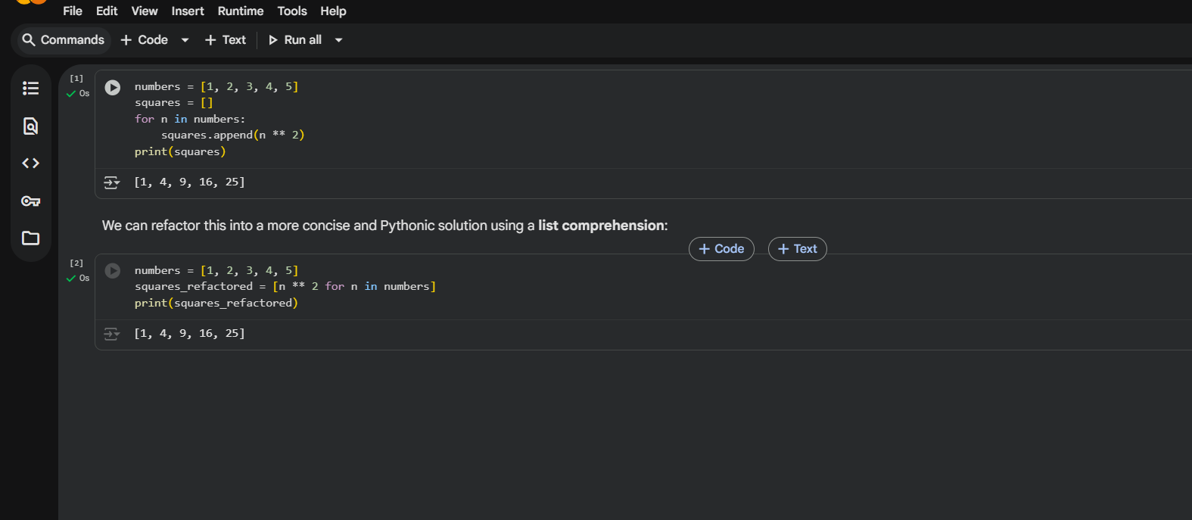  Task 2  Task: Simplify string concatenation.  Instructions:  - Review the loop that builds a sentence using +=.  - Refactor using " ".join() to improve efficiency and readability.  Legacy Code:  words = ["AI", "helps", "in", "refactoring", "code"]  sentence = ""  for word in words:  sentence += word + " "  print(sentence.strip())  Expected Output:  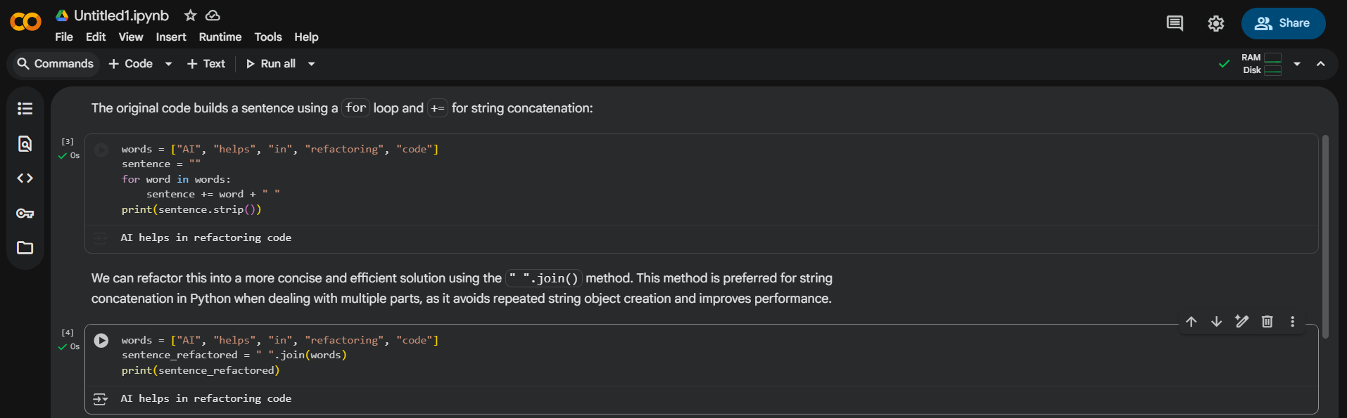  Task 3  Task: Replace manual dictionary lookup with a safer method.  Instructions:  - Check how the code accesses dictionary keys.  - Use .get() or another Pythonic approach to handle missing keys gracefully.  Legacy Code:  student_scores = {"Alice": 85, "Bob": 90}  if "Charlie" in student_scores:  print(student_scores["Charlie"])  else:  print("Not Found")  Expected Output:  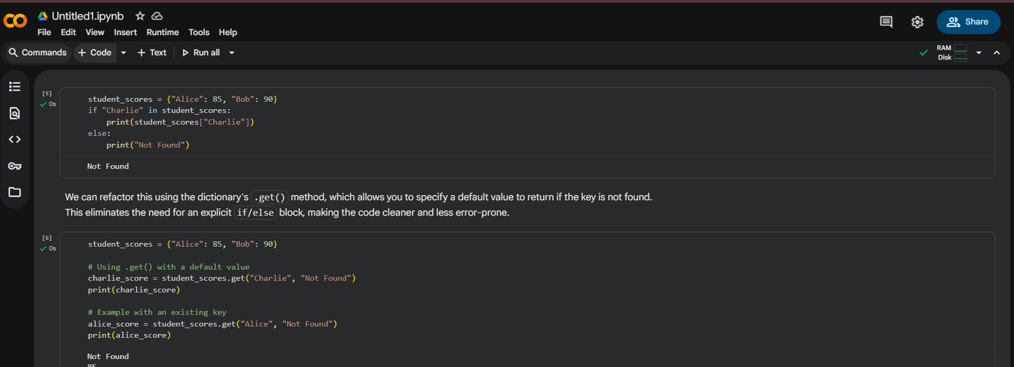  Task 4  Task: Refactor repetitive if-else blocks.  Instructions:  - Examine multiple if-elif statements for operations.  - Refactor using dictionary mapping to make the code scalable and clean.  Legacy Code:  operation = "multiply"  a, b = 5, 3  if operation == "add":  result = a + b  elif operation == "subtract":  result = a - b  elif operation == "multiply":  result = a * b  else:  result = None  print(result)  Expected Output:  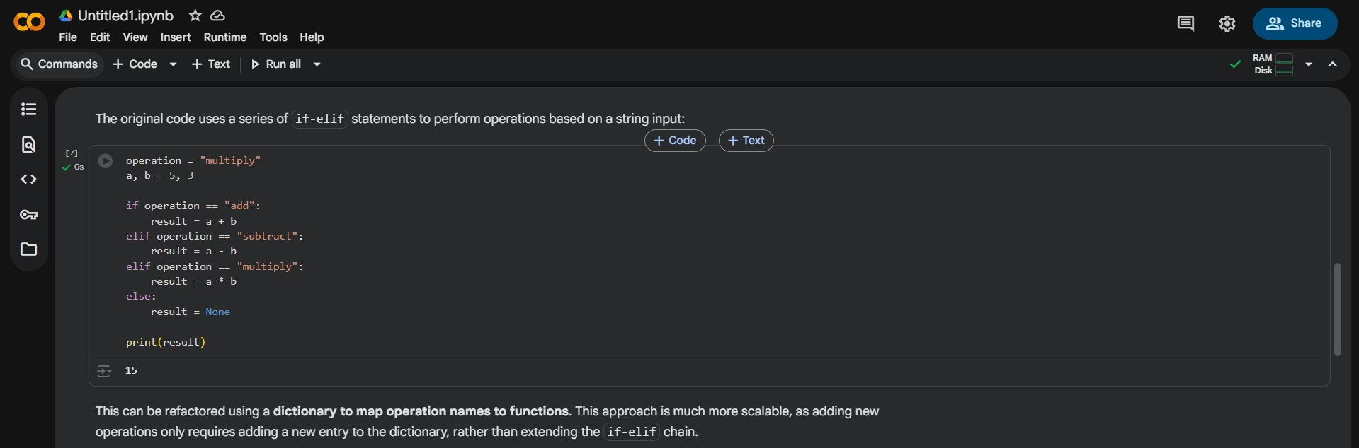  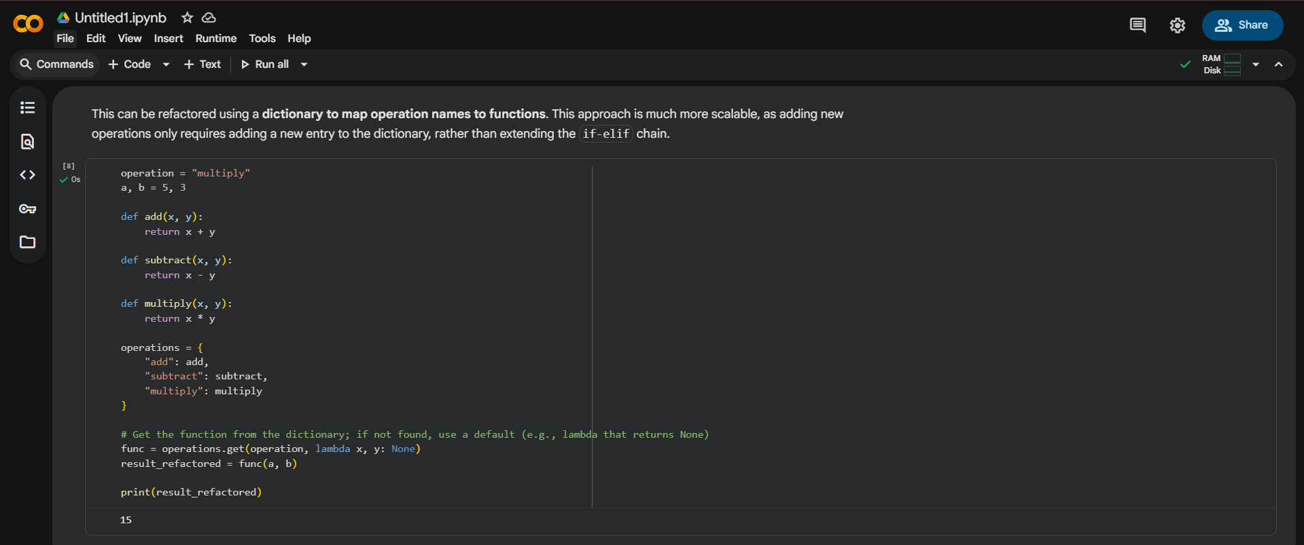  Task 5  Task: Optimize nested loops for searching.  Instructions:  - Identify the nested loop used to find an element.  - Refactor using Python’s in keyword or other efficient search techniques.  Legacy Code:  items = [10, 20, 30, 40, 50]  found = False  for i in items:  if i == 30:  found = True  break  print("Found" if found else "Not Found")  Expected Output:  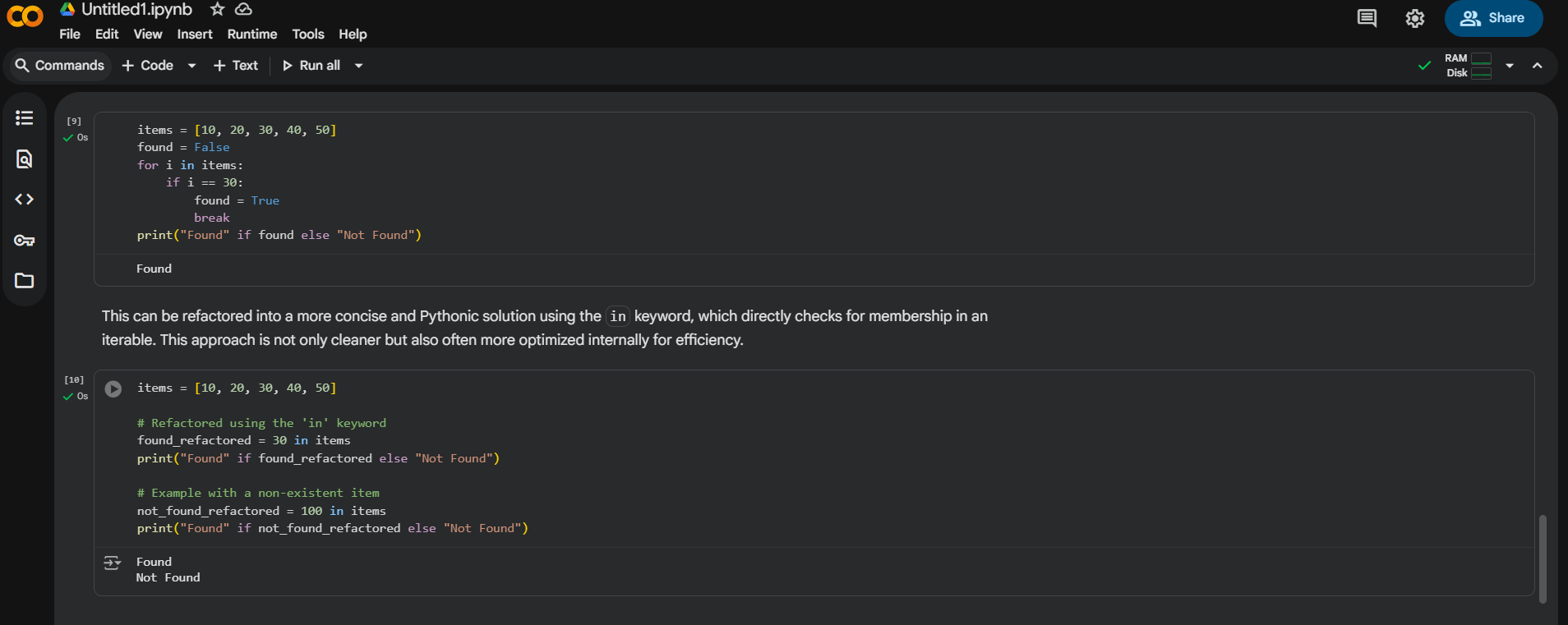 |  |  |  |  |  | Week7 - Thursday

