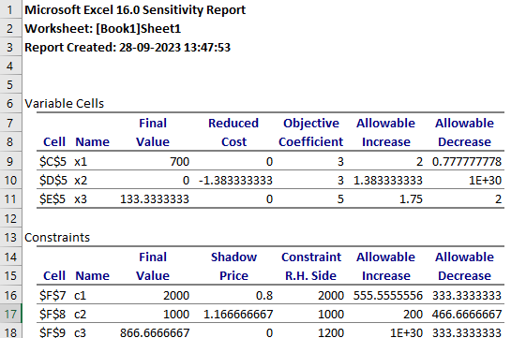

1. **Formulate LP model for this problem ?**

**Ans:** Max z = 3x1+3x2+5x3

constraints :

* 2x1 + 3x2 + 4.5x3 <= 2000
* 1.2x1 + 1.7x2 + 2.3x3 <= 1000
* 0.8x1 + 0x2 + 2.3x3 <= 1200

1. **Solve the problem by SOLVER ?**

**Ans:** 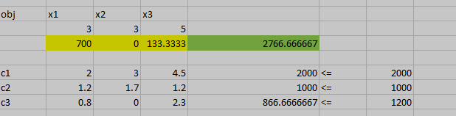

1. **What is the optimal production mix? What contribution can the firm anticipate by producing this mix?**

**Ans:** The Optimal Production mix is 2766.66667.The company can make 2766$ by making 700 lawn chairs, 133 tables and 0 benches. Because there is no profit seen on benches.

1. **What is the value of one unit more of tube-bending time? of welding time? of metal tubing?**

**Ans :** Value of one unit more of tube-bending : 1.16666666666667

Value of one unit more of Weilding : 0

Value of one unit more of metal-tubing : 0.8

1. **A local distributor has offered to sell Outdoors, Inc. some additional metal tubing for $0.60/lb. Should Outdoors buy it? If yes, how much would the firm’s contribution increase if they bought 500 lbs. and used it in an optimal fashion?**

**Ans :**  Purchasing additional metal-tubing for 0.6$/lb is a good thing that can Outdoors, Inc. can do, because the shadow price is o.8 for the metal-tubing. We can also see that the material allowable increase is 555.5555556, then we can also increase 550 lbs. The firm contribution would be 0.8*550 = 440.The profit will be 0.1*550=55.

1. **If Outdoors, Inc. feels that it must produce at least 100 benches to round out its product line, what effect will that have on its contribution?**

**Ans :** The reduced cost of the benches is -1.38333333333333, and if we produce atleast 100 benches there will be a change in overall profit to.The overall profit will be (-1.38333333333333)*100 = -138. That is, there will be the loss of 138$.

1. **The R&D department has been redesigning the bench to make it more profitable. The new design will require 1.1 hours of tube-bending time, 2.0 hours of welding time, and 2.0 lbs. of metal tubing. If it can sell one unit of this bench with a unit contribution of $3, what effect will it have on overall contribution?**

**Ans:**

1. **Marketing has suggested a new patio awning that would require 1.8 hours of tube-bending time, 0.5 hours of welding time, and 1.3 lbs. of metal tubing. What contribution must this new product have to make it attractive to produce this season?**

**Ans:**

**9)** **Outdoors, Inc. has a chance to sell some of its capacity in tube bending at cost + $1.50/hour. If it sells 200 hours at that price, how will this affect contribution?**

**Ans:** The shadow price for tube-bending is 1.1666 and we have 200 units of allowable increase. If it sells 200 hours at at 1.50$ we get 200*(1.50) profit which is equal to 300. But if we sell them at 1.1666667 we get only 233$ which is quite less compared with 1.50$.

1. **If the contribution on chairs were to decrease to $2.50, what would be the optimal production mix and what contribution would this production plan given?**

Ans : 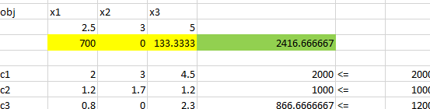

The optimal production mix after decreasing the chairs price to 2.50$ is 2416.666667. The optimal solution doesn’t remains same, it decreased.