**MDSC-103-End Semester Examination**

**Name : G Sai Shravan**

**Regd No : 23904**

**Subject : MDSC-103 (P)**

1) a) Formulate the problem in the Excel file and generate the sensitivity analysis.

Sol: Given, Wilson manufactures the two products baseballs and softballs,

Baseballs take 1 min of time to manufacture dozen balls, whereas softballs take 2 minutes of time. Baseball takes the five sq. of sheet and Softballs takes 6 sq. of sheet. Moreover, 500 baseballs can be made and 500 softballs can be made in one day. The price for baseballs is 7 and price for softballs is 10.

The formulation goes like:

Obj. function: Z = 7x1 + 10X2

Constraints: x1<=500 (x1 = Baseball)

X2<=500 (x2 = Softball)

5x1 + 6x2 <= 3600

X1 + 2x2 <= 960

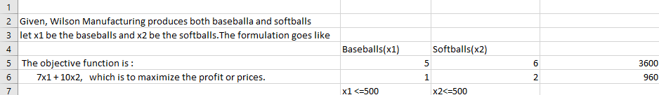

1. b) Write on cost coefficient sensitivity analysis.

**Sol:** 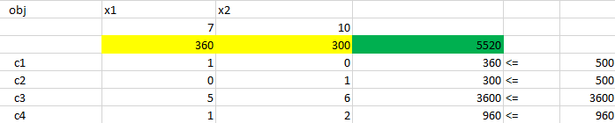

We can clearly see that, if Wilson Manufacturing sells 360 Baseballs and 350 Softballs, the price or cost they can expect is 5520.

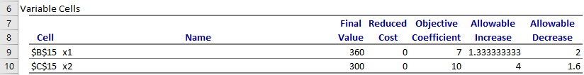

The allowable increase is 1.3333 for the baseball and 4 for the softball.

1. **c)** Write on Right Hand Side Sensitivity Analysis.

Sol:

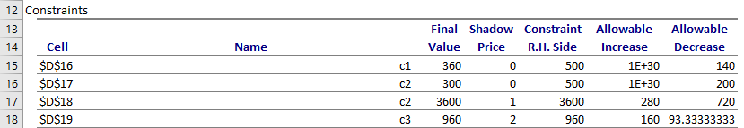

We can see that the Final values for the Baseball and Softballs in dozens that can be sold is 360 and 300, in 3600 sq. ft. of sheet used for the both the products within 960 minutes. The shadow price for the square feet and for the time is 1 and 2, where the more values is given for the time. Allowable increase for the sheet is 280 sq. ft. and for time is 160 minutes. The company can also decrease both the products for 140 and 200.It can decrease 720 sq. ft. sheet and 93.333 minutes.

1. **Consider the following problem:**

**𝑓 (𝑥1, 𝑥2) = 4𝑥1 + 6𝑥2 − 2𝑥1^ 2 − 2𝑥1𝑥2 − 2𝑥2^ 2**

**a) Write a program to visualize the above function.**

**b) Write an iterative program to maximize the function.**

**Sol: Program for Visualizing the given function:**

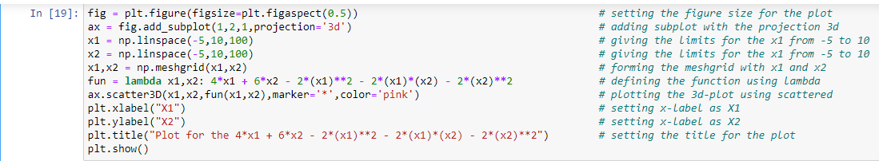

Plot for the given Function:

