Incident Response Agent
Website walkthrough — screenshots and explanation
Screenshots of the live Gradio site, cropped to remove browser chrome. Organized in two parts: the final working demo (what to show judges), followed by two earlier debugging screenshots kept as a record of issues that were found and fixed.

Part 1 — Working demo

1. Analyze an incident → Agent Memory panel
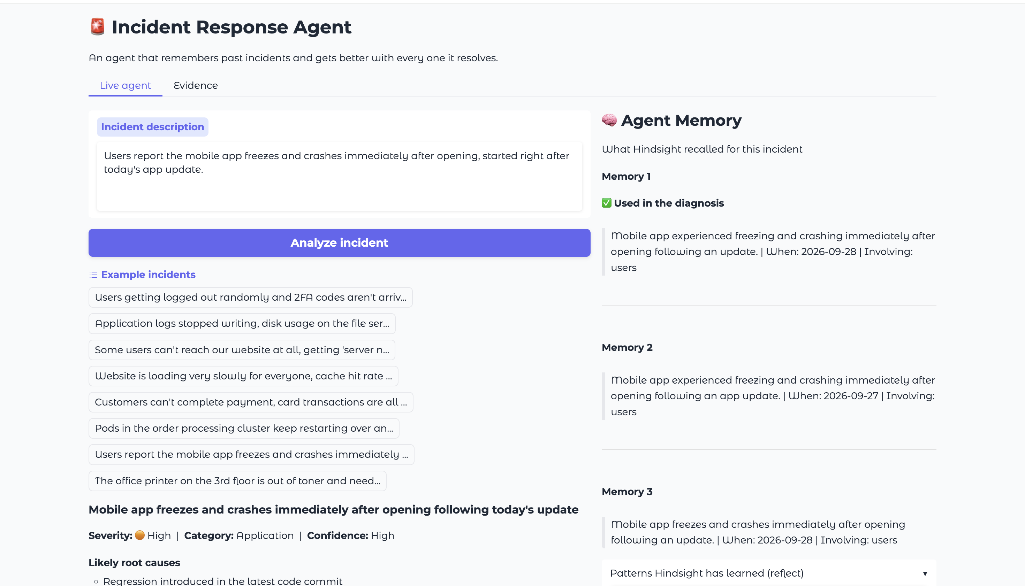
Incident: "Users report the mobile app freezes and crashes immediately after opening, started right after today's app update."
The right-hand Agent Memory panel shows exactly what Hindsight recalled for this incident, ranked as Memory 1, 2, 3. Memory 1 is marked "Used in the diagnosis" — this is the key visual proof that the diagnosis is not a generic LLM answer, it is grounded in a specific retrieved memory ("Mobile app experienced freezing and crashing immediately after opening following an update. | When: 2026-09-28").

2. Full diagnosis output
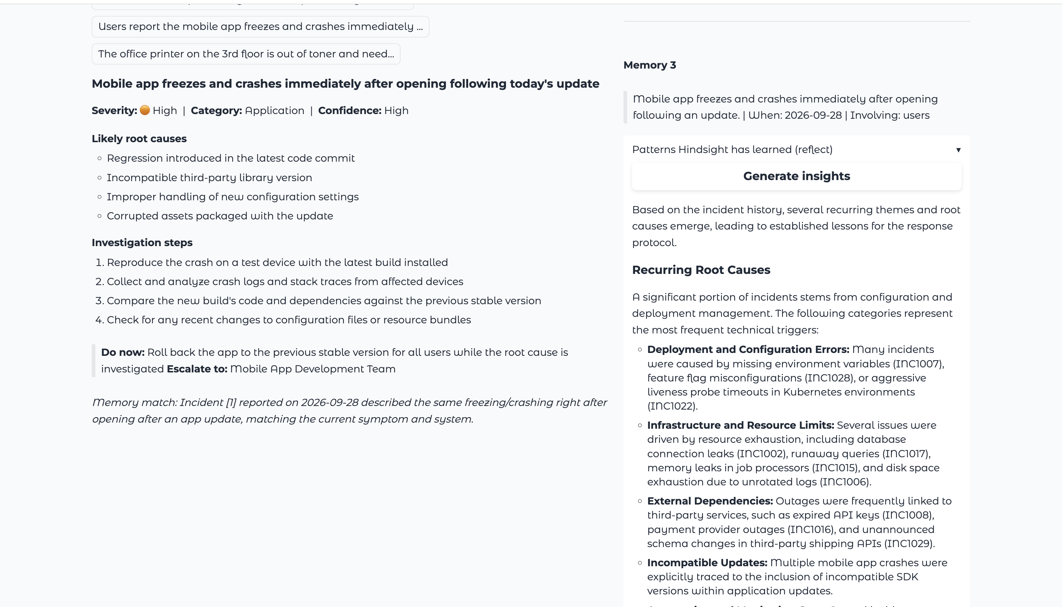
The structured diagnosis for the same incident: severity (High), category (Application), confidence (High), likely root causes, a numbered investigation checklist, a "Do now" immediate action, and an escalation target (Mobile App Development Team). At the bottom, the agent explicitly states which past incident it matched against and why — "Incident [1] reported on 2026-09-28 described the same freezing/crashing right after opening after an app update, matching the current symptom and system." This sentence is the evidence trail that separates this from a generic chatbot answer.

3. Reflect — recurring root causes
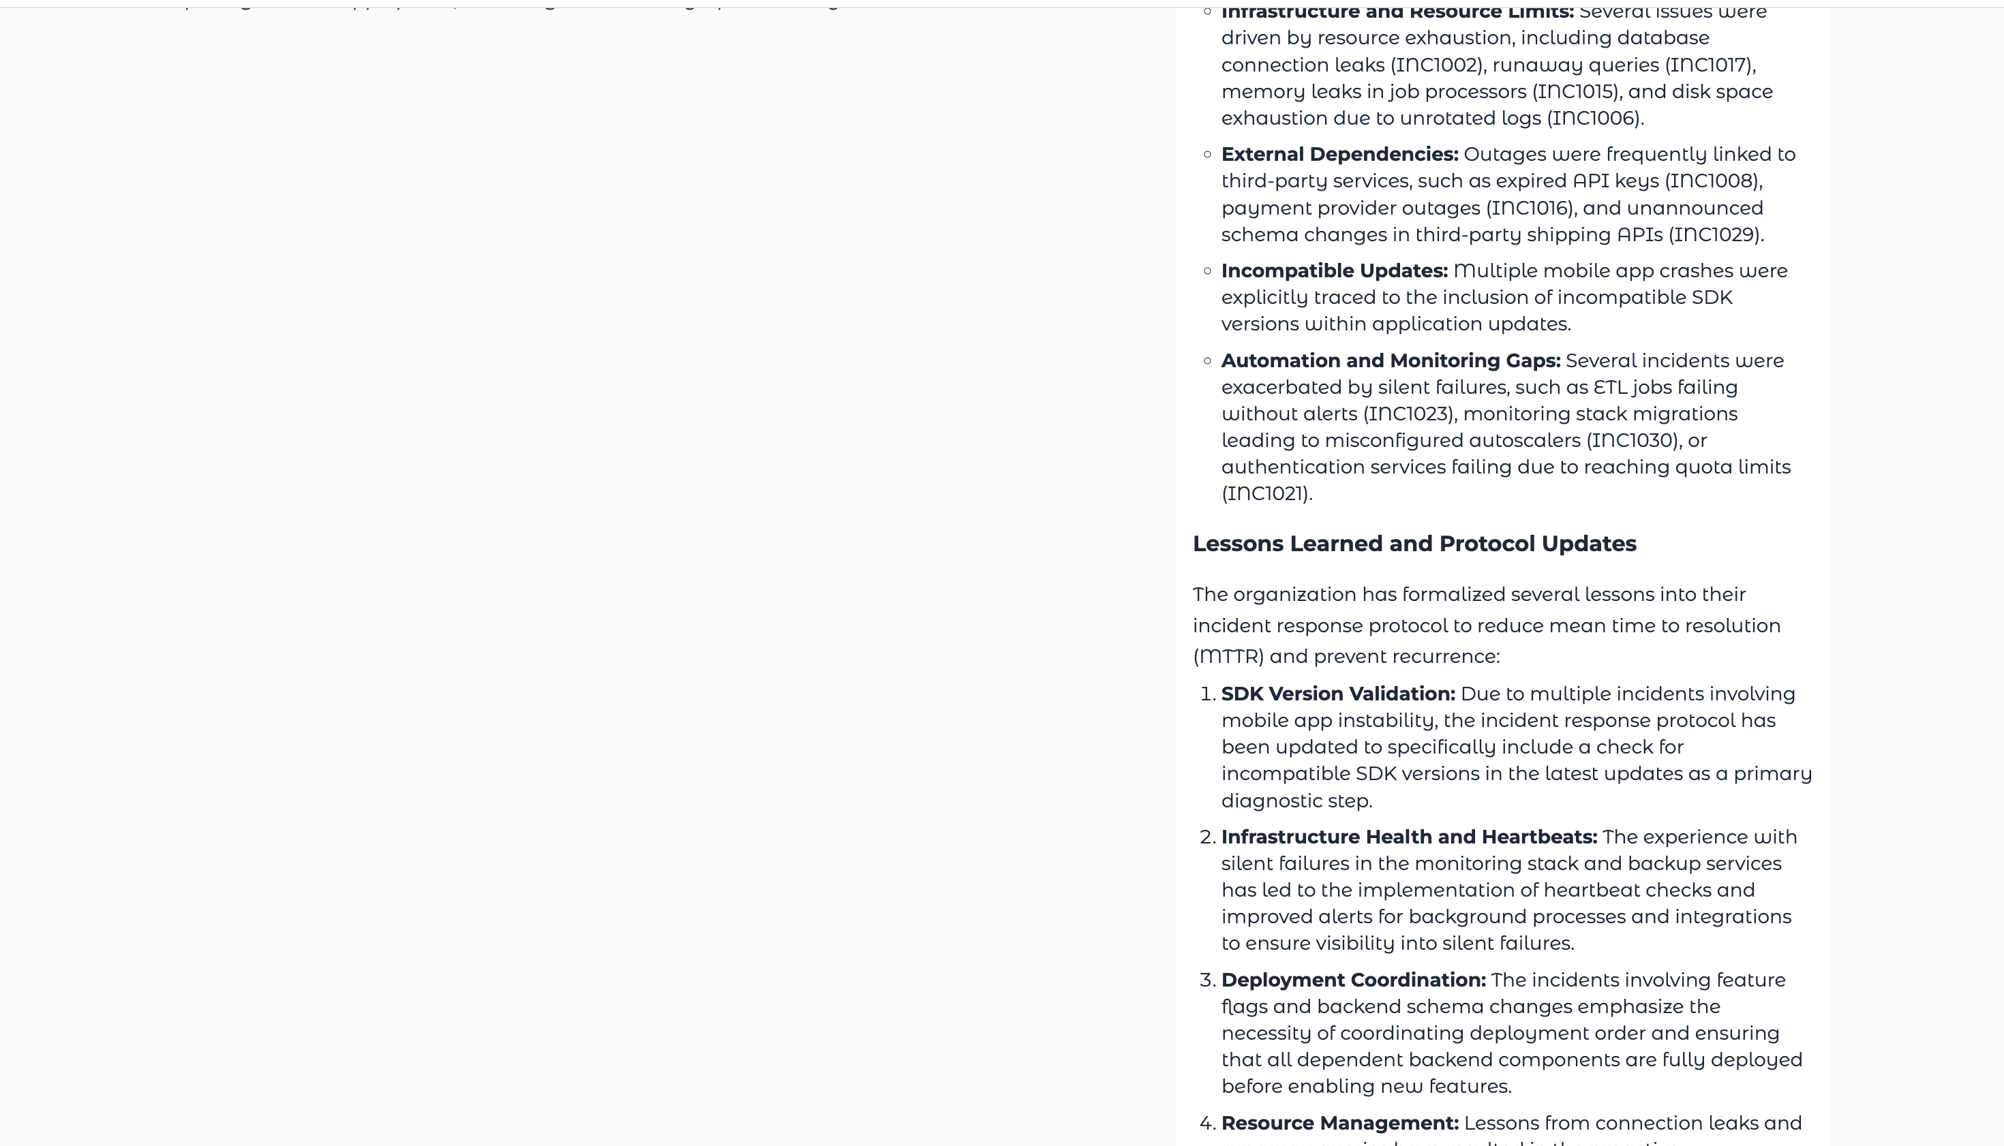
Clicking Generate insights calls Hindsight's reflect, which synthesizes patterns across all stored memories rather than retrieving one match. It groups recurring causes into categories — deployment/config errors, infrastructure limits, external dependencies, incompatible updates — each backed by specific incident IDs (INC1007, INC1022, INC1002, etc.). This is a genuinely different capability from recall: it is reasoning across the whole memory bank, not just answering one query.

4. Reflect — lessons learned
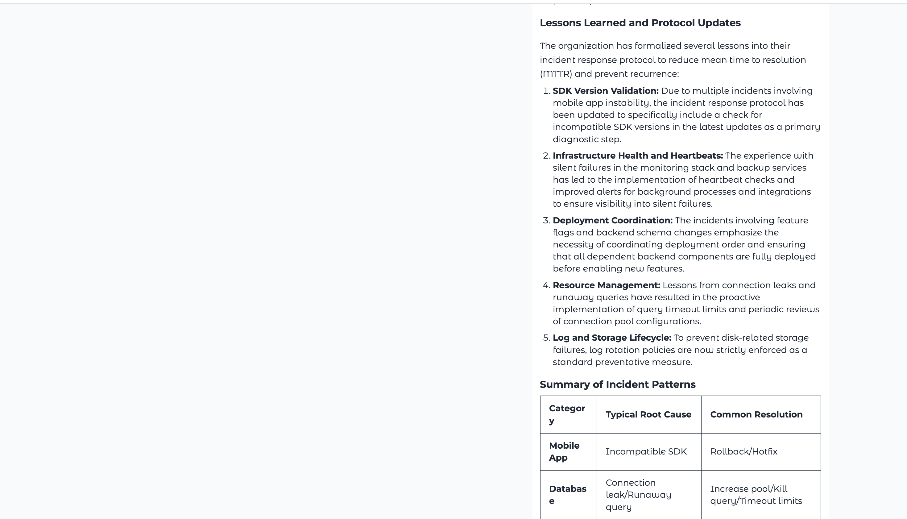
Continuing the same reflect output: the agent turns the recurring patterns into concrete protocol changes (SDK version validation, infrastructure heartbeats, deployment coordination, resource management, log rotation). This is the "does memory actually make the org smarter" story in one screenshot.

5. Incident pattern summary table + Resolve & Teach
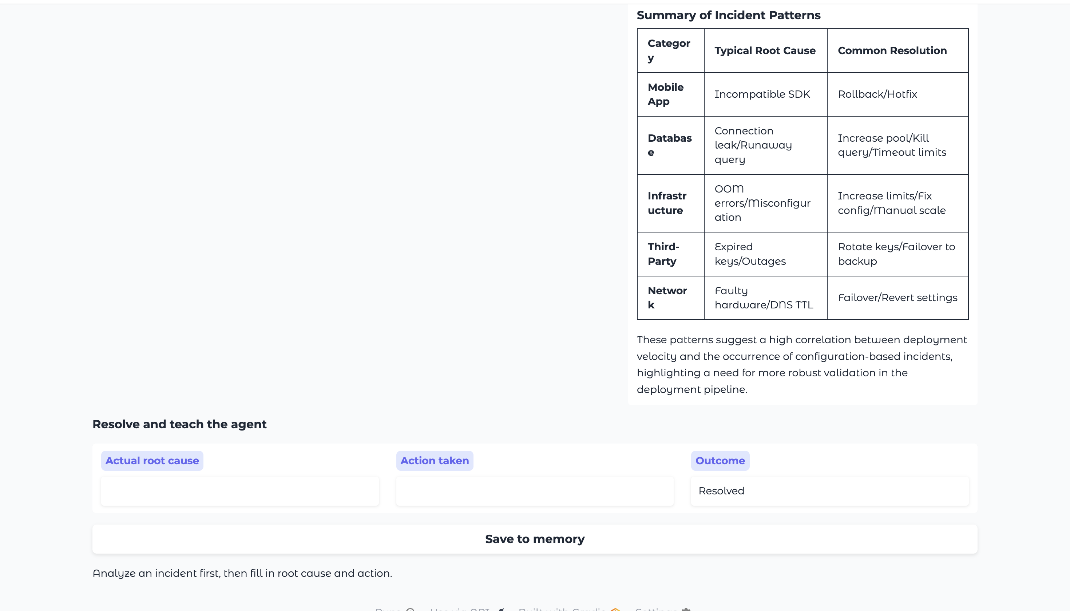
A structured table version of the same insight (category, typical root cause, common resolution), followed by the Resolve and teach the agent panel. This is where a human enters the actual root cause and action taken after resolving an incident, then clicks Save to memory — the step that closes the learning loop: resolve, post-mortem, retain, recalled next time.

6. Evidence tab — does memory actually help?
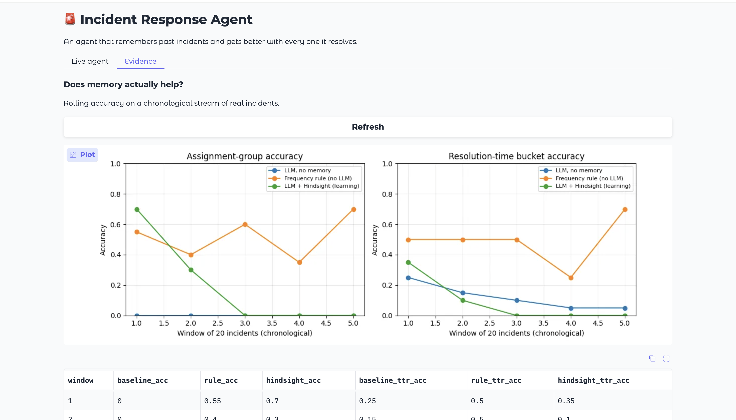
Rolling accuracy on a chronological stream of real (Kaggle) incidents, comparing three approaches: LLM with no memory (blue), a simple frequency rule with no LLM at all (orange), and LLM + Hindsight (green). Read this chart carefully before presenting it — on this specific anonymized dataset, the frequency rule is competitive with or beats the Hindsight-backed agent on both assignment-group accuracy and resolution-time-bucket accuracy. This is an honest limitation, not a bug: the real dataset's categories and symptoms are anonymized codes, not descriptive text, so semantic retrieval has little to work with. It is worth being upfront about this if asked, and pivoting to the curated-bank demo (sections 1 to 5 above) as where memory's advantage is actually visible.

7. Evidence tab — full numeric results
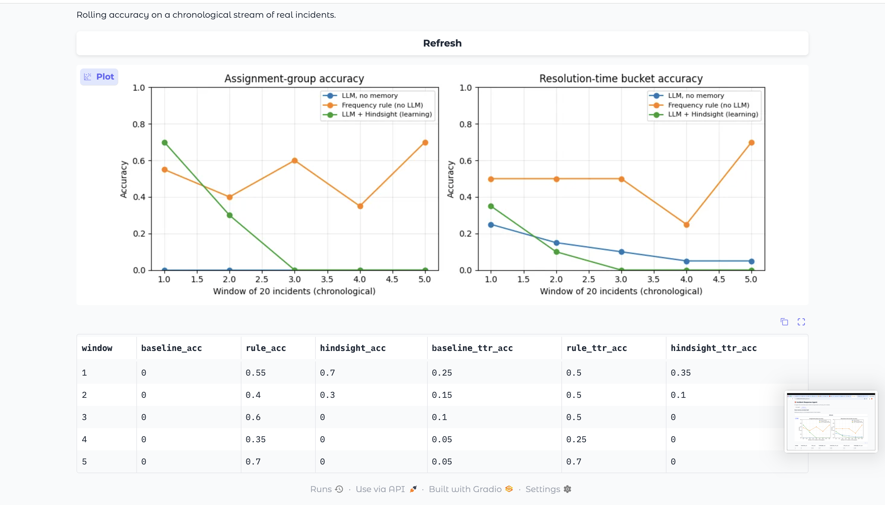
The underlying numbers behind the chart above, window by window (5 windows of 20 incidents each): baseline accuracy, rule accuracy, Hindsight accuracy, and the same three for resolution-time-bucket accuracy.

Part 2 — Debugging record (earlier, broken states)
Kept here as a record of two real issues that came up while building this, both since fixed. Useful if a judge asks "did you run into problems, and how did you debug them."

A. Reflect failing inside a Gradio thread
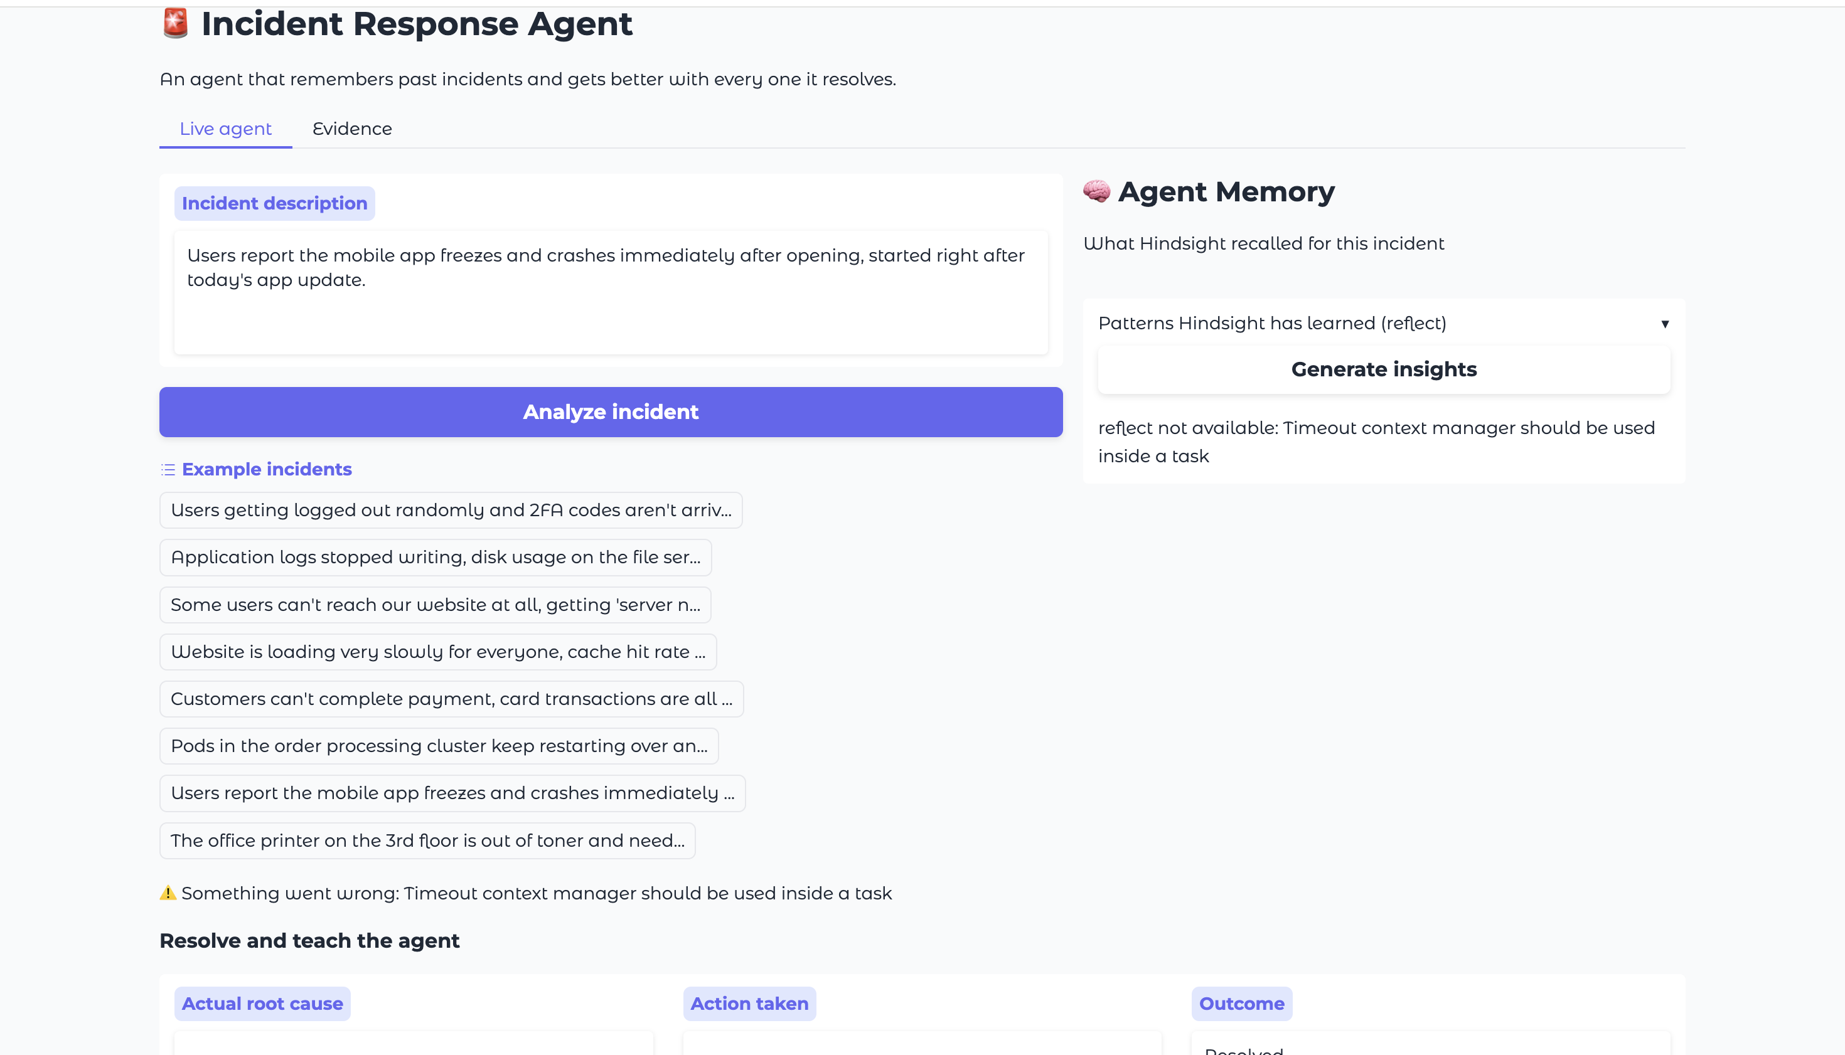
Early version: clicking Generate insights failed with "Timeout context manager should be used inside a task." Root cause: Gradio runs button handlers in worker threads, and the Hindsight client (combined with nest_asyncio, needed for Colab) breaks when called from a thread other than the one holding its event loop. Fixed by routing every Hindsight call through one dedicated background event loop (a thread-safe wrapper around the client).

B. Undefined function after a kernel restart
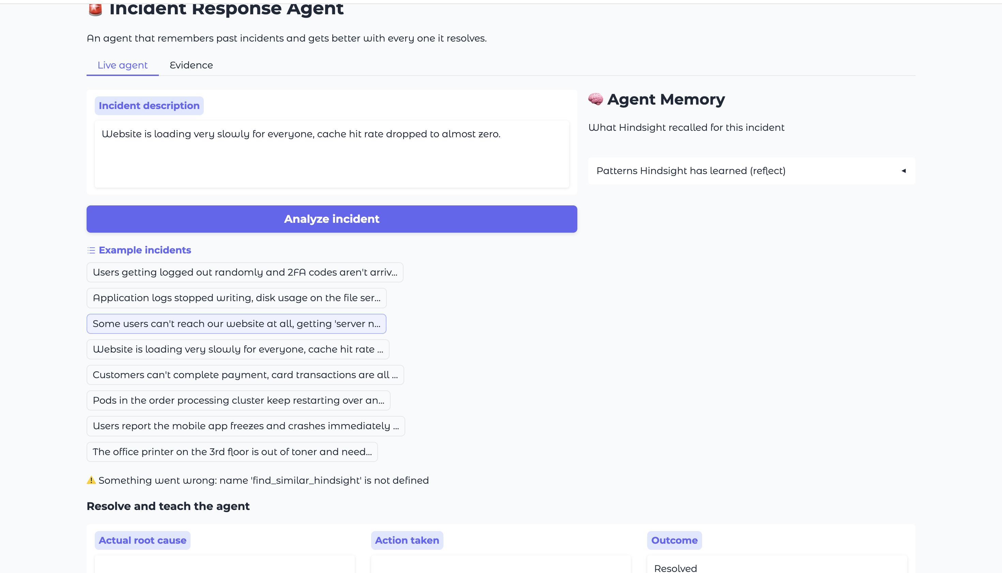
"name find_similar_hindsight is not defined" — this happened after a Colab runtime restart wiped all installed packages and defined functions. Fixed by re-running the setup cells in order before using the UI again (a restart always requires re-running from the top; nothing persists except data already saved to Hindsight's cloud memory).

Screenshots captured 2026-09-28. Cropped to remove browser tabs/address bar; content otherwise unedited.

