Figures 14.2.1/2
Kaplan Meier Curves for Progression Free Survival by Treatment Arm in Second Remission
Randomized Subjects with 2nd Remission

The LIFETEST Procedure

Stratum 1: TRTN = CMP-135

Product-Limit Survival Estimates
AVAL |  | Survival | Failure | Survival Standard Error | Number  Failed | Number  Left
0.0000 |  | 1.0000 | 0 | 0 | 0 | 26
1.0842 | * |  |  |  | 0 | 25
1.3142 |  | 0.9600 | 0.0400 | 0.0392 | 1 | 24
1.7741 |  | 0.9200 | 0.0800 | 0.0543 | 2 | 23
1.8070 |  | 0.8800 | 0.1200 | 0.0650 | 3 | 22
1.8727 |  | 0.8400 | 0.1600 | 0.0733 | 4 | 21
2.1027 | * |  |  |  | 4 | 20
3.1540 |  | 0.7980 | 0.2020 | 0.0808 | 5 | 19
3.5483 | * |  |  |  | 5 | 18
3.5811 | * |  |  |  | 5 | 17
3.7782 | * |  |  |  | 5 | 16
3.7782 | * |  |  |  | 5 | 15
4.0082 | * |  |  |  | 5 | 14
5.2895 |  | 0.7410 | 0.2590 | 0.0930 | 6 | 13
5.4209 | * |  |  |  | 6 | 12
5.4867 | * |  |  |  | 6 | 11
5.5852 |  | 0.6736 | 0.3264 | 0.1062 | 7 | 10
5.6181 |  | 0.6063 | 0.3937 | 0.1149 | 8 | 9
5.7495 | * |  |  |  | 8 | 8
6.9979 |  | 0.5305 | 0.4695 | 0.1231 | 9 | 7
7.4251 | * |  |  |  | 9 | 6
7.6550 |  | 0.4421 | 0.5579 | 0.1305 | 10 | 5
9.1335 |  | 0.3537 | 0.6463 | 0.1310 | 11 | 4
9.1663 | * |  |  |  | 11 | 3
9.3306 | * |  |  |  | 11 | 2
9.4949 | * |  |  |  | 11 | 1
13.2731 |  | 0 | 1.0000 |  | 12 | 0

Note: | The marked survival times are censored observations.

Figures 14.2.1/2
Kaplan Meier Curves for Progression Free Survival by Treatment Arm in Second Remission
Randomized Subjects with 2nd Remission

The LIFETEST Procedure

Stratum 1: TRTN = CMP-135

Summary Statistics for Time Variable AVAL

Quartile Estimates
Percent | Point  Estimate | 95% Confidence Interval
Percent | Point  Estimate | Transform | [Lower | Upper)
75 | 13.2731 | LOGLOG | 7.6550
50 | 7.6550 | LOGLOG | 5.5852
25 | 5.2895 | LOGLOG | 1.3142 | 6.9979

Mean | Standard  Error
8.1682 | 1.0694

Figures 14.2.1/2
Kaplan Meier Curves for Progression Free Survival by Treatment Arm in Second Remission
Randomized Subjects with 2nd Remission

The LIFETEST Procedure

Stratum 2: TRTN = Placebo

Product-Limit Survival Estimates
AVAL |  | Survival | Failure | Survival Standard Error | Number  Failed | Number  Left
0.0000 |  | 1.0000 | 0 | 0 | 0 | 26
0.7556 |  | 0.9615 | 0.0385 | 0.0377 | 1 | 25
1.8727 |  |  |  |  | 2 | 24
1.8727 |  |  |  |  | 3 | 23
1.8727 |  | 0.8462 | 0.1538 | 0.0708 | 4 | 22
2.9569 |  | 0.8077 | 0.1923 | 0.0773 | 5 | 21
3.1211 |  | 0.7692 | 0.2308 | 0.0826 | 6 | 20
3.4497 | * |  |  |  | 6 | 19
3.5154 | * |  |  |  | 6 | 18
3.6468 |  | 0.7265 | 0.2735 | 0.0884 | 7 | 17
3.7125 | * |  |  |  | 7 | 16
3.7125 | * |  |  |  | 7 | 15
3.7782 |  | 0.6781 | 0.3219 | 0.0949 | 8 | 14
3.8768 |  | 0.6296 | 0.3704 | 0.0997 | 9 | 13
5.3224 |  | 0.5812 | 0.4188 | 0.1031 | 10 | 12
5.5195 |  | 0.5328 | 0.4672 | 0.1053 | 11 | 11
5.5195 | * |  |  |  | 11 | 10
5.5852 |  | 0.4795 | 0.5205 | 0.1074 | 12 | 9
5.6838 | * |  |  |  | 12 | 8
5.7166 | * |  |  |  | 12 | 7
5.7823 |  | 0.4110 | 0.5890 | 0.1118 | 13 | 6
7.2936 |  | 0.3425 | 0.6575 | 0.1122 | 14 | 5
7.3922 | * |  |  |  | 14 | 4
7.4251 |  | 0.2569 | 0.7431 | 0.1122 | 15 | 3
7.4251 | * |  |  |  | 15 | 2
9.1992 | * |  |  |  | 15 | 1
9.2320 | * |  |  |  | 15 | 0

Note: | The marked survival times are censored observations.

Figures 14.2.1/2
Kaplan Meier Curves for Progression Free Survival by Treatment Arm in Second Remission
Randomized Subjects with 2nd Remission

The LIFETEST Procedure

Stratum 2: TRTN = Placebo

Summary Statistics for Time Variable AVAL

Quartile Estimates
Percent | Point  Estimate | 95% Confidence Interval
Percent | Point  Estimate | Transform | [Lower | Upper)
75 |  | LOGLOG | 5.7823
50 | 5.5852 | LOGLOG | 3.7782 | 7.4251
25 | 3.6468 | LOGLOG | 1.8727 | 5.5195

Mean | Standard  Error
5.2669 | 0.4609

Note: | The mean survival time and its standard error were underestimated because the largest observation was censored and the estimation was restricted to the largest event time.

Summary of the Number of Censored and Uncensored Values
Stratum | TRTN | Total | Failed | Censored | Percent  Censored
1 | CMP-135 | 26 | 12 | 14 | 53.85
2 | Placebo | 26 | 15 | 11 | 42.31
Total |  | 52 | 27 | 25 | 48.08

Figures 14.2.1/2
Kaplan Meier Curves for Progression Free Survival by Treatment Arm in Second Remission
Randomized Subjects with 2nd Remission

The LIFETEST Procedure

Testing Homogeneity of Survival Curves for AVAL over Strata

Rank Statistics
TRTN | Log-Rank
CMP-135 | -2.6541
Placebo | 2.6541

Covariance Matrix for the Log-Rank Statistics
TRTN | CMP-135 | Placebo
CMP-135 | 6.26595 | -6.26595
Placebo | -6.26595 | 6.26595

Test of Equality over Strata
Test | Chi-Square | DF | Pr >  Chi-Square
Log-Rank | 1.1242 | 1 | 0.2890

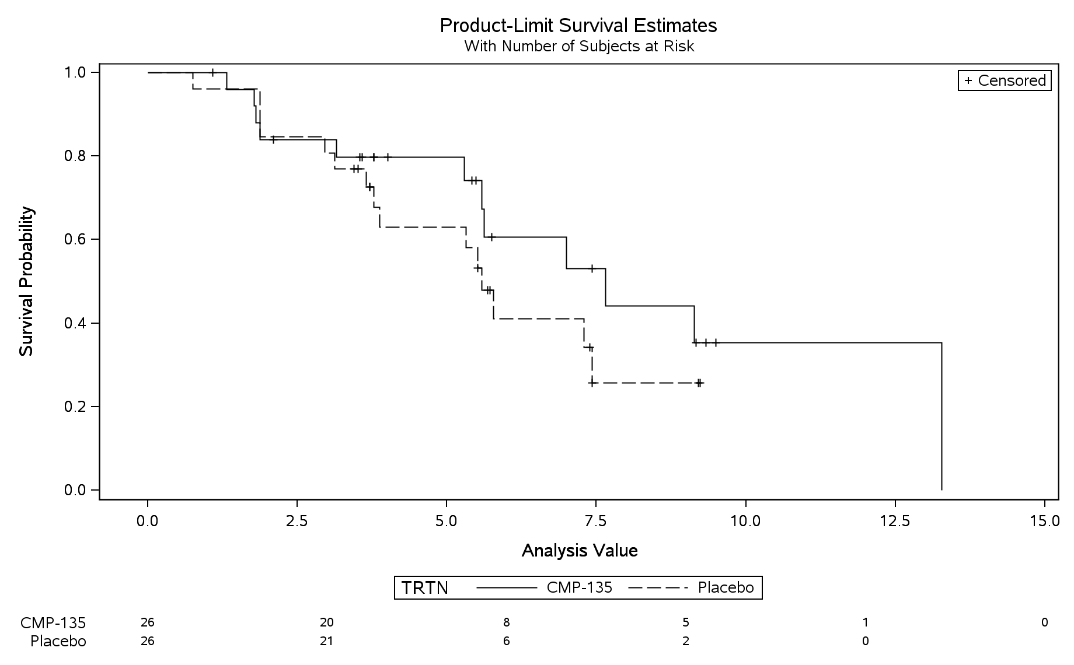

Median Time (months): Placebo=NE; CMP-135=NE
Hazard Ratio=NE; 95% CI=(NE, NE)
Log-rank p-value=0.2890

