
S-VYASA
Swami Vivekananda Yoga Anusandhana Samsthana
(Deemed to be University u/s 3 of UGC Act, 1956)

DEEKSHARAMBH 2026
DIGITAL CREATORS LEAGUE
Theme: Create. Trend. Inspire.
Event Proposal
Deeksharambh 2026 Organizing Team,
S-VYASA Deemed to be University

1. Introduction
Digital Creators League is an online creative contest series organized as part of Deeksharambh 2026 to encourage newly admitted students to showcase their creativity, innovation, confidence, and digital storytelling skills.
The competition provides students with an opportunity to express themselves through reels, photography, talent performances, and yoga while celebrating their first experiences at SVYASA. It also aims to create engaging digital content that reflects the vibrant campus culture and promotes student participation during Deeksharambh 2026.

2. Objectives
- Encourage creativity and self-expression among students.
- Promote student engagement during Deeksharambh 2026.
- Showcase the beauty and culture of the SVYASA campus.
- Provide a platform for students to exhibit their talents.
- Foster digital content creation and storytelling skills.
- Recognize and reward outstanding creative work.

3. Event Categories
Sl. No. | Event | Theme | Submission
1 | 🎬 Campus Diaries | My First Week @ SVYASA | 30–60 sec Reel
2 | 👑 Campus Vogue | Style with Confidence | Fashion Reel
3 | 🌟 Minute to Shine | Every Talent Has a Stage | 60 sec Talent Video
4 | 🧘 Yoga in Motion | Balance. Breathe. Become. | Yoga Reel
5 | 📸 Campus Through Your Lens | The Beauty of SVYASA | Photography

4. Event Details

🎬 Campus Diaries — My First Week @ SVYASA
Create a creative reel showcasing your first week at SVYASA. Share memorable moments, friendships, classrooms, campus exploration, orientation activities, and your journey as a new student.
- Duration: 30–60 seconds
- Format: MP4
- Orientation: Vertical (9:16)
- Minimum Resolution: 720p
- Maximum File Size: 200 MB

👑 Campus Vogue — Style with Confidence
Create a stylish campus fashion reel highlighting your confidence, personality, creativity, and individuality while maintaining university values and decorum.
- Duration: 20–45 seconds
- Format: MP4
- Orientation: Vertical (9:16)
- Minimum Resolution: 720p

🌟 Minute to Shine — Every Talent Has a Stage
Showcase your talent in one minute. You may present singing, dancing, acting, instrumental music, painting, coding, poetry, photography, mimicry, magic, beatboxing, public speaking, Rubik's Cube solving, or any unique skill.
- Maximum Duration: 60 seconds
- Format: MP4
- Minimum Resolution: 720p

🧘 Yoga in Motion — Balance. Breathe. Become.
Create a creative yoga reel demonstrating yoga asanas, flexibility, balance, mindfulness, meditation, or Surya Namaskar while emphasizing proper posture and safety.
- Duration: 30–60 seconds
- Format: MP4
- Orientation: Vertical (9:16)
- Minimum Resolution: 720p

📸 Campus Through Your Lens — The Beauty of SVYASA
Capture photographs representing the beauty, culture, architecture, nature, student life, learning spaces, yoga environment, and memorable moments of the SVYASA campus.
- Format: JPG/JPEG
- Minimum Resolution: 1920 × 1080 pixels
- Basic editing such as cropping, brightness, and contrast adjustments is permitted.

5. Registration
Participants must register through the official Google Registration Form.

Registration Link
https://docs.google.com/forms/d/e/1FAIpQLSf1ebFjaWM3b9FO_Sjx1zvUzWGKc5p9IDyhF6QjJjqCDjjW6A/viewform?usp=header

Registration QR Code
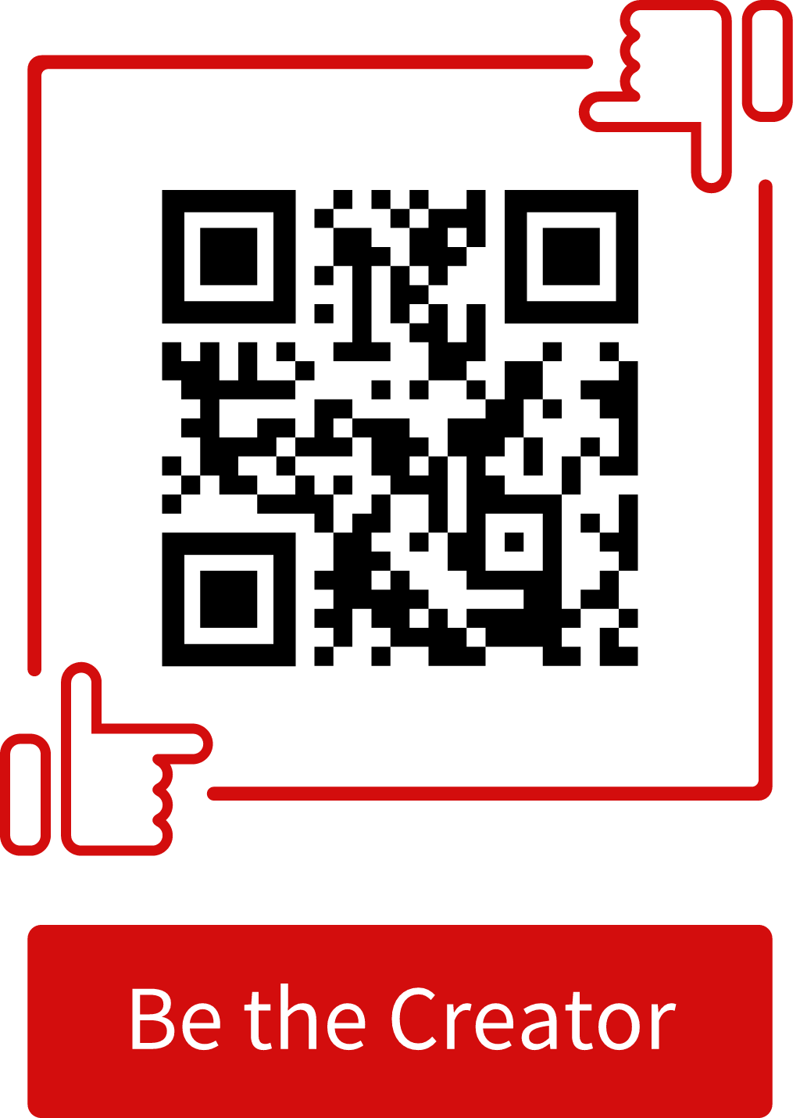

Registration Details Required
- Student Name
- USN
- Department
- Group Number
- WhatsApp Number
- Event(s) of Participation

Registration Guidelines
- Participants may register for one or more events.
- Registration is mandatory.
- Ensure all details are entered correctly.
- Incomplete registrations may be rejected.

6. Submission Process
All entries must be submitted through the official Google Submission Form.

Submission Link
[Insert Submission Google Form Link]

Submission QR Code
[Insert Submission QR Code]

Submission Details
- Student Name
- USN
- Department
- Event Name
- Title of Entry
- Google Drive Link (Videos)
- Photo Upload (Photography)
- Caption (Optional)

Submission Guidelines
- Videos must be uploaded to Google Drive.
- Set sharing permission to “Anyone with the Link”.
- Photography entries should be uploaded in JPG/JPEG format.
- Submit a separate entry for each event.
- Only entries submitted before the deadline will be evaluated.

7. General Rules
- Participation is open exclusively to students attending Deeksharambh 2026.
- Students may participate in multiple events.
- All submissions must be original and created by the participant.
- Entries must strictly follow the respective event theme.
- Content should be respectful and align with university values.
- Obscene, offensive, political, religious, discriminatory, or copyrighted content is prohibited.
- Excessive AI-generated content that replaces original participant creativity is not permitted.
- The organizing committee reserves the right to reject any entry that violates the guidelines.
- The decision of the judges shall be final and binding.

8. Evaluation Criteria
Criteria | Marks
Creativity & Innovation | 30
Originality | 20
Theme Relevance | 20
Technical Quality | 15
Presentation & Overall Impact | 15
Total | 100

9. Judging Process
- Entries will be evaluated by a panel of faculty members and invited experts.
- Each entry will be assessed independently based on the evaluation criteria.
- The judges' decision shall be final and binding.
- Any attempt to influence the judging process will result in disqualification.

10. Plagiarism Policy
- Submitted work must be original.
- Participants are responsible for ensuring that their submissions do not infringe on copyright.
- Plagiarized or copied entries will be disqualified.
- The organizing committee may request the original media files for verification if required.

11. Awards & Prizes
To recognize exceptional creativity and encourage active participation, one winner will be selected from each event category based on the evaluation criteria and the decision of the judging panel.
Sl. No. | Event | No. of Winners | Prize Money
1 | 🎬 Campus Diaries | 1 | ₹2,000(Not Confirmed yet)
2 | 👑 Campus Vogue | 1 | ₹2,000(Not Confirmed yet)
3 | 🌟 Minute to Shine | 1 | ₹2,000(Not Confirmed yet)
4 | 🧘 Yoga in Motion | 1 | ₹2,000(Not Confirmed yet)
5 | 📸 Campus Through Your Lens | 1 | ₹2,000(Not Confirmed yet)
 | Total | 5 Winners | ₹10,000(Not Confirmed yet)

Recognition
- Each event will have one Winner, who will receive a cash prize of ₹2,000.
- Winners will also be awarded a Certificate of Achievement during the Deeksharambh 2026 Valedictory Ceremony.
- All eligible participants who submit valid entries within the stipulated deadline will receive a Certificate of Participation.
- Selected winning entries may be showcased on the University's official website and social media platforms, with due credit to the respective participants.
Note: Additionally, each event will also recognize a Runner-up and Second Runner-up (subject to sufficient eligible entries), who will receive Certificates of Achievement.

12. Important Timeline
Activity | Schedule
Registration Opens | 03/08/2026
Registration Closes | 27/08/2026
Submission Window | 05/08/2026
Evaluation by Judges | To be Announced
Result Announcement | During the Deeksharambh 2026 Valedictory Ceremony
Prize Distribution | During the Deeksharambh 2026 Valedictory Ceremony

13. Organizing Committee Responsibilities

Before the Event
- Finalize event guidelines and rules.
- Prepare registration and submission forms.
- Generate QR codes and promotional posters.
- Publicize the events through official communication channels.
- Coordinate with faculty mentors and student volunteers.

During Registration
- Verify participant details.
- Address participant queries.
- Monitor registrations and send reminders.

During Submission
- Verify submissions for eligibility.
- Check file formats and completeness.
- Organize entries event-wise for evaluation.

During Evaluation
- Share eligible entries with judges.
- Collect evaluation sheets.
- Prepare final score sheets and results.

After the Event
- Verify winners.
- Prepare certificates.
- Publish results.
- Archive submissions.
- Feature selected entries on official university social media platforms (with participant consent).

14. Organizing Team
The Deeksharambh 2026 – Digital Creators League will be organized and coordinated by the Deeksharambh 2026 Core Activity Committee.
The committee will be responsible for planning, publicity, participant registration, submission management, evaluation coordination, result compilation, prize distribution, and the successful execution of all activities under the Deeksharambh 2026 – Digital Creators League.

15. Contact
For any queries regarding registration, submissions, or event guidelines, participants may contact the Digital Creators League Organizing Committee through the official Deeksharambh communication channels.

Let Your Creativity Speak!
Deeksharambh 2026 – Digital Creators League
Create. Trend. Inspire.
“Every creator has a story. Every story deserves a spotlight.”

