YUVA VIRTUAL DATA SCIENCE WITH PYTHON INTERNSHIP
WEEK 4 REPORT
Supervised Learning Model Implementation
Titanic Passenger Survival Prediction Using Random Forest
Submitted by
Sairathnam J
Madras Institute of Technology
2nd Year – Electronics and Communication Engineering
Role: Virtual Data Science with Python Trainee

Abstract
This report presents the implementation of a supervised machine learning model for predicting passenger survival in the Titanic dataset. The project was completed as part of the YUVA Virtual Data Science with Python Internship. The problem was formulated as a binary classification task, where the target variable indicates whether a passenger survived. A Random Forest Classifier was selected because it can model non-linear relationships, combine multiple decision trees, and provide feature-importance information. The workflow covered data inspection, missing-value handling, feature engineering, categorical encoding, numerical scaling, train-test splitting, model training, prediction, evaluation, and cross-validation. The original dataset contained 891 passenger records and 15 variables. Two engineered variables, family_size and is_alone, were added, and nine predictive features were used. On the held-out test set, the model achieved 80.45% accuracy, 81.48% precision, 63.77% recall, 71.54% F1-score, and 0.8407 ROC-AUC. Five-fold stratified cross-validation produced a mean accuracy of 83.39% with a standard deviation of 0.0185. The report also examines the confusion matrix and feature importance to interpret model behavior.

1. Introduction
Supervised learning uses labelled examples to learn a relationship between input features and a known target. In this project, the Titanic dataset is used to develop a classification model that predicts passenger survival. The task provides practical experience with the complete supervised-learning workflow, from preprocessing and feature engineering to model validation and performance interpretation.

2. Problem Definition
The objective is to predict the binary target variable survived using passenger information. A value of 0 represents a passenger who did not survive, while 1 represents a passenger who survived. The model learns from historical labelled records and produces a predicted class and survival probability for unseen test records.

3. Objectives
- Build a supervised classification model using Python and Scikit-learn.
- Prepare the Titanic data for machine learning.
- Engineer family-related features to improve representation of passenger characteristics.
- Train and evaluate a Random Forest Classifier.
- Validate performance using stratified 5-fold cross-validation.
- Interpret performance using classification metrics, a confusion matrix, ROC-AUC, and feature importance.
- Discuss strengths, limitations, and possible improvements.

4. Dataset Description
The notebook loaded the public Titanic dataset with 891 rows and 15 original columns. The original variables include survived, pclass, sex, age, sibsp, parch, fare, embarked, class, who, adult_male, deck, embark_town, alive, and alone. Missing values were found in age (177 records), embarked (2 records), deck (688 records), and embark_town (2 records).
Item | Value
Original dataset size | 891 rows × 15 columns
Target | survived
Target classes | 0 = Did not survive; 1 = Survived
Missing age values | 177
Missing embarked values | 2
Missing deck values | 688
Missing embark_town values | 2
Engineered features | family_size, is_alone

5. Data Preprocessing
Numerical variables were processed using median imputation followed by StandardScaler. Categorical variables were processed using most-frequent imputation followed by one-hot encoding. These transformations were combined with the classifier in a Scikit-learn Pipeline so that preprocessing was applied consistently during training, testing, and cross-validation.

6. Feature Engineering
Two additional features were created. family_size was calculated as sibsp + parch + 1, representing the total immediate family group travelling with the passenger. is_alone was assigned 1 when family_size equalled 1 and 0 otherwise. These features provide a more direct representation of family structure.

7. Selected Features
Feature | Type | Role
pclass | Numerical | Passenger class
sex | Categorical | Passenger gender
age | Numerical | Passenger age
sibsp | Numerical | Siblings/spouses aboard
parch | Numerical | Parents/children aboard
fare | Numerical | Ticket fare
embarked | Categorical | Port of embarkation
family_size | Numerical | Engineered family-size feature
is_alone | Binary | Engineered indicator

8. Train-Test Split
The data was divided into training and testing sets using an 80:20 split with random_state=42 and stratification based on the target. This resulted in 712 training records and 179 testing records. Stratification was used to preserve the class distribution between the two subsets.

9. Model Selection and Rationale
The selected algorithm was RandomForestClassifier. The model used 200 decision trees, maximum depth of 8, minimum samples split of 5, minimum samples leaf of 2, and random_state=42. Random Forest was selected because an ensemble of trees can capture non-linear relationships and interactions while reducing dependence on a single decision tree. It also provides feature-importance values that support interpretation.

10. Model Training
The preprocessing components and Random Forest classifier were combined in a single Scikit-learn Pipeline. The pipeline was fitted on the training data and then used to generate class predictions and survival probabilities for the test set.

11. Model Evaluation
Metric | Score
Accuracy | 80.45%
Precision | 81.48%
Recall | 63.77%
F1-Score | 71.54%
ROC-AUC | 0.8407
Mean 5-Fold CV Accuracy | 83.39%
CV Standard Deviation | 0.0185
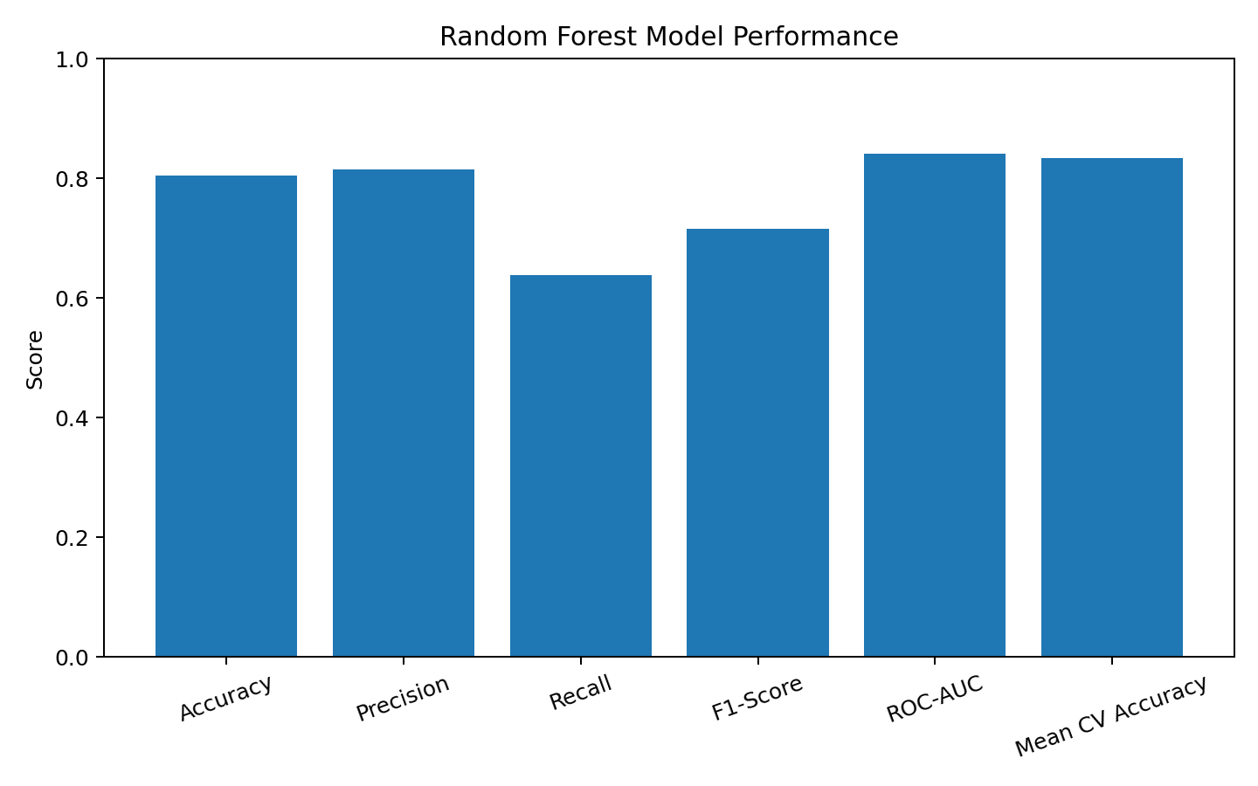
Figure 1. Random Forest model performance on the test set and cross-validation summary.

12. Confusion Matrix Analysis
The test-set confusion matrix was [[100, 10], [25, 44]]. Therefore, 100 passengers who did not survive were correctly classified and 10 were incorrectly predicted as survivors. Among survivors, 44 were correctly classified and 25 were missed. This shows that the model identified non-survivors more successfully than survivors in this test split, consistent with the lower positive-class recall of 63.77%.
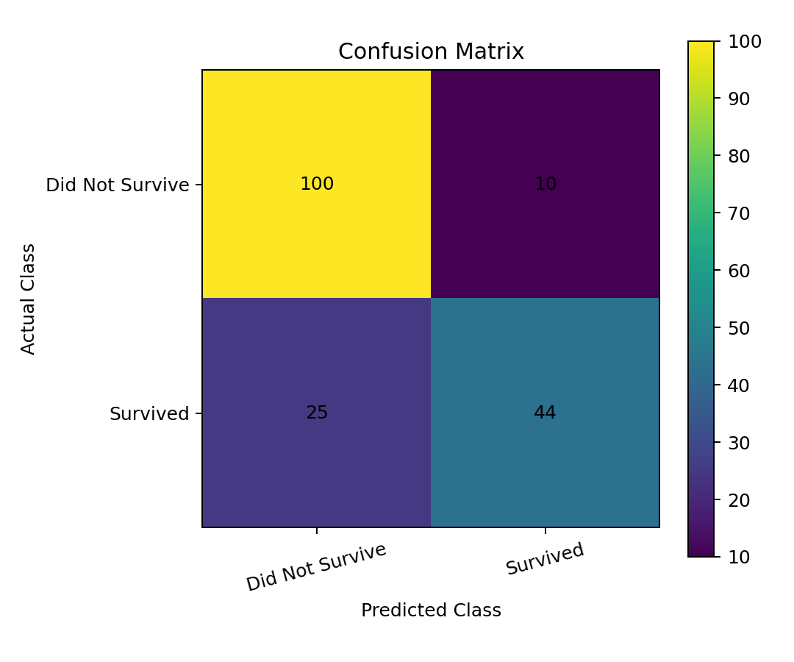
Figure 2. Confusion matrix for the 179-record test set.

13. ROC-AUC Analysis
The test-set ROC-AUC was 0.8407. This metric evaluates the model's ability to distinguish the two classes using predicted survival probabilities across classification thresholds. The result indicates useful separation between the survival and non-survival classes for this dataset and model.

14. Cross-Validation
Five-fold StratifiedKFold cross-validation was performed with shuffling and random_state=42. The fold accuracies were 84.92%, 82.02%, 80.90%, 83.15%, and 85.96%. The mean cross-validation accuracy was 83.39% with a standard deviation of 0.0185.
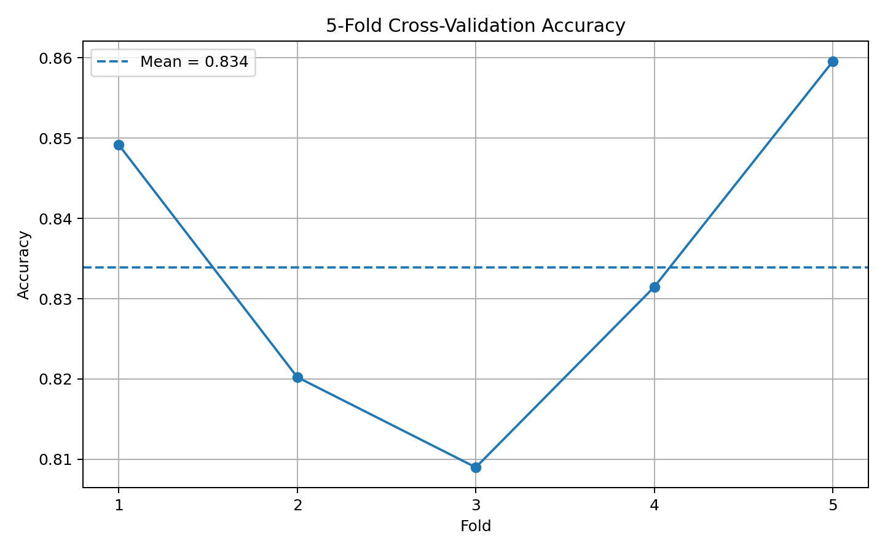
Figure 3. Accuracy across the five cross-validation folds.

15. Feature Importance
The transformed feature-importance output ranked the gender variables highly. The most important features were sex_male (0.2293), sex_female (0.1871), fare (0.1780), age (0.1393), and pclass (0.1120). family_size had an importance of 0.0531. These values describe how the trained Random Forest used the transformed variables and should not be interpreted as causal effects.
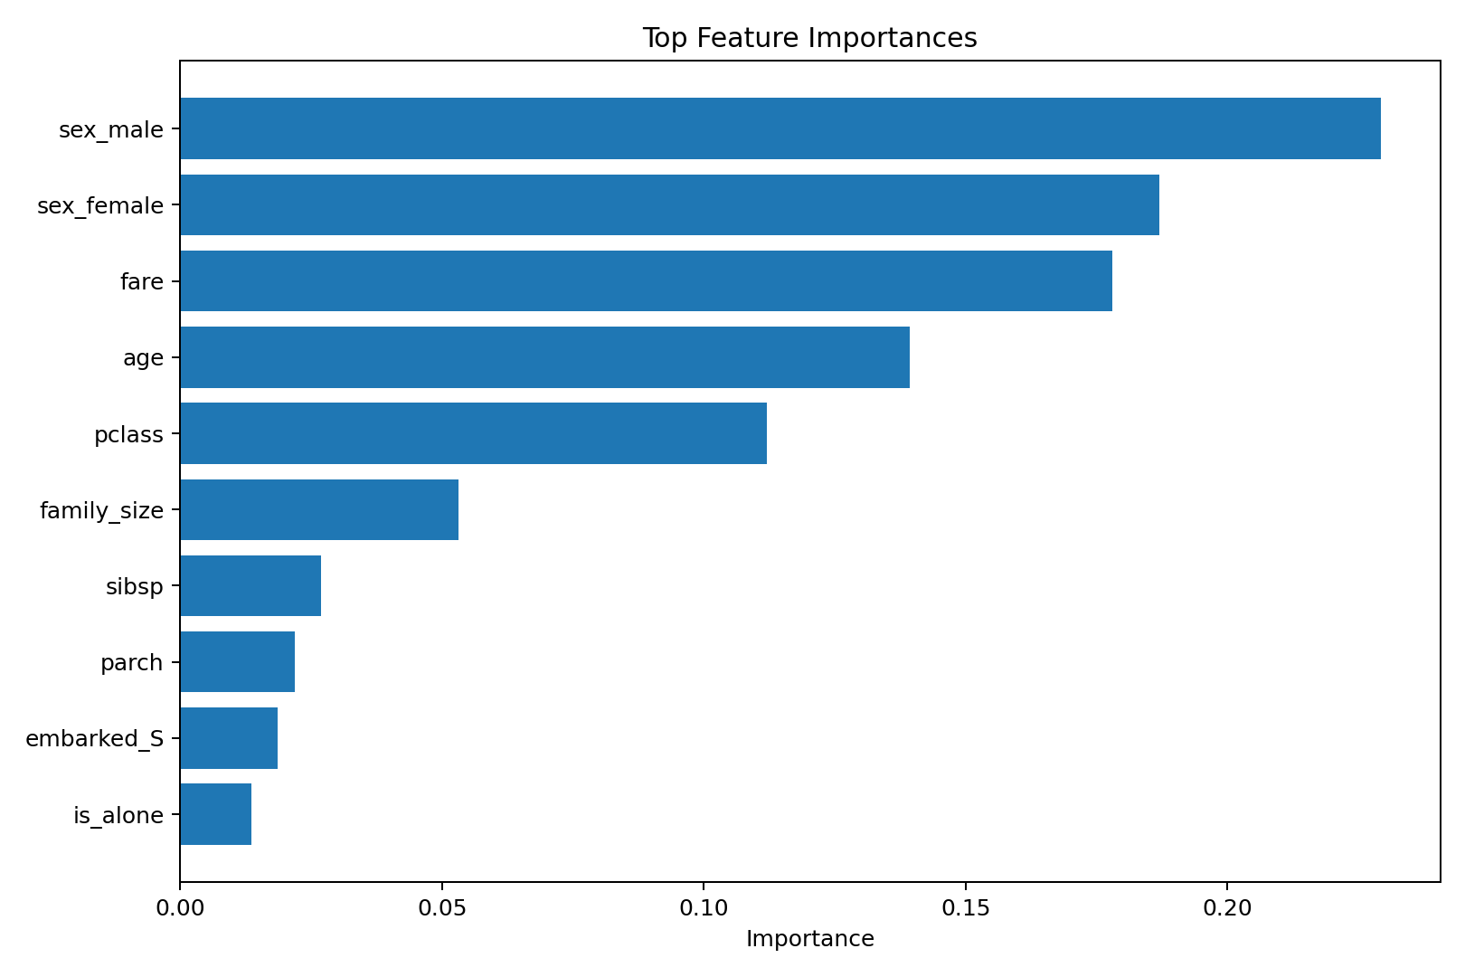
Figure 4. Top feature-importance values from the trained Random Forest.

16. Supporting Dataset Analysis
The notebook also examined survival patterns in the original data. The observed survival rate was 74.20% for female passengers and 18.89% for male passengers. By passenger class, the observed survival rates were 62.96% for first class, 47.28% for second class, and 24.24% for third class. These descriptive results provide context for the model but do not establish causal relationships.
Group | Observed Survival Rate
Female | 74.20%
Male | 18.89%
1st Class | 62.96%
2nd Class | 47.28%
3rd Class | 24.24%

17. Results and Interpretation
The Random Forest model achieved 80.45% accuracy on the held-out test set. Precision was 81.48%, recall was 63.77%, and the F1-score was 71.54%. The ROC-AUC of 0.8407 indicates useful discriminatory performance. Cross-validation produced a mean accuracy of 83.39%, providing an additional estimate across multiple train-validation partitions.

18. Strengths
- Complete preprocessing and modelling pipeline.
- Systematic treatment of missing numerical and categorical values.
- Feature engineering using family_size and is_alone.
- Random Forest can capture non-linear relationships and interactions.
- Multiple evaluation metrics were reported.
- Stratified 5-fold cross-validation was used.
- Feature importance supports interpretation.

19. Limitations
- The Titanic dataset is historical and relatively small, so results should not be generalized to unrelated populations.
- Test-set recall for the survival class was 63.77%, meaning some actual survivors were missed.
- Random Forest feature importance describes model usage rather than causal influence.
- The selected hyperparameters were not obtained through an exhaustive search.
- Alternative feature selections could produce different results.

20. Possible Improvements
- Perform systematic hyperparameter tuning using GridSearchCV or RandomizedSearchCV.
- Compare Random Forest with Logistic Regression, Decision Tree, Gradient Boosting, or Support Vector Machine models.
- Evaluate balanced accuracy and precision-recall AUC.
- Experiment with additional feature-engineering approaches.
- Use repeated cross-validation for more robust estimates.
- Investigate classification-threshold selection when precision and recall requirements differ.

21. Key Code Segments
Feature engineering:
df["family_size"] = df["sibsp"] + df["parch"] + 1
df["is_alone"] = (df["family_size"] == 1).astype(int)
Random Forest configuration:
RandomForestClassifier(
n_estimators=200,
max_depth=8,
min_samples_split=5,
min_samples_leaf=2,
random_state=42
)
Cross-validation:
cv = StratifiedKFold(n_splits=5, shuffle=True, random_state=42)
cv_scores = cross_val_score(model, X, y, cv=cv, scoring="accuracy")

22. Conclusion
This Week 4 project successfully implemented a supervised machine learning classification workflow using the Titanic dataset. The Random Forest Classifier was trained after systematic preprocessing and feature engineering, and its performance was evaluated on an independent test set and through five-fold stratified cross-validation. The model achieved 80.45% test accuracy and 83.39% mean cross-validation accuracy, with an ROC-AUC of 0.8407. Feature-importance analysis highlighted the encoded gender variables, fare, age, and passenger class among the most important transformed features. The project demonstrates practical understanding of supervised learning, data preprocessing, feature engineering, model training, validation, evaluation, and interpretation.

23. Deliverables
File | Description
YUVA_Week4_Supervised_Learning.ipynb | Completed Google Colab notebook
titanic.csv | Public Titanic dataset used for modelling
titanic_predictions.csv | Test-set predictions and survival probabilities
Sairathnam_J_YUVA_Week4_Supervised_Learning_Report.docx | Detailed Week 4 report

