WEEK 5 REPORT
Deep Learning Application in Data Science

Deep Learning Based Fashion Image Classification Using Neural Networks

YUVA Virtual Data Science with Python Internship

Submitted by: Sairathnam J
Madras Institute of Technology
2nd Year – Electronics and Communication Engineering

1. Abstract
This report presents the Week 5 Deep Learning Application in Data Science project completed using the Fashion-MNIST dataset and TensorFlow/Keras. The objective was to design, train, and evaluate a neural network for multi-class image classification. The dataset contains 70,000 grayscale images representing ten categories of clothing and footwear. The implemented model uses a Flatten layer followed by Dense layers with 128 and 64 neurons, ReLU activation, Dropout regularization, and a 10-neuron Softmax output layer. Pixel values were normalized from the original 0–255 range to 0–1. The model was trained with the Adam optimizer and sparse categorical cross-entropy loss, using a 20% validation split and early stopping. On the 10,000-image test set, the executed notebook achieved an accuracy of 84.51% and a test loss of 0.4290. A class-wise classification report, confusion matrix, incorrect-prediction visualization, training curves, and prediction probability analysis were used to assess performance. The results show that the dense neural network can learn useful visual patterns from Fashion-MNIST, while visually similar categories remain more challenging.

2. Introduction
Deep learning is a branch of machine learning that uses neural networks with multiple layers to learn representations from data. It is particularly useful for image, speech, language, and other high-dimensional tasks. In this project, deep learning concepts were applied to Fashion-MNIST, a standard benchmark dataset for image classification. Each observation is a 28 × 28 grayscale image and belongs to one of ten clothing-related classes.
The project was designed to cover the complete deep learning workflow: loading a public dataset, examining the data, preprocessing pixel values, designing a neural network architecture, training the model, monitoring validation behaviour, evaluating the trained model, visualizing errors, and critically discussing limitations and possible improvements.

3. Problem Statement
The problem is defined as a multi-class image classification task. Given a 28 × 28 grayscale Fashion-MNIST image, the model must predict which of the ten predefined clothing or footwear categories the image belongs to.

4. Objectives
- Understand the fundamentals of neural networks and deep learning.
- Use a publicly available image dataset suitable for a deep learning application.
- Preprocess and normalize image data for neural network training.
- Design and implement a neural network using TensorFlow/Keras.
- Train the model while monitoring validation performance.
- Evaluate the model using accuracy, precision, recall, F1-score, loss, and a confusion matrix.
- Analyze incorrect predictions and identify challenging classes.
- Discuss model strengths, limitations, challenges, and possible improvements.

5. Dataset Description
The Fashion-MNIST dataset was loaded directly using tf.keras.datasets.fashion_mnist. The executed notebook reported 60,000 training images and 10,000 testing images. Each image has dimensions of 28 × 28 pixels. The training set is balanced, with 6,000 images for each of the ten classes.
Dataset | Samples | Image Shape
Training | 60,000 | 28 × 28
Testing | 10,000 | 28 × 28
The ten classes are: T-shirt/top, Trouser, Pullover, Dress, Coat, Sandal, Shirt, Sneaker, Bag, Ankle boot.
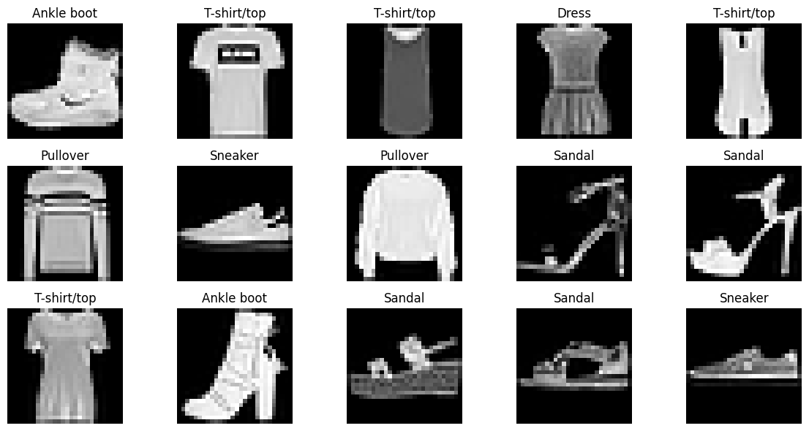
Sample Fashion-MNIST images

6. Data Preprocessing
The notebook converted the image arrays to float32 and divided pixel values by 255.0. This transformed the original pixel range into the interval 0 to 1. The executed preprocessing confirmed a minimum value of 0.0 and a maximum value of 1.0 after normalization. No additional manual feature extraction was performed because the neural network learns representations directly from the normalized pixel grid.
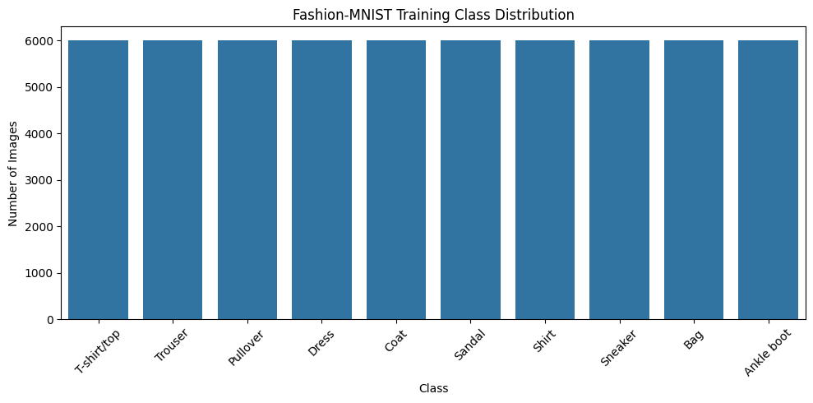
Training class distribution

7. Neural Network Architecture
A fully connected neural network was selected for this implementation. The Flatten layer converts the 28 × 28 image into 784 input values. A Dense layer with 128 neurons and ReLU activation learns non-linear patterns. A 30% Dropout layer is then used for regularization. A second Dense layer contains 64 ReLU neurons followed by 20% Dropout. Finally, a Dense output layer with 10 neurons uses Softmax to produce class probabilities.
The architecture contains 109,386 trainable parameters based on the layer dimensions used in the executed notebook. The design provides a relatively lightweight baseline while still allowing the network to learn non-linear relationships in the image pixels.
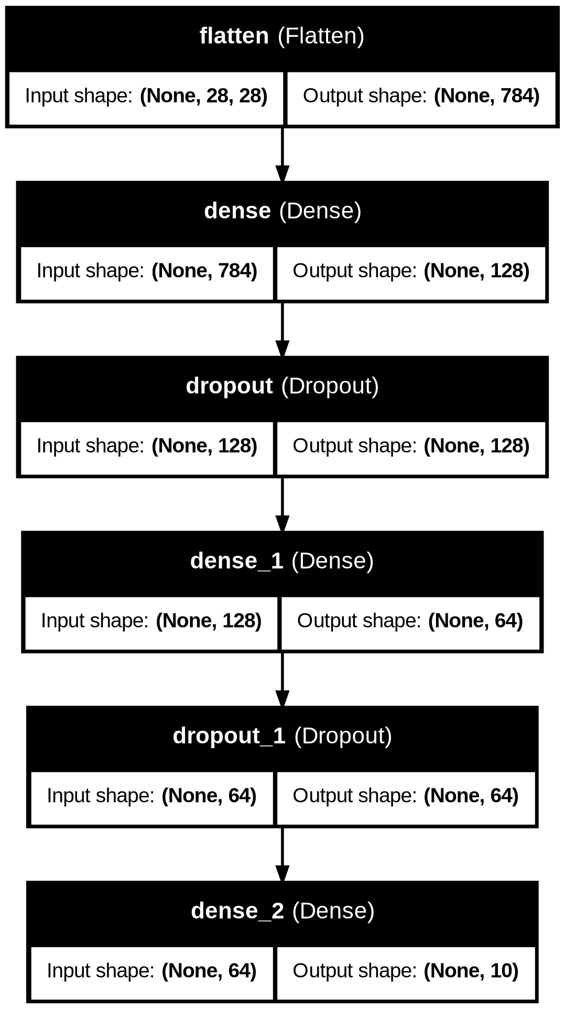
Neural network architecture

8. Design Decisions and Hyperparameters
Component | Choice
Framework | TensorFlow / Keras
Architecture | Flatten → Dense(128) → Dropout(0.30) → Dense(64) → Dropout(0.20) → Dense(10)
Hidden activation | ReLU
Output activation | Softmax
Optimizer | Adam
Loss | Sparse categorical cross-entropy
Batch size | 128
Maximum epochs | 15
Validation split | 20%
Early stopping | Monitor val_loss, patience=3, restore best weights
Adam was selected as the optimizer because it provides adaptive learning rates. ReLU was used in hidden layers to introduce non-linearity, while Softmax is appropriate for producing a probability distribution over ten mutually exclusive classes. Dropout was incorporated to reduce reliance on individual neurons and help control overfitting. Sparse categorical cross-entropy matches the integer class labels used by the dataset.

9. Training Process
The model was trained for a maximum of 15 epochs with a batch size of 128. Twenty percent of the training data was reserved for validation. EarlyStopping monitored validation loss with a patience of three epochs and was configured to restore the best weights. In the executed run, the training log continued through all 15 epochs. Training accuracy increased from 49.30% in the first epoch to 84.31% in the fifteenth epoch, while validation accuracy increased from 70.06% to 85.19%. Validation loss decreased from 0.8895 to 0.4025 over the same period.
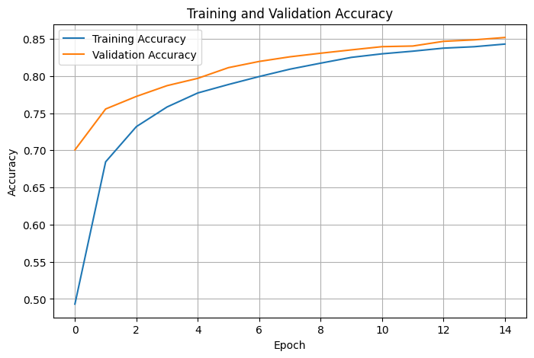
Training and validation accuracy
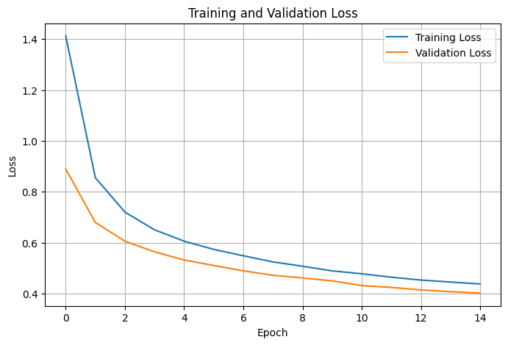
Training and validation loss

10. Model Evaluation
The trained model was evaluated on the separate 10,000-image test set. The test loss was 0.4290 and the test accuracy was 84.51%. The same accuracy was confirmed using sklearn's accuracy_score after generating predictions with the trained model.
Metric | Result
Test Loss | 0.4290
Test Accuracy | 84.51%
Macro Precision | 0.84
Macro Recall | 0.85
Macro F1-score | 0.84
Weighted Precision | 0.84
Weighted Recall | 0.85
Weighted F1-score | 0.84

11. Class-wise Performance
The class-wise classification report shows that performance differs across categories. Trouser achieved the highest F1-score among the listed classes at 0.97, while Bag achieved 0.96 and Ankle boot achieved 0.93. Shirt was the most challenging class in this run, with precision of 0.67, recall of 0.53, and F1-score of 0.59. This pattern indicates that visually similar upper-body clothing categories are more difficult for the dense network to separate.
Class | Precision | Recall | F1-score | Support
T-shirt/top | 0.80 | 0.81 | 0.80 | 1000
Trouser | 0.98 | 0.95 | 0.97 | 1000
Pullover | 0.71 | 0.81 | 0.76 | 1000
Dress | 0.81 | 0.89 | 0.85 | 1000
Coat | 0.76 | 0.74 | 0.75 | 1000
Sandal | 0.94 | 0.91 | 0.92 | 1000
Shirt | 0.67 | 0.53 | 0.59 | 1000
Sneaker | 0.90 | 0.92 | 0.91 | 1000
Bag | 0.95 | 0.96 | 0.96 | 1000
Ankle boot | 0.92 | 0.94 | 0.93 | 1000
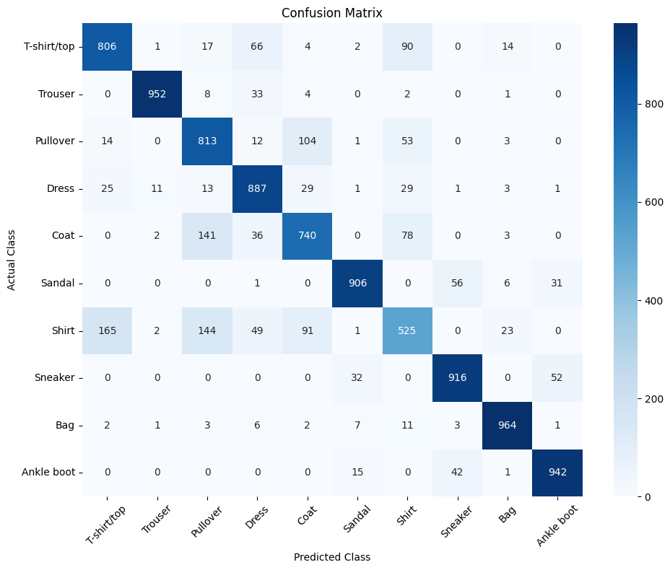
Confusion matrix

12. Error Analysis
A confusion matrix was generated to compare actual and predicted classes. The notebook also visualized twelve incorrectly classified test images. These analyses are important because overall accuracy alone does not reveal which categories are difficult to distinguish. The class-wise results particularly highlight Shirt as a challenging class, while trousers, bags, sandals, sneakers, and ankle boots were classified more consistently.
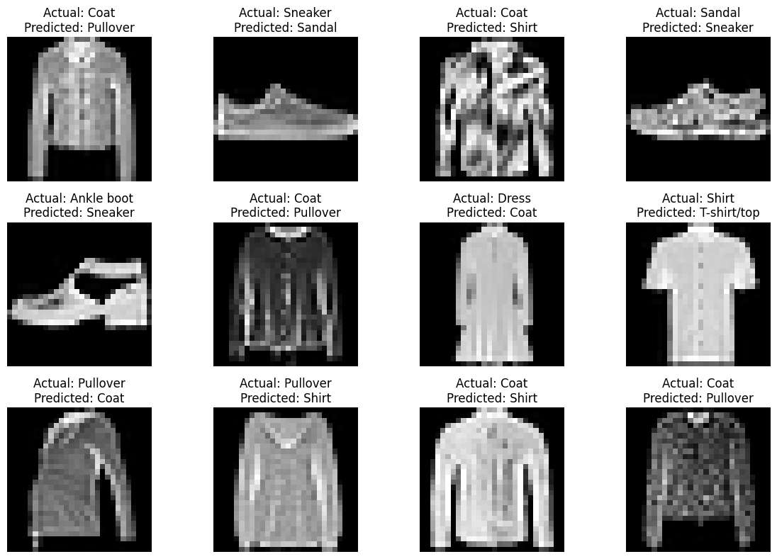
Examples of incorrect predictions
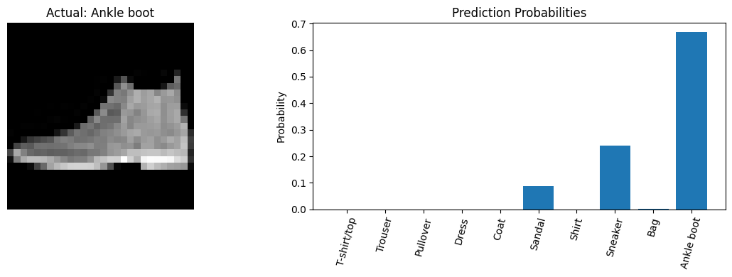
Example prediction probabilities

13. Challenges and Mitigation
Class similarity: Some categories have similar visual structures, particularly among upper-body garments. The confusion matrix and class-wise metrics were used to identify these difficulties.
Overfitting risk: Dropout layers were included and validation performance was monitored during training. Early stopping was also configured to stop training if validation loss stopped improving.
Model capacity: A compact dense architecture was selected so the project could be trained efficiently in a Colab environment while still providing sufficient capacity for the classification task.
Interpretability: Training curves, class-wise metrics, the confusion matrix, incorrect predictions, and prediction probabilities were used to make the model behaviour easier to inspect.

14. Strengths of the Approach
- Uses a public and balanced benchmark image dataset.
- Provides a complete end-to-end deep learning workflow.
- Uses normalization to make input values suitable for training.
- Includes Dropout regularization and validation monitoring.
- Uses multiple evaluation metrics rather than accuracy alone.
- Includes visual error analysis and a network architecture diagram.
- Produces a reusable trained Keras model and a prediction CSV file.

15. Limitations
- The model is a fully connected neural network rather than a convolutional neural network, so it does not explicitly exploit local spatial patterns in images.
- The project uses 28 × 28 grayscale images, which limits the complexity of visual information available to the model.
- The hyperparameters were selected manually rather than through an extensive automated search.
- The model still has difficulty separating visually similar clothing categories, especially Shirt.
- The reported results are specific to the executed training run and configuration in the submitted notebook.

16. Possible Improvements
- Replace the dense network with a Convolutional Neural Network (CNN) to better capture spatial image features.
- Use data augmentation to expose the model to additional image variations.
- Perform systematic hyperparameter tuning for layer sizes, dropout rates, learning rate, and batch size.
- Experiment with Batch Normalization and learning-rate scheduling.
- Compare the dense model with CNN and transfer-learning approaches.
- Perform more detailed error analysis of frequently confused class pairs.

17. Key Code Segments
Neural network architecture
model = Sequential([
Flatten(input_shape=(28, 28)),
Dense(128, activation="relu"),
Dropout(0.30),
Dense(64, activation="relu"),
Dropout(0.20),
Dense(10, activation="softmax")
])
Model compilation
model.compile(
optimizer="adam",
loss="sparse_categorical_crossentropy",
metrics=["accuracy"]
)
Model training
history = model.fit(
X_train,
y_train,
epochs=15,
batch_size=128,
validation_split=0.2,
callbacks=[early_stopping]
)
Test evaluation
test_loss, test_accuracy = model.evaluate(
X_test, y_test, verbose=0
)

18. Project Deliverables
- YUVA_Week5_Deep_Learning_Fashion_Classification.ipynb – executed Google Colab notebook.
- Sairathnam_J_YUVA_Week5_Deep_Learning_Report.docx – project report.
- fashion_mnist_predictions.csv – actual and predicted test labels.
- fashion_mnist_deep_learning_model.keras – saved trained neural network.
- fashion_mnist_model_architecture.png – network architecture diagram.

19. Conclusion
This Week 5 project demonstrated the practical application of deep learning to a multi-class image classification problem using Fashion-MNIST. The executed TensorFlow/Keras model used a Flatten layer, two ReLU Dense layers, Dropout regularization, and a Softmax output layer. After normalization and supervised training, the model achieved 84.51% test accuracy with a test loss of 0.4290. The evaluation showed that the model performs well on several visually distinct classes but has greater difficulty with visually similar clothing categories. The project also demonstrated the importance of monitoring training and validation curves, examining class-wise metrics, and inspecting incorrect predictions rather than relying only on overall accuracy. For future work, a CNN would be a natural next step because convolutional architectures are better suited to learning spatial patterns in images.

20. References / Tools
- TensorFlow / Keras – model development and Fashion-MNIST loading.
- NumPy – numerical array processing.
- Pandas – tabular analysis and prediction export.
- Matplotlib and Seaborn – visualization.
- Scikit-learn – classification metrics and confusion matrix.
- Google Colab – notebook execution environment.

