YUVA VIRTUAL DATA SCIENCE WITH PYTHON INTERNSHIP
WEEK 6 – INTEGRATIVE CAPSTONE PROJECT
Titanic Passenger Analysis, Clustering, and Survival Prediction

Student Details | Information
Name | Sairathnam J
College | Madras Institute of Technology
Department / Year | ECE / 2nd Year
Internship Role | Virtual Data Science with Python Trainee
Notebook | YUVA_Week6_Integrative_Capstone_Titanic.ipynb
Dataset | Titanic Passenger Dataset
Tools | Python, Pandas, NumPy, Matplotlib, Seaborn, Scikit-learn, Google Colab

Final Project Report

Abstract
This Week 6 capstone integrates the main data science stages practiced during the YUVA Virtual Data Science with Python internship. The project uses the Titanic passenger dataset to demonstrate data acquisition, data inspection, preprocessing, exploratory data analysis, unsupervised learning, supervised learning, model evaluation, validation, interpretation, and result export in one coherent workflow. The original dataset contains 891 passenger records and 15 variables. Missing values were handled, additional features were engineered, and passenger characteristics were explored through visual and statistical analysis. K-Means clustering was then applied to selected numerical passenger attributes, while Logistic Regression and Random Forest were developed for survival classification. The Random Forest achieved 81.01% test accuracy and a mean 5-fold cross-validation accuracy of 83.39%. The clustering stage produced three passenger groups for the integrated analysis, with cluster survival rates of 45.45%, 28.41%, and 57.74%. The report also discusses the difference between model performance metrics, the role of feature importance, validation stability, limitations, and possible future improvements.

1. Introduction
The purpose of the Week 6 task was to combine the techniques learned throughout the internship into a complete end-to-end data science project. Instead of treating data cleaning, visualization, clustering, and prediction as isolated exercises, this capstone connects them into a single workflow. The Titanic dataset provides a compact public dataset containing demographic, travel, family, fare, and survival information, making it suitable for demonstrating both descriptive and predictive analytics.

2. Problem Statement
The capstone addresses two related analytical questions. First, can passengers be grouped into meaningful segments using unsupervised learning based on their travel and demographic characteristics? Second, can supervised machine-learning models use passenger attributes to predict the survival outcome? The project therefore combines passenger segmentation with binary classification while maintaining a clear separation between explanatory analysis and prediction.

3. Objectives
- Acquire and inspect a public Titanic passenger dataset.
- Identify missing values, data types, and basic statistical characteristics.
- Clean the data and create useful derived variables.
- Perform exploratory analysis of survival, passenger class, gender, age, fare, and relationships among numerical variables.
- Apply K-Means clustering and inspect passenger segment characteristics.
- Build Logistic Regression and Random Forest survival classifiers.
- Evaluate the models using accuracy, precision, recall, F1-score, ROC-AUC, confusion matrix, and cross-validation.
- Interpret the results and identify limitations and future improvements.
- Export model predictions for reproducibility and further analysis.

4. Dataset Description
The notebook uses the Titanic passenger dataset loaded from titanic.csv. The dataset contains 891 rows and 15 original columns. The target variable for supervised learning is survived, where 0 represents non-survival and 1 represents survival.
Property | Value
Rows | 891
Original columns | 15
Target | survived
Age observations available | 714
Missing age values | 177
Missing embarked values | 2
Missing embark_town values | 2
Deck observations available | 203

5. Data Preparation and Cleaning
Initial inspection showed missing values in age, embarked, embark_town, and deck. The notebook's integrated preprocessing fills missing age and fare values with the median and categorical values with the most frequent category where required by the modeling pipeline. The clustering workflow uses the selected numerical features after age imputation. For supervised learning, the preprocessing pipeline separates numerical and categorical variables so that imputation, scaling, and one-hot encoding are applied consistently.
Feature engineering adds family_size = sibsp + parch + 1 and is_alone, which indicates whether a passenger travelled without family members represented by these fields. The resulting cleaned dataframe reported by the notebook contains 891 rows and 18 columns.

6. Exploratory Data Analysis
The exploratory stage examined the distribution of the target and passenger characteristics before modeling. The original dataset has an overall survival proportion of approximately 38.38%. The notebook also examined survival by gender and passenger class, age and fare distributions, and numerical relationships through a correlation heatmap. These analyses provide context for the later clustering and classification stages.
- Female passengers had a substantially higher observed survival rate than male passengers in the dataset.
- First-class passengers had a higher observed survival rate than second- and third-class passengers.
- The fare distribution is strongly right-skewed, with a maximum fare substantially above the median.
- Age contains substantial missingness, making imputation necessary for machine-learning workflows.

7. Unsupervised Learning – K-Means Clustering
K-Means clustering was applied using pclass, age, sibsp, parch, and fare. The numerical features were standardized before clustering so that variables measured on different scales would contribute more comparably. K values from 2 through 8 were evaluated using silhouette scores. The notebook ultimately used K=3 for the integrated capstone segmentation, consistent with the earlier Week 3 project.
K | Silhouette Score
2 | 0.3758
3 | 0.4170
4 | 0.4136
5 | 0.4289
6 | 0.4281
7 | 0.4012
8 | 0.4058
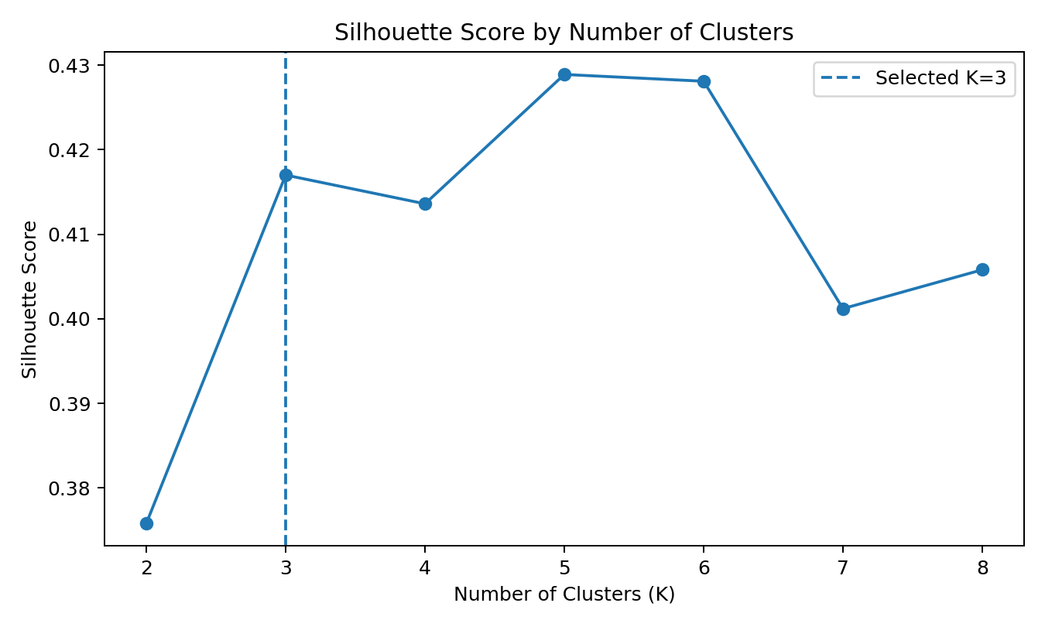
Figure 1. Silhouette scores evaluated for K=2 through K=8.
An important observation is that K=5 produced the highest silhouette score among the tested values (0.4289), while K=3 produced 0.4170. The capstone nevertheless retained K=3 to maintain consistency with the earlier clustering stage and to provide a compact segmentation for integrated interpretation. This is a methodological choice rather than a claim that K=3 maximizes the silhouette criterion.

8. Cluster Characteristics
Cluster | Size | Mean Age | Mean Fare | Mean Class | Mean SibSp | Mean Parch | Survival Rate
0 | 110 | 15.09 | 45.92 | 2.57 | 2.34 | 1.94 | 45.45%
1 | 542 | 27.79 | 12.19 | 2.77 | 0.23 | 0.11 | 28.41%
2 | 239 | 39.50 | 71.27 | 1.14 | 0.36 | 0.28 | 57.74%
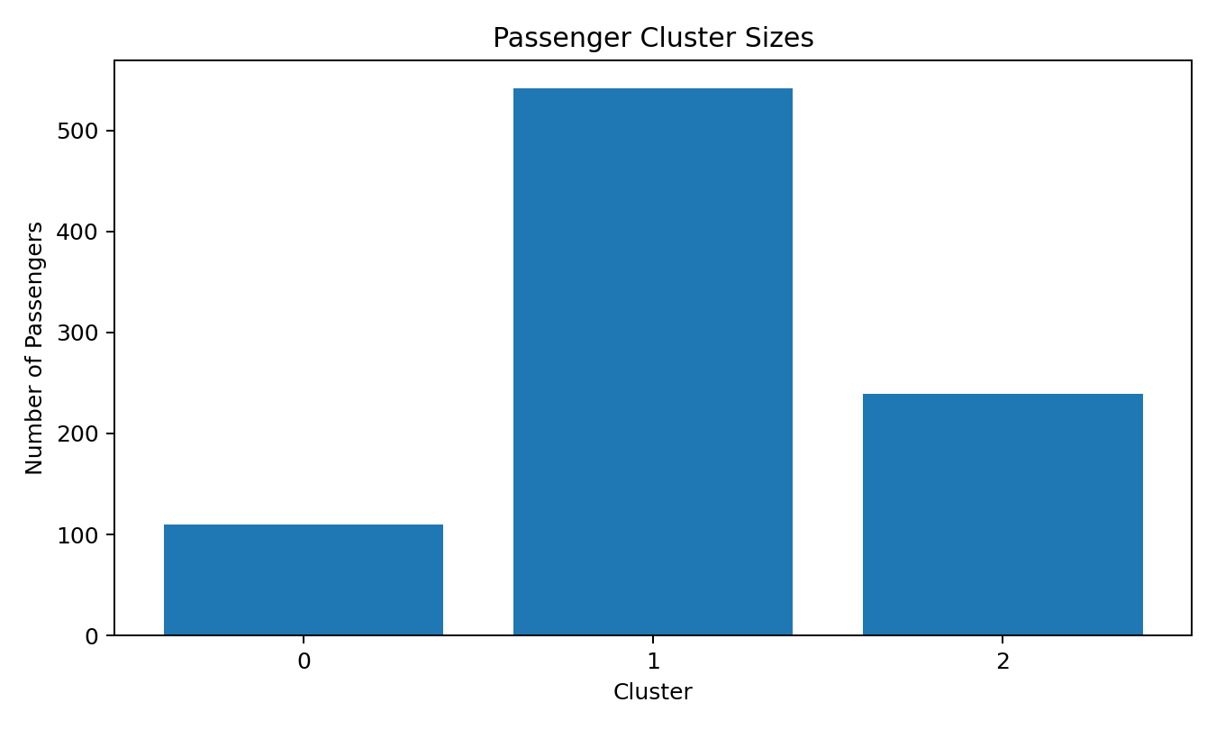
Figure 2. Number of passengers assigned to each selected cluster.
Cluster 0 is comparatively young and has higher average family-group counts, with a mean survival rate of 45.45%. Cluster 1 is the largest group and is characterized by lower fares, third-class-heavy characteristics, low family-group counts, and the lowest observed survival rate of 28.41%. Cluster 2 has the highest average fare and the lowest mean pclass value, corresponding to stronger first-class representation, and it has the highest observed survival rate among the three clusters at 57.74%.

9. Principal Component Analysis Visualization
Principal Component Analysis was used to project the standardized clustering features into two dimensions for visualization. The first principal component explained 33.96% of the variance and the second explained 32.52%, giving a combined explained variance of 66.48%. This two-dimensional projection provides a visual representation of the cluster structure, while the actual K-Means model was trained in the standardized feature space.

10. Supervised Learning
The supervised-learning stage predicts survived using pclass, sex, age, sibsp, parch, fare, embarked, family_size, and is_alone. The data was split into 712 training records and 179 testing records using an 80/20 stratified split with random_state=42.
Numerical variables were processed using median imputation followed by StandardScaler. Categorical variables were processed using most-frequent imputation and OneHotEncoder with handle_unknown='ignore'. Two classifiers were trained: Logistic Regression as a baseline linear model and Random Forest as a nonlinear ensemble model.

11. Model Configuration
Model | Configuration
Logistic Regression | max_iter=1000, random_state=42
Random Forest | 200 trees, max_depth=8, min_samples_split=5, min_samples_leaf=2, random_state=42
Train/Test Split | 80/20, stratified, random_state=42
Cross-validation | 5-fold StratifiedKFold, shuffle=True, random_state=42

12. Model Evaluation Results
Model | Accuracy | Precision | Recall | F1-Score | ROC-AUC
Logistic Regression | 80.45% | 78.33% | 68.12% | 72.87% | 0.8514
Random Forest | 81.01% | 83.02% | 63.77% | 72.13% | 0.8407
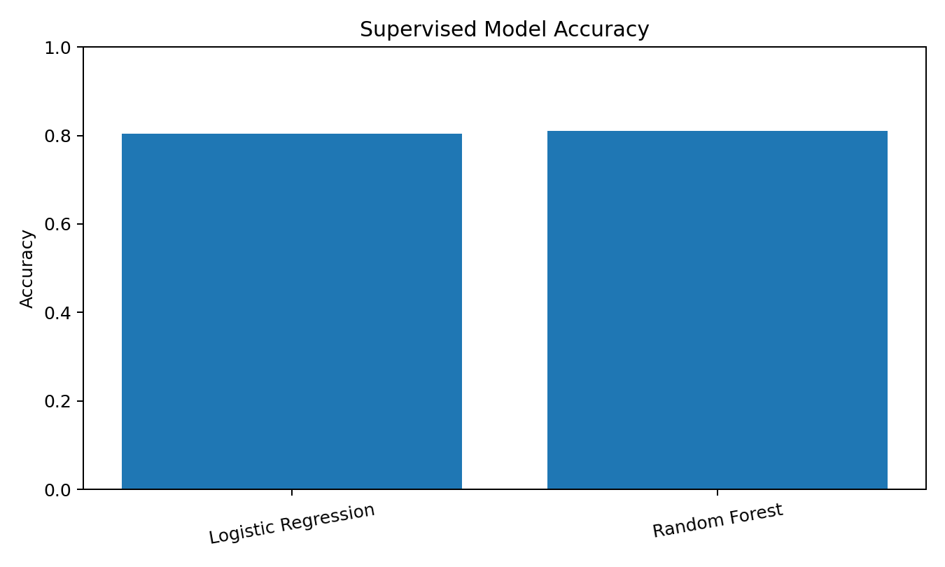
Figure 3. Test-set accuracy comparison between the two supervised models.
The Random Forest recorded a test accuracy of 81.01%, while Logistic Regression recorded 80.45%. Random Forest had higher precision, whereas Logistic Regression had higher recall, F1-score, and ROC-AUC in this particular test split. This demonstrates why model assessment should not rely on accuracy alone.

13. Random Forest Classification Analysis
For the Random Forest, class 0 had precision 0.80, recall 0.92, and F1-score 0.86 across 110 test examples. Class 1 had precision 0.83, recall 0.64, and F1-score 0.72 across 69 test examples. The confusion matrix is 101 true negatives, 9 false positives, 25 false negatives, and 44 true positives.
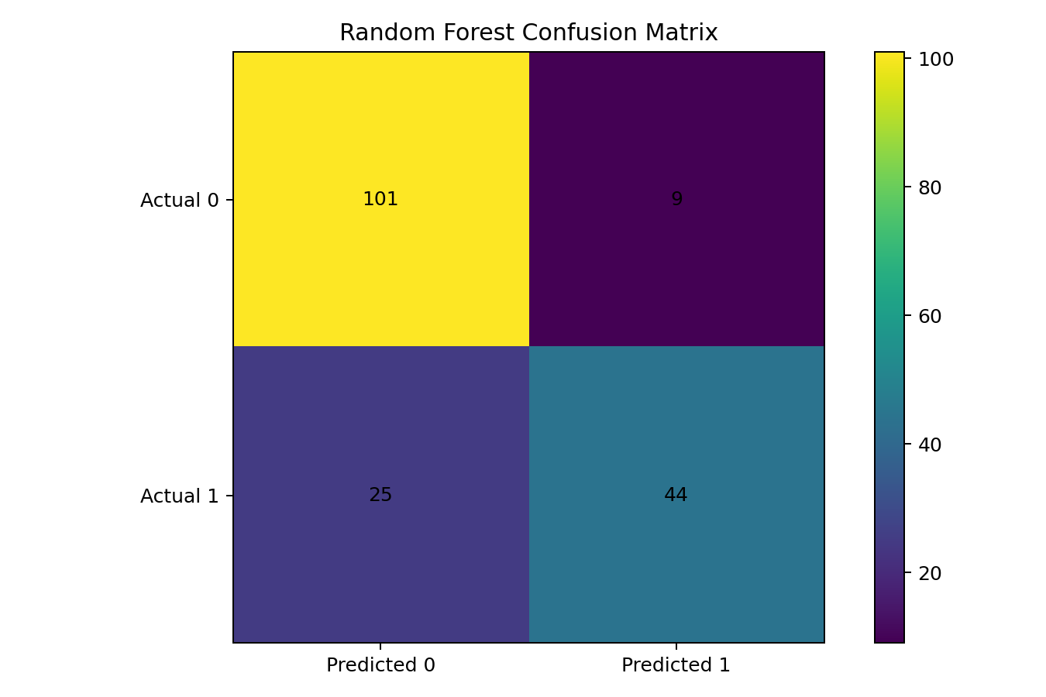
Figure 4. Random Forest confusion matrix on the 179-record test set.

14. Cross-Validation
Five-fold stratified cross-validation was used to examine how consistently the Random Forest performed across different train/validation partitions. The fold accuracies were 84.92%, 82.02%, 80.90%, 83.15%, and 85.96%. The mean accuracy was 83.39% with a standard deviation of 1.85 percentage points.
Fold | Accuracy
1 | 84.92%
2 | 82.02%
3 | 80.90%
4 | 83.15%
5 | 85.96%
Mean | 83.39%
Std. Dev. | 1.85 percentage points
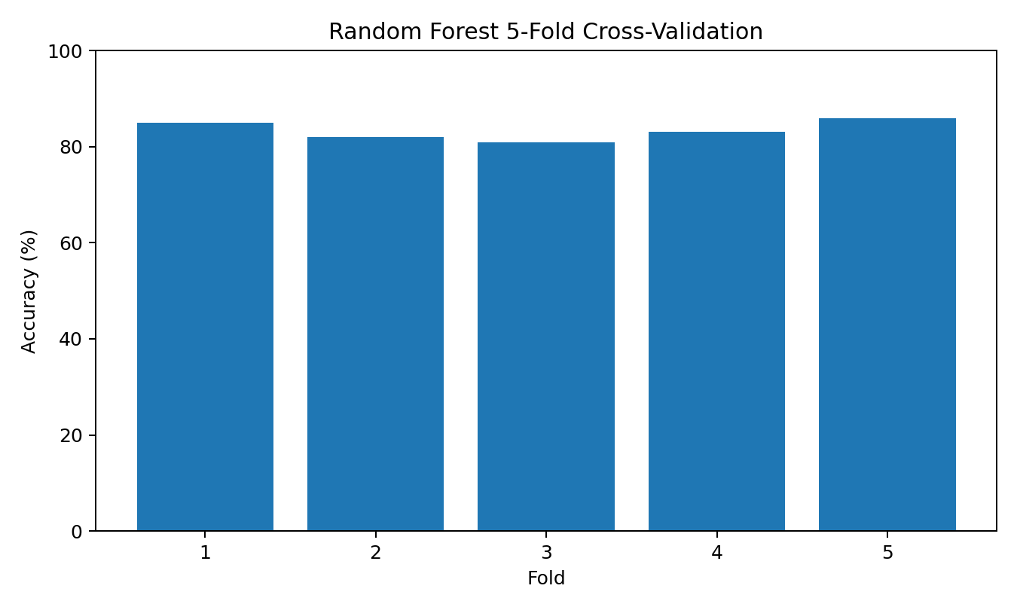
Figure 5. Five-fold cross-validation accuracy for the Random Forest.

15. Feature Importance
The Random Forest feature-importance output indicates that sex-related encoded variables, fare, age, and pclass contributed strongly to the fitted model. The largest individual encoded feature importance was sex_male (0.2283), followed by sex_female (0.1883), fare (0.1793), age (0.1387), and pclass (0.1116). These values describe the fitted model's feature-use patterns and should not be interpreted as causal effects.
Feature | Importance
sex_male | 0.2283
sex_female | 0.1883
fare | 0.1793
age | 0.1387
pclass | 0.1116
family_size | 0.0520
sibsp | 0.0271
parch | 0.0217
embarked_S | 0.0195
is_alone | 0.0137
embarked_C | 0.0131
embarked_Q | 0.0067
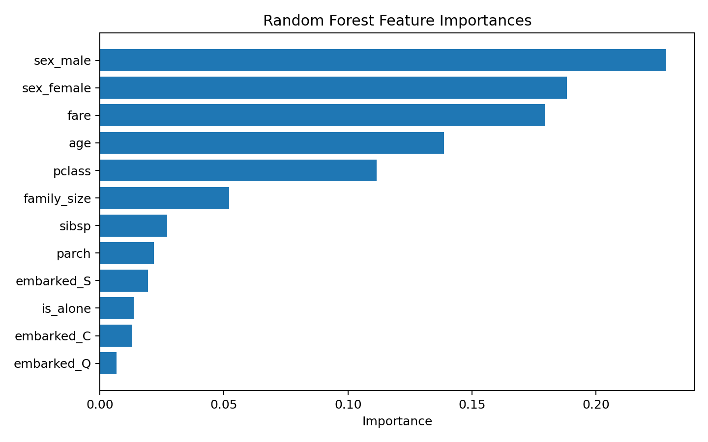
Figure 6. Random Forest feature importances reported by the notebook.

16. Integrated Findings
- The capstone successfully connects data preparation, EDA, clustering, classification, validation, and interpretation in one workflow.
- The selected three-cluster solution produced distinct passenger profiles with different average age, fare, class, and family-group characteristics.
- The largest cluster contained 542 passengers and had the lowest observed cluster survival rate at 28.41%.
- The Random Forest achieved 81.01% test accuracy and 83.39% mean 5-fold cross-validation accuracy.
- Logistic Regression produced a slightly lower test accuracy but a higher ROC-AUC (0.8514 versus 0.8407 for Random Forest).
- The supervised results indicate that passenger gender, fare, age, and class-related information are prominent predictors within the fitted Random Forest.
- Cross-validation results show relatively consistent performance across folds, with an accuracy standard deviation of 0.0185.

17. Business and Research Implications
Although the Titanic dataset is historical and should not be treated as a direct modern operational dataset, the workflow demonstrates general data-science practices applicable to other domains. Clustering can be used to discover groups with different behavioral or demographic profiles, while classification can support outcome prediction when labeled historical data are available. The project also illustrates the importance of combining predictive metrics with exploratory analysis rather than treating a single model score as the complete analytical result.

18. Limitations
- The Titanic dataset is historical and relatively small, so conclusions should not be generalized to modern passenger populations.
- The K=3 clustering choice was retained for consistency with the previous internship stage even though K=5 had the highest tested silhouette score.
- Random Forest feature importance indicates model association with features, not causal relationships.
- The supervised models use a single train/test split for the reported test metrics, supplemented by 5-fold cross-validation for Random Forest.
- The feature set is limited to variables present in the dataset; additional contextual information could change model performance.
- The project does not establish that predicted survival outcomes would be reliable for individual real-world decisions outside the dataset.

19. Possible Improvements and Future Work
- Evaluate additional clustering values and algorithms such as hierarchical clustering or DBSCAN.
- Compare additional classifiers such as Gradient Boosting, Support Vector Machines, or calibrated ensemble models.
- Perform systematic hyperparameter tuning using GridSearchCV or RandomizedSearchCV.
- Use repeated cross-validation or nested validation for more robust performance estimation.
- Investigate class-specific metrics and threshold tuning when the cost of false negatives differs from false positives.
- Apply permutation importance or SHAP-based analysis for more detailed model interpretation.
- Add richer feature engineering and test whether it improves generalization.
- Create a reproducible pipeline that saves preprocessing and model artifacts together.

20. Deliverables
Deliverable | Filename / Description
Google Colab Notebook | YUVA_Week6_Integrative_Capstone_Titanic.ipynb
Final Report | Sairathnam_J_YUVA_Week6_Capstone_Report.docx
Prediction Output | titanic_capstone_predictions.csv
Dataset | titanic.csv
Repository Folder | Week-6-Integrative-Capstone

21. Conclusion
The Week 6 Integrative Capstone demonstrates a complete data science workflow using the Titanic passenger dataset. The project begins with data acquisition and inspection, continues through missing-value handling and feature engineering, and then applies exploratory analysis to understand passenger and survival patterns. Unsupervised learning groups passengers into three analytically distinct segments, while supervised learning compares Logistic Regression and Random Forest for survival prediction. The Random Forest achieved 81.01% test accuracy and 83.39% mean 5-fold cross-validation accuracy. At the same time, the comparison with Logistic Regression shows that different evaluation metrics can lead to different interpretations of model behavior. Overall, the capstone consolidates the practical skills developed throughout the internship and demonstrates how preprocessing, visualization, machine learning, validation, and interpretation can be combined into a structured analytical project.

Appendix A – Key Code Structure
The notebook is organized into the following implementation stages: library import and dataset loading; dataset inspection; missing-value analysis; exploratory visualizations; cleaning and feature engineering; standardized K-Means clustering; silhouette evaluation; PCA visualization; supervised feature preparation; train/test split; preprocessing pipelines; Logistic Regression and Random Forest training; metric comparison; confusion matrix and ROC analysis; 5-fold cross-validation; feature importance; cluster-survival analysis; and prediction export.

Appendix B – Key Reproducibility Settings
Component | Setting
K-Means | n_clusters=3, random_state=42, n_init=10
Train/Test Split | test_size=0.20, random_state=42, stratify=y
Random Forest | n_estimators=200, max_depth=8, min_samples_split=5, min_samples_leaf=2, random_state=42
Cross-validation | 5 folds, shuffle=True, random_state=42
Numerical preprocessing | Median imputation + StandardScaler
Categorical preprocessing | Most-frequent imputation + OneHotEncoder(handle_unknown='ignore')

