YUVA VIRTUAL DATA SCIENCE WITH PYTHON INTERNSHIP
WEEK 3 PROJECT REPORT
Unsupervised Learning and Clustering Analysis

Trainee: Sairathnam J
Institution: Madras Institute of Technology
Department: Electronics and Communication Engineering (ECE)
Year: 2nd Year
Role: Virtual Data Science with Python Trainee
Dataset: Titanic Passenger Dataset
Algorithm: K-Means Clustering

Abstract
This report presents an unsupervised learning and clustering analysis of the Titanic passenger dataset. The work applies K-Means clustering to identify groups of passengers with similar characteristics without using survival as an input feature for cluster formation. The notebook used passenger class (pclass), age, number of siblings/spouses aboard (sibsp), number of parents/children aboard (parch), and fare as clustering variables. Missing age values were replaced with the median, and the selected features were standardized using StandardScaler before K-Means was applied. The Elbow Method and Silhouette Score were used to examine different cluster counts. The notebook selected three clusters for the final segmentation. The resulting groups were analyzed using cluster size, average feature values, survival rates, gender composition, passenger-class composition, and PCA visualization. The final three-cluster solution produced a silhouette score of 0.417. The analysis demonstrates a practical workflow for preprocessing numerical data, applying an unsupervised learning algorithm, evaluating clusters, and interpreting the resulting segments.

1. Introduction
Unsupervised learning is a machine learning approach in which patterns or groups are discovered from data without providing a target label to guide the learning process. Clustering is one of the most common unsupervised learning tasks. In this project, K-Means clustering was used to segment Titanic passengers according to similarities in their travel and demographic characteristics. The purpose was not to predict survival, but to discover passenger groups and then examine how those groups differ.

2. Objectives
- Apply an unsupervised learning technique to a public dataset.
- Preprocess numerical variables so they are suitable for distance-based clustering.
- Use K-Means clustering to create passenger segments.
- Evaluate different cluster configurations using the Elbow Method and Silhouette Score.
- Visualize and interpret the resulting clusters.
- Discuss the characteristics and possible analytical applications of the clusters.

3. Dataset Description
The notebook loaded the Titanic passenger dataset with 891 rows and 15 columns. The columns included survival, passenger class, sex, age, family-related variables, fare, embarkation information, and other passenger attributes. The notebook inspected the data using shape information, data types, descriptive statistics, and missing-value counts.
The numerical variables used for clustering were: pclass, age, sibsp, parch, and fare.
The original dataset contained 177 missing values in age, 2 in embarked, 688 in deck, and 2 in embark_town. For the clustering dataset, only the selected features were retained, and missing age values were handled. After preprocessing, the clustering matrix contained 891 rows and 5 features with no missing values.

4. Tools and Technologies
- Python
- Google Colab
- Pandas
- NumPy
- Matplotlib
- Seaborn
- Scikit-learn

5. Methodology

5.1 Feature Selection
The notebook selected pclass, age, sibsp, parch, and fare. These variables represent passenger class, age, family relationships aboard the ship, and fare paid. Survival was deliberately not included as a clustering feature; it was used later only to interpret the resulting clusters.

5.2 Missing-Value Treatment
Age contained missing values in the original dataset. The notebook filled missing age values with the median age. After this step, all five selected clustering variables had zero missing values.

5.3 Feature Scaling
Because K-Means is distance-based, the selected variables were standardized with StandardScaler. This places the features on comparable scales so that variables with larger numerical ranges, such as fare, do not dominate the distance calculations.

5.4 K-Means Clustering
K-Means was tested for cluster counts from 2 through 10. The model used random_state=42 and n_init=10. The notebook ultimately selected K=3 and fitted the final K-Means model using the standardized five-feature dataset.

5.5 Cluster Evaluation
The notebook used the Elbow Method to examine within-cluster sum of squares (inertia) and calculated Silhouette Scores for K values from 2 to 10. The recorded Silhouette Scores were:
K | Silhouette Score
2 | 0.375760
3 | 0.417016
4 | 0.413555
5 | 0.428949
6 | 0.428131
7 | 0.401198
8 | 0.405833
9 | 0.370341
10 | 0.380772
The highest silhouette score among the tested values was 0.428949 at K=5, followed by 0.428131 at K=6. The notebook nevertheless selected K=3 as the final practical segmentation and reported a final silhouette score of 0.417. This distinction is retained because it reflects the actual notebook workflow.
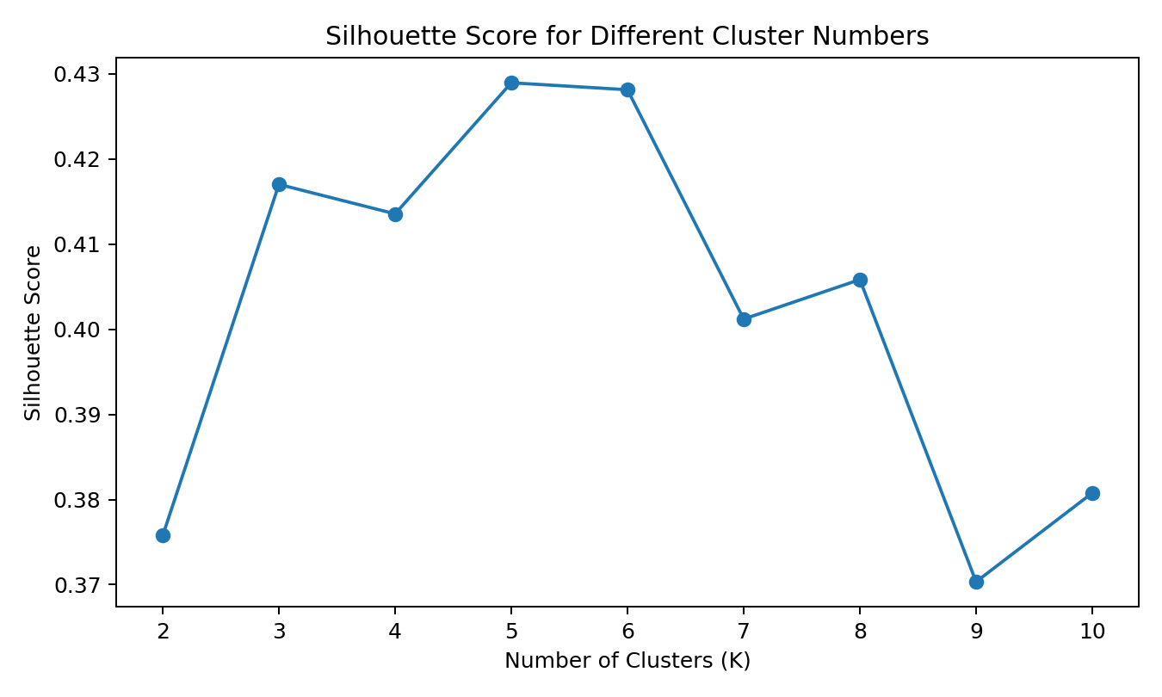
Figure 1. Silhouette scores across tested cluster counts.

6. Results

6.1 Final Cluster Sizes
The final three-cluster solution contained 891 passengers distributed as follows:
Cluster | Passengers
0 | 110
1 | 542
2 | 239
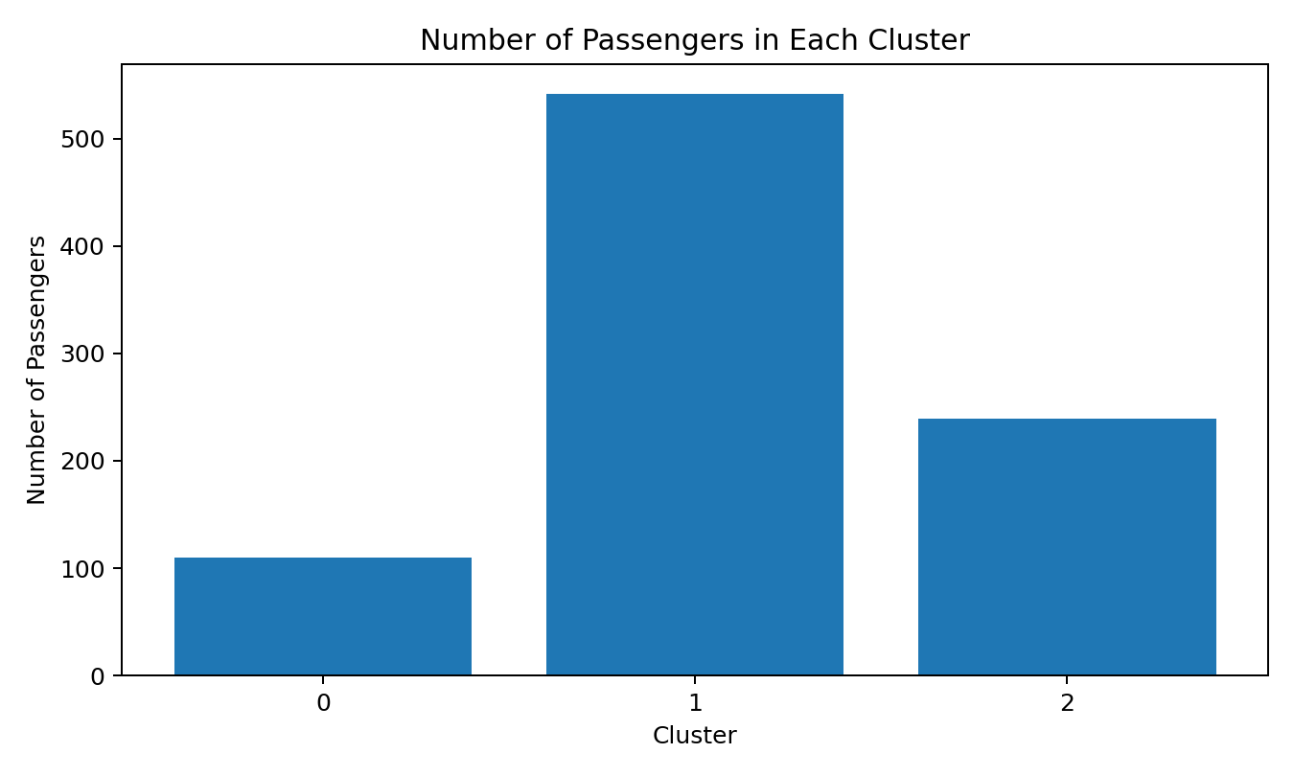
Figure 2. Number of passengers in each final cluster.

6.2 Cluster Characteristics
The notebook produced the following cluster-level averages:
Cluster | Count | Age | Fare | Class | Sib/Spouse | Parent/Child | Survival %
0 | 110 | 13.36 | 45.92 | 2.57 | 2.34 | 1.94 | 45.45
1 | 542 | 27.72 | 12.19 | 2.77 | 0.23 | 0.11 | 28.41
2 | 239 | 41.15 | 71.27 | 1.14 | 0.36 | 0.28 | 57.74

6.3 Interpretation of Clusters
Cluster 0 contained 110 passengers. Its average age was 13.36 years, average fare was 45.92, and average passenger class value was 2.57. It also had the highest average number of siblings/spouses (2.34) and parents/children (1.94), indicating that this group was characterized by younger passengers and relatively larger family group values. Its observed survival rate was 45.45%.
Cluster 1 was the largest group, containing 542 passengers. Its average age was 27.72 years, average fare was 12.19, and average passenger class value was 2.77. It had low average family-related counts, with 0.23 siblings/spouses and 0.11 parents/children. Its observed survival rate was 28.41%.
Cluster 2 contained 239 passengers and had an average age of 41.15 years and an average fare of 71.27. Its average passenger class value was 1.14, showing that this cluster was strongly associated with first-class passengers. Its average family-related counts were relatively low, and its observed survival rate was 57.74%.

6.4 Gender Distribution
Cluster | Female (%) | Male (%)
0 | 54.55 | 45.45
1 | 28.60 | 71.40
2 | 41.42 | 58.58

6.5 Passenger-Class Distribution
Cluster | 1st class (%) | 2nd class (%) | 3rd class (%)
0 | 9.09 | 24.55 | 66.36
1 | 0.00 | 22.88 | 77.12
2 | 86.19 | 13.81 | 0.00

6.6 PCA Visualization
Principal Component Analysis (PCA) was used to reduce the five standardized clustering features to two dimensions for visualization. The first principal component explained 33.96% of the variance and the second explained 32.52%, for a combined 66.48% across the two displayed components.
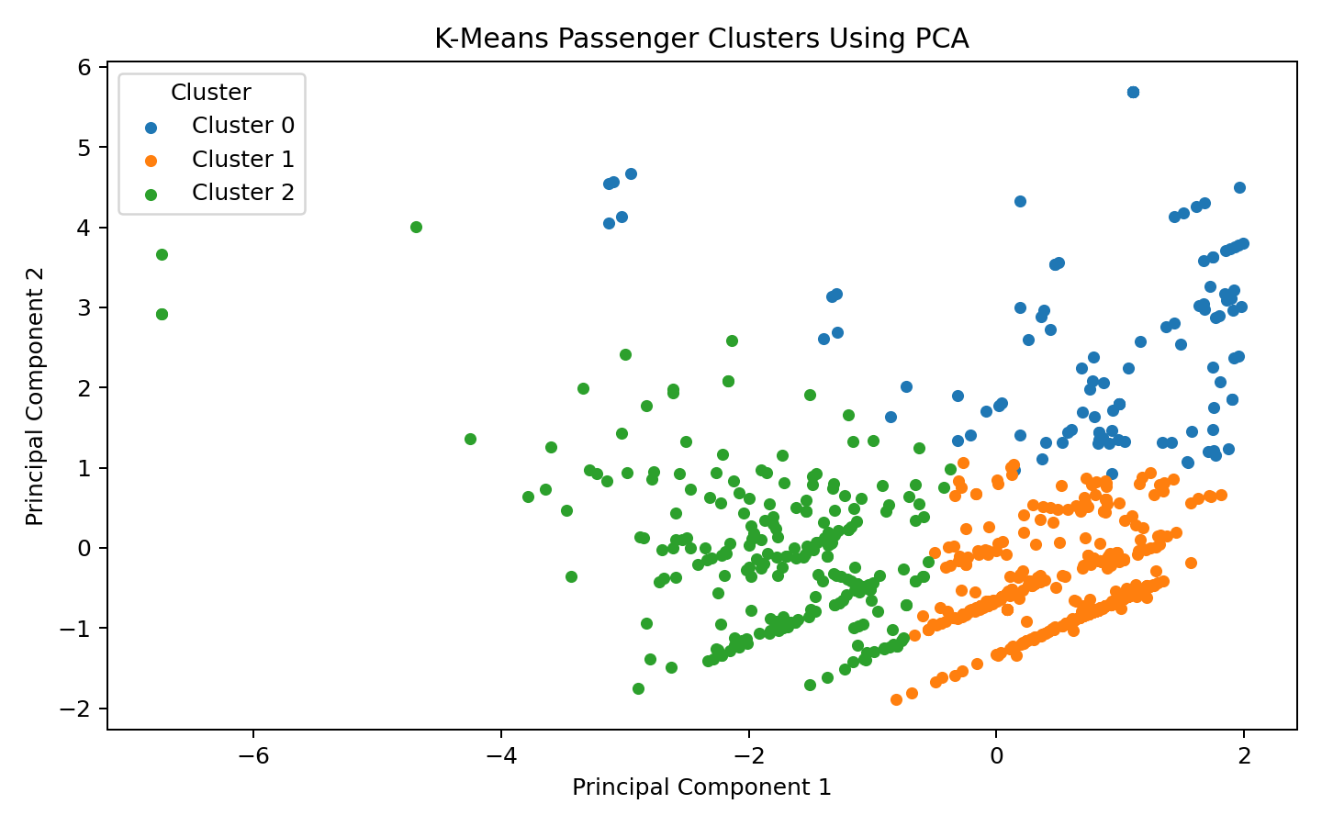
Figure 3. K-Means passenger clusters visualized using PCA.

6.7 Survival by Cluster
Survival was not used to form the clusters. After clustering, however, survival was examined as an interpretive variable. The observed survival rates were 45.45% for Cluster 0, 28.41% for Cluster 1, and 57.74% for Cluster 2.
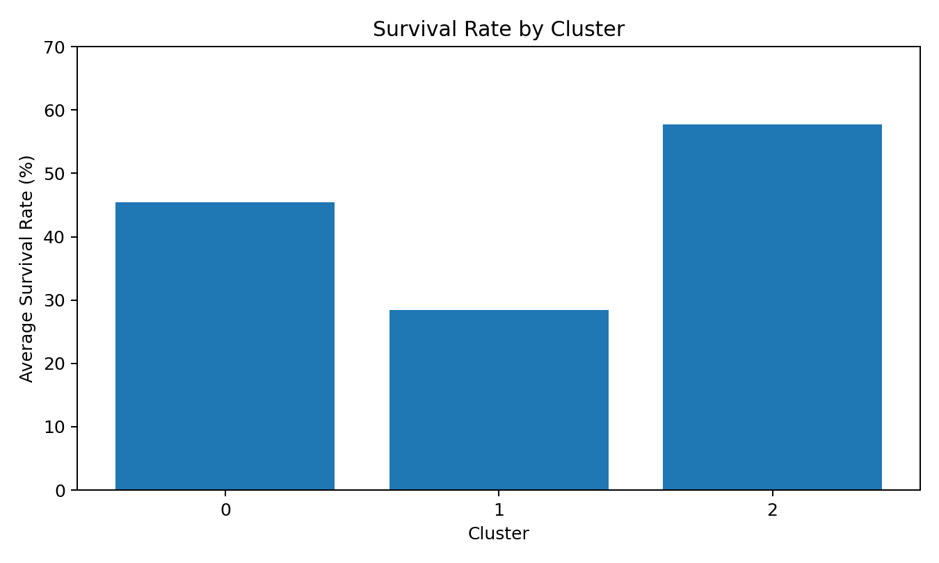
Figure 4. Observed survival rate by cluster.

7. Discussion
The clustering results show that the selected features produced three distinguishable passenger segments in the final analysis. The largest segment, Cluster 1, was associated with lower average fares, higher average pclass values, and lower family-related counts. Cluster 2 was strongly associated with first-class travel, higher fares, and older average age. Cluster 0 was characterized by younger passengers and higher family-related counts. These descriptions are based on cluster averages and should be understood as segment characteristics rather than strict rules for individual passengers.
The PCA visualization provides a two-dimensional view of the segmentation, while the silhouette analysis provides a quantitative measure of how separated the clusters are. The final silhouette score of 0.417 indicates a moderate level of cluster structure for the selected three-cluster solution.

8. Potential Applications and Implications
- Passenger segmentation: The groups can be used to describe different passenger profiles.
- Historical research: Cluster characteristics can support analysis of demographic and travel patterns.
- Customer analytics: The workflow demonstrates how organizations can segment customers using numerical characteristics.
- Data-driven exploration: Clustering can reveal structure without requiring a predefined target variable.

9. Limitations
- The analysis uses only five numerical variables for clustering.
- Categorical variables such as sex and embarkation point were not included in the K-Means feature matrix.
- Cluster labels are algorithmic groups and do not represent predefined real-world categories.
- Survival was analyzed after clustering and was not used to create the clusters.
- The notebook selected K=3 even though K=5 produced the highest tested silhouette score; therefore, the selected solution reflects a practical three-group segmentation rather than the maximum silhouette score alone.

10. Conclusion
This Week 3 project applied K-Means clustering to the Titanic passenger dataset as an example of unsupervised learning. The workflow included feature selection, missing-value treatment, standardization, cluster evaluation, K-Means modeling, cluster profiling, and PCA visualization. The final notebook selected three clusters containing 110, 542, and 239 passengers. The groups differed in age, fare, passenger class, and family-related variables. The final silhouette score for the selected three-cluster solution was 0.417. Overall, the project provided practical experience in applying Scikit-learn clustering methods and interpreting data-driven segments without using a target variable during cluster formation.

11. Appendix – Key Code Snippets

Feature selection
features = ["pclass", "age", "sibsp", "parch", "fare"]
cluster_data = df[features].copy()

Missing-value treatment
cluster_data["age"] = cluster_data["age"].fillna(cluster_data["age"].median())

Scaling
scaler = StandardScaler()
scaled_data = scaler.fit_transform(cluster_data)

K-Means
kmeans = KMeans(n_clusters=3, random_state=42, n_init=10)
cluster_labels = kmeans.fit_predict(scaled_data)

Silhouette score
final_silhouette = silhouette_score(scaled_data, cluster_labels)

PCA
pca = PCA(n_components=2)
pca_data = pca.fit_transform(scaled_data)

12. Deliverables
- YUVA_Week3_Unsupervised_Learning_Clustering.ipynb – Google Colab notebook.
- Sairathnam_J_YUVA_Week3_Clustering_Report.docx – Final report.
- titanic.csv – Input dataset used by the notebook.
- titanic_clustered.csv – Dataset exported by the notebook with cluster assignments.

