YUVA VIRTUAL DATA SCIENCE WITH PYTHON INTERNSHIP
WEEK 2 FINAL REPORT
Exploratory Data Analysis and Visualization

Submitted by: Sairathnam J
Institution: Madras Institute of Technology
Department: Electronics and Communication Engineering
Year: 2nd Year
Role: Virtual Data Science with Python Trainee
Dataset: Titanic Passenger Dataset

Abstract
This report documents the Week 2 Exploratory Data Analysis (EDA) and Visualization task completed as part of the YUVA Virtual Data Science with Python Internship. The analysis uses the Titanic passenger dataset and was implemented in Python with Pandas, NumPy, Matplotlib, and Seaborn in Google Colab. The dataset contains 891 passenger records and 15 variables covering survival, passenger class, sex, age, family-related counts, fare, embarkation, and related categorical attributes. The work begins with loading and inspecting the dataset, checking its structure, descriptive statistics, and missing values. It then uses a series of visualizations and grouped calculations to investigate survival patterns, passenger demographics, fare distributions, and relationships among numerical variables. The notebook includes count plots, bar charts, histograms, box plots, a correlation heatmap, and grouped survival-rate calculations. The results show substantial differences in survival outcomes by gender and passenger class. Female passengers had a survival rate of approximately 74.20%, compared with 18.89% for male passengers. Survival rates also varied by class: approximately 62.96% in first class, 47.28% in second class, and 24.24% in third class. The report presents these results descriptively and explains how visualization supports interpretation of the dataset. It also records the initial file-loading issue encountered in Colab and the upload-based solution used to make the dataset available to the notebook.

1. Introduction
Exploratory Data Analysis is a structured process used to understand a dataset before applying advanced statistical or machine-learning techniques. EDA combines numerical summaries, data inspection, aggregation, and visualization to reveal distributions, relationships, unusual observations, and patterns that may require further investigation. In this Week 2 task, the Titanic dataset was selected because it contains a mixture of numerical and categorical variables and provides several natural questions for exploratory analysis, particularly around passenger survival.
The analysis was carried out in Google Colab using Python. Pandas was used for loading, inspecting, grouping, and summarizing the data; NumPy supported numerical operations and selection of numeric variables; Matplotlib and Seaborn were used to create annotated visualizations.

2. Objectives
- Load and inspect a public Titanic dataset.
- Summarize the dataset using descriptive statistics and structural checks.
- Identify important patterns in passenger survival and demographics.
- Compare survival outcomes across gender and passenger class.
- Examine age and fare distributions and potential extreme values.
- Study relationships among numerical variables using correlation analysis.
- Use clear titles, axis labels, and legends in visualizations.
- Interpret the observed patterns and document the findings critically.

3. Dataset Description
The notebook analyzes the original Titanic dataset loaded from titanic.csv. The final successful load reported a shape of 891 rows and 15 columns. The variables include survived, pclass, sex, age, sibsp, parch, fare, embarked, class, who, adult_male, deck, embark_town, alive, and alone.
The target-style variable used throughout the analysis is survived, where 0 represents a passenger who did not survive and 1 represents a passenger who survived. Numerical variables such as age and fare were examined through distributions and box plots, while categorical variables such as sex, pclass, and embarked were examined with count plots and grouped summaries.

4. Tools and Technologies
- Python 3 in Google Colab
- Pandas for data loading, inspection, grouping, and descriptive analysis
- NumPy for numerical data selection and correlation preparation
- Matplotlib for plotting and figure control
- Seaborn for statistical visualizations

5. Data Loading and Initial Exploration
The notebook initially attempted to read titanic.csv directly. In the Colab session, the file was not yet present, producing a FileNotFoundError. The notebook then checked the available directory, uploaded titanic.csv using Google Colab's files.upload() function, and successfully loaded the dataset. The successful load reported 891 rows and 15 columns.
df = pd.read_csv("titanic.csv")
print("Dataset loaded successfully!")
print("Shape:", df.shape)
df.head()
The first five rows were displayed to verify that the columns and values had been loaded correctly. df.info() showed that most variables were complete, while age contained 714 non-null values and therefore 177 missing observations. The descriptive statistics showed a mean survival value of 0.3838, meaning 38.38% of the 891 records were survivors in the dataset.
df.info()
df.describe()
missing_values = df.isnull().sum()
The missing-value check reported 177 missing values in age, 2 in embarked, 688 in deck, and 2 in embark_town. No missing values were reported in the other columns. The Week 2 notebook focuses on EDA and does not perform a new cleaning/imputation stage.

6. Exploratory Analysis and Visualizations
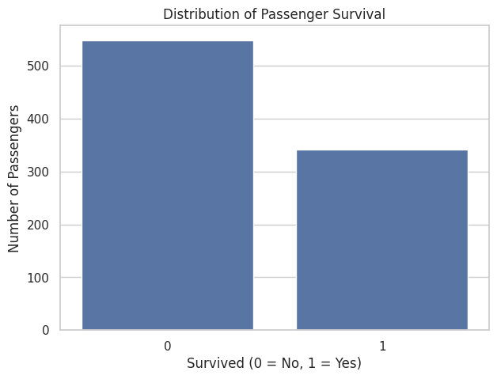
Figure 1. Distribution of passenger survival.
The survival count plot shows that non-survivors form the larger group. This establishes that the outcome variable is not evenly distributed.
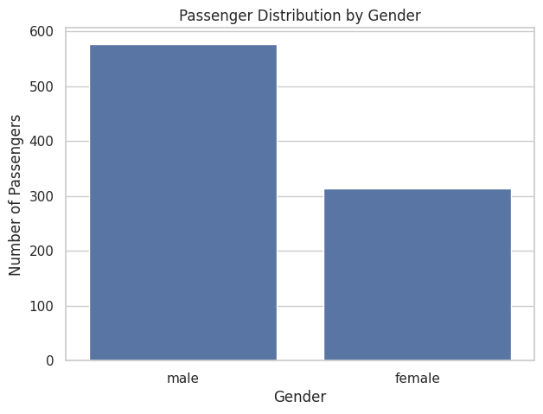
Figure 2. Passenger distribution by gender.
The gender count plot shows the composition of the passenger population. The dataset contains more male passengers than female passengers.
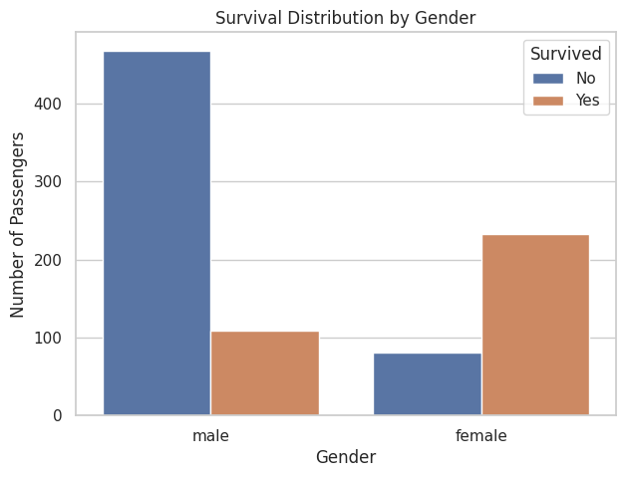
Figure 3. Survival distribution by gender.
When survival is separated by gender, the counts show a pronounced difference between male and female outcomes. This motivated calculation of survival rates rather than relying only on raw counts.
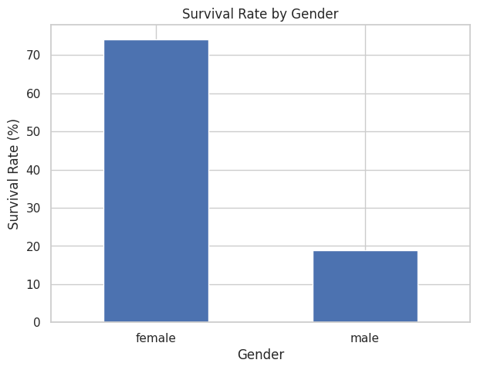
Figure 4. Survival rate by gender.
The grouped calculation gives survival rates of 74.20% for female passengers and 18.89% for male passengers. These are descriptive results from the dataset and show a strong association between gender and survival.
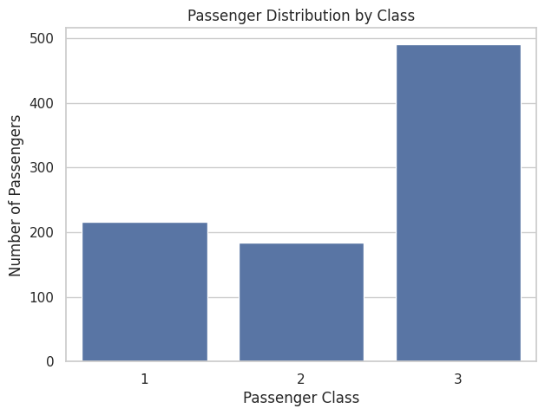
Figure 5. Passenger distribution by class.
The passenger-class count plot shows that third class is the largest passenger group, followed by first and second class.
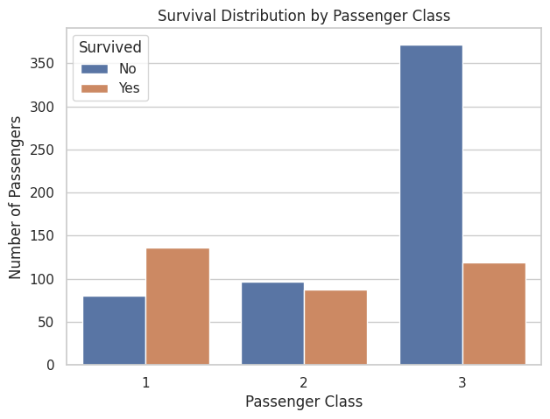
Figure 6. Survival distribution by passenger class.
The class-by-survival plot shows different survival distributions across the three passenger classes.
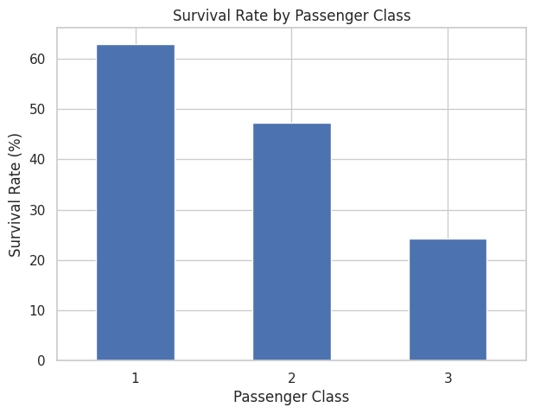
Figure 7. Survival rate by passenger class.
The calculated survival rates were 62.96% for first class, 47.28% for second class, and 24.24% for third class. The descriptive pattern is a decline in survival rate from first to third class.
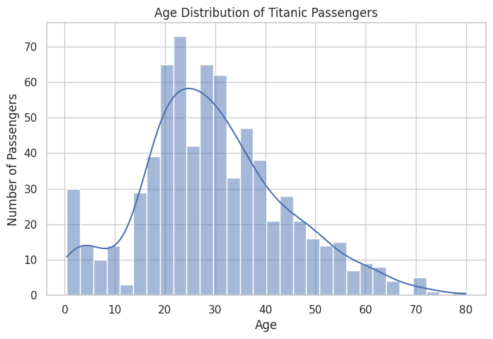
Figure 8. Age distribution of Titanic passengers.
The age histogram displays a broad range of passenger ages and includes both children and adults. The KDE curve provides an additional view of the overall distribution.
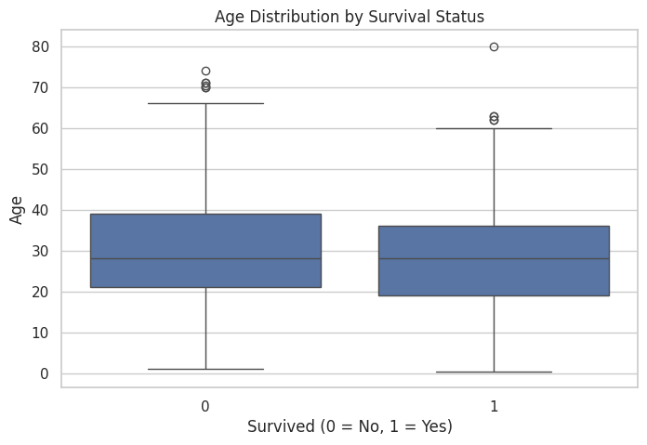
Figure 9. Age distribution by survival status.
The box plot compares age distributions for survivors and non-survivors and provides a visual view of their central tendency, spread, and potential extreme observations.
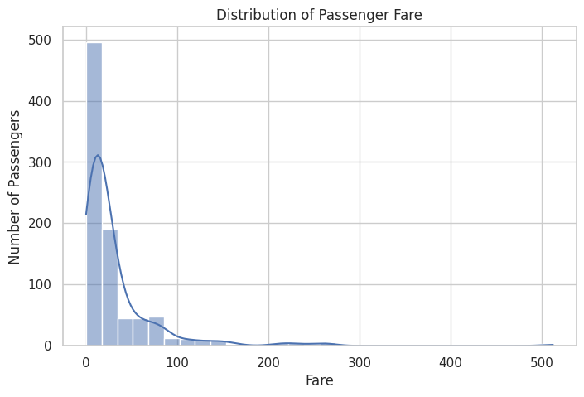
Figure 10. Distribution of passenger fare.
The fare histogram shows a strongly right-skewed distribution: many passengers paid relatively low fares, while a smaller number paid much higher fares.
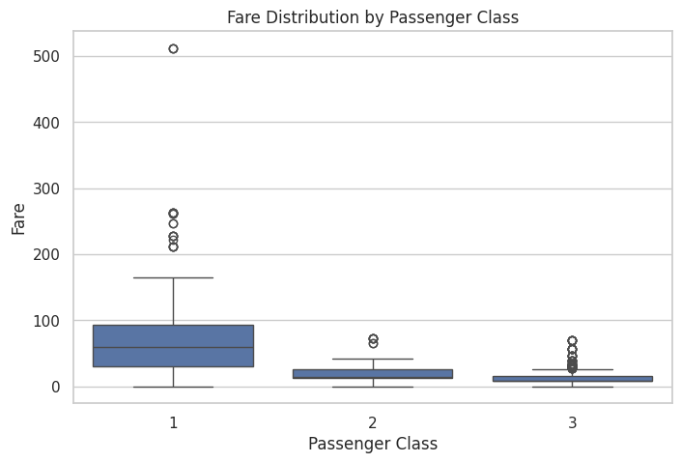
Figure 11. Fare distribution by passenger class.
Fare distributions differ by passenger class. First-class passengers generally show higher fares, while third-class fares are concentrated at lower values.
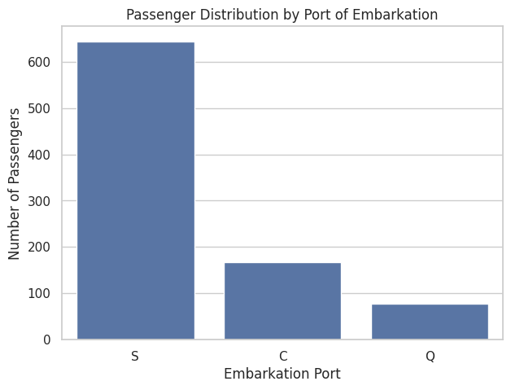
Figure 12. Passenger distribution by port of embarkation.
The embarkation count plot shows the distribution of passengers across the recorded embarkation ports.
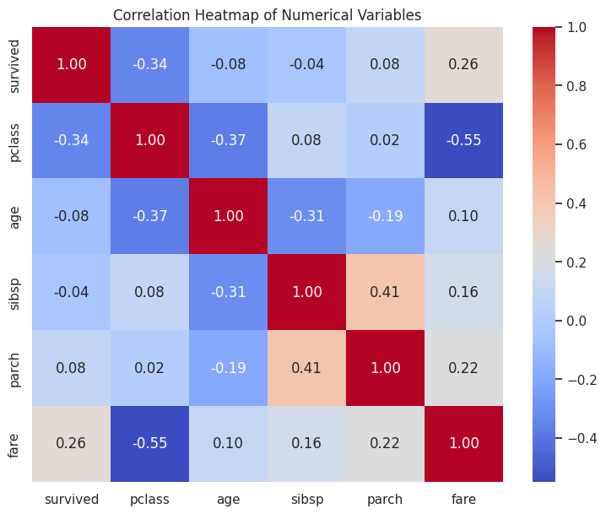
Figure 13. Correlation heatmap of numerical variables.
The correlation heatmap summarizes pairwise linear associations among the numerical variables selected by the notebook. Correlation indicates association and should not be interpreted as proof of causation.
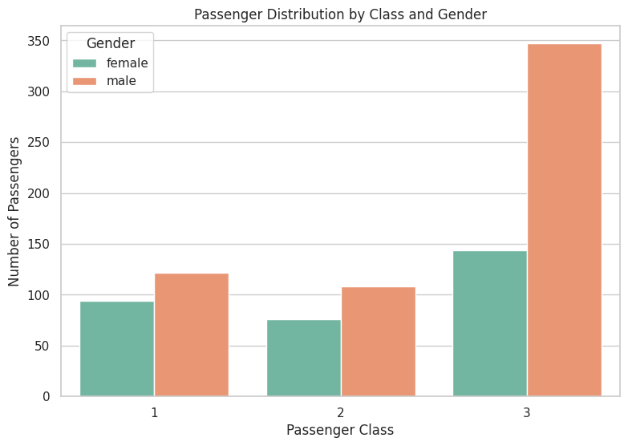
Figure 14. Passenger distribution by class and gender.
The combined class-and-gender plot helps show how passenger composition varied across classes, providing context for the separate class and gender survival analyses.

7. Grouped Analysis and Aggregation
The notebook uses groupby() operations to convert individual passenger records into interpretable summary statistics. Survival rates were calculated by dividing the mean of the binary survived variable by the appropriate grouping and multiplying by 100.
gender_survival = df.groupby("sex")["survived"].mean() * 100
class_survival = df.groupby("pclass")["survived"].mean() * 100
survival_summary = df.groupby(["pclass", "sex"])["survived"].mean() * 100
Passenger class | Female survival | Male survival
1 | 96.81% | 36.89%
2 | 92.11% | 15.74%
3 | 50.00% | 13.54%
The class-and-gender aggregation shows that the highest observed group survival rate in the notebook is for first-class female passengers (96.81%), while the lowest is for third-class male passengers (13.54%). These percentages describe the observed dataset and do not by themselves establish causal explanations.

8. Key Findings
- Overall, 38.38% of the 891 passenger records have survived=1.
- Female passengers have a substantially higher observed survival rate (74.20%) than male passengers (18.89%).
- Observed survival rates vary by passenger class: 62.96% in first class, 47.28% in second class, and 24.24% in third class.
- First-class passengers generally have higher fares than second- and third-class passengers.
- Passenger ages span children through older adults, with missing age values present in the original dataset.
- Fare values are strongly right-skewed, indicating that a relatively small number of passengers paid much higher fares.
- The correlation heatmap provides a compact view of numerical associations and should be interpreted as descriptive rather than causal evidence.

9. Interpretation and Discussion
The strongest descriptive patterns in the notebook concern survival, gender, and passenger class. The difference in survival rates by gender is large, and the class-based rates also differ substantially. Looking at the two dimensions together shows that the relationship is not adequately described by one variable alone. The analysis therefore demonstrates the value of multivariate grouping and visualization in EDA.
The fare analysis also provides useful context. Higher passenger classes generally correspond to higher fares, and the fare distribution contains a long upper tail. The age analysis demonstrates why distribution plots and box plots are useful: a single mean does not fully describe a variable with a wide range and missing observations.
These findings are associations observed in the Titanic dataset. The notebook does not perform causal inference, so the results should not be interpreted as proving that one passenger characteristic caused a particular survival outcome.

10. Challenges Encountered
- The first direct attempt to load titanic.csv produced a FileNotFoundError because the file was not present in the active Colab session.
- The issue was resolved by using Google Colab's file-upload functionality and then re-running the data-loading cell.
- The dataset contains missing values, particularly in age and deck, which need to be remembered when interpreting distributions.
- Choosing several visualization types was necessary because categorical comparisons, numerical distributions, and relationships require different graphical approaches.
- Correlation values require careful interpretation because association does not establish causation.

11. Code Quality and Visualization Design
The notebook uses reusable Pandas groupby operations and standard plotting functions. The visualizations include titles, axis labels, and legends where appropriate. Seaborn's white-grid theme is used consistently. The plots are organized around specific analytical questions rather than being presented as isolated charts.

12. Conclusion
The Week 2 EDA successfully transformed the Titanic dataset from a collection of passenger records into a set of interpretable descriptive findings. The analysis covered dataset structure, descriptive statistics, missing-value inspection, categorical distributions, numerical distributions, grouped survival rates, and numerical correlations. The visualizations made it easier to identify differences in survival across gender and passenger class and to understand the distributions of age and fare.
The most prominent observed patterns are the higher survival rate among female passengers, the variation in survival rate across passenger classes, and the strong right-skew in fares. The combined class-and-gender analysis further demonstrates why EDA should consider multiple variables rather than examining each feature independently. This work provides a practical foundation for subsequent data analysis or machine-learning tasks.

13. Appendix A — Core Code Used
import pandas as pd
import numpy as np
import matplotlib.pyplot as plt
import seaborn as sns
sns.set_theme(style="whitegrid")
df = pd.read_csv("titanic.csv")
print(df.shape)
df.head()
df.info()
df.describe()
df.isnull().sum()
gender_survival = df.groupby("sex")["survived"].mean() * 100
class_survival = df.groupby("pclass")["survived"].mean() * 100
survival_summary = df.groupby(["pclass", "sex"])["survived"].mean() * 100
numeric_columns = df.select_dtypes(include=np.number)
sns.heatmap(numeric_columns.corr(), annot=True, fmt=".2f")

14. Submission Checklist
- Week 2 Colab notebook: YUVA_Week2_EDA_Visualization.ipynb
- Final report: Sairathnam_J_YUVA_Week2_EDA_Visualization_Report.docx
- Dataset used: titanic.csv
- EDA includes descriptive statistics and missing-value inspection
- Multiple annotated visualizations are included
- Grouped survival-rate analysis is included
- Key findings, interpretations, challenges, and conclusion are documented

