YUVA VIRTUAL INTERNSHIP
DATA SCIENCE WITH PYTHON
WEEK 1 TASK REPORT
Data Acquisition, Cleaning, and Preprocessing
Dataset: Titanic Passenger Dataset

Details | Information
Trainee | Sairathnam J
Institution | Madras Institute of Technology
Year / Department | 2nd Year – Electronics and Communication Engineering (ECE)
Role | Virtual Data Science with Python Trainee
Task | Week 1 – Data Acquisition, Cleaning, and Preprocessing
Date | 30 September 2026

Abstract
This report documents the first-week data science task completed as part of the YUVA Virtual Data Science with Python internship. A publicly available Titanic passenger dataset was acquired and processed using Python. The work focused on understanding the structure and quality of the dataset, identifying missing values, checking for duplicates and invalid entries, investigating numerical outliers, and preparing a model-ready representation through categorical encoding and numerical scaling.
The original dataset contained 891 records and 15 columns. Missing-value analysis identified substantial missingness in the deck column (688 values, 77.22%), followed by age (177 values, 19.87%), and two missing values each in embarked and embark_town. Age was imputed using the median, embarked using the mode, and deck was removed because of its high proportion of missing values. Duplicate checking identified 116 exact duplicate rows, which were removed. The cleaned dataset contained 775 records and 14 columns. Outlier analysis using the IQR method identified unusual observations in age, fare, sibsp, and parch; these were investigated rather than automatically deleted.
The preprocessing stage converted sex into a binary representation, one-hot encoded embarked, and standardized age and fare using StandardScaler. The analysis also highlighted an important quality-control issue: two missing embark_town values remained in the final cleaned dataset because the notebook filled embarked but did not fill embark_town. This limitation is explicitly documented rather than concealed.

1. Introduction
Data preparation is a critical stage of the data science workflow. Raw datasets can contain incomplete observations, duplicate records, inconsistent values, different data types, and extreme observations. If these issues are ignored, later statistical analysis and machine-learning models may produce misleading results.
The objective of this task was therefore not simply to load a dataset, but to demonstrate a complete and documented data-quality workflow using Python. Each major decision was considered in terms of its effect on the information retained in the dataset.

2. Objectives
- Acquire a relevant publicly available dataset from a reliable source.
- Explore the structure, dimensions, data types, and statistical characteristics of the data.
- Identify missing values and quantify their extent.
- Handle missing values using appropriate imputation or removal strategies.
- Detect duplicate and potentially erroneous records.
- Check categorical and numerical values for obvious inconsistencies.
- Detect numerical outliers using the Interquartile Range (IQR) method.
- Prepare selected variables for machine-learning use through encoding and scaling.
- Validate the cleaned dataset and export it for future analysis.
- Reflect on the effect of preprocessing choices on subsequent analysis.

3. Dataset Selection and Data Acquisition
The Titanic passenger dataset was selected because it contains a mixture of numerical, categorical, and Boolean features and includes realistic data-quality issues. This makes it suitable for demonstrating missing-value handling, duplicate checking, outlier analysis, categorical encoding, and numerical scaling.
Dataset source used in the notebook:
https://raw.githubusercontent.com/mwaskom/seaborn-data/master/titanic.csv

Data acquisition code
import pandas as pd
import numpy as np
import matplotlib.pyplot as plt
import seaborn as sns
pd.set_option("display.max_columns", None)
url = (
"https://raw.githubusercontent.com/"
"mwaskom/seaborn-data/master/titanic.csv"
)
df = pd.read_csv(url)
print("Dataset shape:", df.shape)
df.head()
The CSV file was loaded directly from the public repository using pandas.read_csv(). The notebook confirmed that the dataset was successfully acquired and contained 891 rows and 15 columns.

4. Tools and Technologies
Tool / Library | Purpose
Python | Programming language used for data processing.
Pandas | Data loading, cleaning, transformation, and tabular analysis.
NumPy | Numerical operations and array-based computation.
Matplotlib | Plotting and visualization.
Seaborn | Statistical visualization, including heatmaps and boxplots.
Scikit-learn | Standardization using StandardScaler.
Google Colab | Cloud-based Python notebook environment used for execution.

5. Initial Data Exploration
The first stage after acquisition was exploratory inspection. Dataset dimensions, column names, data types, non-null counts, descriptive statistics, and the first few records were examined.
print("Number of rows and columns:", df.shape)
print("Column names:", df.columns.tolist())
df.info()
display(df.describe(include="all").T)
display(df.head())

5.1 Dataset Dimensions and Structure
Property | Observed Result
Rows | 891
Columns | 15
Integer columns | 4
Floating-point columns | 2
Object columns | 7
Boolean columns | 2
Memory usage | Approximately 92.4 KB
The dataset contains demographic, travel, passenger-class, fare, survival, and family-related information. Numerical and categorical variables require different preprocessing strategies.

5.2 Dataset Columns
Column | General role / type
survived | Binary survival outcome
pclass | Passenger class; integer
sex | Sex category
age | Age; numerical
sibsp | Number of siblings/spouses aboard
parch | Number of parents/children aboard
fare | Ticket fare; numerical
embarked | Port of embarkation
class | Passenger class category
who | Passenger group category
adult_male | Boolean indicator
deck | Deck category
embark_town | Embarkation town
alive | Survival label as text
alone | Boolean family-travel indicator

6. Missing-Value Analysis
Missing values were quantified using both absolute counts and percentages. This helps determine whether missingness is small enough for imputation or large enough to justify removing a feature.
missing = pd.DataFrame({
"Missing Count": df.isnull().sum(),
"Missing Percentage": (
df.isnull().mean() * 100
).round(2)
})
missing = missing.sort_values(
by="Missing Percentage",
ascending=False
)
display(missing)
Column | Missing Count | Missing Percentage | Treatment
deck | 688 | 77.22% | Dropped
age | 177 | 19.87% | Median imputation
embarked | 2 | 0.22% | Mode imputation
embark_town | 2 | 0.22% | Flagged as remaining issue
All other columns | 0 | 0.00% | No missing-value treatment required

6.1 Missing-Value Visualization
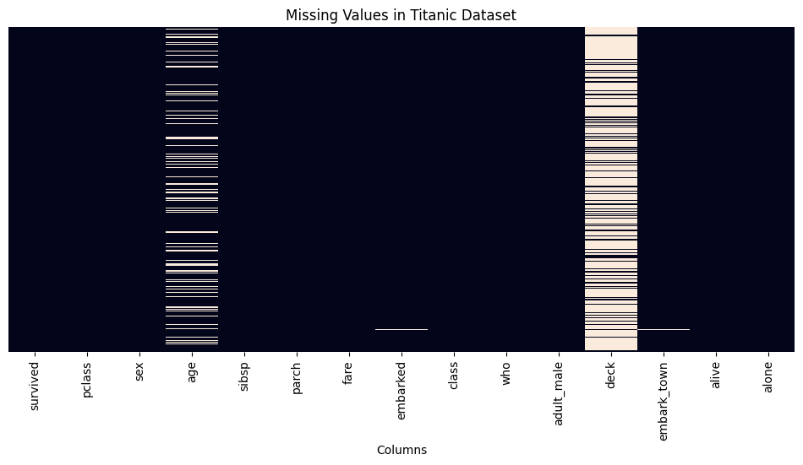
Figure 1. Missing-value heatmap generated during the notebook analysis.
The heatmap provides a visual representation of missingness across records and columns. The most significant missingness was concentrated in the deck and age variables.

7. Missing-Value Treatment
Different treatment strategies were selected according to the variable type and the amount of missing data. The intention was to preserve as much useful information as possible while avoiding excessive distortion.
clean_df = df.copy()
# Median imputation for age
clean_df["age"] = clean_df["age"].fillna(
clean_df["age"].median()
)
# Mode imputation for embarked
clean_df["embarked"] = clean_df["embarked"].fillna(
clean_df["embarked"].mode()[0]
)
# Drop deck because of extensive missing data
clean_df = clean_df.drop(columns=["deck"])
Median imputation was used for age because the median is less sensitive to extreme observations than the mean. Mode imputation was used for the categorical embarked variable. The deck variable was removed because 77.22% of its values were missing, making simple imputation potentially unreliable.

7.1 Quality-Control Observation
The notebook output shows that two missing values remained in embark_town after the treatment. This occurred because the cleaning code filled embarked but did not fill embark_town. Therefore, the final dataset is substantially cleaner but not completely free of missing values. A suitable next revision would fill the two embark_town values using its mode or another justified strategy.

8. Duplicate Detection and Removal
duplicate_count = clean_df.duplicated().sum()
print("Duplicate rows:", duplicate_count)
clean_df = clean_df.drop_duplicates()
print("Shape after removing duplicates:",
clean_df.shape)
The notebook detected 116 exact duplicate rows. These were removed using pandas.drop_duplicates(). The dataset therefore decreased from 891 rows to 775 rows after duplicate removal. The number of columns also decreased from 15 to 14 because deck had already been removed.
Stage | Rows | Columns
Original dataset | 891 | 15
After dropping deck | 891 | 14
After removing 116 duplicates | 775 | 14

9. Consistency and Erroneous-Entry Checks
print(clean_df["sex"].unique())
print(clean_df["embarked"].unique())
print(clean_df["survived"].unique())
print("Age values below zero:",
(clean_df["age"] < 0).sum())
print("Negative fares:",
(clean_df["fare"] < 0).sum())
print("Invalid survival values:",
(~clean_df["survived"].isin([0, 1])).sum())
Validation Check | Result
Sex categories | male, female
Embarked categories | S, C, Q
Survival values | 0, 1
Age below zero | 0
Negative fares | 0
Invalid survival values | 0
The checks did not identify negative ages, negative fares, or invalid survival codes. The categorical values also followed the expected categories present in the dataset.

10. Outlier Detection
Outliers were investigated using the Interquartile Range (IQR) method. For each selected numerical variable, Q1 and Q3 were calculated, followed by IQR = Q3 − Q1. The conventional lower and upper boundaries were then calculated as Q1 − 1.5×IQR and Q3 + 1.5×IQR.
numeric_cols = ["age", "fare", "sibsp", "parch"]
outlier_summary = []
for col in numeric_cols:
Q1 = clean_df[col].quantile(0.25)
Q3 = clean_df[col].quantile(0.75)
IQR = Q3 - Q1
lower = Q1 - 1.5 * IQR
upper = Q3 + 1.5 * IQR
count = (
(clean_df[col] < lower) |
(clean_df[col] > upper)
).sum()
outlier_summary.append({
"Column": col,
"Lower Bound": lower,
"Upper Bound": upper,
"Outlier Count": count
})
outlier_df = pd.DataFrame(outlier_summary)
display(outlier_df)
Column | Lower Bound | Upper Bound | Outlier Count
age | -1.50000 | 58.50000 | 27
fare | -31.17185 | 73.41975 | 102
sibsp | -1.50000 | 2.50000 | 39
parch | -1.50000 | 2.50000 | 15
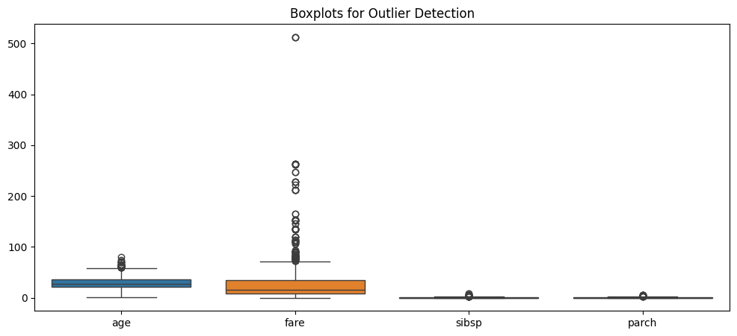
Figure 2. Boxplots used for visual inspection of numerical outliers.
The presence of an IQR-based outlier does not automatically mean that the record is erroneous. For example, a high ticket fare can be legitimate, and a passenger travelling with several family members can legitimately produce a higher sibsp or parch value. Therefore, the notebook identified these observations but did not delete them solely because they were statistically unusual.

11. Data Preprocessing
After cleaning, selected categorical variables were converted into numerical form and selected numerical variables were standardized. This creates a representation that can be used more easily by many machine-learning algorithms.
model_df = clean_df.copy()
# Binary encoding
model_df["sex"] = model_df["sex"].map({
"male": 0,
"female": 1
})
# One-hot encoding
model_df = pd.get_dummies(
model_df,
columns=["embarked"],
dtype=int
)
# Standardization
from sklearn.preprocessing import StandardScaler
scaler = StandardScaler()
scale_cols = ["age", "fare"]
model_df[scale_cols] = scaler.fit_transform(
model_df[scale_cols]
)

11.1 Encoding
The sex column was mapped to 0 for male and 1 for female. The embarked column was one-hot encoded into embarked_C, embarked_Q, and embarked_S. One-hot encoding avoids assigning an artificial numerical order to the three port categories.

11.2 Standardization
Age and fare were standardized using StandardScaler. Standardization transforms each selected feature so that its values are expressed relative to its mean and standard deviation. This can be useful for algorithms affected by differences in feature scale.
For a production machine-learning workflow, the scaler should be fitted only on training data and then applied to validation/test data. The notebook's scaling step is intended as a preprocessing demonstration rather than a complete predictive-model pipeline.

12. Final Validation
print("Original dataset shape:", df.shape)
print("Cleaned dataset shape:", clean_df.shape)
print("Remaining missing values:")
print(clean_df.isnull().sum())
print("Remaining duplicates:",
clean_df.duplicated().sum())
clean_df.to_csv(
"titanic_cleaned.csv",
index=False
)
Validation Item | Final Notebook Result
Original shape | (891, 15)
Cleaned shape | (775, 14)
Remaining duplicate rows | 0
Remaining missing age values | 0
Remaining missing embarked values | 0
Remaining missing embark_town values | 2
Output file | titanic_cleaned.csv
The cleaned dataset was exported as titanic_cleaned.csv. The validation step confirmed that duplicate rows were eliminated and the main missing-value issues were addressed. Two missing embark_town values remained and should be treated in a subsequent revision.

13. Before-and-After Impact of Preprocessing
Aspect | Before Cleaning | After Cleaning / Preprocessing
Rows | 891 | 775 after duplicate removal
Columns | 15 | 14 after removing deck
Age missing values | 177 | 0
Embarked missing values | 2 | 0
Deck missing values | 688 | Column removed
Duplicate rows | 116 | 0
Invalid age/fare/survival checks | Checked | No invalid values detected
Categorical encoding | Original categories | sex encoded; embarked one-hot encoded
Numerical scale | Original units | age and fare standardized in model_df
Preprocessing improves the usability of the dataset, but it also changes the data. Removing duplicates reduces the number of observations, dropping deck removes a potentially informative feature, imputation introduces estimated values, and standardization changes numerical units. These effects should be considered when interpreting later analysis.

14. Challenges Faced and Solutions
Challenge | Solution / Response
Missing age values | Used median imputation to retain records while reducing sensitivity to extreme values.
Large amount of missing deck information | Removed deck because 77.22% of its values were missing.
Missing categorical values | Used mode imputation for embarked.
116 duplicate records | Detected exact duplicates and removed them.
Potential outliers | Used IQR and boxplots to identify unusual observations without automatically deleting them.
Different feature types | Used binary mapping and one-hot encoding for categorical variables.
Different numerical scales | Standardized age and fare using StandardScaler.
Residual missing embark_town values | Identified the issue during final validation; recommended mode imputation in a future revision.

15. Reflective Commentary
The main learning from this task was that data cleaning is not a single operation. Different columns require different decisions based on their data type, missingness, and analytical meaning. For example, replacing every missing value with zero would be simple but could create misleading information. Similarly, deleting every statistical outlier could remove legitimate observations.
The duplicate analysis also demonstrated that preprocessing can substantially change the size of a dataset. In this analysis, 116 exact duplicate rows were removed. Although this improves the dataset if those rows truly represent repeated records, duplicate detection should always be interpreted in the context of the source data.
A further learning point was the importance of final validation. The notebook initially addressed the major missing-value problems, but the final check revealed two remaining missing embark_town values. This demonstrates why a data-cleaning pipeline should always include a final quality check rather than assuming that the cleaning code solved every issue.

16. Potential Impact on Subsequent Analysis
- Imputing missing age values increases the number of usable records but introduces estimated values that may affect distributions.
- Removing the deck feature reduces missingness but also removes information that might have predictive value.
- Removing duplicate rows prevents repeated records from disproportionately influencing descriptive statistics or models.
- Retaining legitimate outliers preserves potentially meaningful real-world variation.
- Encoding categorical variables makes the data usable by algorithms that require numerical input.
- Standardization can improve the behavior of scale-sensitive algorithms, especially when features have different numerical ranges.
- The two remaining embark_town missing values should be handled before any analysis that requires a complete feature matrix.

17. Conclusion
This Week 1 task demonstrated a complete introductory data-preparation workflow using Python. The Titanic dataset was acquired from a public source and systematically examined. Missing values were quantified, major missingness was treated, duplicates were detected and removed, obvious invalid values were checked, and numerical outliers were identified using the IQR method.
The resulting cleaned dataset contained 775 records and 14 columns, with no duplicate rows and no missing age or embarked values. The notebook also produced a model-oriented dataset through categorical encoding and numerical standardization. The remaining two missing embark_town values were identified during final validation and documented as an improvement for the next iteration.
Overall, the task strengthened practical understanding of data acquisition, exploratory data analysis, data quality assessment, missing-value handling, duplicate detection, outlier analysis, feature encoding, and scaling. These steps provide a foundation for reliable exploratory analysis and future machine-learning workflows.

18. Appendix A – Complete Notebook Code

Code Cell 1
import pandas as pd
import numpy as np
import matplotlib.pyplot as plt
import seaborn as sns
pd.set_option("display.max_columns", None)
print("Libraries imported successfully!")
url = (
"https://raw.githubusercontent.com/"
"mwaskom/seaborn-data/master/titanic.csv"
)
df = pd.read_csv(url)
print("Dataset loaded successfully!")
print("Dataset shape:", df.shape)
df.head()
print("Number of rows and columns:", df.shape)
print("\nColumn names:")
print(df.columns.tolist())
print("\nDataset information:")
df.info()
print("\nStatistical summary:")
display(df.describe(include="all").T)
print("\nFirst five rows:")
display(df.head())
missing = pd.DataFrame({
"Missing Count": df.isnull().sum(),
"Missing Percentage": (
df.isnull().mean() * 100
).round(2)
})
missing = missing.sort_values(
by="Missing Percentage",
ascending=False
)
display(missing)
plt.figure(figsize=(12, 5))
sns.heatmap(
df.isnull(),
cbar=False,
yticklabels=False
)
plt.title("Missing Values in Titanic Dataset")
plt.xlabel("Columns")
plt.show()

Code Cell 2
plt.figure(figsize=(12, 5))
sns.heatmap(
df.isnull(),
cbar=False,
yticklabels=False
)
plt.title("Missing Values in Titanic Dataset")
plt.xlabel("Columns")
plt.show()

Code Cell 3
clean_df = df.copy()
# Fill missing age values using the median
clean_df["age"] = clean_df["age"].fillna(
clean_df["age"].median()
)
# Fill missing embarkation values using the mode
clean_df["embarked"] = clean_df["embarked"].fillna(
clean_df["embarked"].mode()[0]
)
# Fill missing fare values using the median
clean_df["fare"] = clean_df["fare"].fillna(
clean_df["fare"].median()
)
# Drop deck because it has extensive missing data
clean_df = clean_df.drop(columns=["deck"])
print("Missing values after treatment:")
print(clean_df.isnull().sum())

Code Cell 4
duplicate_count = clean_df.duplicated().sum()
print("Duplicate rows:", duplicate_count)
clean_df = clean_df.drop_duplicates()
print("Shape after removing duplicates:",
clean_df.shape)

Code Cell 5
print("Unique values in sex:")
print(clean_df["sex"].unique())
print("\nUnique values in embarked:")
print(clean_df["embarked"].unique())
print("\nUnique values in survived:")
print(clean_df["survived"].unique())
print("\nAge values below zero:",
(clean_df["age"] < 0).sum())
print("Negative fares:",
(clean_df["fare"] < 0).sum())
print("Invalid survival values:",
(~clean_df["survived"].isin([0, 1])).sum())

Code Cell 6
print(clean_df.dtypes)

Code Cell 7
numeric_cols = ["age", "fare", "sibsp", "parch"]
outlier_summary = []
for col in numeric_cols:
Q1 = clean_df[col].quantile(0.25)
Q3 = clean_df[col].quantile(0.75)
IQR = Q3 - Q1
lower = Q1 - 1.5 * IQR
upper = Q3 + 1.5 * IQR
count = (
(clean_df[col] < lower) |
(clean_df[col] > upper)
).sum()
outlier_summary.append({
"Column": col,
"Lower Bound": lower,
"Upper Bound": upper,
"Outlier Count": count
})
outlier_df = pd.DataFrame(outlier_summary)
display(outlier_df)

Code Cell 8
plt.figure(figsize=(12, 5))
sns.boxplot(data=clean_df[numeric_cols])
plt.title("Boxplots for Outlier Detection")
plt.show()

Code Cell 9
model_df = clean_df.copy()
# Convert sex into numerical values
model_df["sex"] = model_df["sex"].map({
"male": 0,
"female": 1
})
# One-hot encode embarkation categories
model_df = pd.get_dummies(
model_df,
columns=["embarked"],
dtype=int
)
# Scale selected numerical features
from sklearn.preprocessing import StandardScaler
scaler = StandardScaler()
scale_cols = ["age", "fare"]
model_df[scale_cols] = scaler.fit_transform(
model_df[scale_cols]
)
display(model_df.head())

Code Cell 10
print("Original dataset shape:", df.shape)
print("Cleaned dataset shape:", clean_df.shape)
print("\nRemaining missing values:")
print(clean_df.isnull().sum())
print("\nRemaining duplicates:",
clean_df.duplicated().sum())
print("\nCleaned data preview:")
display(clean_df.head())
clean_df.to_csv(
"titanic_cleaned.csv",
index=False
)
print("Cleaned dataset exported successfully!")

19. Appendix B – Submission Checklist
- Public dataset acquired using Python.
- Dataset structure and data types explored.
- Missing values quantified.
- Missing age values treated using median imputation.
- Missing embarked values treated using mode imputation.
- High-missingness deck column removed.
- Duplicate rows detected and removed.
- Categorical and numerical consistency checks completed.
- Numerical outliers identified using the IQR method.
- Categorical encoding completed.
- Age and fare standardized.
- Final validation completed.
- Cleaned dataset exported as titanic_cleaned.csv.
- Remaining embark_town missing values documented for follow-up.

