Assessing Spatial Distribution and Land Suitability for Zero-Tillage
in the Indo-Gangetic Plains

by

Saisinzita L. Cheruvu

A thesis submitted
in partial fulfillment of the requirements
for the degree of
Master of Science / Environment and Sustainability
in the University of Michigan
April 2025

Thesis Committee:
Dr. Meha Jain, Chair
Dr. Jennifer Blesh, Second Reader
School for Environment and Sustainability
University of Michigan - Ann Arbor

Abstract
Zero tillage (ZT) in rice-wheat farming systems has been shown to improve yield and build climate change resilience in the long term. In the Indo-Gangetic Plains (IGP) intensive rice-wheat farming is practiced by majority small holder farmers. These farmers face higher vulnerability from the instability caused by climate change and resource depletion and could benefit from ZT practices that would both remediate the environment and improve yield. This study aims to first map the spatial distribution of zero tillage and then match weather, irrigation, and socio-economic covariate data to explain the distribution of this practice based on where it currently exits. Furthermore, the drivers of zero tillage are evaluated through a paired Random Forest permutation importance and partial dependence plot analysis done for each of the four states of Punjab, Haryana, Bihar, and Uttar Pradesh. The difference in accuracy between the ZT satellite data and regional characteristics between the eastern and western IGP makes the state wise analysis valuable to explain mechanisms and make tailored relevant recommendations. The permutation importance values, also referenced as feature importance values, are then converted to weights and used to generate a land suitability index (LSI). This suitability index was overlaid with the ZT adoption data to identify regions of high suitably and limited adoption to create recommendations to scale and intensify the practice. Our analysis found that weather variables, particularly winter precipitation and temperature, are the strongest drivers of ZT adoption across all states of the IGP. In the western IGP (Punjab and Haryana), winter rainfall and proximity to permanent canals were most influential, reflecting the importance of irrigation and soil moisture management in these regions. In the eastern IGP (Bihar and Uttar Pradesh), winter temperature and monsoon rainfall were more critical, with Bihar showing a pronounced threshold effect. These findings underscore the need for regionally relevant approaches to scaling ZT in the IGP. By aligning interventions with local climate, resource realities, and infrastructure, policymakers and practitioners can more effectively promote ZT adoption, supporting smallholder farmers in building resilience to ongoing climate change and resource challenges.

Acknowledgements
I thank my faculty advisor, Dr. Meha Jain, for guiding me during this project. Three years ago, your research made me incredibly interested in using GIS and farm surveys to solve wicked problems surrounding agriculture and brought me to the University of Michigan. It has been a dream to work and learn from you. Thank you to members of the Jain Lab who have helped support me. Thank you to my second reader, Dr. Jennifer Blesh, who provided me with invaluable feedback to improve my writing and helped me learn more about soil mechanisms surrounding zero tillage.
I am also incredibly grateful to the Transformative Food Systems (TFS) Fellowship and my cohort for teaching me the importance of bringing kindness into my work and mobilizing my desire to think critically about food and where it comes from. Sami, jøn, Frankie, Sukhmony, and Nia, it has been an absolute pleasure to call you mine at UM. Food is so much more than sustenance to us; it’s love, it’s family, it’s home, it’s us. Lesli Hoey, thank you for bringing us all together as TFS fellows and for nurturing our wild dreams to transform the food system. Our time in the TFS seminar and Turning Theory to Action class taught me never to be complacent because there is always something you can do to help your community.
I appreciate numerous family members and friends who inspire me to have my desired impact on this world. Amma and Nannagaru, thank you for instilling a deep passion for doing some good. I see you, and I know what it means to work hard for what I want. My fiancé, Advaith Sethuraman, thank you for pushing me to challenge myself, take up more space, and learn something new every day. Your curiosity and perseverance are contagious, and I’m incredibly excited for the life that awaits us.
Aryssa and Veda, thank you for your friendship and for making memories with me. You both have been by my side for many seasons, and I’m excited to see where we go next. We laugh when we fall, and I’m grateful to have you both give me a hand to lift myself up and walk forward together onto another day.
Finally, I want to thank my grandmother, Venkata Subbamma Kasibhatla, for being the spark in my life that ignited my deep-rooted passion for sustainable agriculture and improving farmer livelihoods.
With all my heart...Thank you.

Table of Contents
Introduction…………………………………………………………………..1
Methods………………………………………………………………………3
Results………………………………………………………………………..9
Discussion…………………………………………………………………...17
Recommendations…………………………………………………………...19
Limitations and Future Work………………………………………………..20
Conclusion…………………………………………………………………...22
References……………………………………………………………………23

Introduction
Sustainable farming practices are vital holistic approaches with numerous benefits to improve farmers' livelihoods, ensure food security, and make farms resilient to climate change ^{1,2}. The Indo-Gangetic Plains (IGP) region is among the largest global producers of wheat and rice, serving as the cornerstone for millions of smallholder farmers ^{3,4}. Agricultural productivity in the region is threatened by the increased frequency of extreme weather events such as flooding and droughts, along with changes to long-observed weather patterns impacting plant growth and health. The majority of farmers in the IGP are smallholder farmers, which makes them more vulnerable to the effects of climate change due to limited crop and enterprise diversity.
Common unsustainable practices in this region include crop residue burning, which pollutes the atmosphere, and tillage, which reduces soil fertility in the long term, are performed prior to sowing to prepare the seedbeds by removing crop residue ^{5,6}. The sustainable agricultural counterpart to address the negative effects of crop burning and tillage is Zero-Tillage (ZT). ZT is a part of the larger category of conservation tillage efforts, which involves the practice of leaving crop residue between cropping cycles to be used as mulch and has been shown to remediate ecosystem functions while improving farmer livelihoods⁷. Leaving the residue in the fields avoids removing the stubble with crop burning, which reduces air pollution ⁸. Both the above-ground residue and the remaining root structures below ground support in improving the soil quality, which can restore ecosystem function and help mitigate climate change effects. With rising temperatures causing increased evaporation, the residue above ground reduces the impact by acting as mulch covering the soil ⁹. The intact root systems from the previous crop reduced erosion, build/maintain soil organic matter, and increase soil holding capacity ^{10–12}.
It is important to understand where such sustainable practices are being adopted to evaluate influencing factors that could be used to scale the efforts. However, little is known about where zero-tillage is adopted and at what intensity across the IGP. Traditional data collection efforts rely on survey data, which is difficult to collect extensively at scale and does not provide information at the individual field level. This study bridges the gap with the use of satellite data, which enables the mapping of sustainable farming practices at the field scale. As the majority of farmers in the IGP are smallholders, this field-level analysis is valuable in capturing local trends in adoption. Paired with village-level socio-economic (e.g. percent literate), weather (e.g. mean daily temperature during the winter season), and biophysical data (e.g. soil type), this information can be used to understand patterns and drivers of adoption. Previous studies have mainly focused on state-level or district-level factors impacting ZT adoption. Many of these studies rely on plot-level surveys for their methods ^{7,13–16}. Although regional studies are beneficial for gaining a deep understanding of agricultural practices in specific localities, many do not examine the adoption of sustainable farming practices on a large scale or across the entire study region. This analysis allows for a comprehensive understanding of (1) different rates of adoption across the region and (2) the weather, biophysical, and socio-economic factors that influence adoption.
Such information can be used to identify regions that are most suitable for ZT adoption, given the presence of key characteristics associated with historical ZT adoption. By using village-level data for ZT adoption and covariate data for analysis, the study aims to accurately capture high-resolution regional trends in seasonal weather (e.g. average winter temperature, average winter rainfall) , biophysical characteristics (soil type), irrigation trends (e.g. percent of irrigated land, distance to closest permanent canal), and socioeconomic factors (e.g. percent literate, percent of cultivators) that impact zero tillage in the IGP. To our knowledge, a LSI for zero tillage in this region does not exist on a wide scale across the IGP. This study presents a novel method that combines plot-level remote sensing data with various village-level datasets to: (i) understand the spatial distribution of zero tillage across the IGP and identify hotspots of adoption, (ii) identify factors associated with ZT adoption, and (iii) assess areas that are suitable for ZT but have limited adoption. The results from these analyses provide insight into spatial ZT adoption rates and drivers of adoption in the IGP. The goal of this study is to provide actionable recommendations to local governments to plan extension initiatives and develop policies that are backed by region-dependent criteria to promote ZT adoption in areas that are suitable but currently have low adoption rates.

Methods

Study Area

Figure 1. Map of the Indo-Gangetic Plains region, depicted using the WGS 84 /

UTM zone 43N projection (EPSG:32643).

The Indo-Gangetic Plain (IGP) is composed of eight Indian states: Punjab, Haryana, Uttarakhand, Uttar Pradesh, Jharkhand, Bihar, and West Bengal. This region has highly fertile alluvium, produced by the Ganges, Indus, and Brahmaputra rivers ¹⁷. The fertile soil throughout the area allows for extensive rice and wheat cultivation, which are grown in rotation through the Kharif (June through October) and Rabi (November through March) seasons. Rice is mainly grown during the Kharif season, and wheat in the Rabi season.
Rice and wheat are both staple food crops consumed throughout Asia and are in high demand for production. The Indian government guaranteed the purchase of rice and wheat from farmers at a Minimum Support Price (MSP) set before each cropping season, ensuring farmers' income and food security. For Marketing Year (MY) 2024, India is the world's second-largest rice producer, accounting for 27% of global production, estimated at around 145 million metric tons. It is also the third-largest producer of wheat, accounting for 14% of the global output of around 113.29 million metric tons ^{3,4,18}.
The region of study covers the four states of Punjab, Haryana, Uttar Pradesh, and Bihar, as these are prominent rice-wheat farming systems in India ^{3,4}. The Kharif season, from June to October, provides warmer temperatures with more frequent rainfall required for wet rice cultivation in flooded fields. After the crop matures and is harvested, the crop residue is typically burned, particularly in the Western IGP, and the soil is tilled to prepare the land. During the Rabi season, from October to March, wheat is typically cultivated. The analysis for this study was done at the state level due to the ZT data accuracy differences across the eastern and western regions, which makes the within-state variance more accurate than those observed across the entire region. There are also some general characteristics that separate eastern (Bihar and Uttar Pradesh) and western (Punjab and Haryana) IGP, such as increased rainfall and irrigation access in the west and higher temperatures and lower rainfall in the East ^{1,19–21}. The soil type also tends to shift from more porous sandy to denser clay from west to east IGP ^{22,23}. These factors all have implications for the adoption of zero-tillage as a mechanism to improve soil moisture and quality. These differences make a split regions analysis with state-wise trends more valuable for this study.
Crop burning and soil tillage for land preparation between cropping seasons are commonly practiced, which is a highly unsustainable practice in the region. IGP is an agriculture-intensive region, and both practices cause a system of problems for the people and the environment. Crop residue burning causes the production of atmospheric pollutants such as carbon monoxide (CO), nitrogen dioxide (NO₂), methane (CH₄), and carbon dioxide (CO₂), which results in poor air quality and increases the risk of premature death caused by severe cardiovascular and respiratory illnesses ^{24,25}. Rice-wheat systems account for the highest amount of crop residue burning. Within India, from 2011 to 2020, the states of Punjab, Haryana, Bihar, and Uttar Pradesh accounted for consistently high emissions of CO2 due to crop residue burning ⁵. Within the IGP, Punjab accounts for the highest burning activity, and Punjab and Haryana have both shown a significant increase in areas burned from 2011 to 2020 ⁵.
Tillage is the practice of disturbing the soil using machinery with the goal of removing crop residue from the previous crop to prepare the seedbed for the following cropping season. The tillage frequency per field is dependent on soil type and crop type, with rice and wheat tilled on average 3-5 times each cycle ²⁶. In the short term, tillage increases the speed of decomposition of crop residues incorporated into the soil, which exposes them to a greater surface area for microbial degradation ²⁷. Decomposition is important for nutrient cycling on farms to release organically bound nutrients such as nitrogen and phosphorus back to the soil for plant use. However, over time, tillage leads to soil degradation and reduces fertility due to erosion of topsoil and compaction of subsoil. Compacted soil impacts water infiltration and the quality of root proliferation, which hinders plant growth ²⁸. As a result of tillage, the land is depleted of soil organic matter and releases more CO₂ into the atmosphere compared to zero-tillage fields ^{26,29}.
Zero-tillage can help mitigate these issues by maintaining crop residue on the soil surface. ZT has been shown to increase soil organic matter, nutrient availability, crop yield, as well as reduce GHG emissions ^{10,11,26,29}. Given the extensive agricultural activity and intensive rice-wheat farming systems within the IGP, characterized by significant crop residue burning and frequent tillage, it is crucial to understand the factors influencing the adoption of ZT to ensure it is scaled in conditions where it will be successful. The ZT data used for this study is from 2018-2019 winter, which identified 10 m ZT pixels across the IGP after the rice crop before the wheat crop.

Figure 2. Visual representation of methods

Overview
This study broadly integrates processed remote sensing data with compiled datasets on weather, biophysical, and socioeconomic factors that influence farmer decision-making to develop a random forest model. As used by the Census of India, the administrative divisions of India from largest to smallest scale are state, district, sub-district, block, and village ³⁰. Multiple villages make up a block, and multiple blocks make up a sub-district, also called a tehsil or taluk. Statistical analysis was performed on village-level data, and the results were aggregated to the subdistrict level to reduce the effect of satellite streaking prevalent at the village level. For all four states of interest, the ZT spatial distribution maps are included in the results section. The feature importance derived from the model was converted into weights to create a LSI for each state. Feature importance plots are also included in the results section, and their implications within the context of the IGP are explored in the discussion section. Both the ZT adoption and land suitability results are combined to generate bivariate maps categorizing various suitability and adoption levels. These state maps highlight regions of low adoption but high suitability and are presented in the results section, where they are further evaluated in the discussion section.

Data Sets

Sentinel-2 Satellite Data on Zero-Tillage (2018-2019)
This study utilized a remote sensing product developed by Zhou et al. to quantify zero-tillage (ZT) adoption across Punjab, Haryana, Bihar, and Uttar Pradesh.³¹ Zhou et al. derived this product by processing Sentinel-2 Level 1-C satellite data at a 10-meter resolution, generating various vegetation indices that effectively distinguish between ZT and conventional tillage (CT) pixels. The dataset was created using a random forest model that was trained using over one thousand field samples across the IGP. The accuracy of this model was high, reaching an overall accuracy of 75.6%, though accuracy did vary across the IGP, with higher accuracies in the western IGP (Punjab and Haryana) and lower accuracies in the eastern IGP (Uttar Pradesh and Bihar).

Compiled dataset of weather, irrigation, biophysical, and socio-economic variables (2009 - 2017)
Village-scale data on weather, socio-economic factors, and biophysical variables for the four states of interest were compiled from several datasets. Table 1 lists the variables included in the analysis, along with their respective sources. Jain et al. previously collated socio-economic and biophysical data for another study ³². In this study, we use that dataset, along with compiled associated weather data at the village scale. Recognizing that farmers typically base agricultural decisions on multi-year weather trends rather than single-year fluctuations, the four weather variables were calculated as five-year averages. This approach mitigates the influence of short-term weather anomalies and provides a more accurate measure of the climate conditions that influence zero-tillage adoption. Various studies have shown the vital relevance of time scales to farmers' decision-making ^{33–35}. Farmers’ perception of weather changes caused by climate change reflects their adaptation strategies. The variables used in this study can be categorized into four groups: weather, irrigation, biophysical, and socioeconomic. Previous observations of seasonal weather patterns in precipitation and temperature changes are linked to irrigation frequency and impact farmer decision-making for climate change adaptation ³⁶.

Table 1. Variable information used to train the Random Forest regression.
Category | Variable | Definition | Scale | Source
Weather | totalwinrain_5yr_avg | ∑daily rainfall (for winter season start date to winter season end date) in mm | Village; 5-year average (2013-2017) | Tropical Rainfall Measuring Mission (TRMM)
Weather | totalmonrain_5yr_avg | ∑daily rainfall (for wet season start date to wet season end date) in mm | Village; 5-year average (2013-2017) | Tropical Rainfall Measuring Mission (TRMM)
Weather | wetstart_5yr_avg | First wet day (>1 mm) of first 5-day wet spell (wet spell amount ≥ 38-years wet season mean *5) which is NOT immediately followed by 10-day dry spell with <10 mm | Village; 5-year average (2013-2017) | Funk et al., 2015³⁷
Weather | winter_mean_5yr_avg | The mean daily temperature during the winter season (C) | Village; 5-year average (2013-2017) | Harris et al., 2020³⁸
Irrigation | canal_ap, well_ap, tank_ap, other_ap, wfall_ap | Percent of village area that is irrigated by canals, percent of village area that is irrigated by wells, percent of village area that is irrigated by tanks, percent of village area that is irrigated by waterfalls, percent of village area that is irrigated by other sources | Village; one time step | Minor irrigation census (2001) and village amenities census (2011)
Irrigation | irrper | Percent Irrigation | Village; one time step | Village amenities census (2011)
Irrigation | permcanal_dist | Distance to closest permanent canal (km) | Village; one time step | Jain et al., 2017³⁹
Socio-economic | litper | Percent literate | Village; one time step | Socio-economic and demographic census (2001)
Socio-economic | assetind | Assets | Village; one time step | Household amenities census (2011)
Socio-economic | powerhrwin | Number of hours electricity is provided in the winter season | Village; one time step | Socio-economic and demographic census (2001)
Socio-economic | workper | Percentage of workers | Village; one time step | Socio-economic and demographic census (2001)
Socio-economic | aglabper | Percentage of agricultural laborers | Village; one time step | Socio-economic and demographic census (2001)
Socio-economic | scper | Percentage of scheduled caste | Village; one time step | Socio-economic and demographic census (2001)
Socio-economic | cultper | Percentage of cultivators | Village; one time step | Socio-economic and demographic census (2001)
Biophysical | soilwb | Soil type | 1 x 1 km² ; one time step | ISRIC Soil Grids (2014)

Statistical Analysis
The satellite data was analyzed in ArcGIS with the rasterstats tool to extract pixel counts for ZT and CT fields at the village level within each of the four states using the village-level shapefiles as the base layer. The proportion of ZT per village was then calculated as the ratio of ZT pixels to the total number of pixels (ZT + CT) in the cultivated area.
The village-level ZT proportion data were joined with the village-level socio-economic, weather, and biophysical datasets. A random forest regression model, implemented using the RandomForestRegressor tool from the scikit-learn library, was created with ZT proportion as the dependent variable and the remaining variables detailed in Table [insert number] as independent variables. Since Sklearn Random Forest does not inherently handle categorical variables, the non-ordinal categorical variable ‘soilwb’ was handled using the TargetEncoder module from the CategoryEncoders library, which is a model-agnostic approach to handling the variable in the regression. This model used the permutation importance method to calculate feature importances and identify the relative influence of each variable on ZT adoption in each state. The permutation importance method evaluates variable importance by measuring the increase in mean squared error (MSE) when the values of each variable are randomly shuffled, thereby quantifying its influence on the model's predictions. The feature importance values were then used to create a land suitability index by normalizing the weights and calculating the weighted sum of normalized variables multiplied by their respective feature importance values. The highlighted features and their magnitude of impact were evaluated, and the directionality of the significant feature importances was assessed based on partial dependence plots to understand how each variable impacted the ZT adoption in the context of available resources and weather patterns at the state level. Village-level random forest analysis was aggregated at the sub-district level for accuracy. All analyses for this section were conducted using Python (version 3.12.2).
The ZT proportion data was classified into three categories using quantile breaks (Low, Medium, High), while the land suitability scores were classified into three categories (Low, Medium, High) based on natural breaks (Jenks) classification. A bivariate map was generated by overlaying the ZT adoption data with land suitability information to highlight areas that exhibited both medium to high suitability and low adoption rates.

Results

Spatial distribution of ZT across the IGP

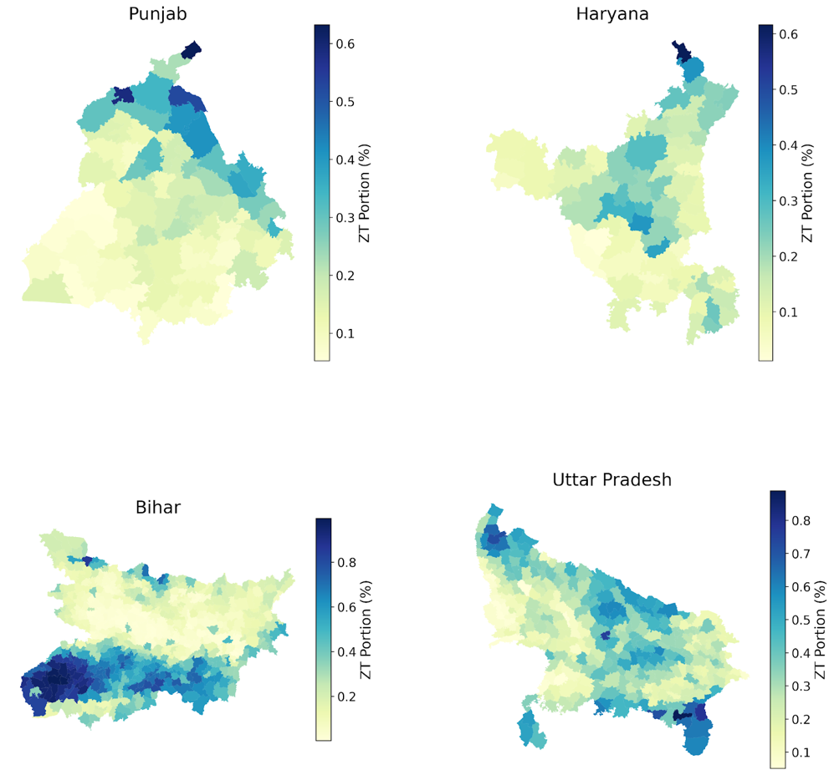
Figure 3. Zero Tillage portion calculated by village and aggregated to the subdistrict level

The analysis on zero-tillage proportion per subdistrict, as shown in Figure 3, is based on 108,181 villages aggregated to 291 subdistricts in Uttar Pradesh, 12,839 villages aggregated to 72 subdistricts in Punjab, 45,653 villages aggregated to 518 subdistricts in Bihar, and 7,067 villages and 67 subdistricts in Haryana. The aggregation of the ZT portion to the subdistrict level was done to reduce the impact of potential local-level inaccuracies in our satellite prediction model, possibly caused by cloud cover.

The adoption of zero tillage (ZT) practices varied significantly across the subdistricts of the four states examined. In Punjab, ZT was most concentrated in the northeastern region, with the Dhar Kalan, Dera Baba Nanak, and Mukerian subdistricts exhibiting the highest adoption rates. A distinct gradient was observed, with the ZT portion decreasing towards the southwestern region of the state. In Haryana, ZT practices were primarily clustered in the northeastern and central regions. Additionally, a few pockets of subdistricts in the southeastern region showed higher ZT adoption. In Bihar, the southern region of the state generally demonstrated higher ZT adoption than the north, with a particularly notable concentration in the southwestern area. Finally, in Uttar Pradesh, the distribution of ZT was more dispersed. While the southeastern tip of the state exhibited higher ZT adoption, there were also pockets of higher concentration in the northwestern tip and a generally higher prevalence in the central region.

Zero Tillage is mainly associated with winter temperatures and seasonal precipitation (winter and monsoon), with trends specific to eastern IGP and western IGP
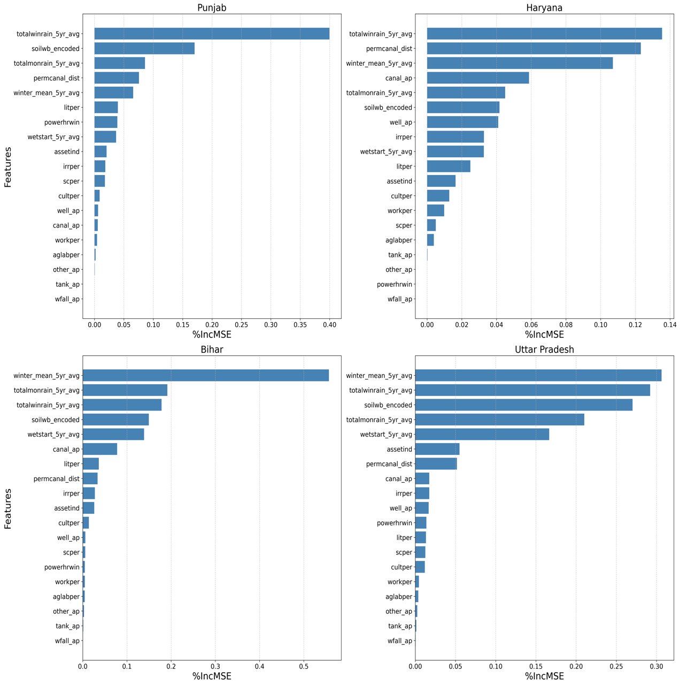
Figure 4. The importance of state permutation features calculated by the Random Forest model
The permutation importance, calculated state-wise for Random Forest Regression models trained on village-level data, indicated that eastern IGP states (Uttar Pradesh and Bihar) and western IGP states (Punjab and Haryana) have similar trends in the importance of ZT predictor covariates. Across the Indo-Gangetic Plains region, the 5-year average weather variables have a higher feature importance than the socio-economic variables. Another trend to note is that the percentage of village area that is irrigated by tanks, waterfalls, and other sources had a minor impact on ZT adoption. The directionality of importance for the top features of total winter rainfall, total monsoon rainfall, distance to permanent canal, and winter mean temperature is discussed in the following section, explaining the results from the partial dependence plots.

The percentage of village area irrigated by canals and wells was relatively more important in regard to the irrigation variable across the four states. The percentage of villages irrigated by canal had the most significant impact on ZT adoption in Punjab. Regional and state-specific patterns are discussed below. The difference in magnitude of feature importance between the states indicates that in Punjab and Bihar, there is one strong factor influencing ZT adoption. In Punjab, this feature is the 5-year average of the total winter rainfall, and in Bihar, this feature is the 5-year average of the mean winter temperature. In the states of Haryana and Uttar Pradesh, which have multiple features with minimal differences between the top 3 to 4 features, the impact on ZT portion could be caused by a combination of interactions between the variables.

Western IGP: Punjab and Haryana
In the Western IGP states, the 5-year average of total winter rainfall was the most influential predictor of ZT adoption. These western states also showed distinctively higher importance for permanent canal distance compared to other regions. The magnitude of impact, specifically for the distance to the permanent canal, was much higher in Haryana than in Punjab. Haryana also has the highest average distance from permanent canals and a negative partial regression coefficient, which indicates that having access to permanent canals is vital for zero tillage in the state. In Punjab, soil type was ranked as the second most important variable. Haryana's results differed, with distance to permanent canals ranking second in importance, which is the highest importance given to this variable of the four states. The magnitude of this effect was not observed in other states. Notably, Haryana also showed higher sensitivity to the percentage of village area irrigated by canals (canal_ap) compared to the other three states.

Eastern IGP: Uttar Pradesh and Bihar
In the eastern IGP, the 5-year average winter temperature was the covariate with the highest predictive power. In comparison to the Western IGP, permanent canal distance has much less of an impact on this region. Both states had the same 5 highest features of importance: mean winter temperature (winter_mean_5yr_avg), total monsoon precipitation (totalmonrain_5yr_avg), total winter precipitation (totalwinrain_5yr_avg), soil type (soilwb), start date of wet season (wetstart_5yr_avg), however, the order of importance was different in each state. In Bihar, the second most important feature was the 5-year average of the total monsoon rain. Followed by total winter rainfall, the soil type variable, and then the date of the first wet day. For Uttar Pradesh, the second most important variable is total winter rainfall, followed by the soil type variable, total monsoon rain, and then the date of the first wet day.

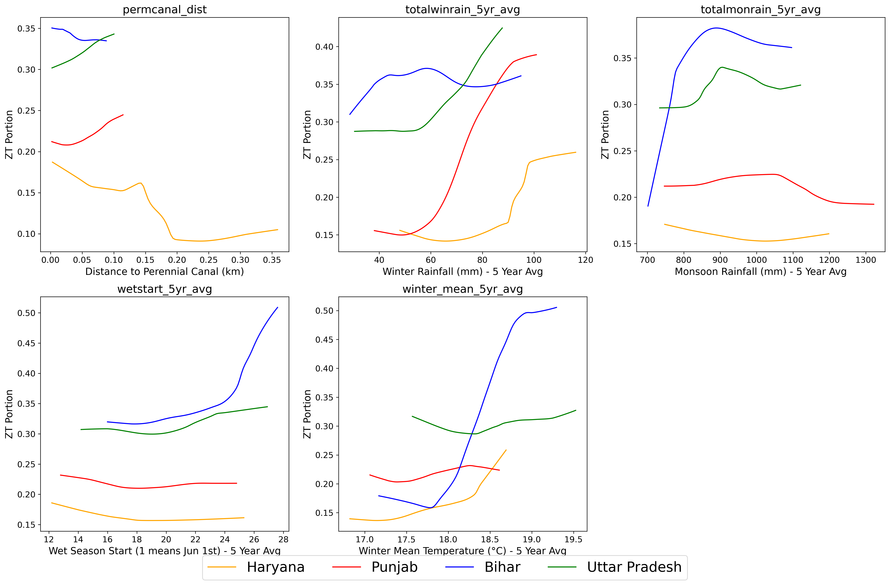
Figure 5. Lowess-smoothed partial dependence plots for the top 6 variables across the four states: distance to permanent canal (permcanal_dist), 5-year average total winter precipitation (totalwinrain_5yr_avg), 5-year average total monsoon precipitation (totalmonrain_5yr_avg), start of wet season (wetstart_5yr_avg), and 5-year average winter temperature (winter_mean_5yr_avg), soil type (soilwb).

To better understand the factors influencing ZT adoption, we developed partial dependence plots for key variables across different states. Seasonal precipitation variables exhibit distinct responses by state. During the winter, there is a general positive association between precipitation and ZT adoption, with regions receiving higher rainfall showing a greater adoption of ZT. In the dry season of winter, precipitation emerged as the most influential variable in the western Indo-Gangetic Plain (IGP) states, where ZT adoption intensity is more pronounced in response to increased rainfall. Regarding monsoon precipitation, the eastern IGP exhibits a distinct positive association between monsoon rainfall and ZT adoption. Bihar shows the highest adoption rates, peaking at 35–37 percent of cultivated land under ZT at intermediate rainfall levels. In contrast, the western IGP demonstrates a modest negative association with monsoon precipitation. The distance to a permanent canal (permcanal_dist) also influences ZT adoption patterns. Haryana exhibits an inverse relationship, with ZT adoption decreasing as proximity to canals increases. Meanwhile, Bihar and Uttar Pradesh display higher overall adoption rates. Bihar maintains consistently high adoption rates (33 – 35%), regardless of canal distance, while Uttar Pradesh shows increasing adoption as the distance from canals increases. The winter mean temperature (winter_mean_5yr_avg) is generally positively correlated with ZT adoption across the region. In Bihar, a notable threshold effect is observed, where adoption rates rise sharply from 16% to 50% of cultivated land under ZT as temperatures exceed 18°C. Other states exhibit more gradual increases in adoption rates as temperatures rise. The timing of the wet season onset plays a more significant role in the eastern IGP, where a later start to the wet season is positively associated with higher adoption rates of ZT.

Land Suitability for Zero Tillage in the IGP

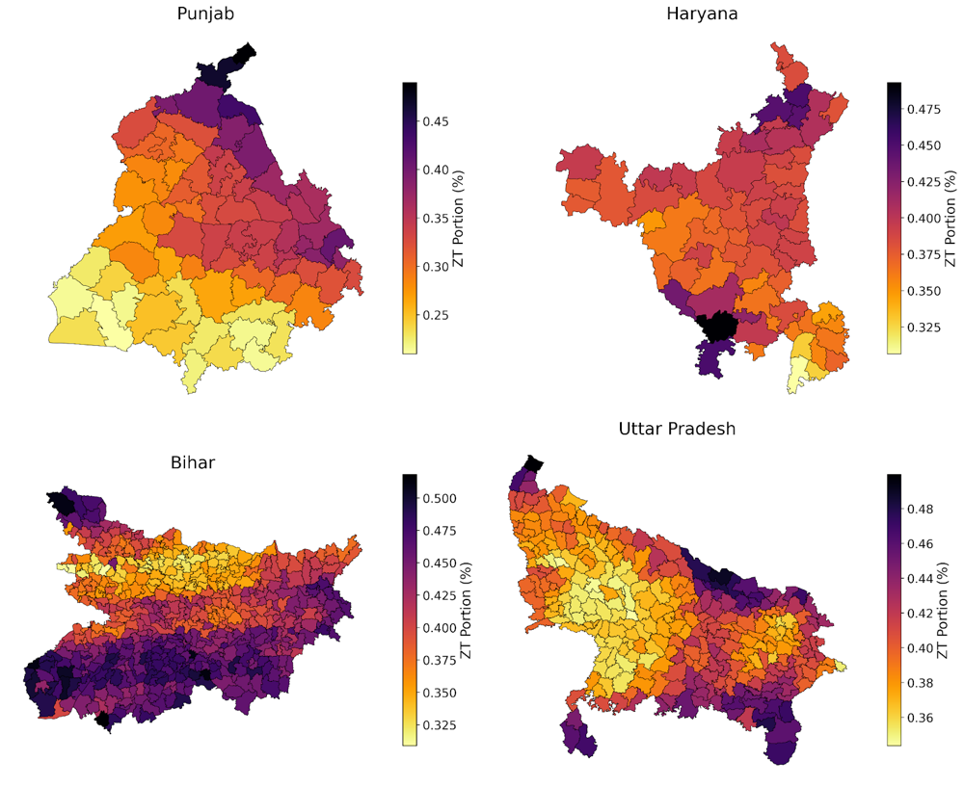

Figure 6. Land Suitability Index values per subdistrict in each state
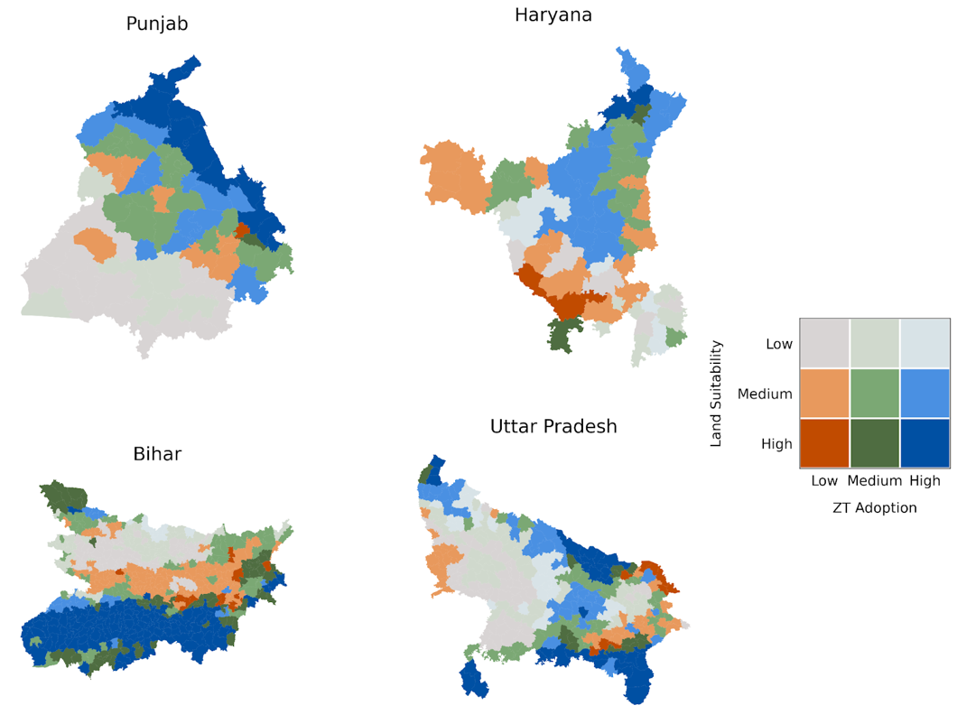
Figure 7. Bivariate map of ZT portion and land suitability for each IGP state

Land Suitability Index (LSI)
The feature importance values were converted to normalized weights to create a LSI which was then visualized on subdistrict maps shown in Figure 5. These land suitability maps highlight regions with varying degrees of suitability across the states. Notably, the eastern and western IGP states exhibit distinct characteristics: the west is marked by limited precipitation, greater access to irrigation, and cooler temperatures, while the east experiences higher precipitation, less irrigation access, and warmer temperatures. These contrasts arise from underlying climatic and geographic variability, adding complexity to the assessment of suitability. Consequently, the profiles of high and low suitability differ across states, influenced by these regional differences and the directionality of their impact. Further discussion of these patterns by region and, where relevant, by state, is provided below.

In Uttar Pradesh, the eastern region of the state is more suitable for ZT than the western region. However, there are hotspots of suitability in the western tip of the state. The main concentrations of suitability in Uttar Pradesh are along the border of the state, along the southeastern, southwestern, and Northwestern regions. Bihar has a larger area of suitability than other states. The south region of Bihar is more suitable for ZT than the Northern region of the state. However, within the northern region, there is a hotspot of suitability in the northwestern border of the state. Within the southern region of high suitability, the southwestern region has higher concentrations of high-suitability subdistricts. There is a distinct gradient of suitability in Punjab, with higher suitability in the eastern region and lower suitability in the western region. The highest suitability is along the northeastern region of the state. The southwestern and northeastern regions of Haryana have a few concentrated subdistricts that are more suitable. There is a general higher suitability across the state without any clear spatial trends compared to the other states of the IGP.

Adoption and Suitability
Previously calculated ZT adoption rates and LSI values per village were aggregated to the subdistrict level and overlaid to highlight areas with low ZT adoption despite high/medium suitability. These priority subdistricts are shown in dark orange in Figure 6. The ZT values were classified using the quantile method, while the LSI values were classified using the natural breaks (Jenks) method. In the Western Indo-Gangetic Plains (IGP), the largest area falls under the low suitability and low adoption category, covering 11,286.82 km² (25.5%). Similarly, Punjab has 13,194.87 km² (26.2%) of land in this category. Among the regions analyzed, Bihar has the highest area in the high suitability and high adoption category with 29,819.16 km² (30.8%). Conversely, Haryana has the smallest area in this category with only 1,208.01 km² (2.7%). Notably, all four states have relatively small areas classified as high suitability but low adoption, which represent key opportunity zones for intervention: Haryana has 1,873.86 km² (4.2%) in the subdistricts of Kosli, Loharu, and Mahendragarh; Punjab has 184.45 km² (0.37%) in the subdistrict of Khamnon; Bihar has 2,184.71 km² (2.3%) distributed across multiple subdistricts including Baisi, Balia, Begusarai, Bhargama, Bihpur, Dhamdaha, Ismailpur, Narayanpur, Rangra Chowk, Sabour, Sahebpur Kamal, Shamho Akha Kurha, and Vaishali; and Uttar Pradesh has 5,919.62 km² (2.4%) across the subdistricts of Bansi, Bhadohi, Handia, Karchhan, Kasya, Nautanwa, Nichlaul, Padrauna, and Tamkuhi Raj.
Table 2. Land suitability for Zero Tillage in Haryana. High suitability, low adoption subdistricts: Kosli, Loharu, and Mahendragarh.
Suitability | Adoption | Area (sq km) | Percentage
Medium | Low | 11286.823085 | 25.5
Medium | High | 11283.506539 | 25.5
Medium | Medium | 7236.725642 | 16.4
Low | High | 3990.959689 | 9.0
Low | Low | 3362.770912 | 7.6
Low | Medium | 2674.752621 | 6.1
High | Low | 1873.857596 | 4.2
High | Medium | 1259.229355 | 2.9
High | High | 1208.011301 | 2.7
Table 2. Land suitability for Zero Tillage in Punjab. High suitability, low adoption subdistrict: Khamanon.
Suitability | Adoption | Area (sq km) | Percentage
Low | Low | 13194.870793 | 26.2
Medium | Medium | 9363.221761 | 18.6
High | High | 7997.313248 | 15.9
Medium | High | 7992.527534 | 15.9
Low | Medium | 6711.978554 | 13.3
Medium | Low | 4644.770920 | 9.2
High | Medium | 247.396210 | 0.5
High | Low | 184.445810 | 0.4
Low | High | - | -
Table 3. Land suitability for Zero Tillage in Bihar. High suitability, low adoption subdistrict: Baisi, Balia, Begusarai, Bhargama, Bihpur, Dhamdaha, Ismailpur, Narayanpur, Rangra Chowk, Sabour, Sahebpur Kamal, Shamho Akha Kurha, Vaishali.
Suitability | Adoption | Area (sq km) | Percentage
High | High | 29819.158092 | 30.8
Medium | Low | 15199.746956 | 15.7
High | Medium | 13298.475751 | 13.7
Medium | Medium | 12863.220947 | 13.3
Low | Low | 9773.557527 | 10.1
Low | Medium | 8898.461969 | 9.2
Medium | High | 3282.341131 | 3.4
High | Low | 2184.707782 | 2.3
Low | High | 1476.912936 | 1.5

Table 4. Land suitability for Zero Tillage in Uttar Pradesh. High suitability, low adoption subdistrict: Bansi, Bhadohi, Handia, Karchhan, Kasya, Nautanwa, Nichlaul, Padrauna, Tamkuhi Raj.
Suitability | Adoption | Area (sq km) | Percentage
Low | Medium | 40082.295228 | 16.5
Low | Low | 39825.679219 | 16.4
High | High | 38519.336207 | 15.8
Medium | High | 36051.018536 | 14.8
Medium | Medium | 28303.283136 | 11.6
Low | High | 23268.004159 | 9.6
Medium | Low | 21546.906068 | 8.9
High | Medium | 9508.341870 | 3.9
High | Low | 5919.615945 | 2.4

Discussion
We analyzed a suite of weather, socioeconomic, irrigation, and biophysical variables across Haryana, Punjab, Bihar, and Uttar Pradesh to determine their influence on ZT adoption and to assess land suitability for this practice. Random Forest analysis allowed us to identify subdistricts with a low risk of non-adoption, highlighting key factors driving ZT implementation. Across all four states, weather variables emerged as the most influential, underscoring the critical role of climate in ZT success. This is likely due to ZT's ability to improve soil moisture retention, a particularly valuable trait given the regional climate patterns. Specifically, regional trends indicated that winter precipitation (and to a lesser extent, monsoon rain) and winter temperature were the most important climatic drivers. Beyond these overarching trends, a more nuanced impact was observed related to permanent canal distance in Haryana. Based on the feature importance, magnitude of influence, and significance derived from our analysis, we further explored the following variables in the context of climate change and the available resources within the IGP: 5-year average of total winter rain (totalwinrain_5yr_avg), 5-year average of winter temperature (winter_mean_5yr_avg), 5-year average of total monsoon rain (totalmonrain_5yr_avg), and distance to permanent canal (permcanal_dist).

Warmer Winter Temperatures in Eastern IGP
In Bihar, ZT adoption increases dramatically above 18°C, from approximately 15% to over 50%, showcasing a pronounced threshold effect that reflects farmers' response to thermal conditions in a region where wheat is typically sown much later (November-December) than in western states like Punjab, Haryana, and western Uttar Pradesh (late October-mid November) ^{40,41}. This timing difference is critical because wheat, a heat-sensitive winter crop, faces increasing challenges from climate change-induced temperature rises that create heat stress, impacting growth stages, increasing disease susceptibility, and reducing both grain quantity and quality ⁴². These challenges are particularly acute in the eastern Indo-Gangetic Plains with their relatively higher temperatures and limited irrigation infrastructure ⁴³. The feature importance plot (Figure 4) confirms winter temperature as Bihar's dominant driver of ZT adoption, accounting for over 50% of model variance, as farmers recognize ZT's value in enabling earlier sowing by reducing land preparation time and decreasing turnaround time between successive crops, thereby mitigating heat stress impacts. Interestingly, Uttar Pradesh, while also showing high feature importance for winter temperature, displays a contrasting pattern with an initial negative correlation (Figure 5) that shifts to positive around 18.4°C, likely because some UP farmers already sow earlier than their Bihar counterparts, making heat stress mitigation less critical for their ZT adoption decisions.¹⁶ Instead, UP's adoption variations appear better explained by complex interactions between seasonal rainfall patterns and soil type, as evidenced by the relatively similar importance values for the top three features, mean winter temperature, total winter rain, and soil type, affecting ZT adoption in the state. This pattern suggests that, in Uttar Pradesh, ZT is possibly more prevalent in area where the combination of moderate winter rainfall and suitable soil types allow farmers to maximize the moisture retention and soil health benefits of the practice, while in areas with either excessive rainfall or less favorable soils, adoption rates remain lower despite similar climatic conditions. The directionality of the link between soil type and ZT adoption needs to be further explored. A hypothesis could be that clay soils retain water longer and farmers are able to grow long-duration rice which causes them to sow wheat later in the year and ZT supports them in turning around their crop sooner even with the delay in sowing. Paired with limited irrigation available in the dry season, ZT most likely helps maintain soil moisture in the dry months with less rainfall.
- Limited Winter Rainfall in Western IGP
Punjab and Haryana exhibit strong positive associations between winter rainfall and ZT adoption, with adoption rates in Punjab rising from ~ 15% to 37% as winter rainfall increases from 40mm to 100mm, suggesting that ZT’s moisture conservation benefits are particularly valued where winter precipitation supplements irrigation. This pattern aligns with Punjab’s feature importance rankings, where winter rainfall emerges as the top predictor of ZT adoption, accounting for about 40% of model importance. Rainfall is closely related to water availability for crop irrigation, and in the western IGP, which generally receives less rainfall than the East, farmers rely more heavily on tube wells and canals to sustain their crops, especially during the lighter winter rainfall months ^{23,43}. Seasonal rainfall thus plays a significant role in crop success. While monsoon rains are typically higher, winter rainfall is crucial for wheat, and any reduction in monsoon rainfall can reduce groundwater and surface water availability for irrigation during the wheat-growing season. The partial dependence plots for Punjab and Haryana show that increased winter rainfall positively influences ZT adoption, likely because greater winter precipitation improves water availability for irrigation, and the more porous soils of the western IGP make ZT particularly advantageous for maintaining soil moisture during dry periods.^{22,44}
- Reduced Distance to Permanent Canal in Haryana

Irrigation methods vary across the IGP based on precipitation patterns and groundwater availability. In both Haryana and Punjab, permanent canal distance showed higher feature importance, likely due to the greater access to irrigation in these regions and the resulting impact of different irrigation methods. The average permanent canal distance in Haryana exhibits a wider range, meaning that, across the IGP, farmers in Haryana are, on average, the farthest from permanent canals. The negative association between the variables, as shown by Figure 5, may be caused by the combined use of permanent canals and well irrigation ⁴⁵. Since ZT is a technique for maintaining soil moisture, precipitation patterns and irrigation access influence its spatial adoption. Farmers farther from canals often rely on well irrigation, which offers greater control over water supply.⁴³ This accessibility to water may reduce the appeal of ZT as a water conservation method, as wells provide a reliable irrigation source for crops. Another mechanism to consider is that canals are irrigated farmers are more likely to grow their crops in clay soils which has been shown to complement the soil conservation benefits of ZT ^{15,44}. In Haryana with limited rainfall there is possibly also a interaction between soil type and distance to canal that needs to be further explored.

Recommendations
Our spatial analysis of ZT adoption reveals distinct regional responses to weather, soil, and irrigation variables across the IGP. The partial dependence plots and spatial distribution maps indicate that effective scaling strategies must be tailored to regional contexts rather than applied uniformly across the region.
The bivariate map provides a list of subdistricts of high suitability and low adoption which have favorable conditions for ZT as defined by historical ZT adoption. Though the subdistrict list may not be comprehensive of all location in the state as the model is limited by the selected variables, it provides a lead for technology targeting and focused extension staff support. Building on the results from the study, the turnaround time between crops and the impact of heat stress make sowing date a vital driver of ZT adoption in both Uttar Pradesh and Bihar. Development of educational programs specifically connecting ZT's early sowing benefits to heat stress mitigation would be beneficial for these states. Furthermore, the steep response curve for wet season start timing (wetstart_5yr_avg) in Bihar suggests ZT adoption becomes significantly more valuable when the monsoon is delayed beyond 22 days. Extension programs could implement seasonal monitoring systems that alert farmers when compressed growing windows make ZT particularly advantageous. In Punjab and Haryana where winter rainfall dominated the feature importance explaining an estimated 40% of variance in Punjab and 14% in Haryana, focused efforts can take place in areas with winter rainfall between 60-90mm where the partial dependence plots show optimal response. Additionally, the northeastern districts of Punjab showing concentrated adoption (dark blue clusters) could be used as knowledge-sharing hubs to learn how farmers are dynamically scaling ZT on their fields. For Haryana, the steep negative relationship between permanent canal distance and ZT adoption would benefit from infrastructure-aware strategies. An effort to scale ZT could concentrate initial efforts within 0.15 km of permanent canals where adoption rates are highest. The impact of ZT on irrigation type should also be further studied to understand how varying irrigation types across the IGP attract or deter farmers from shifting to ZT on their fields. There should also be an effort to address the fragmented adoption pattern visible in the spatial maps through targeted demonstrations in high-potential areas. Areas with high adoption and high suitability in the northeast (blue and dark blue) could be knowledge hubs to expand ZT adoption to areas in the southwest (dark orange).
The implementation of these recommendations should use the suitability vs adoption maps for a clear prioritization farmwork to increase ZT adoption in the IGP. As state policies and program heavily impact the implementation of sustainable agriculture efforts, a proposed method for leveraging the spread of adoption and suitability within each state. Extension staff could focus efforts on dark orange and light orange regions for immediate opportunities where ZT could perform well for the given regional differences. These areas might benefit from education on what ZT is and how it could support their land. Secondary targets could be the green areas which represent medium adoption and medium/high suitability. These areas have more intensification potential and could benefit from technology targeting to increase access to required ZT machinery. The dark blue regions of high suitability and high adoption could be utilized as learning sites or knowledge hubs to understand various field conditions which impact a farmer or community decision to practice ZT successfully over time.

Limitations and Future Work
The analysis provides valuable insights into ZT adoption determinants, but several important limitations warrant consideration and suggest directions for future research. Reliance on five-year averaged weather patterns (2013-2017captures recent conditions but cannot account for projected climate changes. The pronounced threshold effects visible in our partial dependence plots, particularly the 18°C winter temperature threshold in Bihar and 22-day wet season start timing, suggest that shifting climate regimes could fundamentally alter spatial suitability patterns. Future research should integrate these adoption models with downscaled climate projections to map evolving ZT suitability under different scenarios, particularly in regions approaching critical thresholds. Furthermore, the satellite-based classification of ZT versus conventional tillage had varying accuracy across states, with higher reliability in the western states (Punjab and Haryana) than eastern states (Bihar and eastern UP). This spatial disparity in data quality partially explains the more distinct adoption patterns visible in the maps for Bihar (clear north-south divide) versus the more scattered patterns in Haryana. Future studies should employ multi-sensor approaches and increased ground validation to improve classification consistency across regions. Regarding our suitability analysis, the permutation importance and land suitability index relies on the same dataset, potentially creating circular reasoning where high adoption areas automatically appear highly suitable. This limitation may explain the relative scarcity of high-suitability/low-adoption areas (dark orange) in certain states. Future work should incorporate independent measurements to establish suitability criteria separate from adoption patterns. An analysis of national and state agricultural policies that impact ZT adoption among each state would help better contextualize the results beyond environmental factors and could better explain resource availability.
By addressing these limitations, future research can build on our spatial analysis to develop more comprehensive and accurate models of ZT adoption that better inform climate adaptation strategies across the diverse agricultural landscapes of the IGP.

Conclusion
The environmental context fundamentally shapes agriculture, and climate change impacts manifest most severely in farming systems, especially smallholder farming systems. The analysis of this study reveals how zero tillage (ZT) adoption across the Indo-Gangetic Plain (IGP) represents a critical adaptation strategy with benefits that vary according to regional climatic conditions and infrastructure access. The Random Forest feature importance paired with the partial dependence plots highlights the dominant role of winter precipitation (western IGP) and temperature (eastern IGP) in driving ZT adoption, with notable threshold effects, such as the sharp increase in adoption above 18°C winter temperature in Bihar. At the same time, other regions show more gradual responses. The feature importance rankings and spatial maps further reveal that factors like proximity to permanent canals in Haryana are critical in shaping where ZT is most suitable and widely adopted. Notably, the bivariate suitability and adoption maps show that high suitability does not always translate to high adoption, suggesting that local constraints, infrastructure, and knowledge gaps remain significant and could be locations for targeted ZT extension efforts. Overall, these findings show the need for regionally tailored approaches to scaling ZT, as aligning interventions with local climate and resource realities will be essential for building agricultural resilience.

References

1. Meena M, Rajesh T., Beer K. Adoption and impact of zero tillage in the rice-wheatproduction system of Haryana. ResearchGate. 2016;50(6). doi:10.18805/ijare.v50i6.6677

2. Biswakarma N, Pooniya V, Zhiipao RR, et al. Five years integrated crop management in direct seeded rice–zero till wheat rotation of north-western India: Effects on soil carbon dynamics, crop yields, water productivity and economic profitability. Agric Ecosyst Environ. 2021;318:107492. doi:10.1016/j.agee.2021.107492

3. Wheat | USDA Foreign Agricultural Service. Accessed March 22, 2025. https://www.fas.usda.gov/data/production/commodity/0410000

4. Rice | USDA Foreign Agricultural Service. Accessed March 22, 2025. https://www.fas.usda.gov/data/production/commodity/0422110

5. Deshpande MV, Kumar N, Pillai D, Krishna VV, Jain M. Greenhouse gas emissions from agricultural residue burning have increased by 75 % since 2011 across India. Sci Total Environ. 2023;904:166944. doi:10.1016/j.scitotenv.2023.166944

6. Deshpande MV, Pillai D, Krishna VV, Jain M. Detecting and quantifying zero tillage technology adoption in Indian smallholder systems using Sentinel-2 multi-spectral imagery. Int J Appl Earth Obs Geoinformation. 2024;128:103779. doi:10.1016/j.jag.2024.103779

7. Keil A, Mitra ,Archisman, McDonald ,Andrew, and Malik RK. Zero-tillage wheat provides stable yield and economic benefits under diverse growing season climates in the Eastern Indo-Gangetic Plains. Int J Agric Sustain. 2020;18(6):567-593. doi:10.1080/14735903.2020.1794490

8. Keil A, Krishnapriya ,P. P., Mitra ,Archisman, et al. Changing agricultural stubble burning practices in the Indo-Gangetic plains: is the Happy Seeder a profitable alternative? Int J Agric Sustain. 2021;19(2):128-151. doi:10.1080/14735903.2020.1834277

9. Kumar A, Rana KS, Choudhary AK, et al. Sole- or Dual-Crop Basis Residue Mulching and Zn Fertilization Lead to Improved Productivity, Rhizo-modulation and Soil Health in Zero-Tilled Pigeonpea–Wheat Cropping System. J Soil Sci Plant Nutr. 2022;22(2):1193-1214. doi:10.1007/s42729-021-00723-6

10. Singh A, Phogat VK, Dahiya R, Batra SD. Impact of long-term zero till wheat on soil physical properties and wheat productivity under rice–wheat cropping system. Soil Tillage Res. 2014;140:98-105. doi:10.1016/j.still.2014.03.002

11. Gandhamanagenahalli A R, Dass A, Venkatesh P, et al. Soil moisture dynamics, rooting traits, crop and water productivity of wheat under different tillage, irrigation and nutrition conditions. Farming Syst. 2024;2(2):100087. doi:10.1016/j.farsys.2024.100087

12. Hassan W, Li Y, Saba T, et al. Improved and sustainable agroecosystem, food security and environmental resilience through zero tillage with emphasis on soils of temperate and subtropical climate regions: A review. Int Soil Water Conserv Res. 2022;10(3):530-545. doi:10.1016/j.iswcr.2022.01.005

13. Akter S, Gathala MK, Timsina J, et al. Adoption of conservation agriculture-based tillage practices in the rice-maize systems in Bangladesh. World Dev Perspect. 2021;21:100297. doi:10.1016/j.wdp.2021.100297

14. El-Shater T, Mugera A, Yigezu YA. Implications of Adoption of Zero Tillage (ZT) on Productive Efficiency and Production Risk of Wheat Production. Sustainability. 2020;12(9):3640. doi:10.3390/su12093640

15. Erenstein O, Farooq U. Factors Affecting the Adoption of Zero Tillage Wheat in the Rice–Wheat Systems of India and Pakistan. Outlook Agric. 2009;38(4):367-373. doi:10.5367/000000009790422124

16. Naeher D, Albanna B, Kumar A, Vollmer S. Household and plot-level survey data on adoption, outcomes, and perceptions of early sown wheat and zero tillage in Northwest India. Sci Data. 2023;10(1):516. doi:10.1038/s41597-023-02401-x

17. Rattan M, Sidhu GS, Singh S. History of Land Use In The Indo Gangetic Plains, India and Its Impact On Population: A Review. Plant Arch. 2021;21:532-537. doi:10.51470/PLANTARCHIVES.2021.v21.S1.082

18. India Rice Area, Yield and Production. USDA Foreign Agricultural Service. April 10, 2025. Accessed March 22, 2025. https://ipad.fas.usda.gov/countrysummary/Default.aspx?id=IN&crop=Rice

19. Manekar VL, Thakur R. An overview of irrigation practices in Punjab. In: Water Projects and Technologies in Asia. 1st ed. Taylor & Francis; 2023:239-252. doi:10.1201/9781003222736-24

20. McDonald AJ, Balwinder-Singh, Keil A, et al. Time management governs climate resilience and productivity in the coupled rice–wheat cropping systems of eastern India. Nat Food. 2022;3(7):542-551. doi:10.1038/s43016-022-00549-0

21. Umashaanker M, Solomon D, Rao P, et al. Groundwater irrigation is critical for adapting wheat systems to warming temperatures in the Eastern Indo-Gangetic Plains in India. Environ Res Food Syst. 2024;1(2):021002. doi:10.1088/2976-601X/ad5727

22. Kullu A, Mohanty A, Prasad B, et al. Soil Type as One of the Major Contributing Factors for Top Ten Agri-Producing States of India. J Biomed Res Environ Sci. 2021;2(9):790-811. doi:10.37871/jbres1312

23. Kar G, Singh AK, Datta D. Potential impact of climate change on water productivity and water footprints of rice and wheat in the Indo-Gangetic plains of India. Environ Monit Assess. 2024;196(11):1101. doi:10.1007/s10661-024-13287-6

24. Huang T, Ma J, Song S, et al. Health and environmental consequences of crop residue burning correlated with increasing crop yields midst India’s Green Revolution. Npj Clim Atmospheric Sci. 2022;5(1):1-9. doi:10.1038/s41612-022-00306-x

25. Lan R, Eastham SD, Liu T, Norford LK, Barrett SRH. Air quality impacts of crop residue burning in India and mitigation alternatives. Nat Commun. 2022;13:6537. doi:10.1038/s41467-022-34093-z

26. Thirunagari BK, Kumar R, Kota SH. Assessing and mitigating India’s agricultural emissions: A regional and temporal perspective on crop residue, tillage, and livestock contributions. J Hazard Mater. 2025;488:137407. doi:10.1016/j.jhazmat.2025.137407

27. Lupwayi NZ, Clayton GW, O’Donovan JT, Harker KN, Turkington TK, Rice WA. Decomposition of crop residues under conventional and zero tillage. Can J Soil Sci. 2004;84(4):403-410. doi:10.4141/S03-082

28. Nassir AJ, Mishall AAH, sabah QS, Al-mothefer AAAK, Awad AH, Alwan AAM. Soil Compaction Induced by Different Tillage Systems and its Impact on Growth and Yield of Maize (Zea Mays L.) : A Review. Thi-Qar J Agric Res. 2024;13(1):185-200. doi:https://doi.org/10.54174/szm42027

29. Nandan R, Singh V, Singh SS, et al. Impact of conservation tillage in rice–based cropping systems on soil aggregation, carbon pools and nutrients. Geoderma. 2019;340:104-114. doi:10.1016/j.geoderma.2019.01.001

30. Office of the Registrar General & Census Commissioner, India. Census (2011) Government of India. http://censusindia.gov.in

31. Zhou W, Rao P, Jat ML, et al. Using Sentinel-2 to Track Field-Level Tillage Practices at Regional Scales in Smallholder Systems. Remote Sens. 2021;13(24):5108. doi:10.3390/rs13245108

32. Jain M, Fishman R, Mondal P, et al. Groundwater depletion will reduce cropping intensity in India. Sci Adv. 2021;7(9):eabd2849. doi:10.1126/sciadv.abd2849

33. Born L, Prager S, Ramirez-Villegas J, Imbach P. A global meta-analysis of climate services and decision-making in agriculture. Clim Serv. 2021;22:100231. doi:10.1016/j.cliser.2021.100231

34. Robert M, Thomas A, Sekhar M, et al. A dynamic model for water management at the farm level integrating strategic, tactical and operational decisions. Environ Model Softw. 2018;100:123-135. doi:10.1016/j.envsoft.2017.11.013

35. Schattman RE, Caswell ,Martha, and Faulkner JW. Eyes on the Horizon: Temporal and Social Perspectives of Climate Risk and Agricultural Decision Making among Climate-Informed Farmers. Soc Nat Resour. 2021;34(6):765-784. doi:10.1080/08941920.2021.1894283

36. Jha CK, Gupta V. Farmer’s perception and factors determining the adaptation decisions to cope with climate change: An evidence from rural India. Environ Sustain Indic. 2021;10:100112. doi:10.1016/j.indic.2021.100112

37. Funk C, Peterson P, Landsfeld M, et al. The climate hazards infrared precipitation with stations—a new environmental record for monitoring extremes. Sci Data. 2015;2(1):150066. doi:10.1038/sdata.2015.66

38. Harris I, Osborn TJ, Jones P, Lister D. Version 4 of the CRU TS monthly high-resolution gridded multivariate climate dataset. Sci Data. 2020;7(1):109. doi:10.1038/s41597-020-0453-3

39. Jain M, Singh B, Srivastava AAK, Malik RK, McDonald AJ, Lobell DB. Using satellite data to identify the causes of and potential solutions for yield gaps in India’s Wheat Belt. Environ Res Lett. 2017;12(9):094011. doi:10.1088/1748-9326/aa8228

40. Jain M, Srivastava AK, Balwinder-Singh, et al. Mapping Smallholder Wheat Yields and Sowing Dates Using Micro-Satellite Data. Remote Sens. 2016;8(10):860. doi:10.3390/rs8100860

41. Vyas S, Nigam R, Patel NK, Panigrahy S. Extracting Regional Pattern of Wheat Sowing Dates Using Multispectral and High Temporal Observations from Indian Geostationary Satellite. J Indian Soc Remote Sens. 2013;41(4):855-864. doi:10.1007/s12524-013-0266-3

42. Dubey R, Pathak H, Chakrabarti B, Singh S, Gupta DK, Harit RC. Impact of terminal heat stress on wheat yield in India and options for adaptation. Agric Syst. 2020;181:102826. doi:10.1016/j.agsy.2020.102826

43. Erenstein O. Comparing water management in rice–wheat production systems in Haryana, India and Punjab, Pakistan. Agric Water Manag. 2009;96(12):1799-1806. doi:10.1016/j.agwat.2009.07.018

44. Ishtiaque A, Singh S, Lobell D, Balwinder-Singh, Fishman R, Jain M. Prior crop season management constrains farmer adaptation to warming temperatures: Evidence from the Indo-Gangetic Plains. Sci Total Environ. 2022;807:151671. doi:10.1016/j.scitotenv.2021.151671

45. Erenstein O, Farooq U, Malik RK, Sharif M. Adoption and Impacts of Zero Tillage as a Resource Conserving Technology in the Irrigated Plains of South Asia.; 2007. Accessed April 22, 2025. https://archive.iwmi.org/assessment/files_new/publications/CA%20Research%20Reports/CARR19.pdf

