Day 6 Documentation – Automated Network Request Management
Objective: Implement client-side scripting, status lifecycle, reports, and dashboard for the Network Request Management application.

Figure 6.1 – Catalog Client Script Configuration
Configured an onChange Catalog Client Script to dynamically display fields based on the selected Request Type.
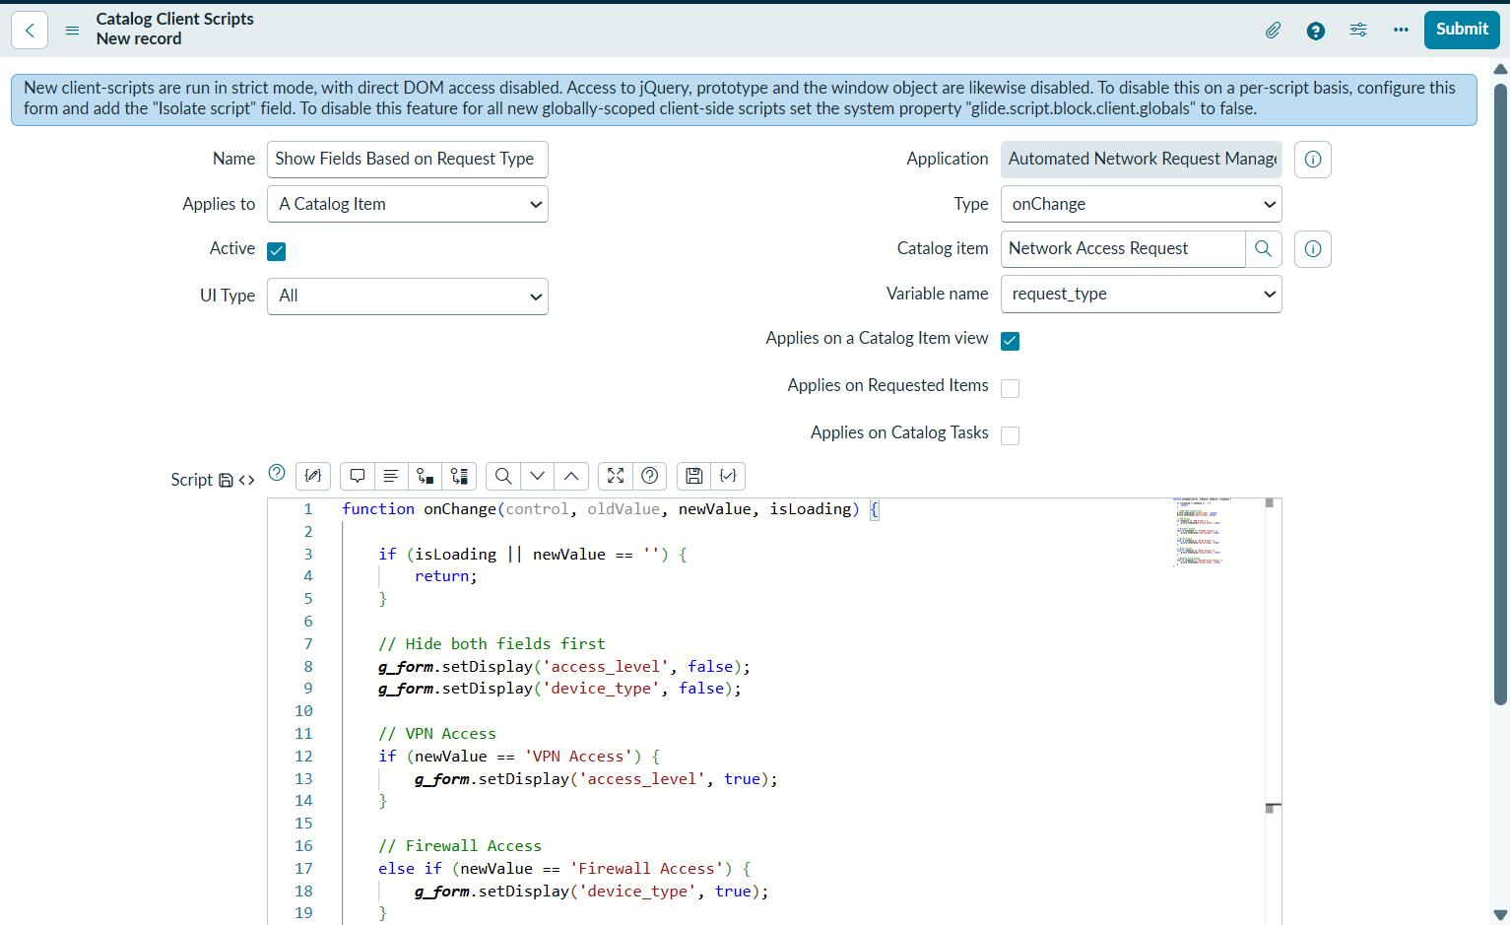
Figure 6.1 – Catalog Client Script Configuration

Figure 6.2 – Dynamic Field Display
Verified that the client script displays only the relevant fields according to the selected request type.
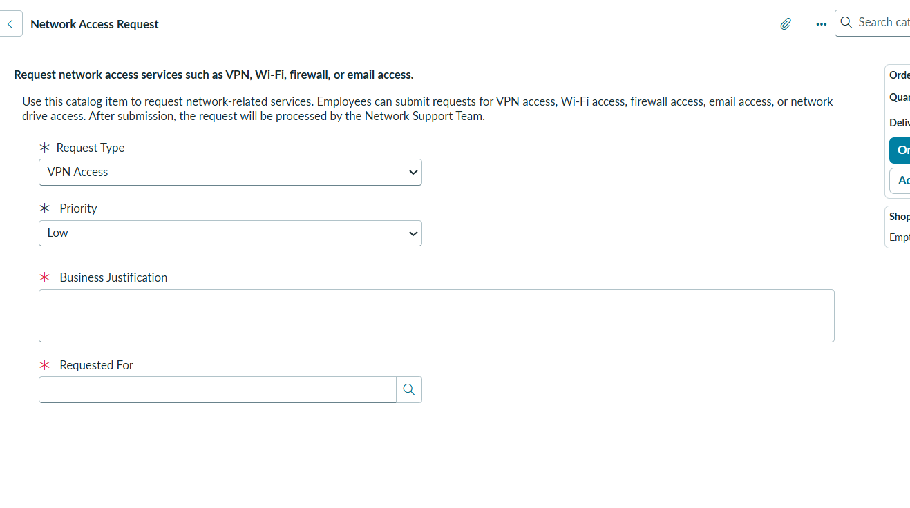
Figure 6.2 – Dynamic Field Display

Figure 6.3 – Start Work UI Action
Created the Start Work UI Action to update the request status from New to In Progress.
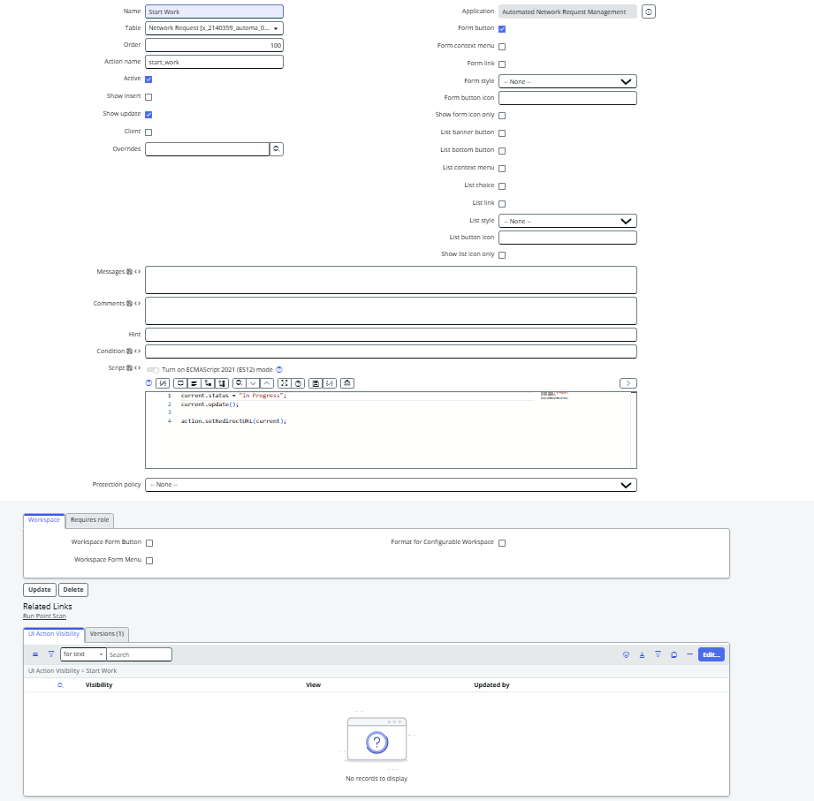
Figure 6.3 – Start Work UI Action

Figure 6.4 – Complete Request UI Action
Created the Complete Request UI Action to update the request status from In Progress to Completed.
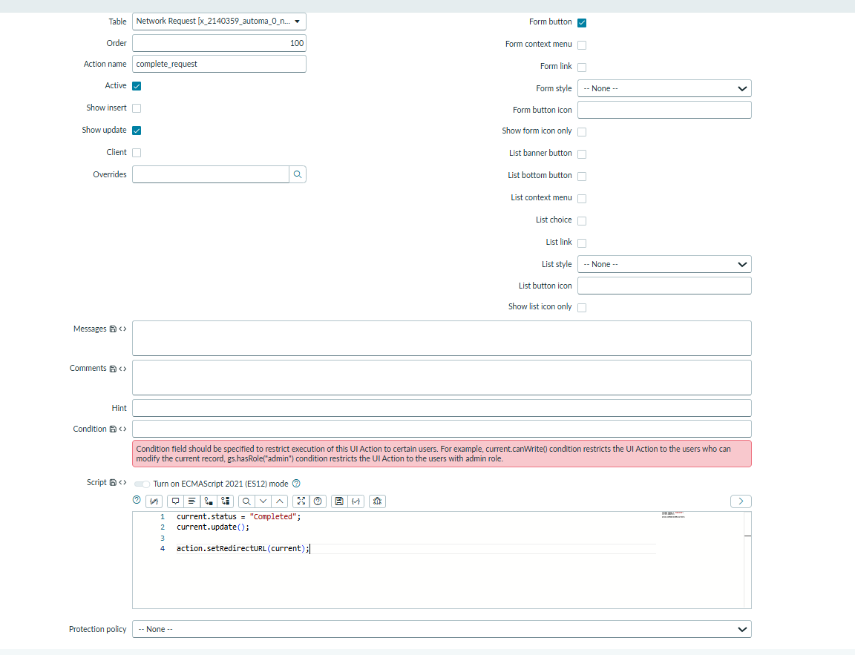
Figure 6.4 – Complete Request UI Action

Figure 6.5 – Status Lifecycle
Validated the request lifecycle by updating request statuses successfully.
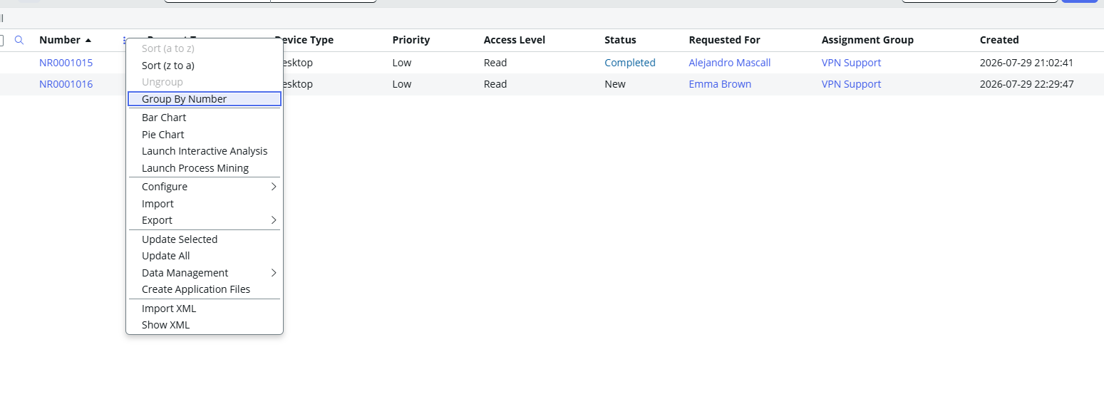
Figure 6.5 – Status Lifecycle

Figure 6.6 – Network Requests by Status Report
Created a pie chart report showing the distribution of requests by status.
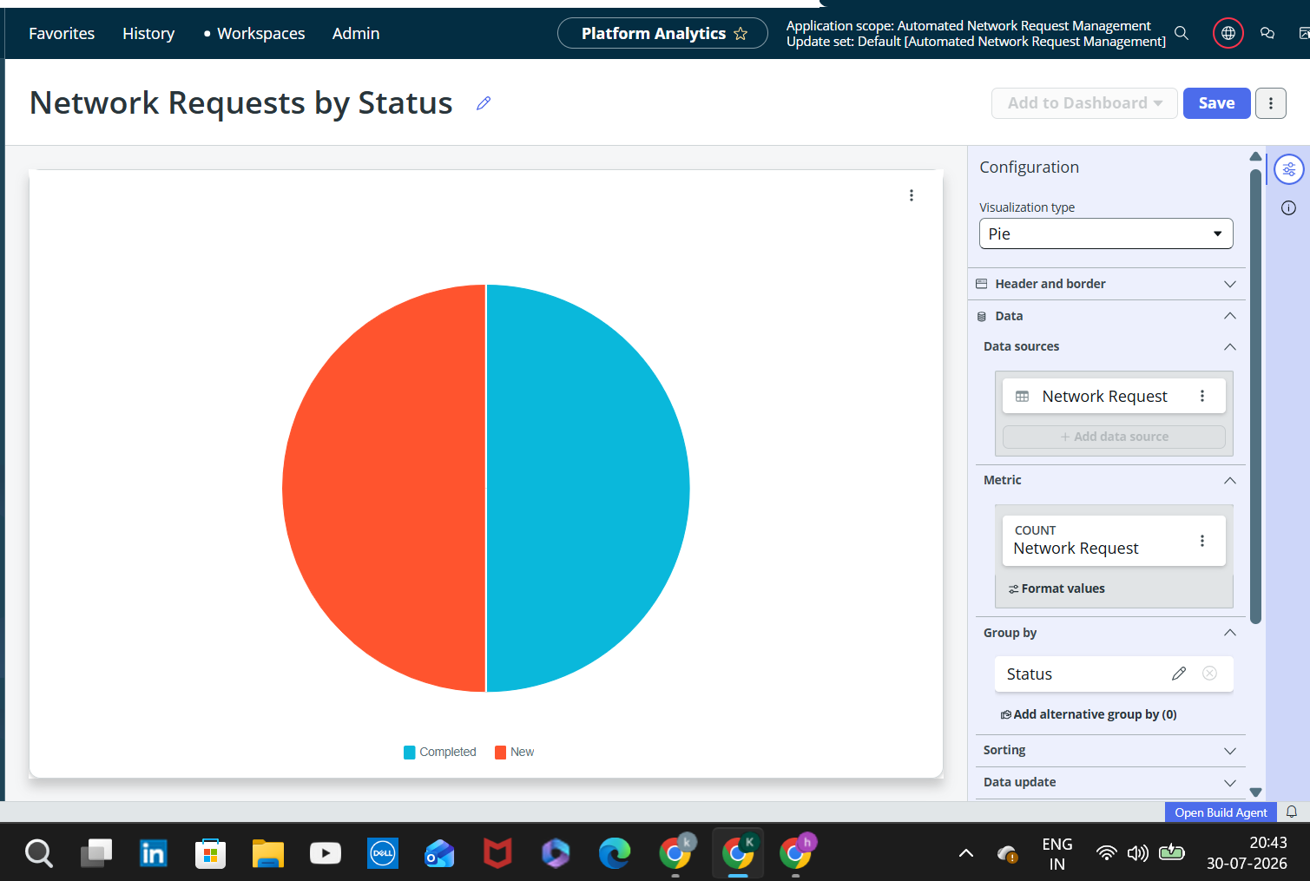
Figure 6.6 – Network Requests by Status Report

Figure 6.7 – Network Requests by Assignment Group Report
Created a vertical bar chart report showing requests by assignment group.
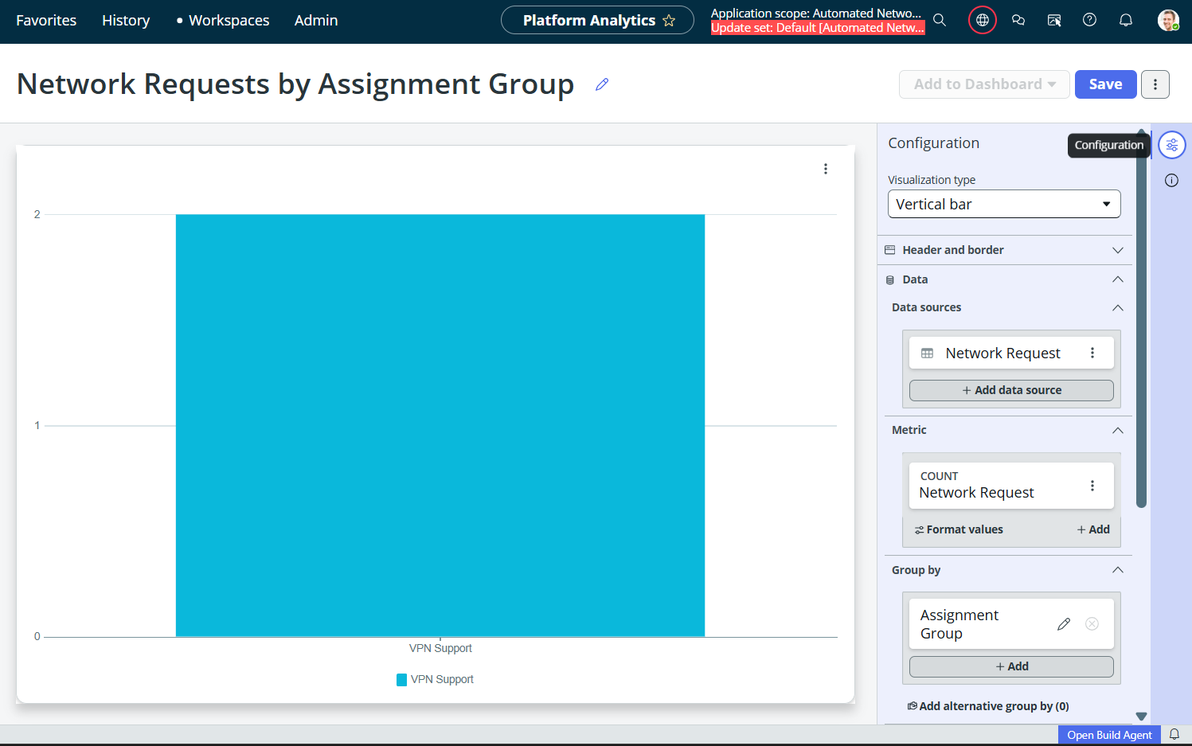
Figure 6.7 – Network Requests by Assignment Group Report

Figure 6.8 – Network Requests by Priority Report
Created a vertical bar chart report showing requests by priority.
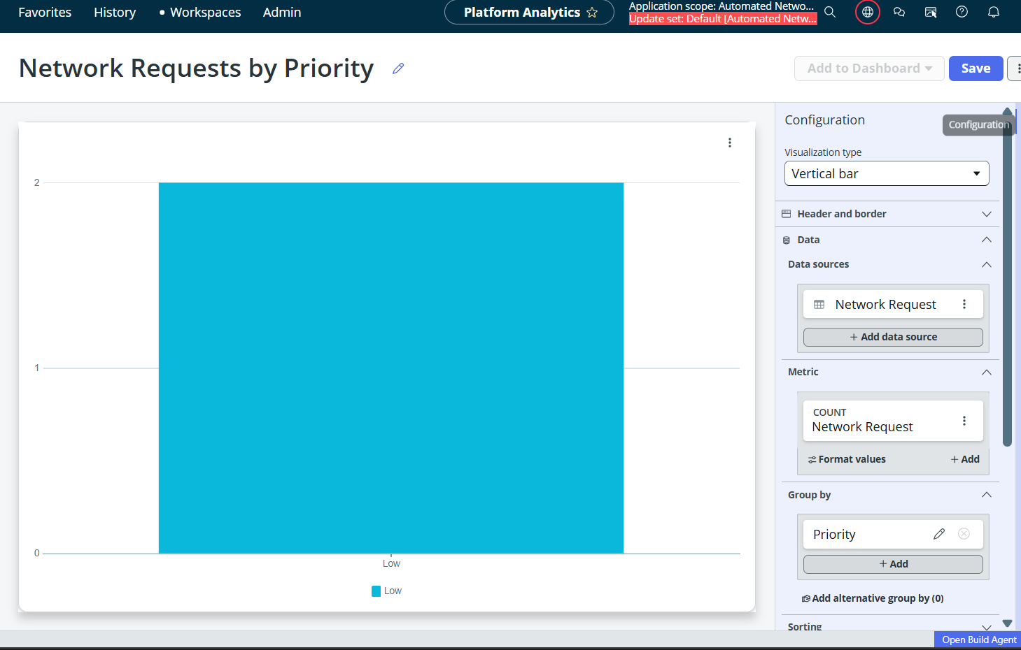
Figure 6.8 – Network Requests by Priority Report

Figure 6.9 – Dashboard
Built an interactive dashboard containing all created reports.
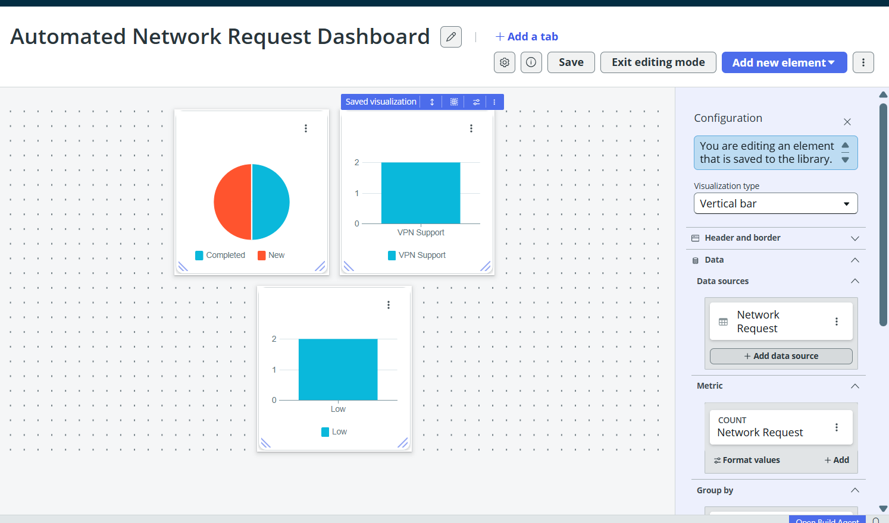
Figure 6.9 – Dashboard

Conclusion
Day 6 completed the client-side enhancements, request status lifecycle, reporting, and dashboard visualization, providing a complete monitoring interface for the Automated Network Request Management application.

