Day 4 – Automatic Request Assignment
Objective: Configure automatic routing of network access requests to the appropriate support teams using Flow Designer, assignment groups, and users.

4.1 Creating Assignment Group
Created the Network Support assignment group used to automatically route general network-related requests.
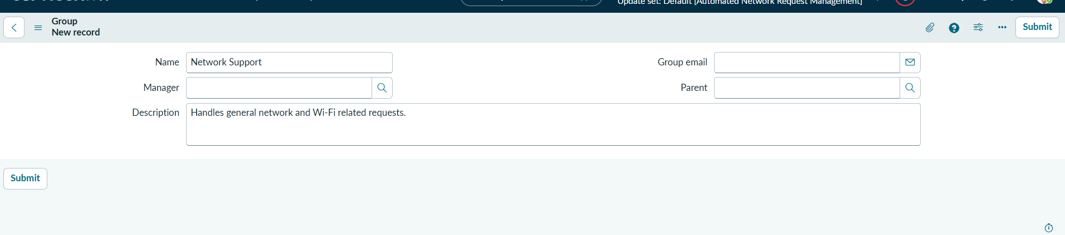

4.2 Creating User
Created an IT support user who will manage assigned requests.
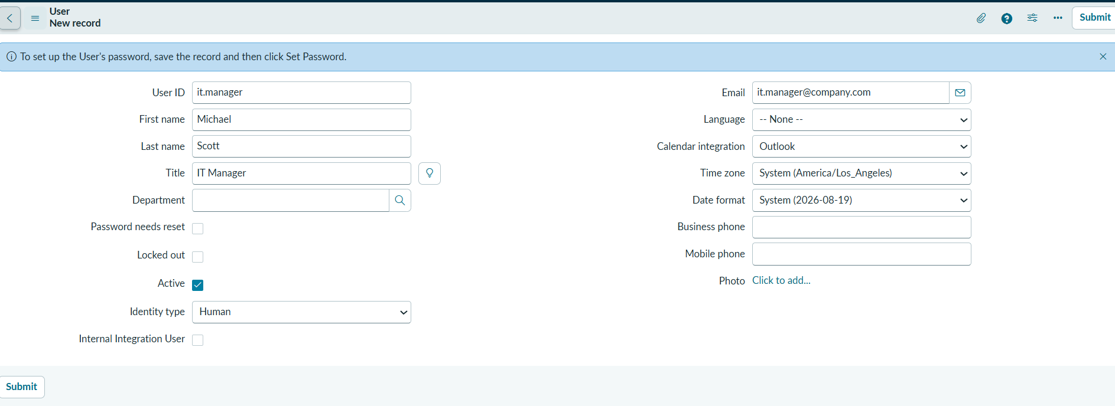

4.3 User Group Assignment
Assigned users to their respective assignment groups.
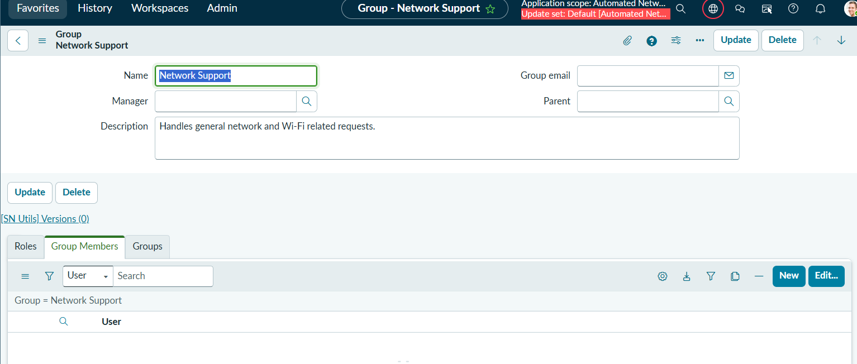

4.4 Flow Designer Routing
Configured the complete routing flow.
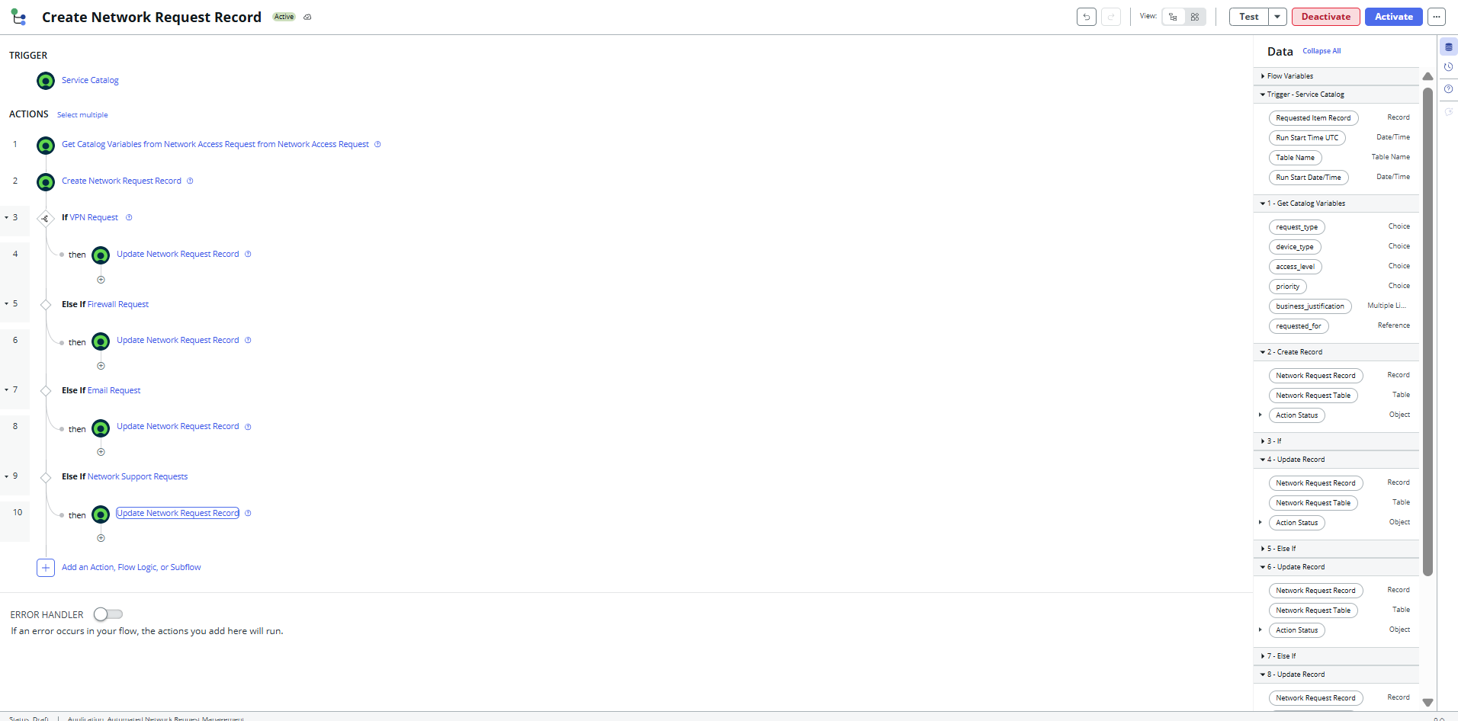

4.5 Routing Logic
Implemented IF / ELSE IF logic for request type routing.
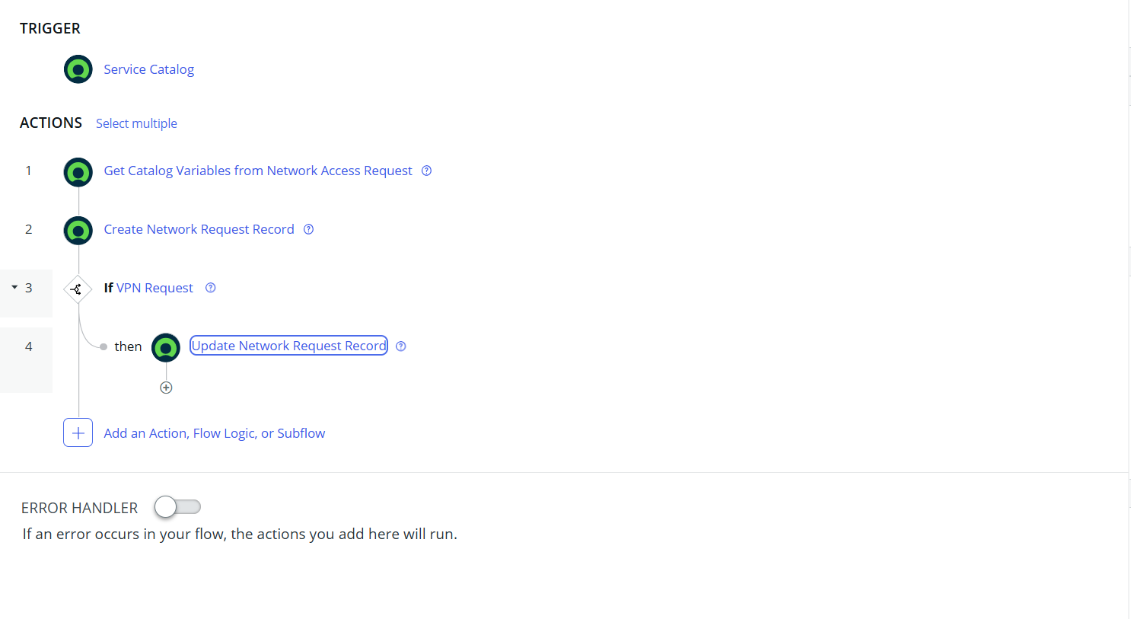

4.6 Update Record Action
Updated the Assignment Group field of the Network Request record.
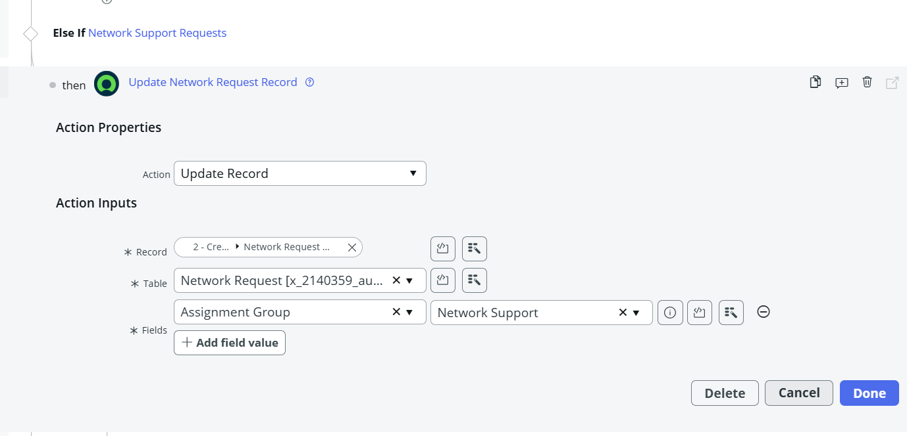

4.7 Testing Result
Verified successful request submission and automatic assignment.
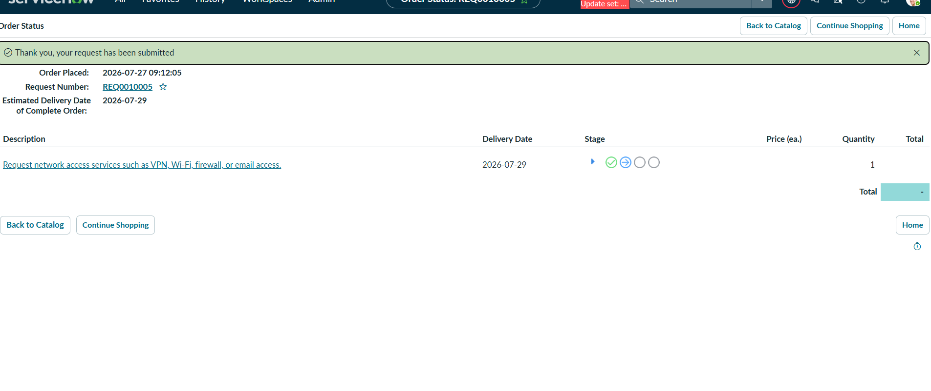

Conclusion
Day 4 implementation was completed successfully. Requests are automatically routed to the appropriate assignment group based on the selected request type, improving efficiency and reducing manual assignment.

