AUTOMATED NETWORK REQUEST MANAGEMENT
Day 2 Documentation

1. DAY 2 OBJECTIVE
The objective of Day 2 was to design the complete data model and user interface for the Network Request table. This included creating business fields, configuring choice values, establishing reference relationships, designing a user-friendly form, customizing the list view, and testing record creation.

2. FIELD CREATION
The following business fields were created:
Field Name | Type
Request Type | Choice
Device Type | Choice
Priority | Choice
Access Level | Choice
Business Justification | HTML
Assignment Group | Reference (Group)
Requested For | Reference (User)
Requested By | Reference (User)
Assigned To | Reference (User)
Status | Choice
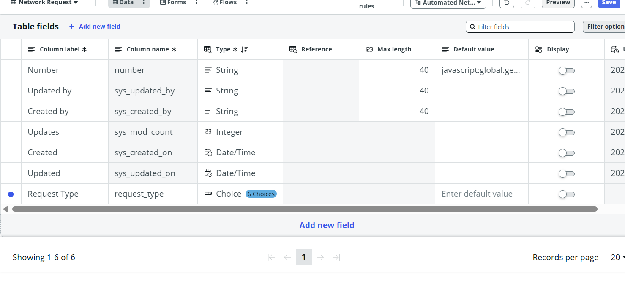
3. CHOICE FIELD CONFIGURATION
Configured predefined choice values for Request Type, Device Type, Priority, Access Level, and Status to ensure consistent data entry and improve reporting.

4. REFERENCE FIELD CONFIGURATION
Configured Assignment Group, Requested For, Requested By, and Assigned To as reference fields linked to the Group and User tables.
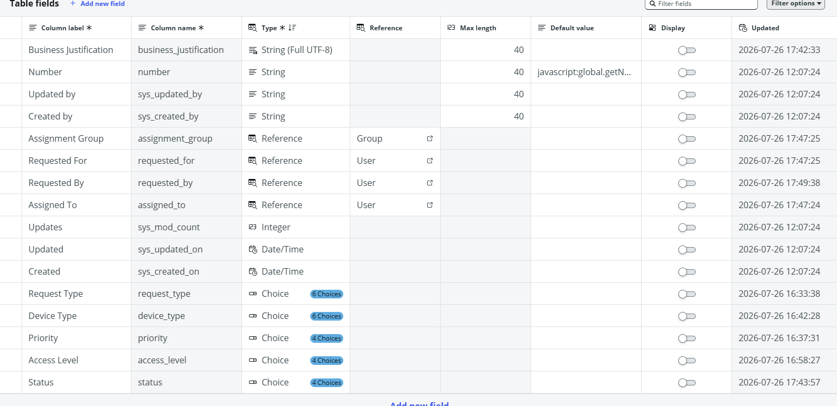

5. FORM DESIGN
The Network Request form was customized using Form Designer. It contains two sections: 'Network Request' and 'Network Request Details'. A two-column layout was used. The left column contains Request Type, Device Type, and Access Level. The right column contains Priority and Business Justification.
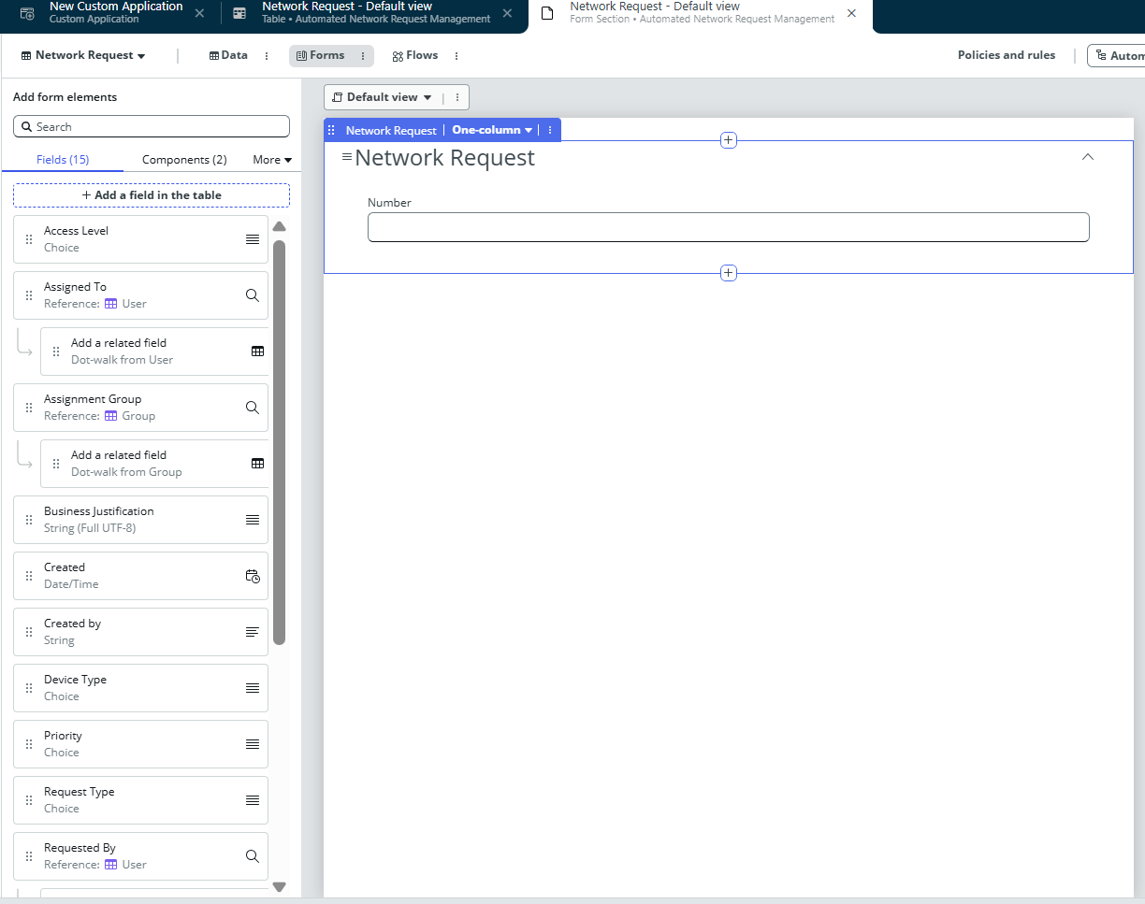

6. LIST VIEW CONFIGURATION
The list view was customized to display Number, Request Type, Device Type, Priority, Access Level, Status, Requested For, Assignment Group, and Created.

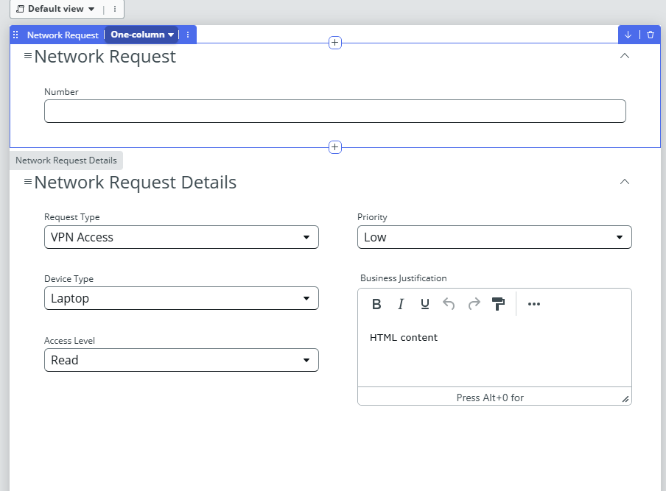
7. LIST LAYOUT CONFIGURATION
The Configure List Layout feature was used to arrange the displayed columns and remove unnecessary system fields.
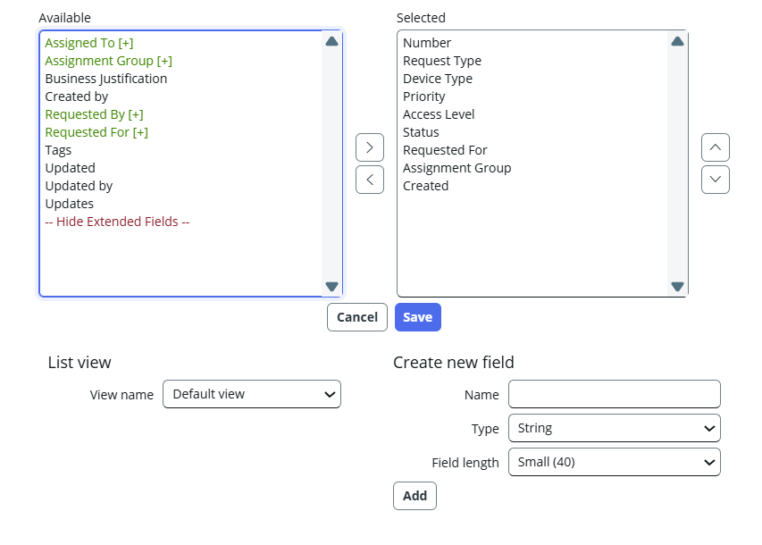

8. RECORD TESTING
A sample Network Request record was created successfully to verify automatic number generation, choice fields, HTML field functionality, record creation, and customized list display.
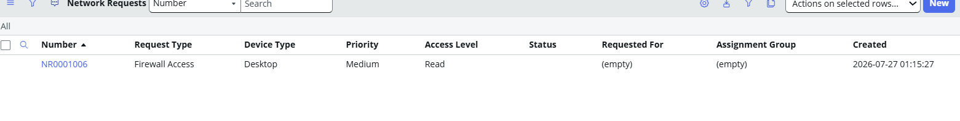

9. CONCEPTS LEARNED
Concept | Status
Table Fields | Completed
Choice Fields | Completed
Reference Fields | Completed
HTML Fields | Completed
Form Designer | Completed
Form Sections | Completed
Two-Column Layout | Completed
List View | Completed
Configure List Layout | Completed
Record Creation | Completed
Data Modeling | Completed

10. DAY 2 CONCLUSION
Day 2 focused on building the data model and user interface for the Automated Network Request Management application. Business fields were created, the form and list view were customized, and sample records were successfully tested. This foundation prepares the application for implementing workflows, approvals, notifications, reports, dashboards, and other advanced ServiceNow features in the upcoming phases.

