Day 3 Documentation – Flow Designer Automation
Objective: Automate the Network Access Request process using Flow Designer. When a user submits the catalog item, the flow reads the submitted values and creates a record in the custom Network Request table.

Step 1: Create Flow
Description: Created a Flow named 'Create Network Request Record' using the Service Catalog trigger.
Why: The trigger starts the flow automatically when the catalog item is submitted.
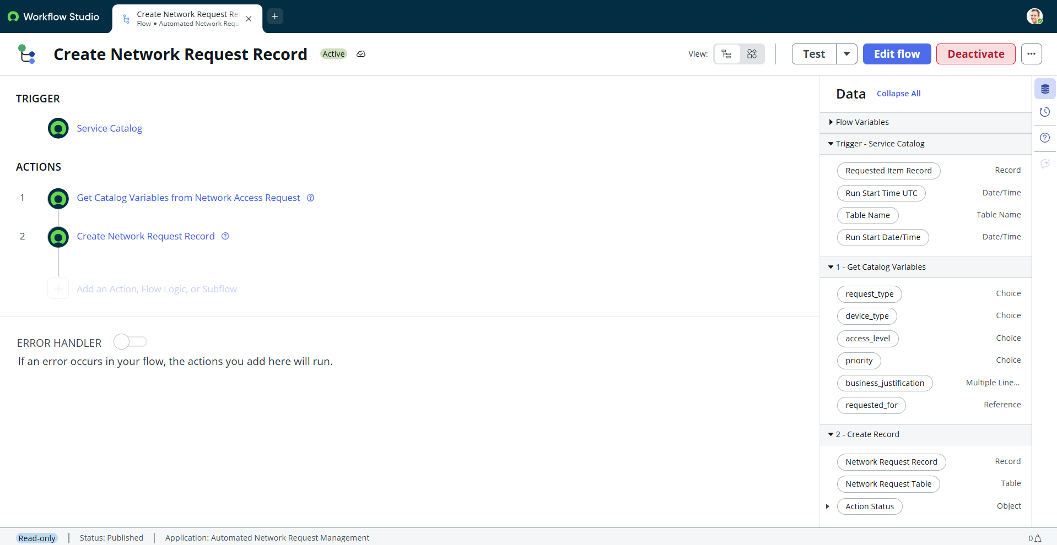

Step 2: Configure Service Catalog Trigger
Description: Configured the trigger as Service Catalog.
Why: It is the starting point of the automation.
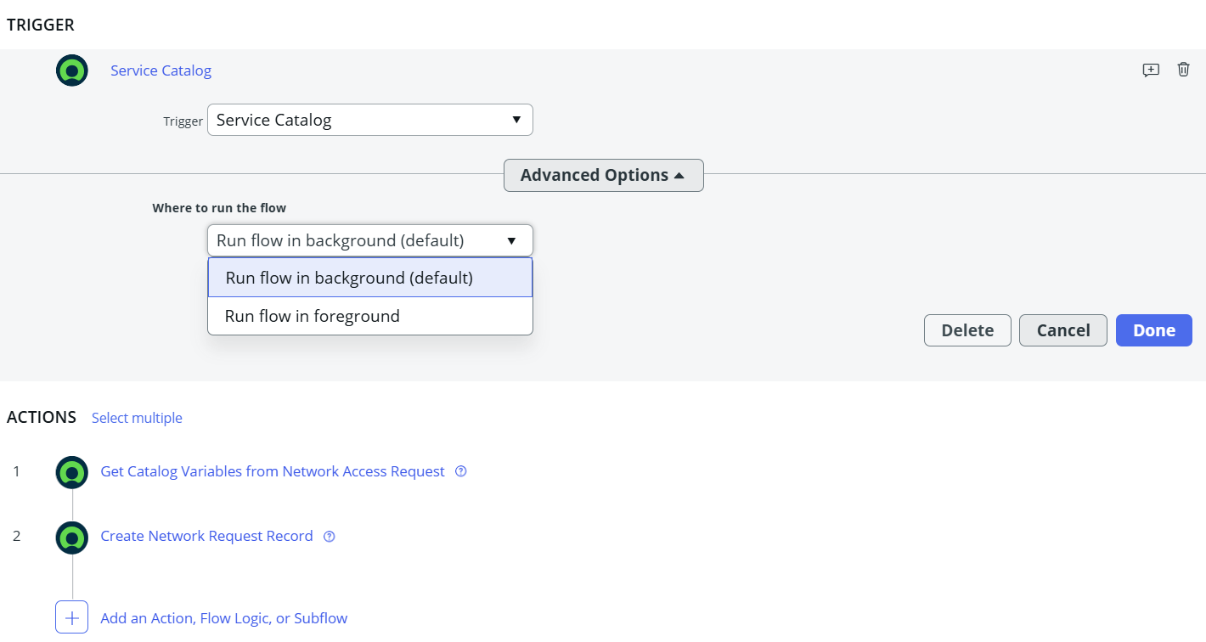

Step 3: Get Catalog Variables
Description: Added Get Catalog Variables to read Request Type, Device Type, Access Level, Priority, Business Justification and Requested For.
Why: The flow needs these user-entered values before creating a record.
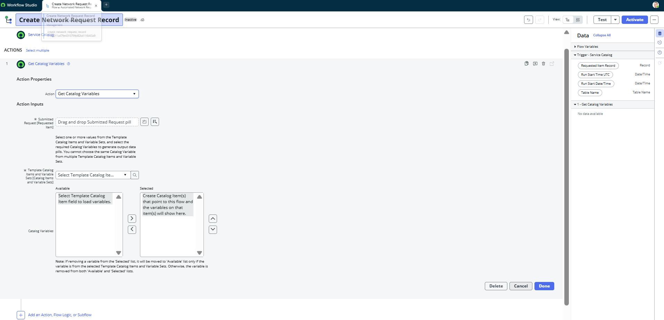

Step 4: Create Record
Description: Added Create Record and selected the custom Network Request table.
Why: Creates a new record for every submitted request.
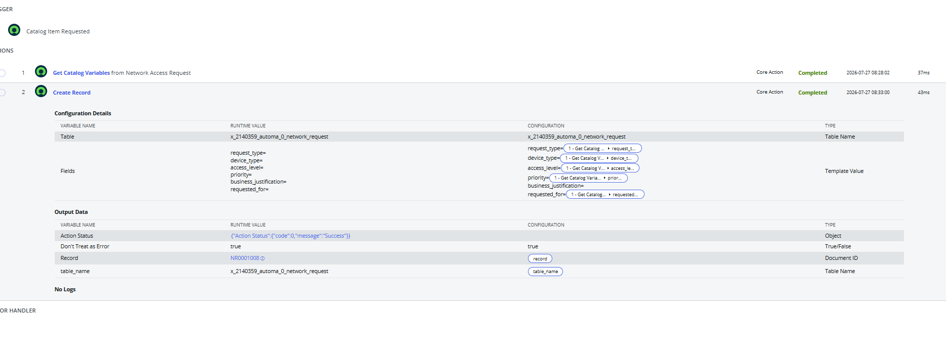

Step 5: Map Variables
Description: Mapped each catalog variable to the matching table field.
Why: Ensures the correct values are stored in the correct fields.
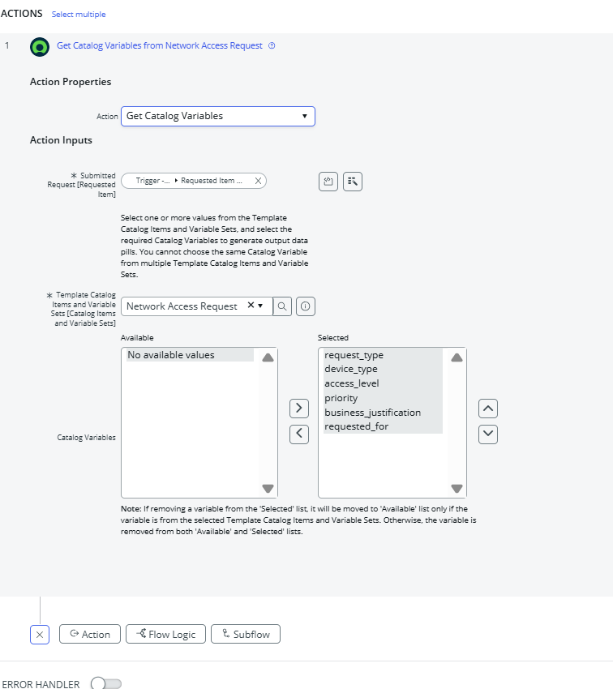

Step 6: Activate Flow
Description: Activated the flow.
Why: Only activated flows run automatically.
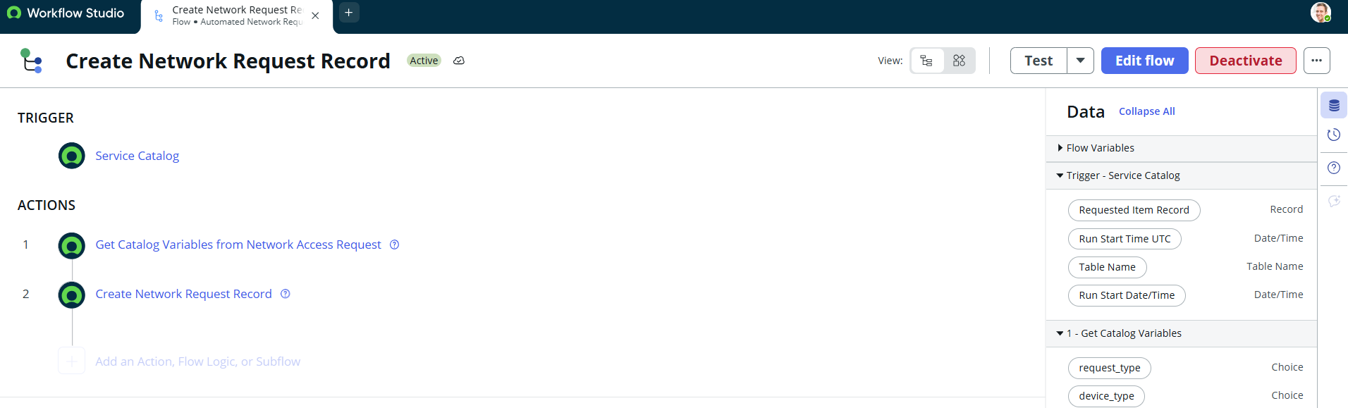

Step 7: Link Flow to Catalog Item
Description: Configured Process Engine: Flow = Create Network Request Record, Workflow = Empty, Execution Plan = Empty.
Why: Connects the catalog item to the flow.
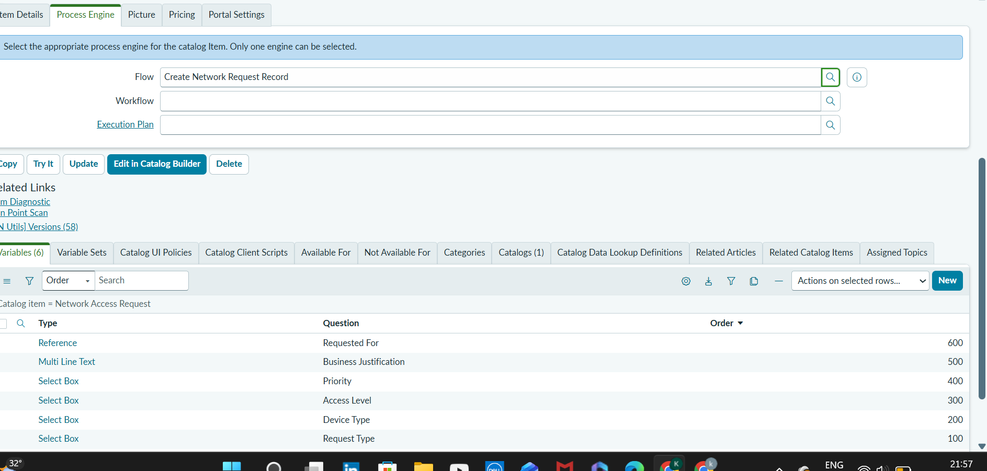

Step 8: Test Catalog Item
Description: Filled and submitted the Network Access Request form.
Why: Verifies the form accepts user input.
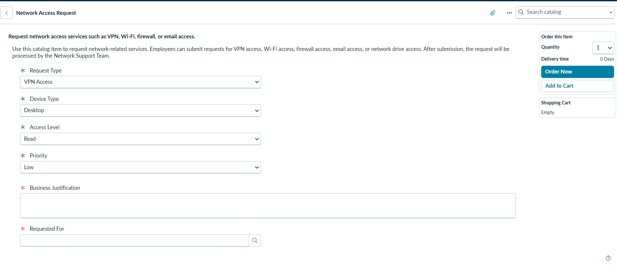

Step 9: Submit Request
Description: Submitted the request and generated a REQ.
Why: Confirms successful request submission.
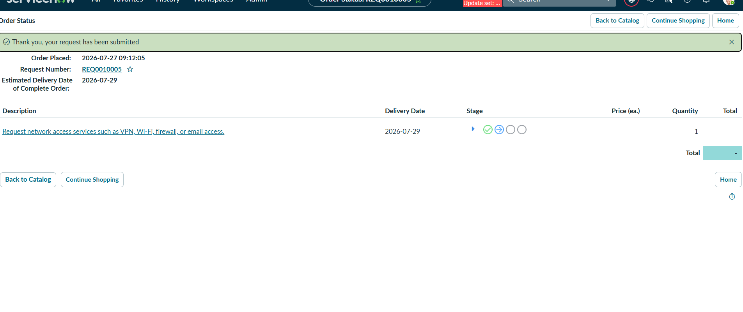

Step 10: Verify RITM
Description: Verified the Requested Item (RITM) and variables.
Why: Confirms request data is stored correctly.
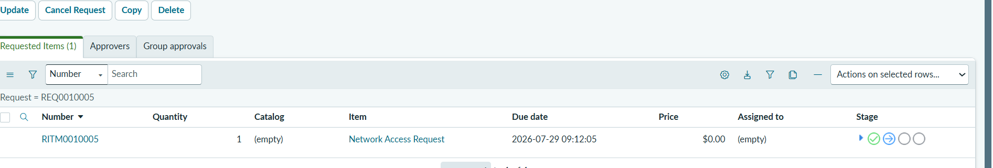

Step 11: Verify Network Request Record
Description: Verified a new record was created in the custom table.
Why: Confirms the flow created the record.
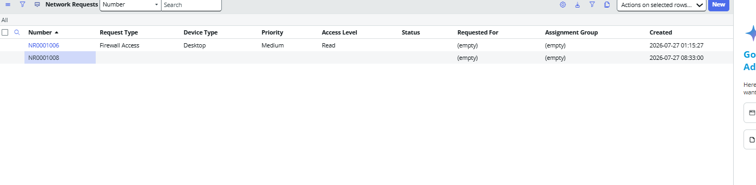

Step 12: Debug Validation
Description: Validated Trigger, Get Catalog Variables and Create Record using Debug.
Why: Ensures the flow executes correctly.
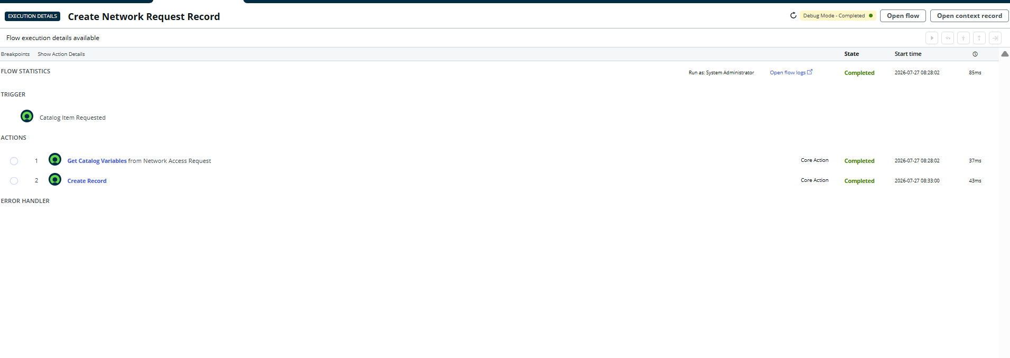

Workflow
User Opens Service Catalog
↓
Network Access Request
↓
User Fills Variables
↓
Clicks Order Now
↓
Service Catalog Trigger
↓
Get Catalog Variables
↓
Create Record
↓
Network Request Table

Learning Outcomes
- Flow Designer
- Service Catalog Trigger
- Get Catalog Variables
- Create Record Action
- Field Mapping
- Flow Activation
- Process Engine Configuration
- Flow Debugging
- Catalog Item Automation

Result
The Network Access Request process was successfully automated. The flow reads the submitted catalog variables and creates a new record in the custom Network Request table.

