Day 5 – Automated Network Request Management

Objective
Configure status mapping and email notifications for the Network Request application.

Figure 5.1 – Flow Designer: Status Field Mapping
Configured the Create Record action to map Service Catalog variables into the Network Request table and initialized the Status field as New.
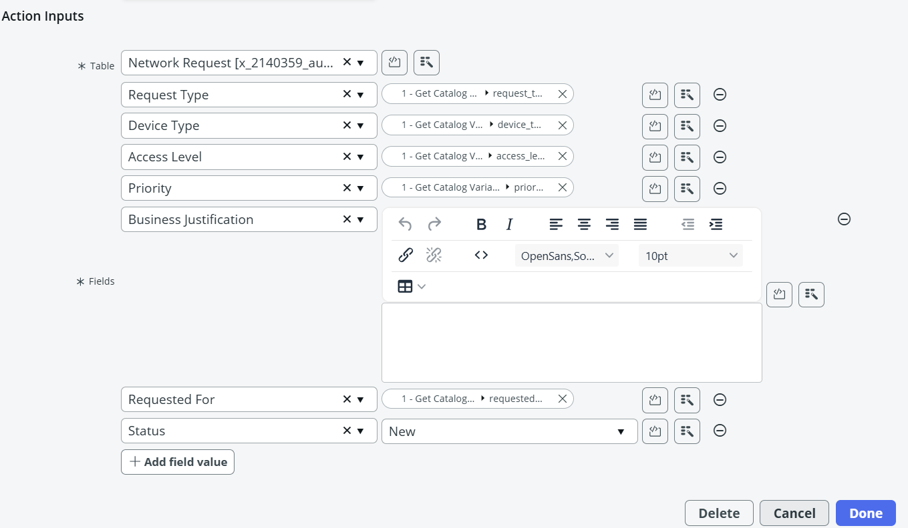

Figure 5.2 – Email Notification Configuration
Created and activated the Network Request Submitted notification for the Network Request table.
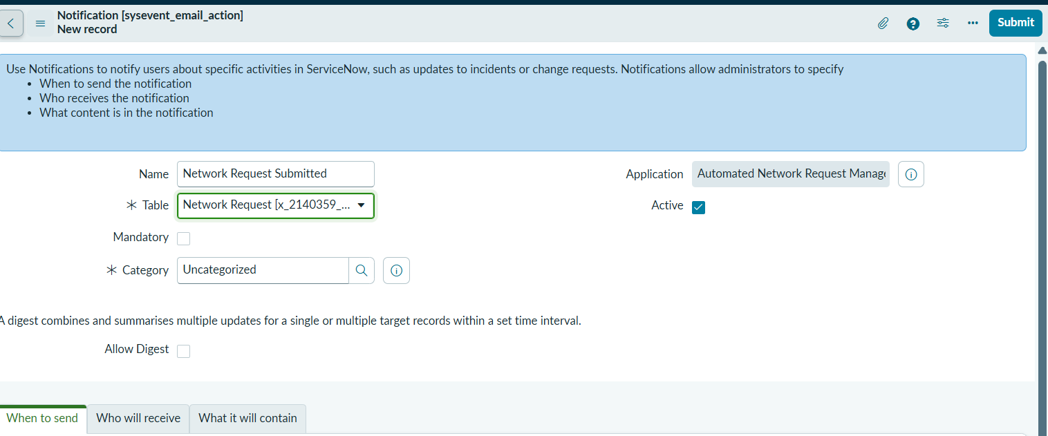

Figure 5.3 – Notification Trigger Configuration
Configured the notification to trigger when a Network Request record is inserted.
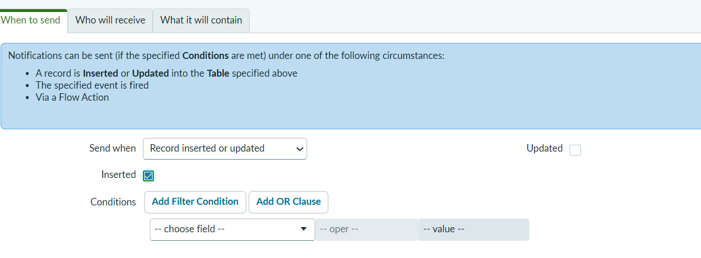

Figure 5.4 – Notification Recipient Configuration
Configured Requested For as the recipient using Users/Groups in Fields.
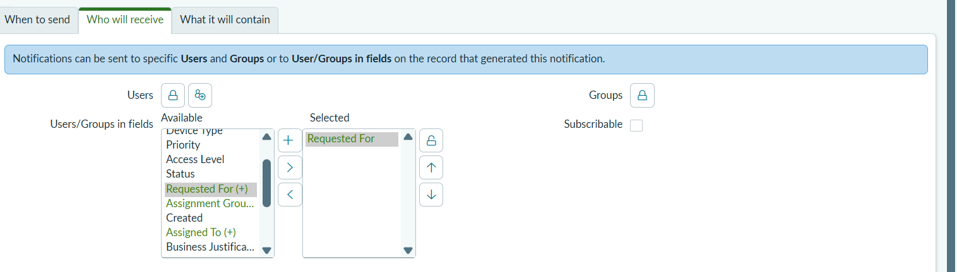

Figure 5.5 – Email Message Template
Designed the notification subject and HTML message displayed to the requester.
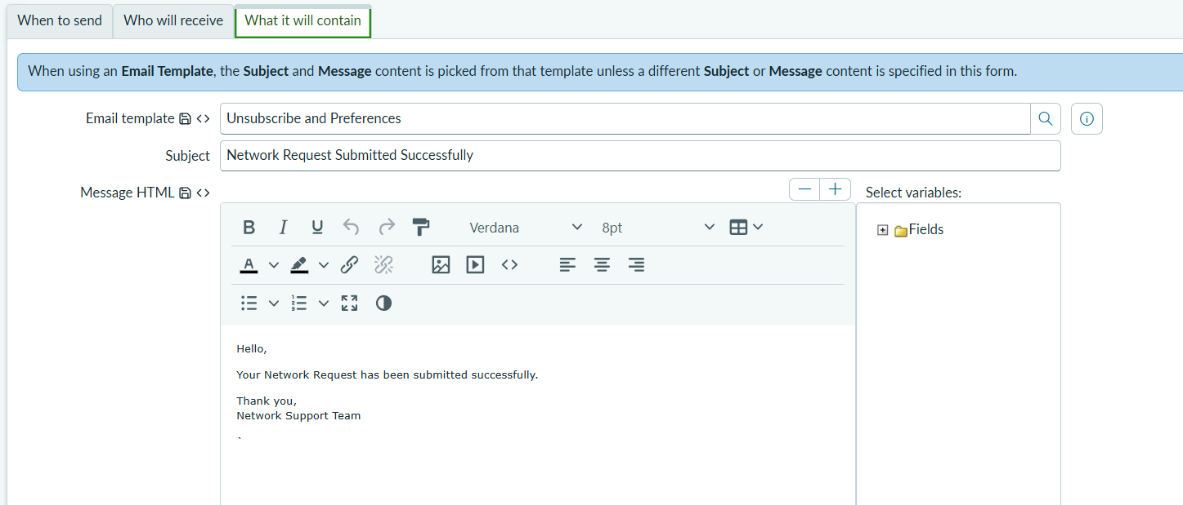

Figure 5.6 – Email Sending Configuration
Verified that outbound email sending is disabled in the development instance.
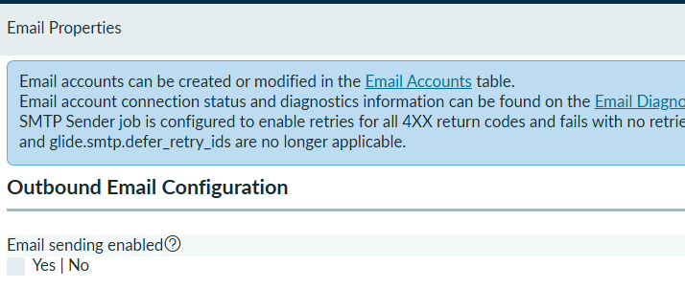

Conclusion
Day 5 configuration was completed successfully. Email notifications were configured, but actual email delivery could not be tested because outbound email is disabled in the ServiceNow developer instance.

