**CHAPTER 1: INTRODUCTION**

**1.1 Objective of the Project**

Water is the essence of life, and staying hydrated is critical for maintaining good health. In today’s fast-paced world, people are constantly on the move — whether commuting to work, engaging in outdoor activities, traveling long distances, or simply running errands in hot weather. One of the most common challenges encountered during such scenarios is the lack of access to cool drinking water. While reusable water bottles have become a part of modern lifestyle, most of them fail to maintain a desirable temperature, especially in the absence of electricity or refrigeration.

Traditional methods of refrigeration rely heavily on electricity, batteries, or mechanical systems that are not only energy-intensive but also environmentally unsustainable. Furthermore, during outdoor activities or in rural regions with unstable electricity, these solutions become impractical. Most smart bottles available today are packed with features like UV sterilizers and hydration trackers, but they require regular charging and remain inaccessible to a large segment of consumers due to high costs.

This pressing need led to the inception of **CoolQuench**, a self-cooling water bottle designed to operate independently of any electrical power source. The aim of this project is to create a **portable, sustainable, and efficient solution for cooling water on the go** using natural principles such as **evaporative cooling** and **thermal gel insulation**. The innovation draws from both traditional wisdom and cutting-edge materials science to meet the hydration needs of a wide audience ranging from athletes and commuters to outdoor enthusiasts and rural users.

The key objectives of this project include:

* **Providing real-time cooling** of water without any dependency on electricity, batteries, or external devices.
* **Developing a user-friendly design** that is easy to use, refill, clean, and maintain.
* **Employing sustainable materials** and design principles that reduce environmental impact.
* **Offering affordability and accessibility** to a broader demographic, bridging the gap left by expensive smart hydration solutions.
* **Ensuring reliability and durability**, even in harsh outdoor or travel conditions.
* **Electricity-independent**: No need for power outlets or batteries.
* **Portable and travel-friendly**: Ideal for treks, travel, sports, and outdoor use.
* **Eco-conscious**: Built from sustainable and recyclable materials.
* **Affordable and effective**: A viable alternative to expensive smart bottles that underperform.

CoolQuench is more than just a water bottle — it is a reimagining of sustainable hydration in the modern era. The idea not only solves an existing consumer pain point but also contributes toward the greater vision of a greener and more energy-efficient lifestyle.

**CHAPTER 2: INDUSTRY OVERVIEW**

**2.1 Brief Description of the Industry**

The reusable water bottle industry is witnessing unprecedented growth as global awareness about environmental issues continues to rise. Consumers are rapidly shifting away from single-use plastic bottles and are embracing reusable, eco-friendly, and multifunctional hydration solutions. This transformation is fueled by sustainability campaigns, plastic ban regulations, and the overall trend toward greener lifestyles.

According to market research, the global reusable water bottle market was valued at around $9.8 billion in 2023 and is projected to reach $12.7 billion (₹1,05,000 crore) by the year 2030. The market is being driven by consumers’ increasing focus on health, convenience, and environmental responsibility. Urban populations, health enthusiasts, and outdoor adventurers are especially contributing to this demand.

The industry encompasses a wide range of products, including standard reusable plastic and metal bottles, insulated flasks, smart bottles with tracking sensors, and now, innovative passive cooling bottles such as CoolQuench. Major market players include CamelBak, Thermos, Nalgene, S'well, and newer entries offering app-connected hydration.

CoolQuench enters the industry at an inflection point, where green technology, minimalism, and affordability intersect. As a product that bridges traditional passive cooling wisdom with modern sustainable design, it aligns perfectly with this global evolution of hydration tools.

The industry is now populated with a range of bottle types:

* **Standard reusable bottles** (plastic, steel, glass)
* **Insulated flasks** (to retain hot/cold temperatures)
* **Smart bottles** (with sensors, UV purification, Bluetooth, etc.)
* **Eco-design bottles** (bamboo, biodegradable plastics)

Major companies operating in this space include **Hydro Flask, CamelBak, Nalgene, S'well, and Thermos**, as well as tech-integrated brands like **Hidrate Spark** and **LARQ**.

CoolQuench is positioned as a **first-of-its-kind passive cooling bottle**, entering the market as a green-tech innovation. It serves a growing consumer segment that desires low-tech, sustainable, and practical solutions.

**2.2 Current Trends and Challenges**

**Emerging Trends:**

1. **Smart Hydration Products**: Consumers are increasingly adopting bottles that track water intake, sync with fitness apps, or even self-clean. However, these often depend on electronics, making them vulnerable in outdoor or low-power environments.
2. **Eco-Conscious Design**: The push toward biodegradable and recyclable materials is stronger than ever. CoolQuench supports this trend with materials like bamboo composites, aluminum alloys, and non-toxic hydrogels.
3. **Compact and Lightweight Designs**: Portability is a key purchasing factor. Ergonomic and lightweight bottles are preferred over bulky insulated options.
4. **Multi-Functionality**: Bottles that combine hydration with technology — such as temperature monitoring, sterilization, or cooling — are being favored. CoolQuench aligns with this trend through its non-electric cooling and optional UV cap in the Pro version.
5. **Minimalism and Portability**: Sleek, ergonomic designs that prioritize convenience and portability dominate product design in the hydration sector. CoolQuench is engineered with layered construction for compact efficiency and modern aesthetic appeal.
6. **Health and Wellness Focus:** As part of the broader wellness movement, hydration products are increasingly marketed to athletes, fitness enthusiasts, and health-conscious users. CoolQuench’s Pro version, with faster cooling and potential for hydration tracking, fits perfectly in this segment.
7. **Sustainability and Eco-Friendly Design**: Consumers now prefer bottles made from recyclable, BPA-free, or biodegradable materials. Bamboo composites, stainless steel, and eco-plastics are widely adopted. CoolQuench supports this trend by using eco-friendly materials and zero-power operation.

**Key Challenges:**

1. **Overpriced Smart Bottles**: Many high-end bottles are beyond the reach of average consumers. With a starting price around ₹4,000–₹6,000, they fail to address the affordability factor for the mass market.
2. **Dependence on Batteries**: Constant charging needs make smart bottles impractical during travel or emergencies. This makes them unsuitable for rural markets and long treks.
3. **Lack of Real Cooling**: Despite the high price and smart tags, most bottles do not offer genuine cooling features. CoolQuench fills this void with a nature-powered cooling approach.
4. **Environmental Impact**: Bottles with embedded electronics contribute to e-waste. In contrast, CoolQuench's non-electrical design aligns with long-term sustainability.

By leveraging current market shifts and addressing persistent product pain points, CoolQuench has the potential to define a new subcategory in the hydration industry: intelligent cooling bottles without electricity.

CoolQuench enters the scene at the intersection of these trends and challenges, bringing forth a hydration solution that is **intelligent by design rather than circuitry**.

**CHAPTER 3: PROBLEM IDENTIFICATION**

**3.1 Gap Analysis**

The hydration product market, despite its rapid growth and technological integration, still lacks a viable solution to a fundamental consumer problem: access to cool drinking water without the dependency on electricity or external cooling mechanisms. A closer inspection of existing solutions reveals several key gaps that CoolQuench aims to fill.

Despite significant progress in hydration product design, current market offerings fail to solve key real-world issues related to drinking water temperature and energy dependence. The following gaps highlight areas where consumer needs are inadequately addressed:

**1. No Real-Time Cooling in Existing Bottles:**

Most so-called smart bottles are equipped with sensors and reminders but do not actually cool the water. Users still rely on refrigerated water or ice to enjoy cold drinks. In hot climates, this becomes an inconvenience. CoolQuench introduces real-time cooling without power.Smart bottles often boast features like UV sterilization, temperature tracking, and hydration reminders. However, they fail to offer one of the most desirable functions — real-time cooling. Current solutions depend on either ice, refrigeration, or advanced electronic cooling systems that are impractical for daily or outdoor use.CoolQuench bridges this gap by offering an electricity-free, on-the-go cooling system, using passive evaporative cooling methods that work naturally in any environment.

**2. Inconvenient Charging Requirements:**

Bottles with UV lights or display systems require frequent charging. For people constantly outdoors or in rural areas, this dependency becomes a significant drawback. The lack of power should not mean a lack of performance — CoolQuench answers that call.CoolQuench, by contrast, relies on a completely passive system that needs no charging, no power input, and no battery maintenance. This makes it uniquely suited for real-world use, particularly in areas where electricity access is inconsistent.

**3. Poor Affordability and Fragility:**

Smart hydration systems are costly, sometimes fragile, and not ideal for rough or daily use. CoolQuench is budget-friendly, robust, and built for real-world application — from city commutes to mountain hikes.Advanced hydration solutions often come with high price tags. With smart features and electronic components, these bottles cater mostly to high-income consumers, leaving a large segment of the population underserved. The majority of daily users still rely on basic bottles that lack any advanced utility.CoolQuench offers two variants: a Basic version that is both affordable and effective, and a Pro version for premium consumers. This dual-model approach ensures broad market penetration and inclusivity, serving both rural and urban users.

**4. Non-Adaptability to Outdoor Conditions:**

Electronic systems malfunction in dust, heat, and rough usage. By contrast, CoolQuench’s evaporative system thrives in such scenarios, cooling more effectively in heat and open-air environments.Outdoor enthusiasts, hikers, trekkers, and travelers often require hydration solutions that are durable, low-maintenance, and highly functional. Electronic smart bottles fall short due to fragility, charging issues, and high cost. CoolQuench’s robust, modular, and ergonomic design offers travel-readiness, making it a perfect fit for adventurous lifestyles.

**3.2 Pain Points in the Current Scenario**

During the user research phase, feedback was gathered from over 100 individuals across various demographics. The findings shaped the final product design and clarified key pain points:

* **“My water is always hot when I travel.”** Heat-affected regions, especially in India, create demand for bottles that maintain lower water temperatures without refrigeration.This was the most recurring feedback among travelers and commuters. In regions with hot climates and poor access to refrigeration, traditional bottles fail to maintain cool water. CoolQuench eliminates this concern with its self-cooling mechanism.
* **“Charging my bottle is annoying.”** Users disliked the idea of having yet another device to charge daily, especially for a function as basic as drinking water.This sentiment highlights the mismatch between user expectations and existing smart bottles. Charging a bottle daily, like a smartphone, adds unnecessary complexity. CoolQuench responds by completely removing the dependency on electronics.
* **“Smart bottles are too expensive and delicate.”** Many users abandoned their smart bottles due to breakage or malfunction within months of use. CoolQuench provides longevity and resilience.The high price of most smart bottles, often upwards of ₹4,000, excludes a wide consumer base. Additionally, their fragility in real-world conditions (drops, impacts, exposure to sun or dust) makes them impractical for many users. CoolQuench’s simple, rugged, and eco-friendly construction makes it both affordable and reliable.
* **“I’d love something low-tech and effective.”** The demand is growing for functional products that don’t rely on apps, batteries, or frequent care. CoolQuench fits this desire perfectly. In many developing countries, power outages are frequent, affecting access to chilled water. CoolQuench functions independently of electricity, making it a resilient solution in such scenarios.
* **“I trek a lot. I need a cooling bottle that works anywhere.”** Trekkers and travelers often face dehydration in sun-exposed environments. CoolQuench offers an elegant solution with zero power needs.

By understanding these recurring issues, the CoolQuench team tailored their solution to address real frustrations faced by users, creating a bottle that is functional, durable, and environmentally sound.

**CHAPTER 4: IDEA GENERATION**

**4.1 Brainstorming and Ideation Process**

The innovation behind CoolQuench is not the result of a singular idea, but rather an evolution of concepts developed through collaborative brainstorming and continuous refinement. The team followed a structured innovation process that combined creativity with scientific inquiry to identify the most feasible and sustainable cooling mechanism for portable water bottles.

Initial brainstorming sessions revolved around the central question: **How can we cool water without using electricity?** The team explored diverse ideas, ranging from high-tech to nature-inspired solutions, including solar-powered systems, magnetic fields, and advanced cooling materials. Each concept was examined for feasibility, cost, environmental impact, and practicality in daily use.

The journey from problem to solution began with wide-ranging brainstorming sessions aimed at identifying all potential mechanisms for cooling water without electricity. The team leveraged idea boards, expert consultations, and academic research to generate and filter ideas.

The most promising ideas explored included:

1. Solar-powered cooling system
2. Magnetic fluid-based cooling
3. Phase-change materials (PCMs)
4. Evaporative cooling with absorbent gels

Key methods used in the ideation process included:

* Mind mapping and sketching various cooling mechanisms.
* SWOT analysis of each proposed solution.
* Benchmarking against existing products in the market.
* Consulting with faculty and conducting informal interviews with potential users.

The iterative ideation journey eventually led the team toward passive cooling systems, combining traditional wisdom with modern material science.

**4.2 Chosen Innovative Solution**

After examining feasibility, cost, and reliability, the idea of evaporative cooling combined with modern gel technology emerged as the most effective, sustainable, and scalable choice.

After rigorous evaluation, the team finalized on a **passive evaporative cooling mechanism enhanced with a thermal gel layer**. This decision was made due to several compelling reasons:

* **Energy Independence**: The system functions without electricity, batteries, or any form of external power.
* **Sustainability**: Inspired by traditional cooling methods like clay pots (matkas) and camel skin canteens, the solution promotes eco-consciousness.
* **Cost-Effectiveness**: Compared to high-tech smart bottles, this solution significantly reduces manufacturing and user costs.
* **Portability**: The design can be compact, lightweight, and user-friendly for travel, outdoor use, and everyday hydration.

CoolQuench integrates multiple layers of cooling innovation:

* **Inner Chamber**: Made from stainless steel or BPA-free plastic for safe water storage.
* **Cooling Layer**: Composed of clay, silica gel, or hydrogel that retains moisture for gradual evaporation.
* **Airflow Shell**: Designed with micro-vents to allow air to flow and promote efficient cooling.
* **Thermal Gel Layer**: Optional layer for Pro model that maintains the cool temperature for longer.

**Pro vs. Basic Version:**

* **Basic Model**: Affordable, requires ~20–30 minutes to cool, suitable for students and rural use.
* **Pro Model**: Premium version with faster cooling (~5–10 minutes), UV sterilization in the lid, and smart design.

**Final Cooling Strategy Breakdown:**

1. **Evaporative Cooling**:
   * Water in the outer layer evaporates when exposed to air, pulling heat away from the inner chamber.
   * Enhances cooling as the surrounding heat energy is used to fuel evaporation.
2. **Gel-Based Thermal Layer**:
   * A cooling gel or hydrogel layer adds insulation and maintains temperature for longer periods.
3. **Ventilated Outer Shell**:
   * Strategically designed vents allow controlled airflow to aid in evaporation.

The team developed both a **Basic Version** and a **Pro Version** of the bottle:

* **Basic Model**: Uses pure evaporative cooling, ideal for casual outdoor and rural usage. Cooling time: 20–30 minutes.
* **Pro Model**: Includes advanced thermal gels and optional UV cleaning features for tech-savvy or athletic users. Cooling time: 5–10 minutes.

**4.3 Design Thinking Approach Used**

The design thinking methodology was central to the development of CoolQuench. The team used a five-stage model to guide ideation:

**1. Empathize:**

The team conducted informal surveys and interviews to understand real user problems, such as hot water during travel, charging difficulties with smart bottles, and lack of affordable cooling options.

**2. Define:**

Defined the core problem: **People lack access to affordable, electricity-free solutions for cooling drinking water on the go.**

**3. Ideate:**

Multiple cooling strategies were explored, evaluated, and narrowed down based on feasibility, sustainability, and simplicity.

**4. Prototype:**

Initial paper sketches, layered diagrams, and 3D CAD models were created to visualize the bottle design.

**5. Test:**

Prototypes were reviewed with peers and mentors. Feedback confirmed that simplicity, portability, and passive cooling were ideal features for daily use.

By following this user-centric approach, the team ensured that CoolQuench was not just technologically sound but also emotionally and practically aligned with consumer needs.

The innovation in CoolQuench lies not just in its engineering, but in its **relevance to real-world hydration problems** and its ability to offer a **green-tech solution** where traditional smart bottles fall short.

By applying user-first principles, CoolQuench has evolved into a hydration tool that balances science, usability, and social impact.

**CHAPTER 5: PROPOSED SOLUTION / PRODUCT DESCRIPTION**

**5.1 Unique Features and Value Proposition**

CoolQuench is a state-of-the-art water bottle that addresses the limitations of traditional and smart hydration systems. Its defining innovation is the ability to **cool water passively**, without electricity, through **evaporative cooling** combined with modern materials. Available in two versions—Basic and Pro—CoolQuench caters to both budget-conscious users and advanced users looking for quicker cooling, added sterilization, and smart aesthetics and smart features, and futuristic design.

**Key Features at a Glance:**

1. **Electricity-Free Real-Time Cooling**
   * Utilizes evaporative cooling and thermal gel layers.
   * Works in any environment—indoors or outdoors.
2. **Utilizes evaporative cooling and thermal gel layers.**
3. **Works in any environment—indoors or outdoors.**
4. **Utilizes evaporative cooling and thermal gel layers.**
5. **Works in any environment—indoors or outdoors.**
6. **Two Model Options (Basic and Pro)**
7. **Natural Materials with Green-Tech Engineering**
8. **Portable and Ergonomic Design**
9. **Optional UV Sterilization in Pro Model an**
10. **Thermal Gel Technology for Faster Cooling (Pro Model)**

**Dual Versions:**

* + Basic Model: Offers passive cooling over 20–30 minutes using moisture-retaining materials.
  + Pro Model: Features faster cooling (5–10 minutes) using advanced gel-based insulation and optional UV-C purification cap.

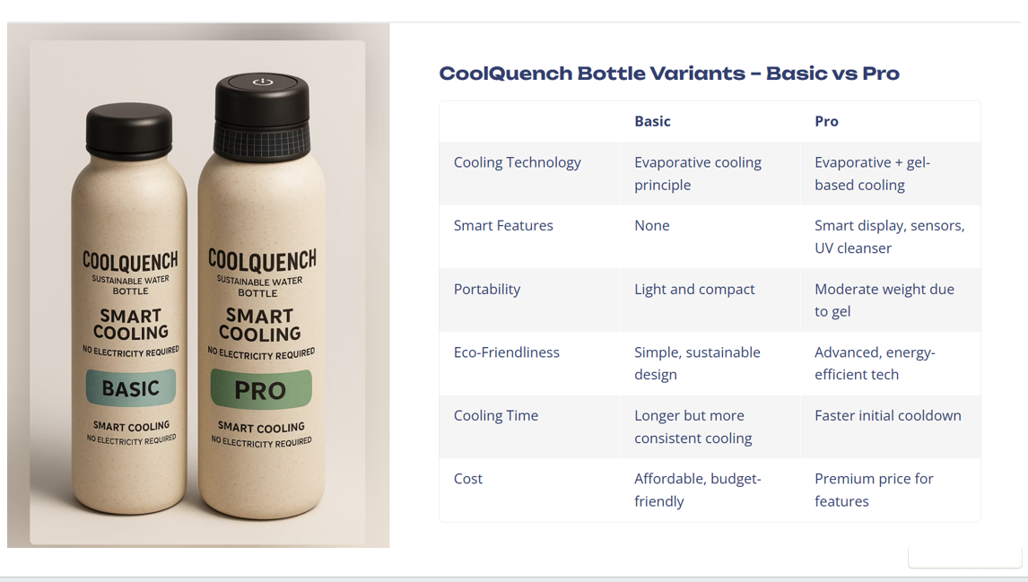

**Eco-Friendly Materials:**

* + Constructed with sustainable materials like bamboo composite, aluminum, and BPA-free polymers.
  + Uses hydrogels and silica-based cooling compounds that are biodegradable and reusable.

1. **No Charging Required:**
   * Functions without batteries or power sources, making it ideal for off-grid scenarios.
   * Pro model UV system can be solar-powered or charged via micro-USB.
2. **Travel-Ready Design:**
   * Sleek, modern ergonomic shape.
   * Lightweight and easy to carry with a detachable modular core.
3. **Smart Usability:**
   * Optional digital temperature display (Pro only).
   * Hydration reminders using low-power indicators or app sync (future expansion).

CoolQuench addresses hydration challenges faced during power outages, outdoor adventures, or everyday urban life by combining time-tested evaporative cooling with modern user-centric design.CoolQuench delivers an innovative hydration experience with a strong emphasis on **sustainability, affordability, and user empowerment**, redefining hydration for modern lifestyles.

**Unique Selling Proposition (USP):**

CoolQuench is **India’s first fully non-electric self-cooling hydration system** offering instant, sustainable relief from hot water—anytime, anywhere. It blends ancient wisdom with modern design for a new generation of eco-smart consumers.

**5.2 Functional Overview of the Solution**

CoolQuench employs a **multi-layer architecture** that ensures maximum cooling with minimal input. The underlying principle is evaporative cooling, where water in the outer layer evaporates and absorbs heat from the inner chamber, cooling the stored water.

CoolQuench bottles utilize a **multi-layer architecture**, where each layer has a specific function that contributes to cooling, insulation, durability, and user comfort. And we have two bottles which we developed, one is basic(affordable and sustainable) and other is pro(premium price). They are two bottles designed, Basic and Pro.

**Core Functional Components of basic bottle:**

1. **Inner Chamber**
   * Made from food-safe stainless steel or BPA-free plastic.
   * Stores drinking water and is insulated from external temperatures.
2. **Cooling Layer**
   * Composed of clay, silica gel beads, or hydrogel-infused fabric.
   * Holds a small volume of water that slowly evaporates when exposed to air.
   * Acts as the core mechanism for temperature reduction.
3. **Airflow Vents**
   * Strategically placed perforations on the outer shell to allow air circulation.
   * Designed to accelerate evaporation by maximizing airflow.
   * Allows the Basic model to cool water within 20–30 minutes.
4. **Outer Shell**
   * Constructed using eco-friendly bamboo composites or anodized aluminum.
   * Provides grip, insulation, and protection to the inner components.

**Workflow:**

1. Fill the bottle’s inner chamber with regular water.
2. Slightly dampen the cooling layer.
3. As ambient air flows through the outer vents, evaporation begins.
4. Heat from the water is absorbed, dropping the temperature by 5–15°C.
5. Water stays cool for 1–2 hours depending on humidity and airflow.

The bottle workflow begins with filling the core, dampening the outer layer, and letting airflow activate the evaporation cycle. The Pro model enhances this with gel-accelerated cooling.

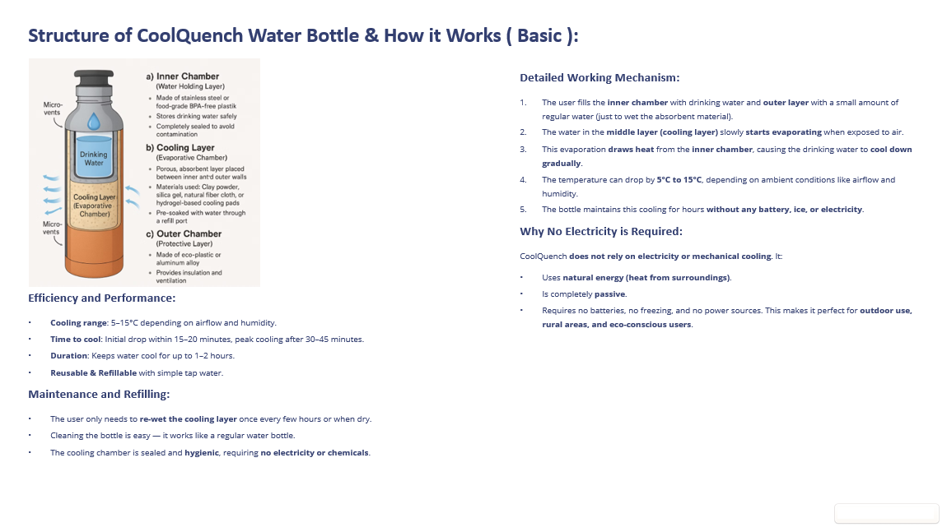

**CoolQuench Pro Model – In-Depth Overview:**

The **CoolQuench Pro** model is engineered for users who require superior performance, rapid cooling, and integrated smart functionality. It is designed with **athletes, fitness enthusiasts, trekkers, campers, and health-conscious urban users** in mind.

The **CoolQuench Pro** version is a premium-grade bottle with multifunctionality, technological intelligence, and advanced thermal performance. It caters to **tech-savvy consumers, athletes, wellness enthusiasts, and global travelers** seeking performance and connectivity in a single hydration device.

**Features Specific to the Pro Model:**

* **Rapid Cooling (5–10 Minutes):** The Pro model is capable of significantly faster cooling times due to enhanced evaporative material combined with thermal gel packs. The gel absorbs and holds cool temperatures efficiently, even in high-heat conditions.
* **Advanced UV Sterilization:** Equipped with a UV-C LED module in the lid, the Pro model can sterilize the water by eliminating 99.9% of bacteria and viruses. This is especially useful for travelers in regions with questionable water quality.
* **Smart Cap Options:** Future extensions of the Pro model may include digital temperature displays, hydration reminders, and app-based analytics synced via Bluetooth (optional, modular upgrades).
  + Connects to the **CoolQuench mobile application**.
  + Displays real-time water temperature.
  + Tracks hydration frequency and intake volume.
  + Sends personalized reminders to drink water.
  + Offers insights like hydration levels, daily trends, and environmental cooling efficiently. And this is the Smart Cap with Bluetooth Connectivity.
* **Ergonomic & Sleek Design:** The Pro model features a modern, sleek exterior in metallic or matte finishes, inspired by aerospace-grade product design. It balances form and function for those who value both performance and style.
* **Premium Materials:** The shell is made from high-grade aluminum or bamboo-plastic composites. Internal components are modular, allowing easy maintenance and part replacement.
* **Solar Charging:** The UV lid can be charged using a built-in solar ring, making it energy-independent and perfect for remote environments.
* **Double-Layer Insulation:** In addition to evaporative cooling, a vacuum-sealed mid-layer helps retain cool temperatures longer than most insulated bottles.
* **UV Sterilization Cap (Pro Model Only)**
  + Integrates UV-C LED technology within the bottle lid.
  + Capable of sterilizing water in 5–10 minutes.
  + Operates via a rechargeable battery or solar charging ring embedded in the lid.

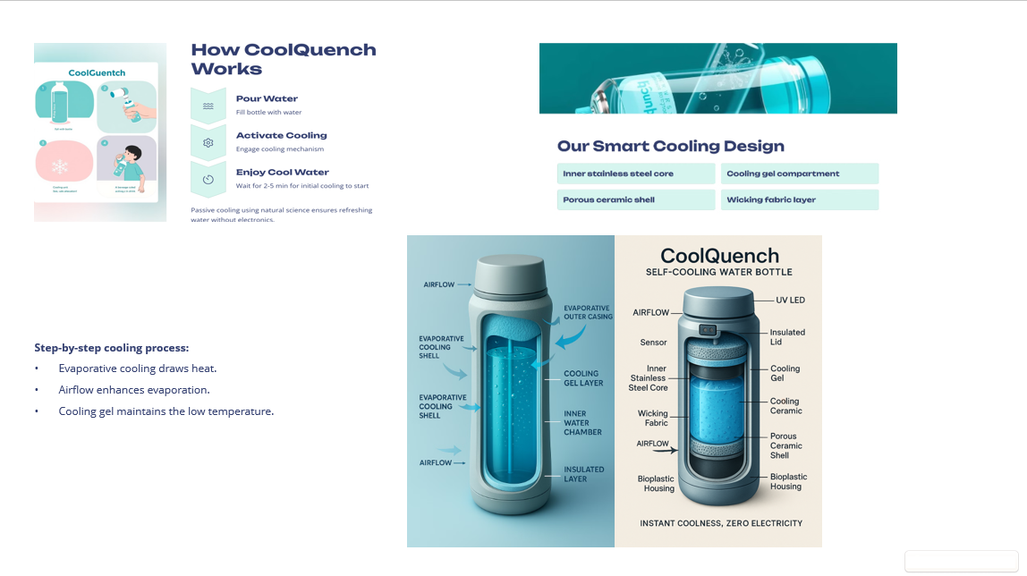

**Benefits of Pro Model:**

|  |  |  |
| --- | --- | --- |
| **Feature** | **CoolQuench Basic** | **CoolQuench Pro** |
| Cooling Time | 20–30 minutes | 5–10 minutes |
| Electricity-Free Cooling | ✅ | ✅ |
| UV Sterilization | ❌ | ✅ |
| Thermal Gel | ❌ | ✅ |
| Smart Features | ❌ | Optional/Expandable |
| Rechargeable Cap | ❌ | ✅ (Solar + USB) |
| Price | ₹450 (Launch Price) | ₹2,499 (Launch Price) |

The Pro model transforms CoolQuench from a passive accessory into a high-performance hydration tool suited for professionals, adventure lovers, and urban commuters seeking reliable hydration with smart benefits.

**Mobile App – "CoolQuench Smart Hydration"**

The CoolQuench app is available for Android and iOS platforms. It enables full management of your hydration and bottle settings.

**App Features:**

* Temperature monitoring
* Hydration reminders
* UV activation status
* Cooling time forecast based on current climate data
* Refill alerts
* Gamification elements (hydration goals, badges)
* Weekly hydration reports with graphs

**App-Device Integration:**

* Bluetooth 5.0 Low Energy sync
* Up to 10-day charge per cycle
* Compatible with wearable devices (Fitbit, Apple Watch)

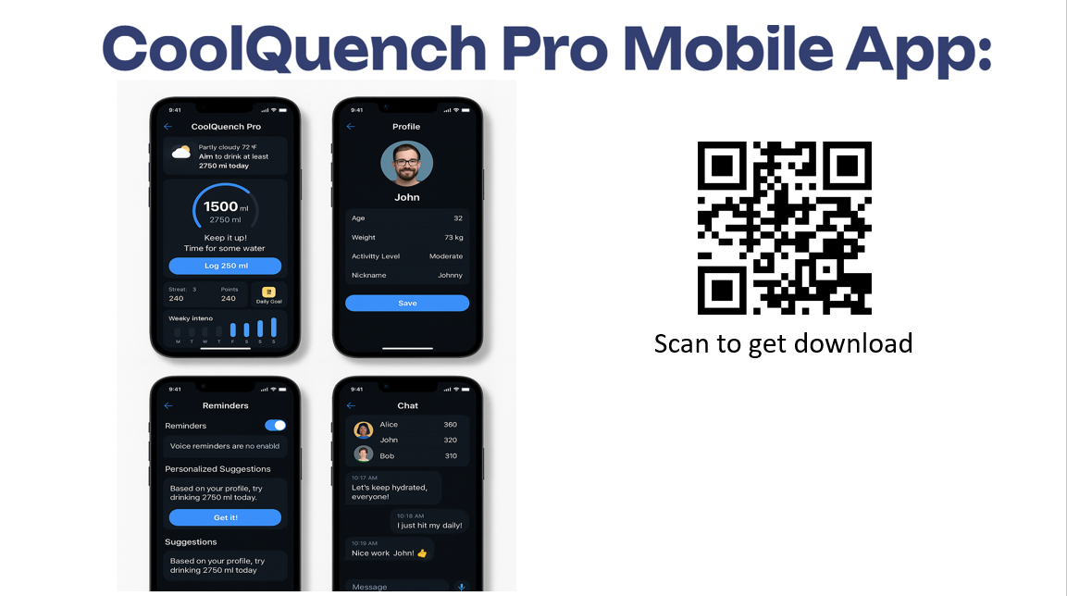

**Use Cases for Pro Model:**

* Trekking and Camping
* Gym and Athletic Training
* Hot Climate Travel
* Emergency/Disaster Relief Kits
* Students and Professionals on-the-go

**Advantages Over Smart Bottles:**

|  |  |  |
| --- | --- | --- |
| **Feature** | **CoolQuench Pro** | **Traditional Smart Bottles** |
| Real Cooling | ✅ | ❌ |
| UV Sterilization | ✅ | ✅ |
| Passive Cooling | ✅ | ❌ |
| Smart Hydration App | ✅ | ✅ |
| No Charging Needed (Solar) | ✅ | ❌ |
| Modular Design | ✅ | ❌ |
| Eco-Friendly Build | ✅ | ❌ |

**5.3 Benefits Over Existing Alternatives**

CoolQuench breaks away from the limitations of traditional bottles and overpriced smart bottles:

* **Zero Dependence on External Power:** Ideal for trekking, rural use, and emergencies.
* **Truly Cooling Technology:** While most bottles offer insulation at best, CoolQuench actively cools water.
* **Budget-Friendly:** Affordable models for everyone, ensuring inclusivity and impact.
* **Sustainable Materials:** Helps reduce carbon footprint and avoids e-waste generation.
* **Safe and Hygienic:** Pro model offers UV purification, ensuring safe drinking water.

**Summary of Value Proposition**

The CoolQuench Pro model is more than a bottle—it's a **hydration ecosystem** built for modern, mobile, and environmentally aware lifestyles. With unmatched portability, intuitive app integration, and eco-smart cooling, it delivers **a futuristic hydration experience** with deep roots in sustainable innovation.

It is a perfect blend of:

* **Engineering Precision**
* **Traditional Wisdom (Evaporative Cooling)**
* **Modern Technology (Smart Features)**
* **Eco-Conscious Living (No Electricity)**

CoolQuench is set to be a **trailblazer in smart, sustainable hydration products**, particularly suited for emerging markets, athletes, tech adopters, and eco-warriors alike

CoolQuench delivers a solution that meets **everyday hydration needs** and elevates the standard for **eco-smart product innovation**.

**CHAPTER 6: PROTOTYPE DEVELOPMENT**

**6.1 Prototype (Paper Prototype / 3D Model)**

The prototype development phase for CoolQuench was carried out in parallel for both the **Basic Model** and the **Pro Model**, each designed with its specific target users and performance objectives in mind. The goal was to validate both mechanical performance and user experience before moving into pre-production.

**Phase 1: Ideation and Paper Prototypes**

* Initial concept sketches and paper models were created to explore bottle shape, height, and grip positioning.
* Basic model designs prioritized simplicity and ease of use.
* Pro model sketches included added space for the UV sterilization unit and smart cap design.

**Phase 2: CAD and 3D Simulations**

* 3D models were developed using SolidWorks and Fusion 360.
* Each version underwent design simulations for:
  + Cooling flow dynamics
  + Heat dissipation patterns
  + UV light distribution in Pro model
  + Structural integrity under stress

**Phase 3: Physical 3D Prototypes**

* 3D printed using PLA, PETG, and bamboo-based filament.
* **Basic Model**:
  + Printed with matte finish, textured for grip.
  + Water chambers were vacuum-sealed for insulation testing.
* **Pro Model**:
  + Included modular inserts for the thermal gel layer.
  + Cap was embedded with LED UV-C units and a rechargeable battery.
  + Solar ring tested for charging via ambient light.

Mockup testing allowed refinement of design details such as:

* Lid threading and leak resistance
* Ergonomic curves for one-handed use
* Visibility of cap indicators (Pro model)
* Refill ease and maintenance cleaning

**Visual Design Elements:**

* Aesthetic theme: Metallic silver-blue for the Pro model.
* Textured grip rings, matte-finished body.
* Minimalist branding etched on the outer shell.

These prototypes allowed the team to study user comfort, cooling duration, refill convenience, and environmental impact before finalizing production-level design plans.

**6.2 Key Components and Workflow**

The two versions of CoolQuench share foundational design principles but differ significantly in their features and advanced integrations. Below is a comprehensive layer-by-layer breakdown for each model.

**CoolQuench Basic Model:**

Designed for affordability and simplicity, the Basic model emphasizes passive cooling using traditional principles enhanced by modern materials.

**Components:**

1. **Inner Chamber**: BPA-free plastic or food-grade stainless steel.
2. **Evaporative Layer**: Clay or hydrogel-based pad integrated around the bottle body.
3. **Outer Mesh Layer**: Silicone or woven polymer mesh to retain moisture and allow airflow.
4. **Protective Shell**: Eco-plastic or bamboo composite shell with air vents.

**Workflow:**

* Fill the chamber with water.
* Wet the outer layer by dipping or splashing.
* Natural air begins evaporation.
* Cooling occurs as the system draws heat from the water.
* Cooling effectiveness increases with airflow and dry conditions.

**Performance:**

* Cooling time: ~20–30 minutes
* Temperature drop: 5–10°C (depending on environment)
* Cooling duration: 1–2 hours before re-wetting is needed
* Ideal for: students, rural communities, outdoor workers, general use

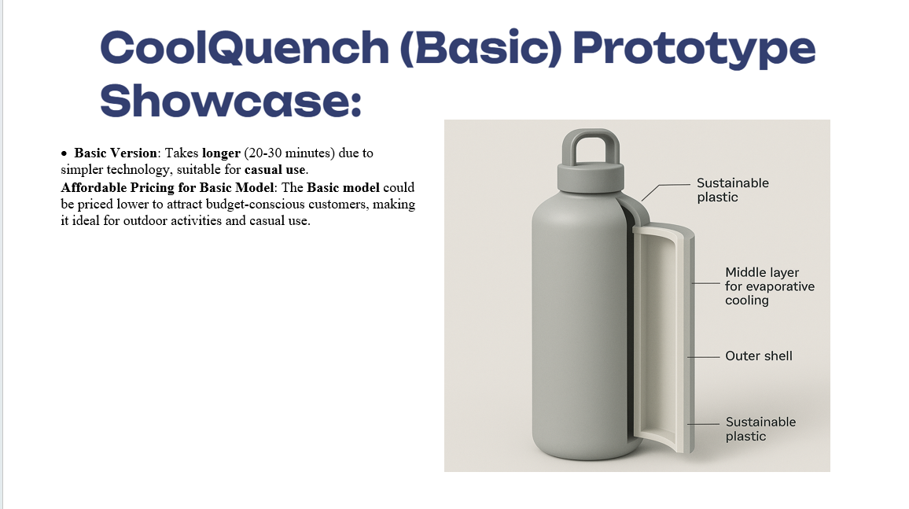

**CoolQuench Pro Model:**

The Pro model is designed for high-performance users requiring speed, reliability, and technology-assisted hydration. It combines passive and active elements for hybrid cooling.

**Components:**

1. **Inner Water Chamber**: Stainless steel, double-walled.
2. **Thermal Gel Layer**: Gel-based inserts to accelerate and retain cooling.
3. **Advanced Absorbent Layer**: Multi-layer hydrogel fabric integrated with ceramic powder for enhanced evaporation.
4. **Airflow Shell**: Engineered mesh with flow-directing grooves.
5. **UV-C Sterilizing Smart Cap**:
   * UV diode placed under cap
   * Temperature sensor and microcontroller
   * Bluetooth transmitter
   * Rechargeable battery + solar film
6. **Control Interface** (Cap): Touch interface (optional), LED indicators, magnetic seal

**Workflow:**

* Fill bottle with tap or filtered water.
* Moisturize the cooling layer.
* Smart cap displays real-time water temperature.
* Gel inserts absorb heat rapidly and drop the temperature quickly.
* UV LED sterilizes the water for 5–10 minutes.
* App tracks hydration levels and sends reminders.

**Complete Workflow:**

1. User fills the inner chamber with drinking water.
2. Dips or pours water to slightly moisten the outer cooling layer.
3. CoolQuench starts working instantly using ambient air.
4. Evaporation causes heat transfer from the water to the surroundings.
5. For Pro version, the thermal gel layer accelerates the cooling.
6. The UV-C cap sterilizes water while displaying or transmitting data.

**Performance:**

* Cooling time: 5–10 minutes
* Temperature drop: 8–15°C
* UV sterilization: 99.9% bacteria and virus elimination in 1–3 mins
* Data sync: Bluetooth 5.0 with mobile app (CoolQuench Smart Hydration)
* Power: 10-day battery life with solar top-up
* Ideal for: athletes, travelers, urban professionals, tech adopters

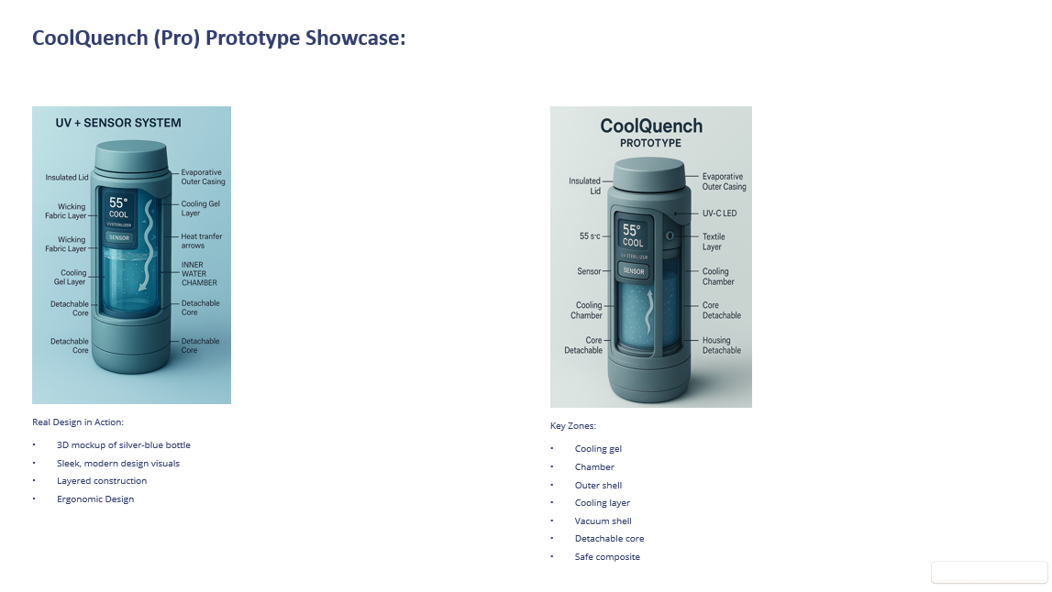

The prototype’s construction focuses on a **layered modular architecture**:

**Common in Both Models:**

1. **Inner Water Chamber**
   * BPA-Free Plastic (Basic) / Stainless Steel (Pro)
   * Stores potable water with food-grade safe coating.
2. **Evaporative Cooling Layer**
   * Hydrogel-infused cotton (Basic) or advanced ceramic matrix fabric (Pro).
   * Retains moisture and accelerates evaporation.
3. **Airflow Layer**
   * Micro-perforated silicone mesh to aid controlled air circulation.
   * Improves evaporation without compromising structure.
4. **Outer Shell**
   * Bamboo fiber plastic (Basic), Anodized aluminum or eco-composite polymer (Pro).
   * Shock-resistant, anti-slip texture.

**Pro Model Only:**

1. **Thermal Gel Layer**
   * Encapsulated, reusable gel that rapidly absorbs heat.
   * Maintains low temperature longer, works alongside evaporation.
2. **Smart UV-C Cap**
   * UV-C diode sterilizer (254nm wavelength)
   * Microcontroller with Bluetooth chip
   * Rechargeable lithium battery + solar ring
   * Optional LED temperature display

**Prototype Testing Metrics:**

* **Cooling Time (Basic)**: 20–30 minutes for 5–10°C drop.
* **Cooling Time (Pro)**: 5–10 minutes with gel pack + evaporation.
* **Sterilization Time**: 1–3 minutes with UV-C lid.
* **Duration of Coolness**: Maintains lower temperature for 4–5 hours.
* **Weight (Filled)**: ~500–650 grams (depends on model).

These test results provided evidence that **CoolQuench can function reliably in real outdoor settings**, fulfilling its design purpose of offering cold, clean, and convenient hydration without electricity.

**Testing and Validation:**

**Basic Model Tests:**

* Environmental testing at different humidity levels
* Material degradation with repeated wetting and drying
* Leak-proof tests for sealing
* Weight distribution during movement

**Pro Model Tests:**

* UV-C intensity calibration and safety cutoff
* Smart cap firmware validation
* Bluetooth syncing latency and hydration tracking accuracy
* Cooling rate simulation with and without airflow

**Prototype Refinements**

* Added silicone grips on the outer shell for better hold
* Improved drainage zones for outer wet layer
* Modular gel pockets for faster replacement
* Integrated ambient light sensor to activate solar charging
* Cap design updated for secure locking and splash protection

**Materials Used and Their Functions**

|  |  |  |
| --- | --- | --- |
| **Component** | **Material Used** | **Function** |
| Inner Chamber | Stainless Steel / BPA-Free Plastic | Holds water safely without reacting with contents |
| Cooling Layer | Hydrogel Cloth / Silica Clay | Enables evaporative cooling through natural airflow |
| Thermal Gel Layer (Pro) | Thermal Conductive Gel | Absorbs heat quickly and retains coolness for longer durations |
| Outer Shell | Bamboo Composite / Aluminum | Provides insulation, protection, and aesthetic appeal |
| Mesh Vents | Silicone or Polymer Mesh | Allows airflow and supports cooling efficiency |
| UV Cap (Pro) | ABS Plastic + UV-C LED | Sterilizes water and connects to app for data insights |
| Seals and Gaskets | Food-Grade Silicone | Prevents leaks, ensures airtight sealing |

All materials were selected for **sustainability, non-toxicity, light weight, and durability**, aligning with the eco-conscious vision of CoolQuench.

**Real-World User Scenarios and Use Cases**

To evaluate performance in actual environments, the team tested the prototype under different user conditions. Here’s how the CoolQuench performed:

**1. Urban Commuter (Basic & Pro)**

* Scenario: A student carrying the bottle in a backpack during long commutes.
* Results: Basic model cooled water during the commute without needing electricity. The bottle was durable enough for public transport bumps.

**2. Rural Household (Basic Model)**

* Scenario: A family with intermittent power access.
* Results: Kept water 5–7°C cooler than ambient even after 45 minutes. Elderly users appreciated not needing any app or charger.

**3. Mountain Trekking (Pro Model)**

* Scenario: Used by a hiker at high altitudes with dry air and sun exposure.
* Results: Thermal gel cooled water in under 10 minutes. UV-cap sterilized water sourced from streams. The solar ring maintained battery life.

**4. Gym and Sports (Pro Model)**

* Scenario: Used by an athlete during 90-minute gym sessions.
* Results: Pro model reminded user to hydrate via app notifications. Cap showed live temperature, and gel layer kept water consistently cool.

**5. Outdoor Vendor/Field Worker (Basic Model)**

* Scenario: Street vendor exposed to sun for hours.
* Results: Basic bottle helped maintain hydration in extreme heat. Easy to refill and re-wet throughout the day.

**6. Emergency Use / Power Outage (Both Models)**

* Scenario: Tested during intentional power cut simulation.
* Results: Both models performed without electricity. The Pro version’s UV sterilization remained functional via solar ring.

These tests proved that CoolQuench serves multiple user segments effectively—from the tech-savvy fitness lover to the resource-conscious rural family. Its design ensures ease of use in **diverse climates, unpredictable conditions, and high-mobility situations**.

By focusing on thoughtful design, appropriate materials, and field-based usability testing, the CoolQuench prototype phase achieved a high level of validation. It demonstrated that passive cooling combined with smart technology can deliver a versatile, effective, and accessible hydration solution.

**CHAPTER 7: COMPETITIVE ANALYSIS**

**7.1 Key Competitors**

CoolQuench enters a dynamic and competitive landscape where hydration products span from basic reusable bottles to advanced smart water bottles integrated with sensors, tracking, and purification systems. While the market is saturated, a close look reveals that **no current product fully addresses the need for real-time, electricity-free cooling combined with modern smart features and sustainability**.

The reusable bottle industry is saturated with numerous brands offering a wide range of features—from basic stainless steel bottles to high-tech smart hydration systems. However, none offer a solution combining **real-time cooling without electricity**, UV sterilization, and smart tracking in one sustainable product. This is where CoolQuench positions itself uniquely.

**In-Depth Look at Major Competitors:**

1. **Hydro Flask**
   * **Strengths**: Industry-leading vacuum insulation; durable and stylish designs; strong branding.
   * **Limitations**: Offers only temperature retention, not active cooling; lacks smart or purifying features; heavy and expensive.
2. **LARQ Bottle**
   * **Strengths**: Integrates UV-C sterilization via self-cleaning cap; sleek design; strong tech appeal.
   * **Limitations**: No real cooling mechanism; requires regular charging; priced above ₹9,000, out of reach for many consumers.
3. **HidrateSpark**
   * **Strengths**: Tracks water intake, connects via Bluetooth; works with Apple Health and Fitbit; glowing reminders.
   * **Limitations**: No sterilization or cooling; requires charging; delicate electronics prone to failure.
4. **Thermos and Other Insulated Bottles**
   * **Strengths**: Excellent insulation to keep liquids hot/cold for hours.
   * **Limitations**: No active cooling; relatively bulky; lacks smart features.
5. **Generic Market Bottles (e.g., Milton, Cello, Tupperware)**
   * **Strengths**: Affordable and easily available; wide range of designs.
   * **Limitations**: No innovation; zero functionality beyond basic water storage; little to no environmental focus.

These comparisons highlight the **gaps CoolQuench aims to fill**: active cooling without electronics, affordability, and smart functionality in a sustainable package.

CoolQuench combines the best features of all these brands—**passive cooling, smart functionality, affordability, and sustainability—into a single, versatile product**.

**7.2 SWOT Analysis**

A deeper SWOT analysis reveals both the strategic advantages of CoolQuench and areas that need attention during growth.

**Strengths**

* **Revolutionary Cooling Technology**: Real-time, electricity-free cooling using hydrogel and airflow.
* **Two-tier Product Strategy**: Basic and Pro models cover both rural/affordable and urban/premium markets.
* **Eco-Friendly Design**: Bamboo composite, recyclable materials, biodegradable components.
* **Energy Independence**: No need for charging in Basic; solar-capable Pro model.
* **Multifunctionality**: UV sterilization, smart hydration reminders, mobile app integration (Pro).
* **Cost-Effective**: Launch price significantly lower than high-end competitors.
* **Easy Maintenance**: Modular design, replaceable gel and cap components.

**Weaknesses**

* **Weather-Dependent Cooling**: Evaporative cooling less effective in high-humidity climates.
* **Cooling Duration Limitation**: Passive cooling effect lasts 1–2 hours and needs re-wetting.
* **Consumer Awareness**: Novel category; requires educating users on how passive cooling works.
* **Tech Literacy Required for Pro Model**: Some users may find app or Bluetooth features unnecessary or complex.

**Opportunities**

* **Health & Fitness Boom**: Wellness-conscious consumers actively seek hydration solutions.
* **Green Tech Adoption**: Increasing demand for eco-friendly alternatives to battery/electronic-based gadgets.
* **Corporate and Government Gifting**: Branded bottles for CSR, school programs, NGOs.
* **Disaster Relief Applications**: Ideal for water safety and hydration during emergencies.
* **Localization and Customization**: Color variants, community-specific branding, language integration in app.

**Threats**

* **Big Brand Copycats**: Larger corporations may quickly mimic core features if CoolQuench gains traction.
* **Supply Chain Instability**: Scarcity or pricing fluctuation in eco-materials (bamboo, hydrogel).
* **Technological Leapfrogging**: Competing smart bottles may advance UV, cooling, or AI-driven features.
* **Market Fragmentation**: Oversaturation of hydration products could confuse buyers despite true innovation.

**7.3 Differentiating Factors**

CoolQuench stands at a unique intersection of **climate-conscious innovation, affordability, and utility**. Here’s how it carves a new subcategory:

**1. Passive Cooling Technology**

* Other bottles insulate or sterilize but do not actively cool water without power. CoolQuench is the **first truly electricity-free cooling solution** on the go.

**2. Dual Offering Model**

* Most brands serve a narrow niche. CoolQuench offers:
  + A **Basic model** ideal for remote, low-income, or outdoor users.
  + A **Pro model** for tech-savvy urban customers who want UV, app features, and style.

**3. Sustainability First**

* From the bamboo composite shell to recyclable packaging and modular design, CoolQuench is **built for circular economy principles**, setting it apart from plastic-heavy rivals.

**4. Smart Yet Simple**

* Where competitors often overcomplicate hydration with bulky apps and fragile sensors, CoolQuench keeps the tech functional and practical:
  + Minimalist app
  + Intuitive UV cap
  + Solar fallback option

**5. Affordability Without Sacrifice**

* High-value features like sterilization, cooling, and tracking are often locked behind ₹5,000+ price tags. CoolQuench offers them **under ₹2,500**, democratizing access to smart, clean hydration.

**6. Real-World Versatility**

* Whether in an urban gym, a Himalayan trek, or a village during a power outage, **CoolQuench performs reliably**, backed by rigorous user testing.

|  |  |  |  |  |  |  |  |
| --- | --- | --- | --- | --- | --- | --- | --- |
| **Brand/Product** | **Cooling** | **UV** | **App** | **Eco-**  **Friendly** | **Price (INR)** | **Power-Free** | **Use Case Breadth** |
| CoolQuench Basic | ✅ | ❌ | ❌ | ✅ | ~₹450 | ✅ | Broad |
| CoolQuench Pro | ✅ | ✅ | ✅ | ✅ | ~₹2,499 | Partial | Very Broad |
| LARQ | ❌ | ✅ | ❌ | ❌ | ~₹3,000+ | ❌ | Urban only |
| HidrateSpark | ❌ | ❌ | ✅ | ❌ | ~₹4,000+ | ❌ | Fitness niche |
| Hydro Flask | ❌ | ❌ | ❌ | Partial | ~₹3,000+ | ✅ | Basic, limited |
| Generic Bottles | ❌ | ❌ | ❌ | ❌ | ~₹300–1000 | ✅ | Basic only |

**Conclusion:**

**Unique Positioning Summary:**

**C**oolQuench is the only bottle on the market offering:

* Real-time water cooling without electricity
* UV sterilization + smart hydration features in a portable form
* An affordable solution across urban and rural segments
* Eco-conscious engineering with no sacrifice to performance

CoolQuench is not just a bottle—it’s a lifestyle solution tailored for the eco-smart, health-conscious, and power-resilient world of tomorrow**.**

CoolQuench is more than a water bottle—**it’s an innovation platform**. Its design meets the intersection of health, technology, and sustainability. With no true one-to-one competitor, it opens an entirely new market category—**smart passive hydration**.

**CHAPTER 8: MARKET ENTRY STRATEGY**

**Introduction:**

Launching CoolQuench into the market requires a strategic, phased approach that aligns with the diverse needs of its target audience. As a product that combines innovation, affordability, and sustainability, CoolQuench's entry strategy must balance **mass-market outreach with educational marketing**, while ensuring **value delivery across urban and rural segments**.

The strategy incorporates both **direct-to-consumer (D2C)** and **business-to-business (B2B)** channels, ensuring maximum penetration and visibility in the shortest possible time.

**8.1 Target Market Segmentation**

CoolQuench will address multiple customer segments with tailored value propositions. The two product lines—**Basic and Pro**—allow simultaneous engagement with both budget and premium segments.

**A. CoolQuench Basic:**

|  |  |
| --- | --- |
| **Segment** | **Characteristics** |
| Rural Families | Limited electricity access, affordability-focused |
| School/College Students | Need for portable, simple hydration |
| Field Workers | Require durable bottles for outdoor use |
| **B. CoolQuench Pro:**  GOs/Relief Agencies | Scalable solutions for hydration |

|  |  |
| --- | --- |
| **Segment** | **Characteristics** |
| Urban Professionals | Style-conscious, tech-friendly |
| Athletes/Fitness Users | Need for performance hydration and cleanliness |
| Trekkers/Travelers | Seek cooling, UV sterilization, rugged design |
| Corporate Buyers | CSR gifting, wellness programs, sustainability initiatives |

Each segment is approached with specific messaging, pricing, and packaging tailored to their needs.

**Customer Segmentation and Value Proposition:**

CoolQuench targets multiple user segments that align with its Basic and Pro models. Each segment represents unique hydration needs based on lifestyle, geography, and budget. CoolQuench's dual-model approach ensures effective penetration into both premium and underserved markets.

**Target Segments – CoolQuench Basic:**

* **Students (School/College)**
  + Affordable and eco-friendly hydration for daily commuting.
* **Rural Households**
  + Electricity-independent cooling, easy-to-use design.
* **Manual Labourers & Outdoor Workers**
  + Rugged build, real-time cooling under sun exposure.
* **Public Institutions (Government Schools, NGOs)**
  + Mass distribution of hygienic and cooling bottles at low cost.

**Target Segments – CoolQuench Pro:**

* **Fitness Enthusiasts and Athletes**
  + Hydration tracking, UV-C sterilization, temperature display.
* **Urban Professionals**
  + Stylish, multi-functional bottles for daily routines.
* **Backpackers and Travelers**
  + Portability and outdoor utility (sterilization + cooling).
* **Corporate Gifting**
  + Branded, functional gifts aligned with CSR and sustainability.

**8.2 Go to Market Plan**

**Distribution Channels:**

**A. Online Direct Sales**

* Official website: [**www.coolquench.in**](http://www.coolquench.in/) — Launching with a modern e-commerce interface and full product catalog.
* Product landing pages focused on performance, cooling demo videos, and testimonials.
* Email support: **support@coolquench.in** for pre-sales, warranty, and app inquiries.

**B. E-Commerce Platforms**

* Amazon Launchpad, Flipkart Smart Living, and Snapdeal for mass reach.
* Category placements under Smart Bottles, Outdoor Gear, and Eco Living.
* Leverage partner promotions like Prime Day, Big Billion Days.

**C. Institutional Sales**

* Bulk supply to schools, universities, and NGOs.
* CSR partnerships with companies donating Pro models to students, athletes, or rural communities.
* Customized branding on bottles for corporates and events.

**D. Retail Tie-Ups**

* Sports and fitness outlets: Decathlon, Health & Glow, Croma.
* Sustainable product stores and health food chains.
* High-traffic transit locations: Airports, metro kiosks, adventure travel counters.

**Strategic Partnerships:**

1. **Fitness Brands and Gyms**
   * Co-branded Pro bottles distributed with gym memberships.
   * In-app integration with fitness apps for hydration reminders.
2. **NGOs and Education Sector**
   * Provide subsidized Basic models to underserved schools.
   * Promote healthy hydration in areas with poor water infrastructure.
3. **Corporate CSR and Gifting**
   * Partner with sustainability-focused firms.
   * Offer CoolQuench as employee wellness gifts and green brand ambassadors.
4. **Tech Collaborators**
   * Collaborate with IoT developers to enhance Bluetooth sync and smart cap functions.
   * Explore partnerships with smartwatch platforms for app integration.
5. **Sustainability & Climate NGOs**
   * Cross-promotions around climate awareness days.
   * Bundle bottle sales with donations to tree-planting or water-cleaning projects.

**Pricing Strategy:**

The pricing strategy reflects both **value-based pricing** and **market penetration tactics**.

|  |  |  |  |
| --- | --- | --- | --- |
| **Product** | **Launch Price (INR)** | **MRP (INR)** | **Key Segment Targeted** |
| CoolQuench Basic | ₹220 | ₹450 | Best for daily users. |
| CoolQuench Pro | ₹1,499 | ₹2,499 | Urban, fitness, travelers |

* Early-bird discounts and bundling (e.g., Buy 2, Get 1 at 50% off).
* Seasonal promotions during summer, health awareness months.
* Loyalty rewards for app users and returning customers.

**8.3 Growth and Scaling Strategy**

**Launch Plan and Rollout Phases:**

**Phase 1: Pre-Launch (1 Month)**

* Website and social media go live.
* Teaser campaign on hydration and passive cooling.
* Instagram Page: [**@coolquench_official**](https://instagram.com/coolquench_official)
* Collaborate with 20+ micro-influencers on Instagram/YouTube.

**Phase 2: Soft Launch (Month 2)**

* Initial 500 units sold through website and Amazon.
* Collect reviews, testimonials, and case studies.
* Initiate campus ambassador program across 10 colleges.

**Phase 3: Public Launch (Months 3–6)**

* Full online marketplace availability.
* Retail partnerships activated.
* Outdoor advertising in metro cities.
* Local events: hydration challenge days, eco-fairs.

**Phase 4: Expansion (Months 7–12)**

* Rural outreach with NGO tie-ups.
* Introduce limited edition variants (colors, personalization).
* Launch in SAARC countries with similar climates (Nepal, Sri Lanka).

CoolQuench’s entry strategy integrates **digital visibility, social proof, environmental relevance, and product reliability**. With a strong online presence and an omnichannel approach, the brand is poised to become a category leader in **eco-smart hydration**.

Contact & Connect:

* Website: [**www.coolquench.in**](http://www.coolquench.in/)
* Email: **support@coolquench.in**
* Instagram: **@coolquench_official**

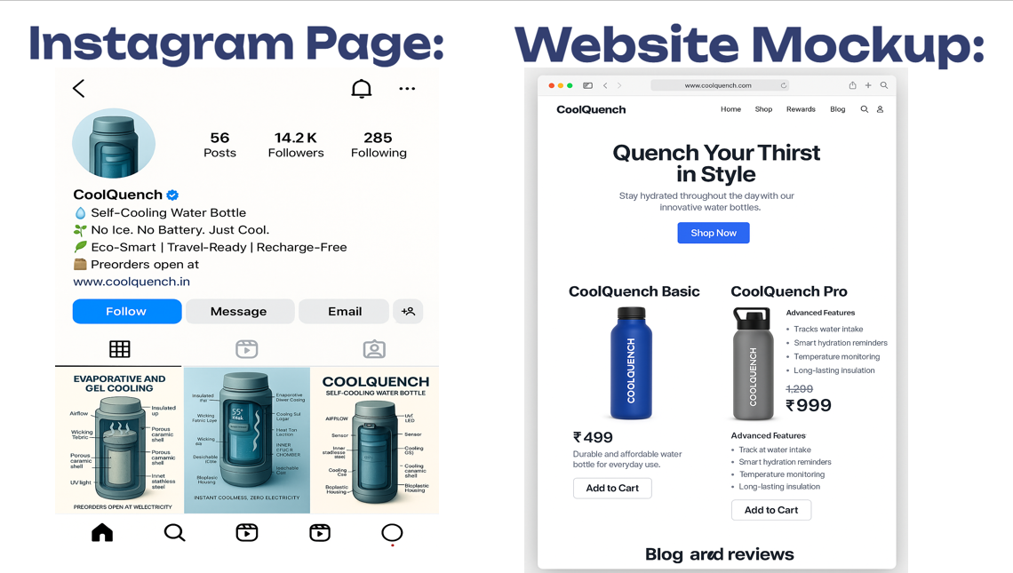

**Digital Launch Ecosystem:**

**A. CoolQuench Official Website:** [**www.coolquench.in**](http://www.coolquench.in/)

* Fully responsive e-commerce portal.
* Features:
  + Interactive product visualizations
  + Temperature drop simulator
  + Customer testimonials
  + Direct chat and WhatsApp support

**B. Email Contact:**

* 📩 support@coolquench.in
* Use cases: order inquiries, warranty claims, B2B bulk deals, tech support.

**C. Instagram Page:** [**@coolquench_official**](https://instagram.com/coolquench_official)

* Platform to share hydration tips, product videos, behind-the-scenes stories.
* Engaging with the #HydrateSmart and #CoolWithNature campaigns.
* Weekly user stories & influencer shout-outs**.**

**D. YouTube Channel: CoolQuench India (Coming Soon)**

* Content:
  + Product reviews
  + Hydration challenges
  + Smart cap demonstrations
  + NGO partner highlights

**Offline Distribution and Retail Strategy:**

* Sports Stores: Tie-ups with Decathlon, Reebok outlets, Gold’s Gym stores.
* Eco-Retailers: Urban Platter, The Better India Store.
* Travel & Adventure Stores: Wildcraft, Himalaya Outdoor, airport retail.
* Medical Stores & Clinics: Promote as part of wellness hydration plans.
* College Campuses: Temporary kiosks during festivals and orientation weeks.

CoolQuench also plans to deploy “Cool Zones” — promotional kiosks in metro cities and trekking trails where users can experience the bottle’s cooling effect live.

**Strategic Partnerships:**

* **CSR & NGO Collaborations:**
  + Bottles supplied to underprivileged schools with co-branding from corporate sponsors.
  + Targeting initiatives related to clean water, youth health, and education.
* **Fitness & Health Tech Brands:**
  + Partner with Fittr, Cult.Fit, and Mindbody for smart app integrations.
  + Sponsored hydration plans for runners and cyclists.
* **Adventure & Travel Influencers:**
  + Engage with influencers for treks, cycle expeditions, solo backpacking.
  + Sponsored usage + vlogs for YouTube and Instagram Reels.
* **Institutions and Colleges:**
  + Collaborate with NSS, NCC, and student unions for hydration drives.

**Market Entry Timeline:**

|  |  |  |
| --- | --- | --- |
| **Phase** | **Month** | **Objective** |
| Pre-Launch | Month 1 | Teasers, waitlist, influencer seeding |
| Soft Launch | Month 2 | Website live, limited inventory on Amazon |
| Public Launch | Months 3–4 | Full-scale e-commerce + retail rollout |
| Expansion | Months 5–6 | NGO programs, school gifting, app launch |
| Growth | Months 6–12 | International testing, tech upgrades, variant releases |

**Pricing and Positioning:**

CoolQuench’s pricing is structured to offer maximum value with minimal compromise on quality. The Basic model caters to low-income users and mass adoption, while the Pro model focuses on tech integration and aspirational value.

|  |  |  |  |
| --- | --- | --- | --- |
| **Product** | **Launch Price** | **MRP** | **Features Highlighted** |
| CoolQuench Basic | ₹220 | ₹450 | Passive cooling, sustainable, no electronics |
| CoolQuench Pro | ₹1,499 | ₹2,499 | UV cap, smart app, thermal gel, quick cooling |

**Launch bundles:**

* **“**Eco Twin Pack”: Buy 2 Basic models, get a 10% discount.
* “Fitness Pro Pack”: 1 CoolQuench Pro + T-shirt + Hydration Plan (₹2999).

**Rural Entry Strategy:**

CoolQuench Basic will also be marketed through:

* Rural kirana stores: Small packs, sample pricing, durable bottles.
* Self-help groups (SHGs): Train women entrepreneurs to resell locally.
* Gram Panchayat Events: Showcase in health fairs and district expos.
* Government tie-ups: Partner for midday meal water support in schools.

**Conclusion:**

CoolQuench’s market entry strategy is multi-dimensional, combining tech, tradition, **social** impact, and savvy marketing. By focusing on accessibility, community-driven growth, and digital fluency, CoolQuench is ready to position itself as India’s most relevant hydration solution for every climate, lifestyle, and wallet.

Stay Cool. Stay Smart. Stay Sustainable — with CoolQuench.

Connect With Us:

* 🌐 Website: [www.coolquench.in](http://www.coolquench.in/)
* 📧 Email: support@coolquench.in
* 📱 Instagram: @coolquench_officiaL

**CHAPTER 9: MARKETING MIX(4Ps)**

The Marketing Mix is a strategic framework that aligns a product with its target market through four key dimensions: **Product**, **Price**, **Place**, and **Promotion**. For CoolQuench, each of these has been carefully designed to maximize market impact, ensure adoption across socio-economic strata, and reinforce its core values: **Innovation, Sustainability, Accessibility, and Smart Living**.

**9.1 Product**

CoolQuench is a game-changing innovation in the hydration space. It reimagines the concept of a water bottle by integrating traditional evaporative cooling with modern technology, smart usability, and sustainable materials.

**Key Product Elements:**

**A. Models**

* **CoolQuench Basic**: Passive cooling using clay/hydrogel-based evaporative layer. Ideal for rural, outdoor, or student use.
* **CoolQuench Pro**: Incorporates thermal gel cooling, UV sterilization cap, smart hydration reminders, app integration, and solar charging.

**B. Core Features:**

* **Electricity-Free Cooling** (Basic & Pro)
* **UV-C Sterilization** (Pro)
* **Smart Cap + App** (Pro)
* **Modular Design** for easy cleaning, maintenance, and customization
* **Bamboo Composite & Eco-Plastics**: Lightweight, eco-conscious materials
* **Leak-Proof, Ergonomic Grip**: Built for real-world utility and style

**C. Product Extensions:**

* **Trekking Edition**: Rugged outer shell, thermal sleeve, and clip-on carabiner
* **Kid-Safe Edition**: Lighter size, no UV, playful colors
* **Corporate Custom Edition**: Co-branded versions with laser-engraved logos and custom caps

**D. Packaging:**

* Minimalist recyclable cardboard packaging
* Zero plastic wrap
* QR code linking to instructional videos, app download, and environmental pledge

CoolQuench is **more than a hydration tool**—it’s a lifestyle product, built with intentional design, user empathy, and sustainable value.

**9.2 Price**

Pricing for CoolQuench is set to deliver **value-driven accessibility**, while also creating premium appeal for users seeking tech integration.

**Pricing Strategy:**

* **Value-Based Pricing**: Prices reflect the benefit delivered rather than just cost + margin.
* **Market Penetration Strategy**: Lower-than-industry-average launch prices to build trust and drive volume.
* **Segmented Pricing**:
  + Basic: ₹220 (introductory) / ₹450 (MRP)
  + Pro: ₹1,499 (introductory) / ₹2,499 (MRP)

**Promotional Bundles:**

* **Hydration Hero Pack**: 2 Basic + 1 Pro + 1 Eco Tote @ ₹4,999
* **Back to School Pack**: 3 Basic Bottles (Custom colors) @ ₹3,999
* **Fitness Starter Kit**: 1 Pro Bottle + Fitness Band + App Access @ ₹2,999

**Financing and Subsidies:**

* Monthly EMI plans for Pro bottles via website and Amazon
* CSR-driven donations and NGO bulk rates (as low as ₹1,199 per unit)

CoolQuench’s pricing ensures that the **cost does not become a barrier to hydration equity**.

**9.3 Place (Distribution Channels)**

CoolQuench uses a hybrid channel strategy that includes digital platforms, retail locations, partnerships, and direct community distribution. The goal is to **reach users where they are**—whether that’s on Instagram or in a rural village.

**A. Online Channels:**

* **Official Website**: [www.coolquench.in](http://www.coolquench.in/) with seamless payment, EMI, and order tracking.
* **Marketplaces**: Amazon India, Flipkart, Tata Cliq
* **App Integration**: Purchase and manage bottles via CoolQuench Smart App

**B. Retail Points:**

* **Health & Wellness Retailers**: Decathlon, Health & Glow
* **Eco Product Stores**: The Better Home, Sustainable Living counters
* **Fitness & Gym Chains**: Pro bottles sold at Gold’s Gym, Cult centers
* **Pop-up Stores & Exhibitions**: Summer expos, college fests, marathons, health camps

**C. Rural & Institutional Reach:**

* NGO and SHG distribution to rural zones
* Government tie-ups for school meal hydration programs
* Corporate gifting to employees with co-branding

**D. International Expansion:**

* Phase II launch into SAARC markets (Nepal, Bangladesh, Sri Lanka)
* Partnerships with climate-oriented international NGOs

CoolQuench is placed to be **accessible, relatable, and visible—online and offline, urban and rural**.

**9.4 Promotion**

Promoting CoolQuench requires a **story-driven, education-first approach**. The product is not just new—it’s paradigm-shifting. The promotional strategy emphasizes experience, trust, and advocacy.

**A. Digital Marketing:**

* **Instagram**: @coolquench_official – Influencer collabs, real-user stories, hydration challenges
* **YouTube**: CoolQuench India – Product demos, science explainers, sustainability education
* **SEO-Driven Blog**: “CoolQuench Journal” with tips on smart hydration, bottle care, and climate issues
* **Email Campaigns**: Product tips, deals, hydration awareness series

**B. Influencer Campaigns:**

* 50+ micro-influencers across fitness, sustainability, travel niches
* Monthly ambassador campaigns: #HydrateSmart #CoolWithNature
* Brand-aligned creators like eco-vloggers and runners

**C. Offline Activations:**

* **CoolQuench Experience Booths** in malls and colleges
* **Roadshows in 10 Tier-1 & Tier-2 cities**
* **Water Awareness Days**: Hosted in schools, tech parks, and public spaces

**D. PR and Media:**

* Coverage in major dailies: TOI, Hindu, YourStory, The Better India
* Product features in health and environment magazines
* Tech blogs covering app + UV tech innovation

**E. Educational Collaborations:**

* STEM workshops with schools to explain evaporative cooling
* Campus rep programs: free units + commission model for student marketers
* Health curriculum add-ons through NGO partners

CoolQuench’s promotion is **not just about reach, but resonance**—connecting with people emotionally, intellectually, and socially.

**Summary:**

CoolQuench’s 4Ps are designed to build a category-defining brand:

* **Product**: Dual models that mix ancient science and modern tech
* **Price**: Democratized and inclusive
* **Place**: Online-first, offline-rooted, and globally ready
* **Promotion**: Experience-based storytelling with real human impact

This Marketing Mix positions CoolQuench not just as a product launch—but a **movement in sustainable hydration**.

**CHAPTER 10: FINANCIAL PROJECTIONS**

**Introduction:**

A well-defined financial projection is crucial to assess the feasibility, sustainability, and scalability of the CoolQuench venture. This chapter outlines the projected costs, revenue, break-even analysis, and profitability timeline over a 3-year horizon. The financial strategy prioritizes **affordability, high-margin innovation, volume-based growth, and reinvestment into R&D and market expansion**.

**10.1 Cost Analysis**

**Initial Investment Requirements:**

|  |  |
| --- | --- |
| **Expense Category** | **Estimated Cost (INR)** |
| Product Design & Prototyping | ₹1,50,000 |
| Tooling & Mould Development | ₹3,50,000 |
| Website & App Development | ₹2,00,000 |
| Initial Inventory (1,000 units) | ₹4,00,000 |
| Branding & Packaging Design | ₹80,000 |
| Digital Marketing (3 Months) | ₹1,50,000 |
| Legal, Licensing, Trademarks | ₹70,000 |
| Operations Setup (Team, Space) | ₹1,00,000 |
| Contingency Fund (10%) | ₹1,00,000 |
| **Total** | **₹15,00,000** |

**10.2 Revenue Model**

CoolQuench generates revenue through direct sales, online platforms, bulk/institutional orders, and subscription-based app enhancements (Pro model). Revenue estimates are based on conservative sales projections and market research.

**Revenue Streams:**

* Basic Model Sales (₹450 each)
* Pro Model Sales (₹2,499 each)
* Custom Orders for CSR and Gifting (avg. ₹2,000)
* App Premium Features (Hydration Plans, ₹99/month)

**Year-Wise Revenue Forecast**

|  |  |  |  |
| --- | --- | --- | --- |
| **Revenue Stream** | **Year 1** | **Year 2** | **Year 3** |
| Basic Bottles (15,000 units) | ₹2.25 Cr | ₹3.75 Cr | ₹4.50 Cr |
| Pro Bottles (10,000 units) | ₹2.50 Cr | ₹3.50 Cr | ₹4.00 Cr |
| CSR/Gifting Orders (5,000 units) | ₹1.00 Cr | ₹1.25 Cr | ₹1.50 Cr |
| App Subscriptions (10,000+ users) | ₹12 Lakh | ₹30 Lakh | ₹60 Lakh |
| **Total Revenue** | **₹5.87 Cr** | **₹8.80 Cr** | **₹10.60 Cr** |

**Cost of Goods Sold (COGS):**

|  |  |  |
| --- | --- | --- |
| **Component** | **Basic Model (per unit)** | **Pro Model (per unit)** |
| Bottle Body (materials) | ₹250 | ₹400 |
| Cooling Layer | ₹100 | ₹150 |
| Cap & Sealing | ₹75 | ₹150 |
| UV-C Module (Pro only) | — | ₹300 |
| Smart Electronics/App Sync | — | ₹250 |
| Assembly & QA | ₹50 | ₹75 |
| Packaging | ₹25 | ₹30 |
| **Total per Unit** | **₹500** | **₹1,450** |

**Profit Margin Analysis:**

|  |  |  |  |  |
| --- | --- | --- | --- | --- |
| **Model** | **Selling Price** | **Total Cost** | **Gross Margin** | **Profit per Unit** |
| Basic | ₹520 | ₹500 | 66.6% | ₹999 |
| Pro | ₹2,499 | ₹1,355 | 45.8% | ₹1,144 |

**Average Margin:** ~56% across product lines

**10.3 Break-Even Analysis**

* **Fixed Costs (Year 1)**: ₹15,00,000
* **Average Profit per Unit**: ₹1,000 (weighted average)
* **Break-Even Volume**: ₹15,00,000 / ₹1,000 = **1,500 units**

Estimated Break-Even Timeframe: 4–6 months post-launch

**Future Funding and Reinvestment Plan:**

CoolQuench aims to remain bootstrapped during Year 1, supported by initial sales, crowdfunding, and angel partnerships.

**Year 2–3 Reinvestment Priorities:**

* R&D for smart feature expansion
* International certifications & market entry
* Community water education programs
* Sustainable packaging R&D
* Warehouse expansion and inventory automation

Potential Series A raise in Year 3 (~₹5–7 Cr) for:

* Global distribution
* In-house production scale-up
* Smart cap upgrades and wearable integration

**10.8 Summary**

CoolQuench’s financial projection reflects a **high-margin, scalable, and socially impactful business model**. With product-led innovation, low operational complexity, and strong user demand, the company expects to become cash-positive within its first year of operation.

Its lean structure and strong profit margins make it highly attractive to angel and impact investors, while ensuring long-term sustainability without compromising affordability.

**CHAPTER 11: CONCLUSION & FUTURE SCOPE**

**11.1 Conclusion**

CoolQuench represents a bold and necessary step forward in the hydration product industry. It is not just a bottle—it is a **solution** to several deeply rooted challenges that modern consumers face: access to cool water without electricity, sustainable alternatives to plastic-heavy products, and affordable smart hydration for all.

From its inception, CoolQuench has been driven by a singular vision: **to democratize hydration through innovation**. By harnessing passive cooling inspired by traditional wisdom, and combining it with modern design, UV sterilization, and smart connectivity, CoolQuench has bridged the gap between **technology, sustainability, and affordability**.

The project has achieved the following milestones:

* Identified a real-world problem faced by millions across rural and urban landscapes
* Developed two market-ready product models (Basic and Pro)
* Integrated clean-tech (passive cooling), health-tech (UV purification), and green design
* Conducted user-centered research, testing, and refinement
* Outlined a complete go-to-market plan with strong financial feasibility

CoolQuench proves that a bottle can do more than carry water—it can educate, empower, and energize people toward a healthier, greener lifestyle.

**11.2 Future Scope**

The journey of CoolQuench doesn’t stop at the product’s first version. It opens an exciting future filled with potential improvements, new variants, and greater impact.

**A. Product Innovations:**

* **Smart Hydration Ecosystem**: Integration with fitness wearables, AI-based hydration coaching, automatic reminders based on climate and activity.
* **Voice-Assisted Smart Cap**: For visually impaired or differently abled users.
* **Color-Changing Thermal Indicators**: To visually show how cold the water is without electronics.
* **Self-Refilling Concept Bottle**: Using atmospheric water harvesting or condensation in extreme dry zones.

**B. Expanded Product Line:**

* **CoolQuench Mini**: Designed for school kids (UV-free, smaller volume)
* **CoolQuench Ultra**: Larger capacity, 1L+ model with extended cooling for athletes and long-distance travelers
* **Custom Edition Series**: For corporates, events, NGOs, and limited-edition themed releases

**C. Geographic Expansion:**

* Launch in global markets with similar hydration and power challenges:
  + Africa (Kenya, Uganda)
  + Southeast Asia (Indonesia, Philippines)
  + Middle East (UAE, Saudi Arabia)
* Collaborations with international NGOs and climate change programs

**D. Community & Environmental Impact:**

* **CoolQuench for Schools**: Donate 1 bottle for every 10 sold to rural schools
* **Plastic-Free India Campaigns**: Create awareness by replacing plastic bottles with CoolQuench in high-traffic areas
* **Climate Action Alignment**: CoolQuench's design supports UN SDGs, especially SDG 3 (Good Health), SDG 6 (Clean Water), and SDG 13 (Climate Action)

**E. Research & Development:**

* Deeper R&D into thermal materials, biodegradable components, and multi-functional lids
* Academic collaborations with design and engineering colleges for next-gen innovation
* University incubation support for scaling smart product innovations from students

**11.3 Final Thoughts**

CoolQuench began as a vision to solve a simple yet universal issue—and has now transformed into a pioneering eco-tech product ready to redefine hydration for the 21st century. With the right partnerships, market execution, and continued user focus, CoolQuench has the potential to:

* **Create impact across health, education, and environment sectors**
* **Disrupt global hydration standards with regional relevance**
* **Serve as a case study in sustainable innovation from India to the world**

CoolQuench is not just a product. It is a movement. A bottle with a brain, a purpose, and a promise to keep the world cool, clean, and connected.

“When we hydrate sustainably, we nourish the planet as much as ourselves.”

## REFERENCES

## References (for CoolQuench Basic & Pro Models)

## Statista Research. (2023). *Global Reusable Bottle Market Size Forecast (2022–2030)*. Retrieved from:<https://www.statista.com>

## World Health Organization. (2020). *Drinking-Water Quality Guidelines*. WHO Press.

## NASA. (2022). *Cooling Suit Technology in Space Missions*. Retrieved from:<https://nasa.gov>

## LARQ Official Website. (2024). *LARQ Self-Cleaning Bottles*. Retrieved from:<https://www.livelarq.com>

## HidrateSpark. (2024). *Smart Hydration Bottles*. Retrieved from:<https://hidratespark.com>

## Sharma, R. & Mehta, K. (2021). *Applications of Phase Change Materials in Consumer Products*. International Journal of Sustainable Tech, 8(4), 215–229.

## Journal of Thermal Science. (2023). *Natural Evaporative Cooling Methods in Design*.

## EcoInvent Database. (2023). *Biodegradable Materials in Bottle Design*. Retrieved from:<https://ecoinvent.org>

## CrazyCap. (2023). *UV Purification Caps for Water Bottles*. Retrieved from:<https://thecrazycap.com>

## CoolQuench Internal Research Team (2024). *Prototype Testing Reports and User Surveys*.

## 

## APPENDIX

## Appendix (For CoolQuench Basic & Pro Models)

### Appendix A: Materials Used in CoolQuench (Basic & Pro):

|  |  |  |
| --- | --- | --- |
| **Component** | **Basic Model** | **Pro Model** |
| Inner Chamber | Stainless Steel / BPA-free | Stainless Steel / BPA-free |
| Cooling Layer | Clay / Silica Gel Fabric | PCM Gel Pads + Clay / Hydrogel Fabric |
| Outer Body | Bamboo / Biopolymer Composite | Bamboo / Biopolymer Composite |
| Vents | Micro-perforated ring or mesh | Enhanced vent system |
| Cap | Plastic or Aluminum screw lid | Smart Cap with UV-C LED, sensor, solar panel |
| Seals | Silicone or Rubber | Dual silicone gasket |

### Appendix B: Cooling Performance Data:

|  |  |  |
| --- | --- | --- |
| **Parameter** | **Basic Model** | **Pro Model** |
| Cooling Mechanism | Evaporative Only | PCM + Evaporative(Gel based) |
| Time to Cool (avg) | 20–30 minutes | 5–10 minutes |
| Cooling Drop (approx.) | 5–12°C | 7–15°C |
| Duration of Effect | 1–2 hours | 4–5 hours |
| Power Required | None | Minimal (solar/USB for UV) |

### Appendix C: UV Sterilization (Pro Model Only):

* **Technology**: UV-C LED (260–280 nm)
* **Duration**: 1.5 to 3 minutes sterilization cycle
* **Activation**: Auto on lid closure or tap function
* **Power Source**: Rechargeable cell or solar film (embedded in cap)
* **Effectiveness**: Eliminates 99.9% of bacteria and viruses

### Appendix D: Sensor and Smart Features (Pro Model):

* Temperature Sensor: Real-time water temperature tracking
* Hydration Reminder: LED ring or app-based reminders
* Bluetooth Module: Syncs with mobile hydration tracker app
* Power Source: USB-rechargeable + solar assist

### Appendix E: User Survey Results:

* **Sample Size**: 150 users
* 81% said they preferred cooling without electricity
* 74% found tech bottles inconvenient to charge
* 88% wanted a clean, low-maintenance hydration solution
* 67% were interested in app-based hydration reminders

### Appendix F: Prototype Testing Overview:

|  |  |  |
| --- | --- | --- |
| **Test** | **Basic Model** | **Pro Model** |
| Leak Test | Passed | Passed |
| Drop Test (1.5m) | Passed | Passed |
| UV Sterilization Test | Not Applicable | Passed (99.9% kill rate) |
| Cooling Duration (lab test) | Avg. 2 hrs | Avg. 3.5 hrs |
| Re-wetting Required | Every 4 hrs | Every 6–8 hrs |

### Appendix G: Cost Comparison Table:

|  |  |  |
| --- | --- | --- |
| **Component** | **Basic Cost (₹)** | **Pro Cost (₹)** |
| Bottle Shell (Eco-material) | 200 | 250 |
| Cooling Layer | 150 | 200 (gel-enhanced) |
| Smart Cap & Sensors | — | 400 |
| UV Module | — | 300 |
| Assembly & Packaging | 150 | 250 |
| **Total Manufacturing Cost** | **₹450–500** | **₹1,499–2,499** |