SCREENSHOTS



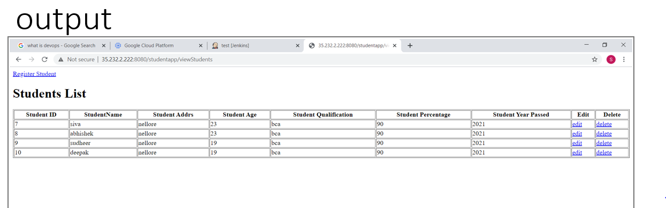

**CONCLUSION**

* DevOps is helping business in a tremendous way.
* It is bridging the gap between developers and operation team and resist change which create a smooth path for continuous development and continuous integration.
* The point is to start somewhere and make small, meaningfull changes. Measure the results and keep iterating. Take advantage of small tools and workflows that devs and ops are using.

BIBLOGRAPHY

* Javatpoint.com
* Tutorialspoint.com
* Apache.org