**TWITTER ANALYSIS AND TEXT CAPTURE**

1. How does the program work?

Data mining on Twitter is performed using the Twitter API,i.e Tweepy. Tweepy is first installed using packet management system in python, pip. To get our code working, we must create an app in the developer section of Twitter, which will then generate our 4 API keys. Using these keys as authorisation, we can retrieve data from Twitter. The given code script is used to retrieve particular tweets using the specific keywords such as string required, date and time of tweets etc in the search function. The output will be a file containing the username, time, tweet, retweet count, and followers of the user.

1. How do you think you can use this code?

The code can be used for several purposes such as data analysis, data collection from websites on different topics and sentimental analysis of tweets and statuses posted by users on social media like Twitter, Facebook respectively.

1. Can you think of different scenarios where this code could be used for data collection?

Different scenarios can be sentimental analysis, predictive analysis and finding twitter influencers and analysing follower trends.

**Token generated:**

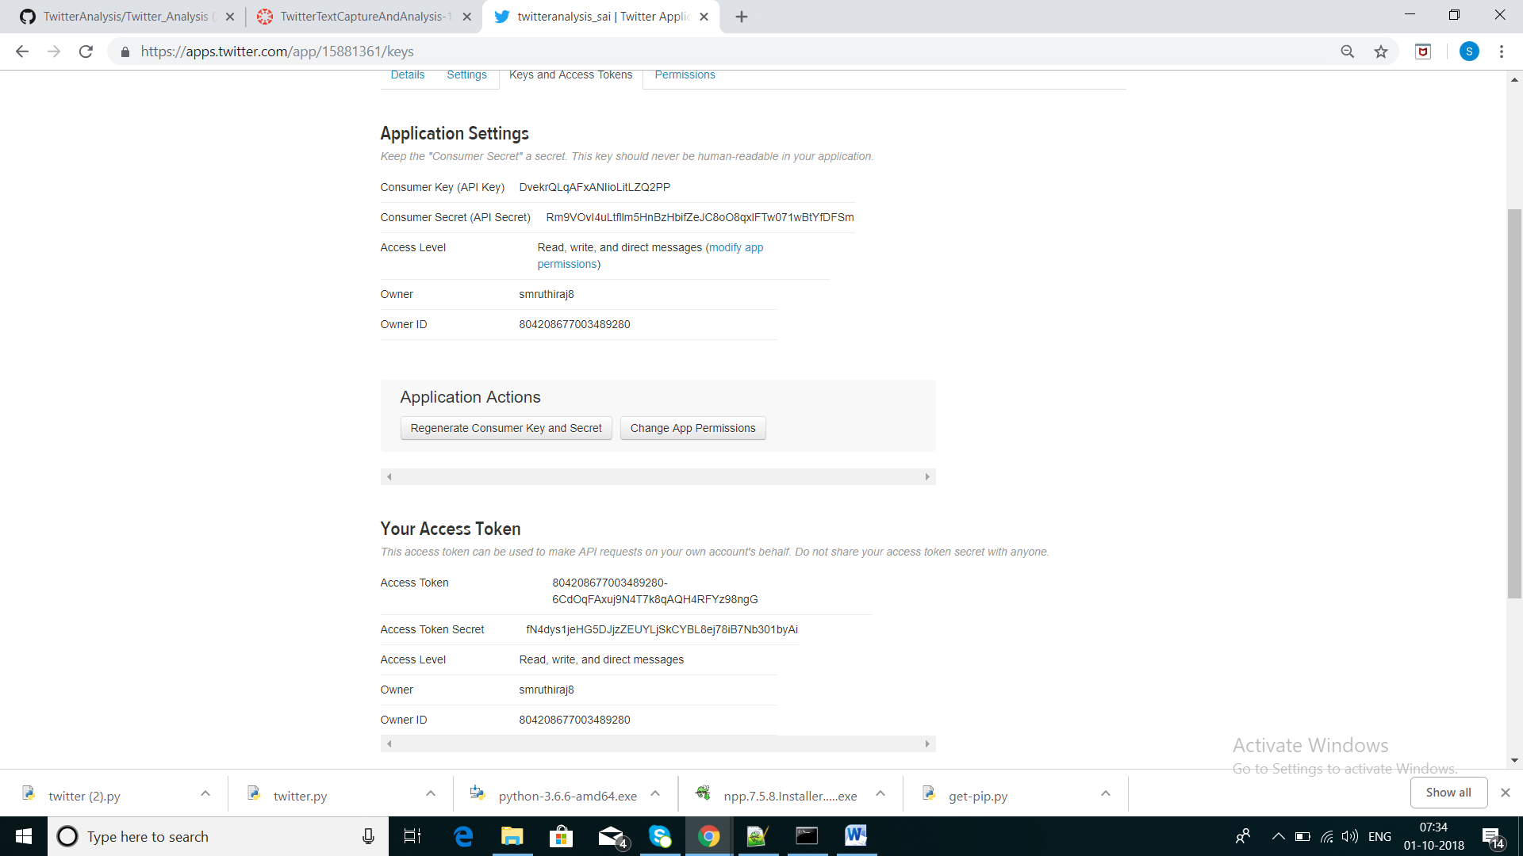

**Pip installed:**

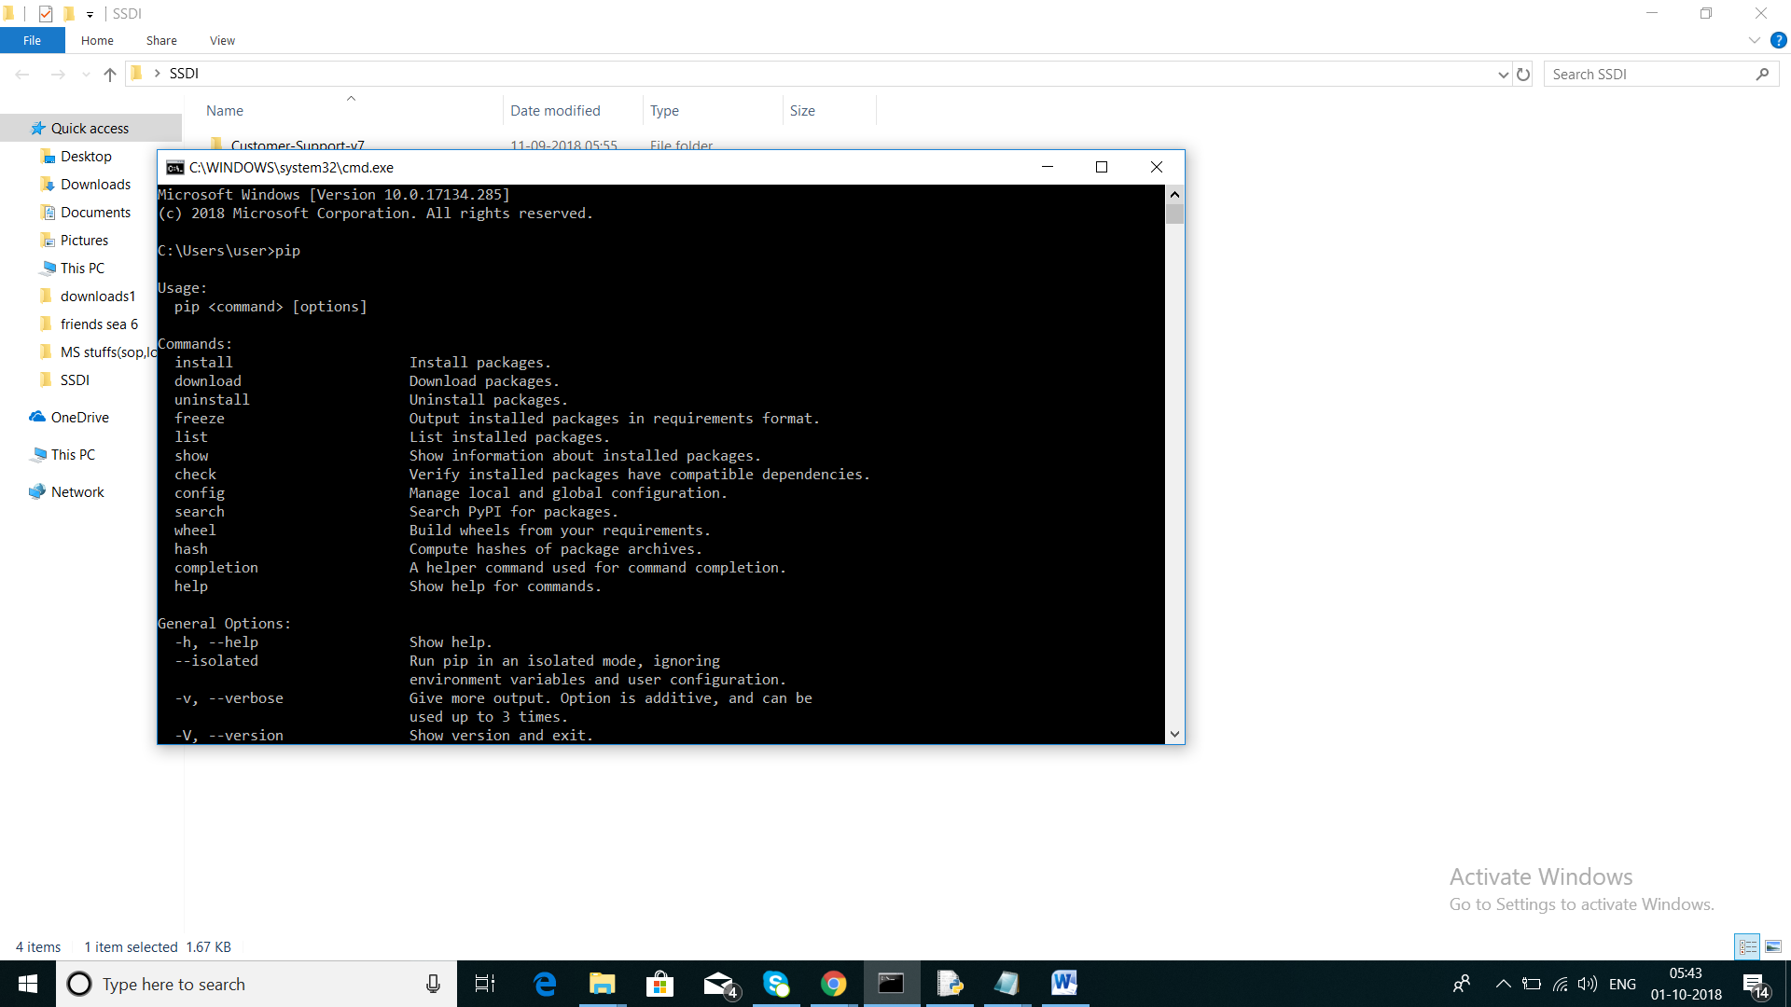

**Tweepy installed:**

***pip install tweepy=3.3.0***

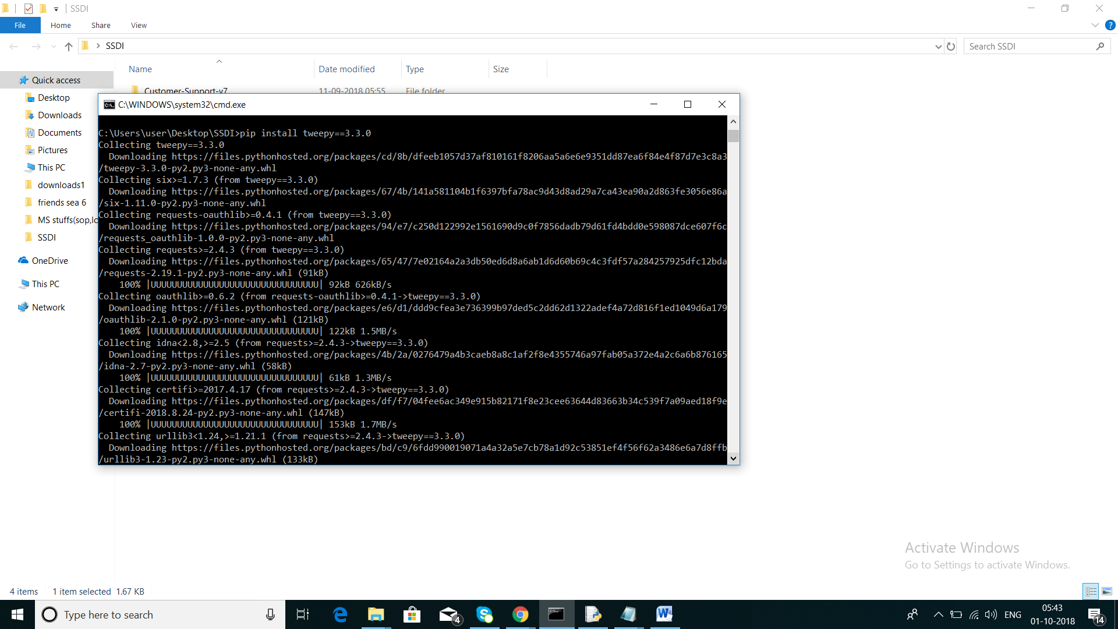

**Running twitter.py**

***python twitter.py***

Enter the search string Bigg Boss

Enter the from date (YYYY-MM-DD format) 2018-09-01

Enter the to data (YYYY-MM-DD format) 2018-09-30

Enter the number of tweets you want to retrieve for the search string 100

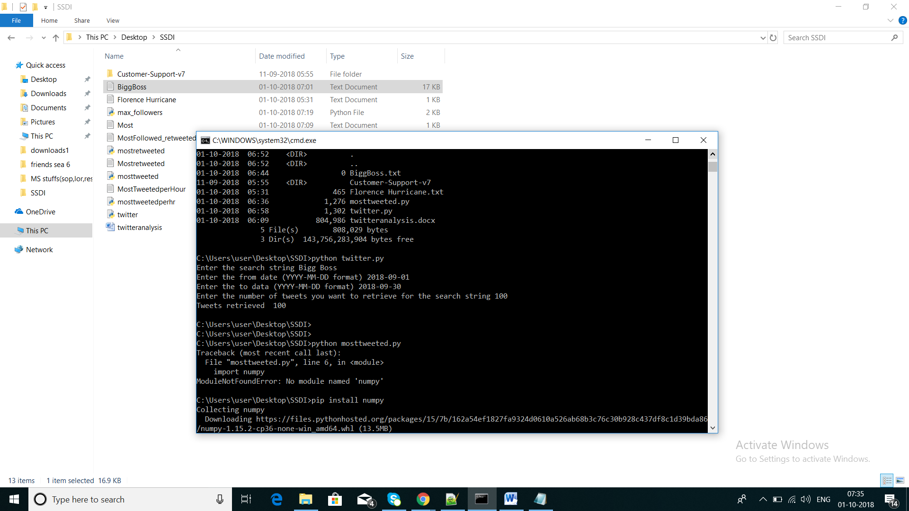

**Output file:**

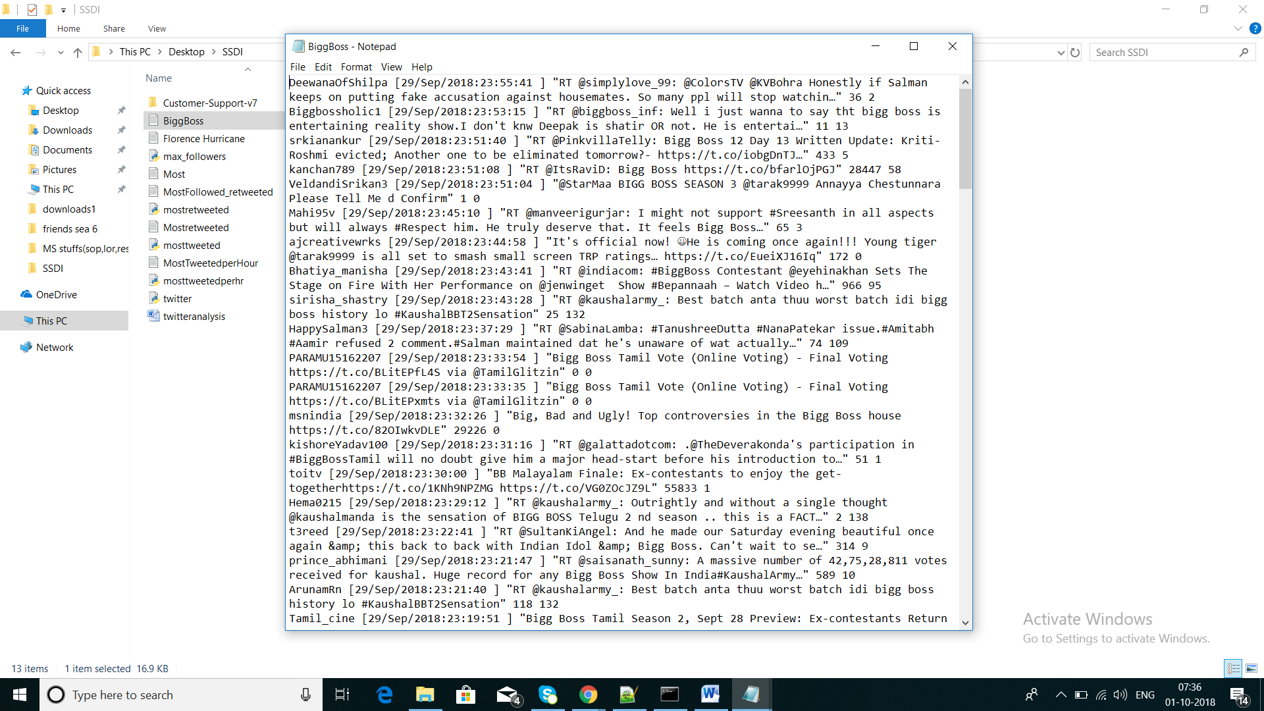

**Challenge:**

Program to read the generated file – BiggBoss.txt

Github link: