**DOCUMENTATION:**

Steps included in the process –

* Installed the MarkLogic Server
* Loaded the Database into the server – given Shakespeare database
* Wrote the sample queries on the database to ensure that the database is loaded correctly and the connection is working
* Built a web application to display the list of plays from the xml database file. Search for a word or a group of words to display the lines of script in each play where that particular word or group of words occurred; and highlight those respective words’.
* The database is connected to the back-end server using the host name, port name, username, password and ip settings.
* The backend code is written in Java. Servlets, MarkLogic API for Java is used to establish the connection between the data objects that are get through the class functions.
* The UI is designed on bootsrap framework using JQuery, Javascript, HTML and CSS. The data objects are post through the UI templates to the backend.
* Sample queries are written in Xquery to query the MLDB.
* Xquery functions are used to list and search the items of the MLBD.

Supporting Screenshots –

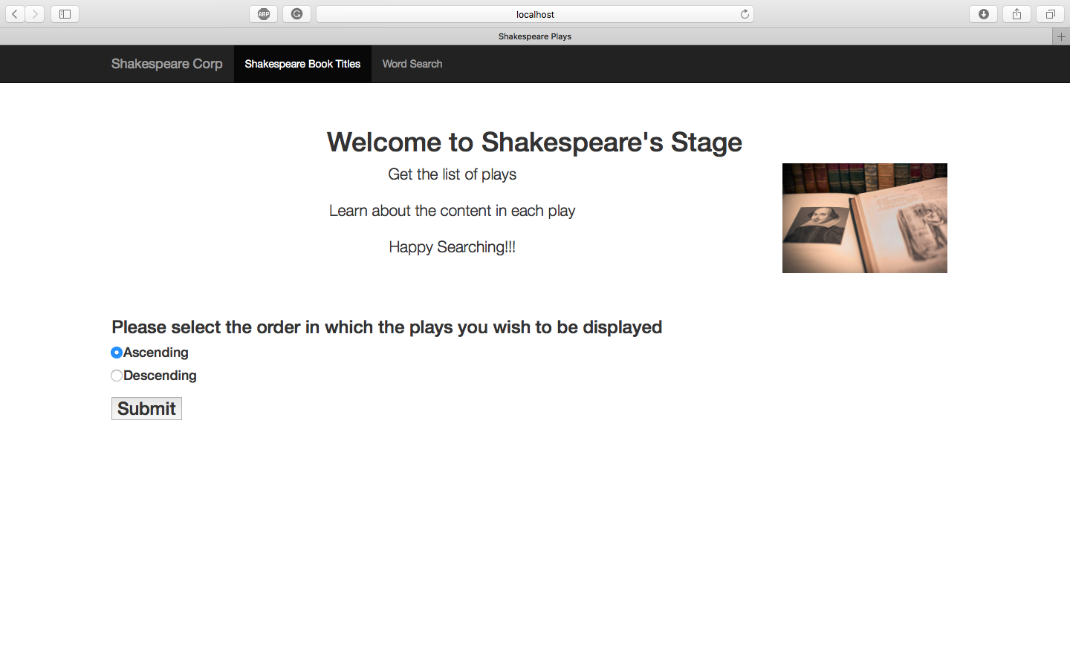

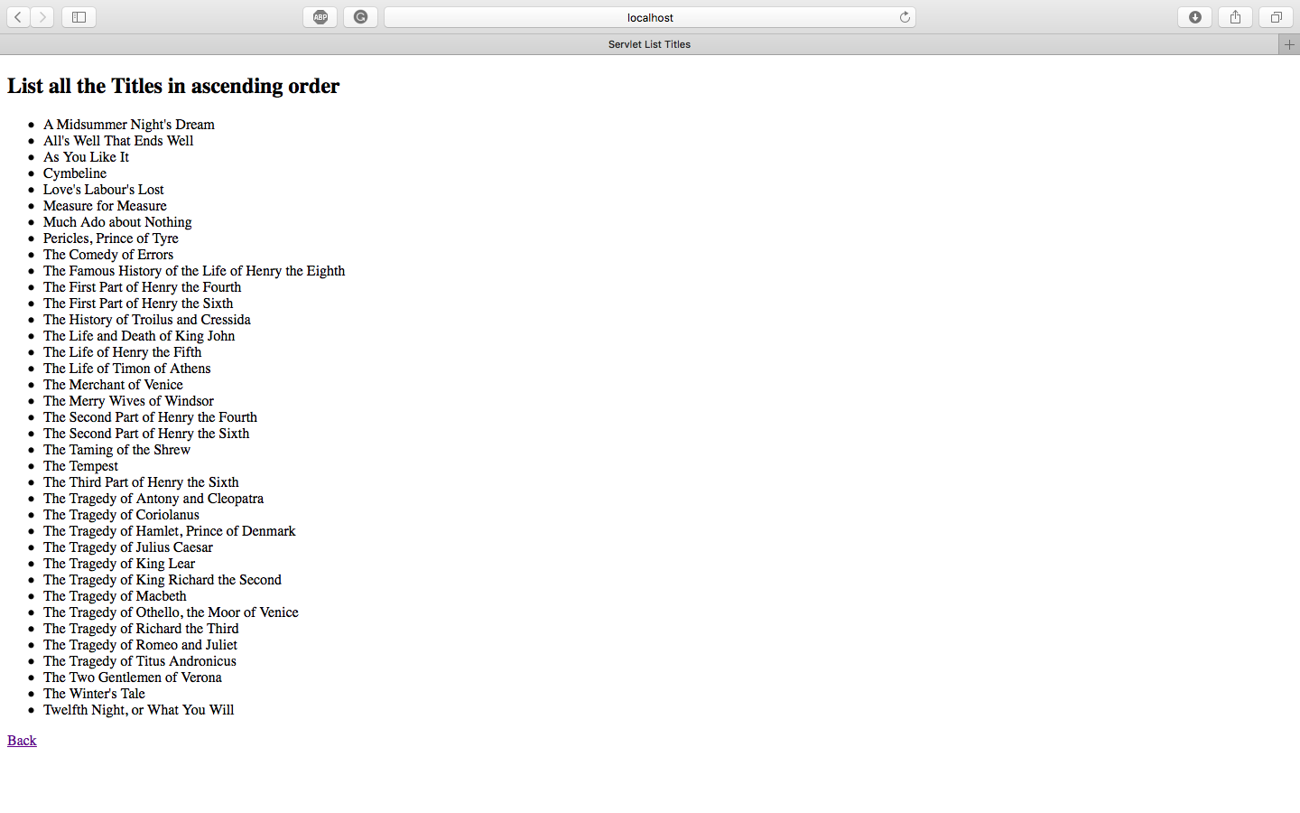

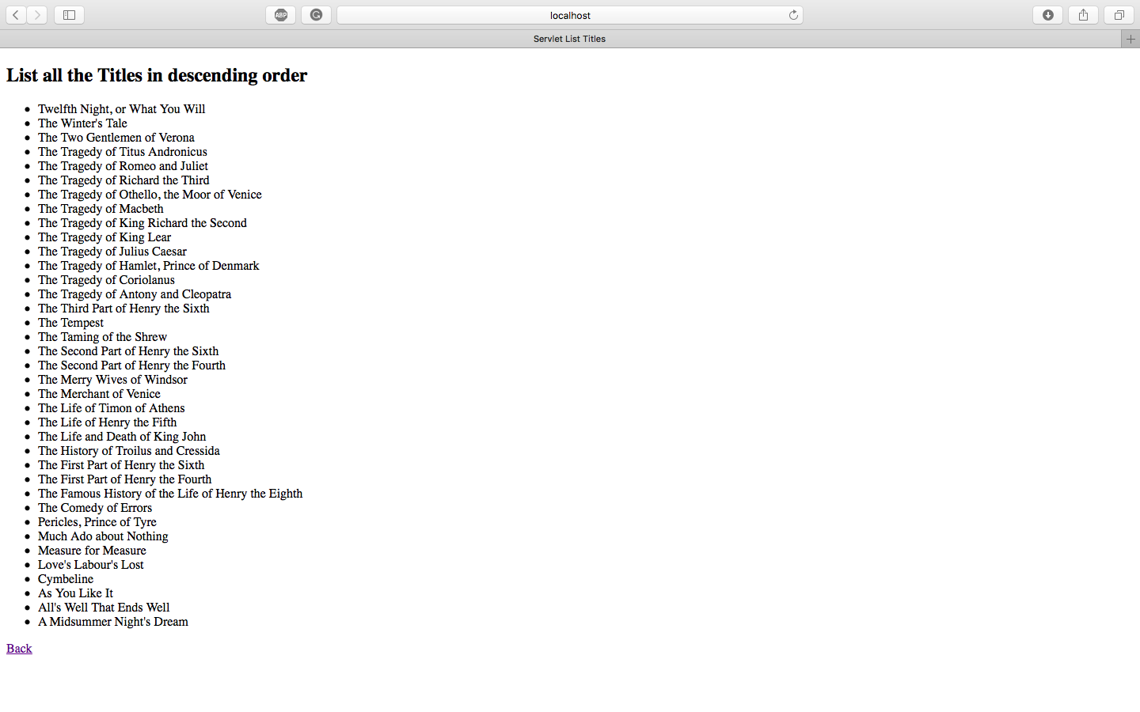

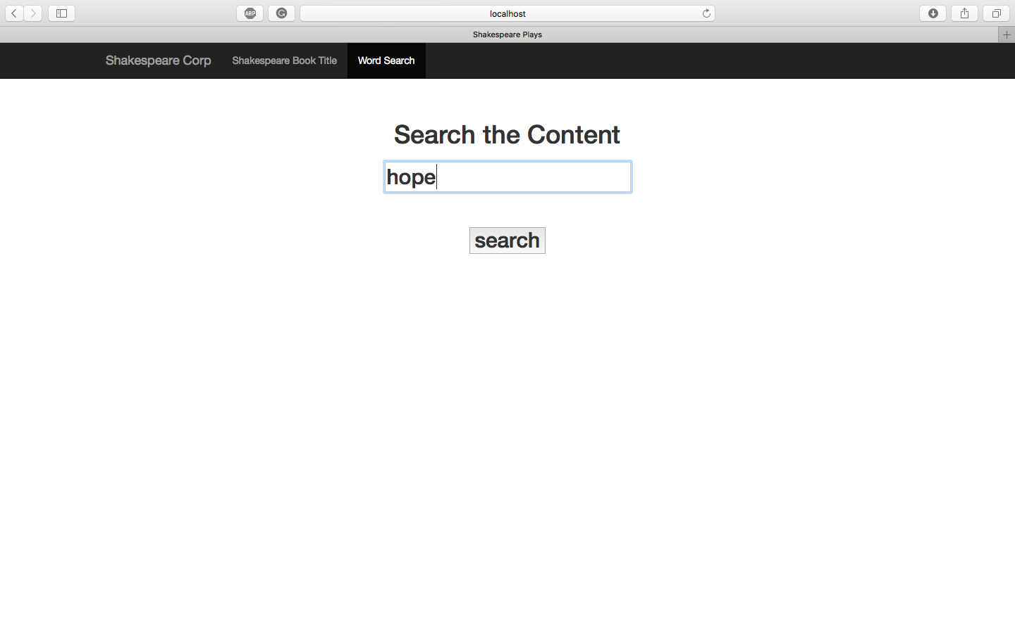

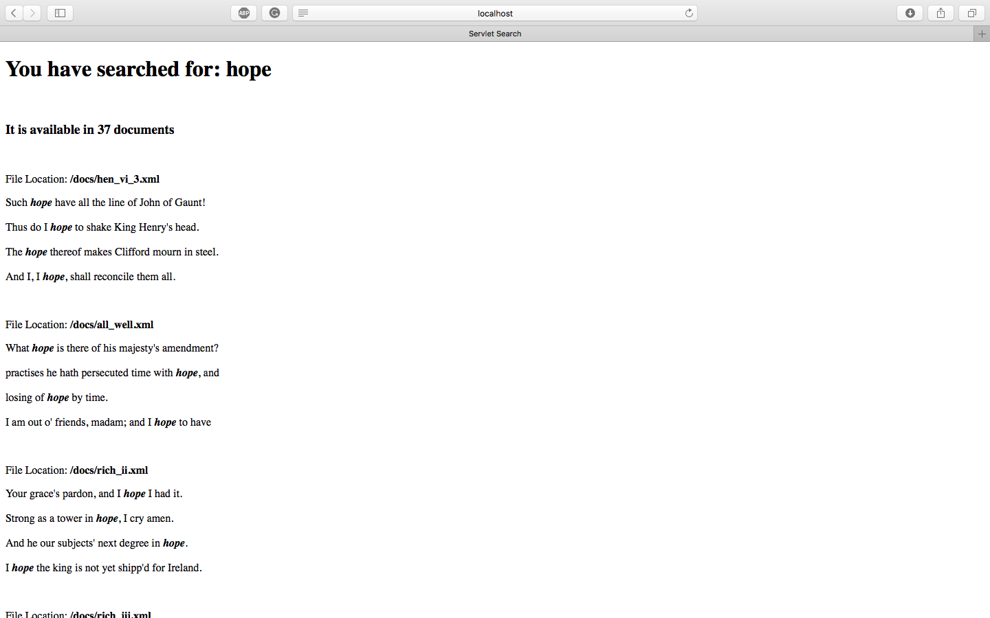

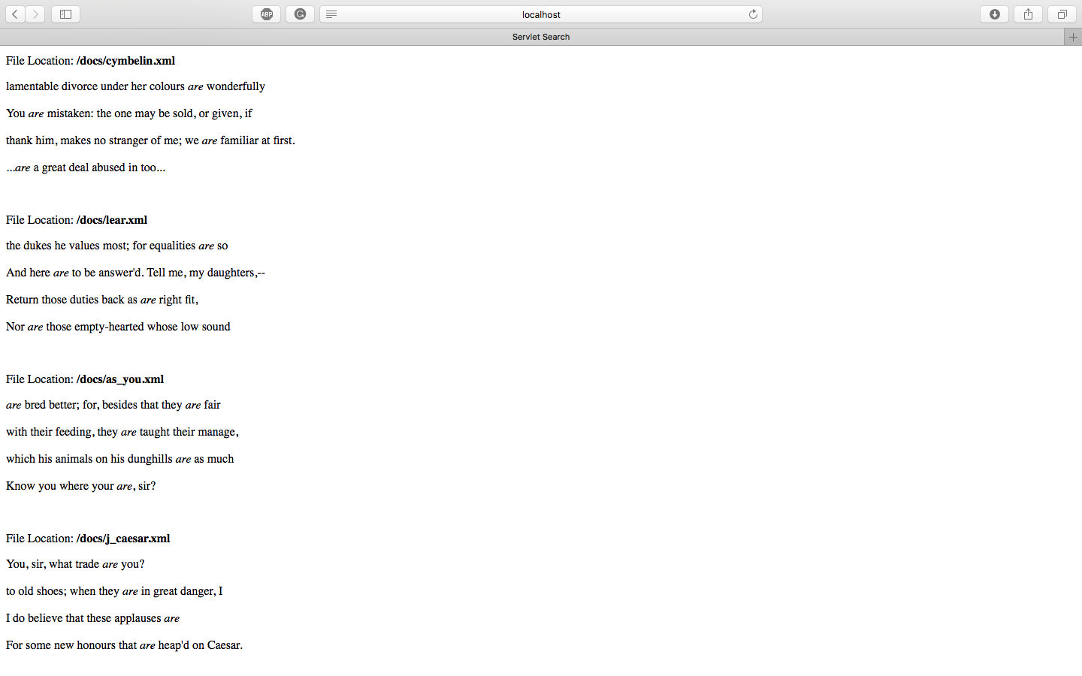

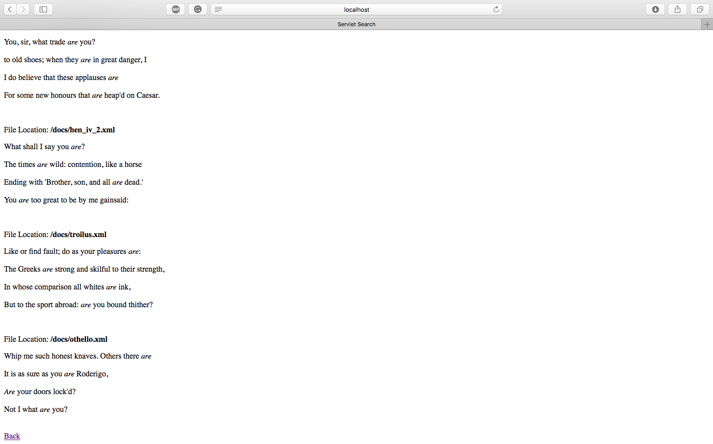

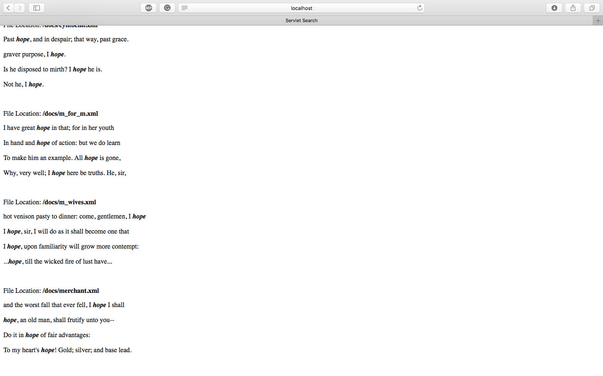

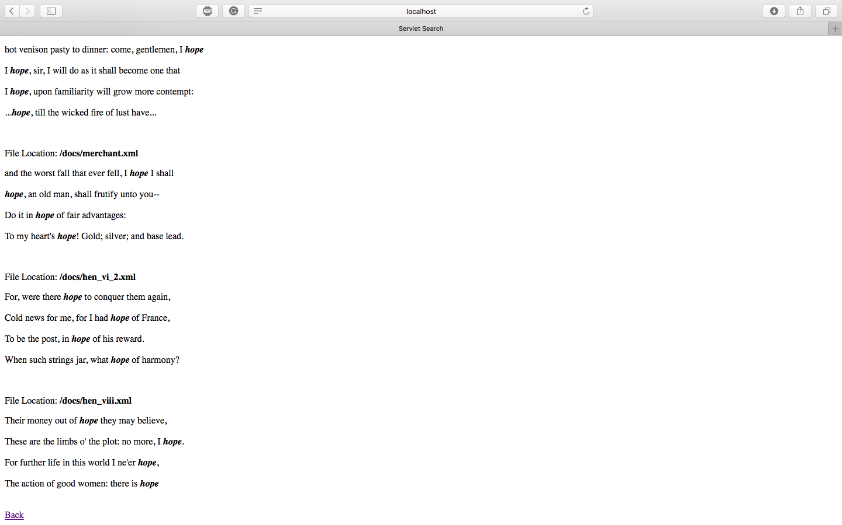

Sample Queries –

query-1

xquery version "1.0-ml";

for $x in cts:search(doc("/C/shaks200/dream.xml")/PLAY/ACT/SCENE/SPEECH/LINE, "hope")

return

cts:highlight($x, "hope", <b>{$cts:text}</b>)

------------------------------------------------------------------------

query-2

xquery version "1.0-ml";

for $speakers in distinct-values(doc()//SPEECH/LINE)

order by $speakers

return string($speakers)

Supporting Screenshots –

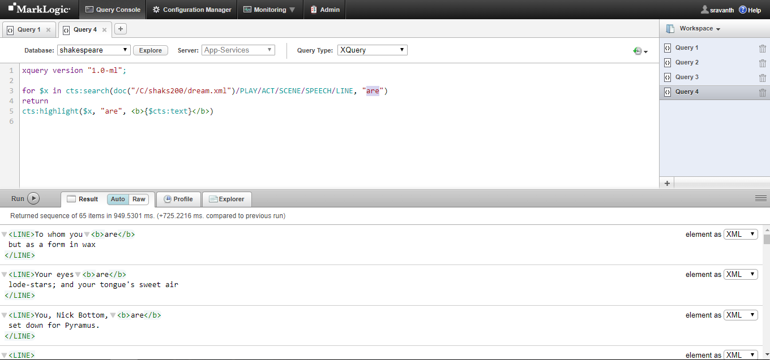

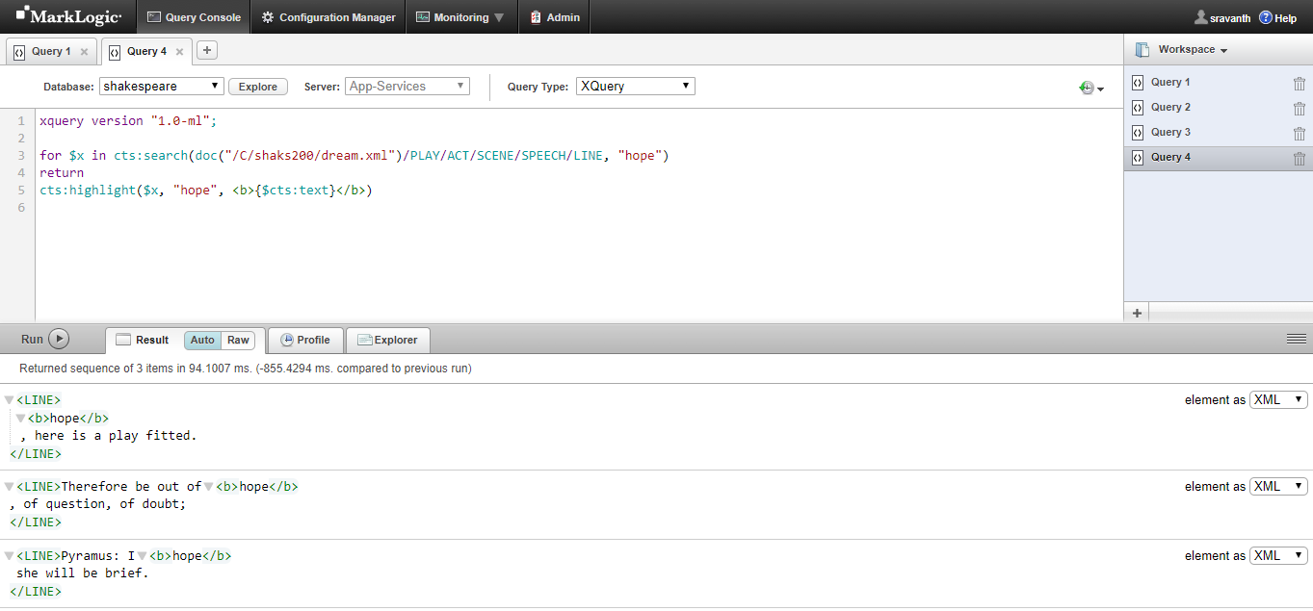

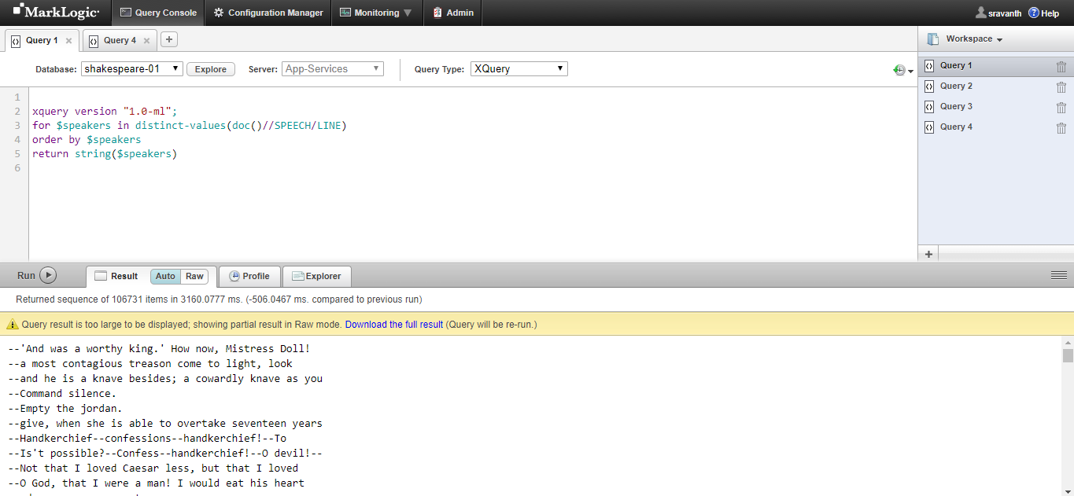

GIT:

Code and related documents uploaded in GIT. Below is the link:

<https://github.com/saisravanth/MarkLogic_Assignment.git>

References:

* <https://www.w3schools.com/xml/xquery_flwor_html.asp>
* [arklogic.com/javadoc/client/index.html?com/marklogic/client/io/QueryOptionsListHandle.html](http://arklogic.com/javadoc/client/index.html?com/marklogic/client/io/QueryOptionsListHandle.html)
* <https://docs.marklogic.com/guide/search-dev/query-options>