Deep Learning-Based Sign Language Recognition Using Video and Hand Gesture Analysis

Abstract
Sign language is the primary mode of communication for millions of deaf and hard-of-hearing individuals, yet limited sign-language literacy among the hearing population creates a lasting communication gap. Most existing automated sign recognition systems recognize only a small vocabulary of isolated words, struggle to generalize across different signers, lighting conditions and backgrounds, and rarely run fast enough for real-time use, which limits their value as everyday assistive tools.
This project proposes a Deep Learning-Based Sign Language Recognition system that analyzes ordinary webcam video to recognize hand gestures and full-body sign movements and translate them into text or speech in real time. The system extracts hand, body-pose and facial landmarks using MediaPipe Holistic and combines them with appearance features from a CNN backbone (such as EfficientNet or MobileNetV3), so the model learns both precise hand geometry and visual context. A Transformer encoder with temporal attention then models how gestures unfold over consecutive frames, enabling recognition of both isolated signs and continuous, sentence-level signing rather than single words alone.
To improve robustness, the pipeline uses landmark-based augmentation (small jitter, scaling and mirroring of skeleton points) and background randomization so recognition accuracy stays stable across signers and environments rather than overfitting to a specific camera setup. The system is trained and evaluated on established public datasets — WLASL for isolated word-level American Sign Language, RWTH-PHOENIX-Weather 2014 for continuous sign sequences, and INCLUDE for Indian Sign Language — using accuracy, F1-score, Word Error Rate (WER) and real-time inference speed (frames per second) as evaluation metrics. The goal is a lightweight, deployable model that targets a measurable accuracy improvement over baseline architectures reported in the literature while remaining fast enough for practical use in mobile apps, video-call plugins, or assistive kiosks.

Problem Statement
Deaf and hard-of-hearing individuals often face difficulty communicating with people who do not know sign language, especially in everyday settings such as schools, hospitals, and public offices. Current sign-language recognition tools are typically restricted to a narrow vocabulary of isolated signs, are highly sensitive to the specific signer, background, and lighting used during training, and are usually too slow or too resource-heavy for real-time, on-device use. There is a need for a system that can recognize continuous, natural signing from ordinary video with high accuracy, low latency, and good generalization across users and environments.

Objectives
- Design a deep learning pipeline that recognizes sign language gestures directly from video captured on a standard camera.
- Fuse hand/body/face landmark features (MediaPipe Holistic) with CNN-based appearance features for richer gesture representation.
- Use a Transformer-based temporal model to handle variable-length gesture sequences and support continuous (sentence-level) recognition, not just isolated words.
- Improve robustness to signer, lighting, and background variation through landmark-level and visual data augmentation.
- Benchmark the model on standard datasets (WLASL, RWTH-PHOENIX-Weather, INCLUDE) against reported baseline accuracies and demonstrate a measurable improvement.
- Build a real-time demo interface that converts recognized signs into text and speech output.

Datasets
Dataset | Description | Link
WLASL (Word-Level ASL) | 2,000+ isolated American Sign Language words, 21k+ videos | dxli94/WLASL (GitHub)
RWTH-PHOENIX-Weather 2014 | Continuous German Sign Language, weather broadcast domain | www-i6.informatik.rwth-aachen.de
INCLUDE (Indian Sign Language) | 4,287 videos, 263 signs across everyday categories | AI4Bharat / IIIT-B INCLUDE dataset
How2Sign | Multi-modal ASL dataset with video, depth, speech and text | how2sign.github.io

Approach (High-Level Pipeline)
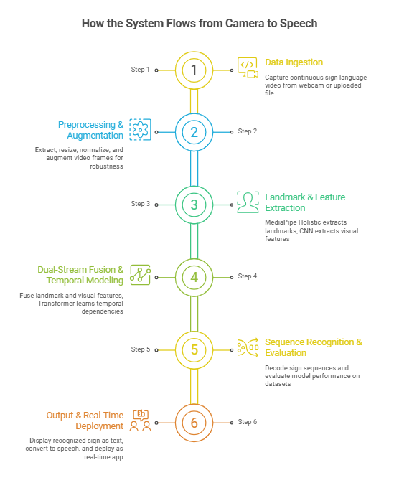

Project Group Members
S.No. | Roll No. | Student Name
1 | 2420030168 | KOSARAJU SAI SREE CHOWDARY

