**ASSIGNMENT-1:**

**IaaS , PaaS & SaaS**

**DONE BY:**

**BL.EN.U4CSE15070 – M.Harsha**

**BL.EN.U4CSE15076 – M.Manideep**

**BL.EN.U4CSE15098 -Raghul Thukaram**

* IaaS (Infrastructure as a Service), as the name suggests, provides you the computing infrastructure, physical or (quite often) virtual machines and other resources like virtual-machine disk image library, block and file-based storage, firewalls, load balancers, IP addresses, virtual local area networks etc.

Examples: Amazon EC2, Windows Azure, Rackspace, Google Compute Engine.

* PaaS (Platform as a Service), as the name suggests, provides you computing platforms which typically includes operating system, programming language execution environment, database, web server etc.

Examples: AWS Elastic Beanstalk, Windows Azure, Heroku, Force.com, Google App Engine, Apache Stratos.

* While in SaaS (Software as a Service) model you are provided with access to application software often referred to as "on-demand software". You don't have to worry about the installation, setup and running of the application. Service provider will do that for you. You just have to pay and use it through some client.

Examples: Google Apps, Microsoft Office 365.

IaaS(Infrastucture as a Service) by Microsoft Azure

Microsoft Azure, formerly known as Windows Azure, is Microsoft's public cloud computing platform. It provides a range of cloud services, including those for compute, analytics, storage and networking. Users can pick and choose from these services to develop and scale new applications, or run existing applications, in the public cloud.

Microsoft Azure is widely considered both a [Platform as a Service (PaaS)](http://searchcloudcomputing.techtarget.com/definition/Platform-as-a-Service-PaaS) and [Infrastructure as a Service (IaaS)](http://searchcloudcomputing.techtarget.com/definition/Infrastructure-as-a-Service-IaaS) offering.

Microsoft categorizes Azure services into 11 main product types:

* Compute – these services provide [virtual machines](http://searchservervirtualization.techtarget.com/definition/virtual-machine), [containers](http://searchservervirtualization.techtarget.com/definition/container-based-virtualization-operating-system-level-virtualization), batch processing and remote application access.
* Web and mobile – these services support the development and deployment of web and mobile applications, and also offer features for API management, notification and reporting.
* Data storage – this category includes [Database as a Service](http://whatis.techtarget.com/definition/Database-as-a-Service-DBaaS) offerings for [SQL](http://searchsqlserver.techtarget.com/answer/What-is-SQL) and [NoSQL](http://searchdatamanagement.techtarget.com/definition/NoSQL-Not-Only-SQL), as well as unstructured and cached cloud storage.
* Analytics – these services provide distributed analytics and storage, as well as [real-time analytics](http://searchcrm.techtarget.com/definition/real-time-analytics), [big data](http://searchcloudcomputing.techtarget.com/definition/big-data-Big-Data) analytics, [data lakes](http://searchaws.techtarget.com/definition/data-lake), [machine learning](http://whatis.techtarget.com/definition/machine-learning) and [data warehousing](http://searchsqlserver.techtarget.com/definition/data-warehouse).
* Networking – this group includes [virtual networks](http://searchservervirtualization.techtarget.com/definition/virtual-networking), dedicated connections and [gateways](http://internetofthingsagenda.techtarget.com/definition/gateway), as well as services for traffic management, [load balancing](http://searchnetworking.techtarget.com/definition/load-balancing) and [domain name system (DNS)](http://searchnetworking.techtarget.com/definition/domain-name-system) hosting.
* Media and [content delivery network (CDN)](http://searchaws.techtarget.com/definition/content-delivery-network-CDN) – these services include on-demand streaming, encoding and media playback and indexing.
* Hybrid integration – these are services for server backup, site recovery and connecting [private](http://searchcloudcomputing.techtarget.com/definition/private-cloud) and [public clouds](http://searchcloudcomputing.techtarget.com/definition/public-cloud).
* Identity and access management (IAM) – these offerings ensure only authorized users can employ Azure services, and help protect encryption keys and other confidential information.
* Internet of Things (IoT) – these services help users capture, monitor and analyze [IoT](http://internetofthingsagenda.techtarget.com/definition/Internet-of-Things-IoT)data from sensors and other devices.
* Development – these services help application developers share code, test applications and track potential issues. Azure support a range of application programming languages, including JavaScript, Python, .NET and Node.js.
* Management and security – these products help cloud administrators manage their Azure deployment, schedule and run jobs, and create automation. This product group also includes capabilities for identifying and responding to cloud security threats..

To ensure availability, Microsoft has Azure data centers located around the world. As of January 2016, Microsoft said Azure services are available in 22 regions across the globe, including in the United States, Europe, Asia, Australia and Brazil.

### PRICING FOR APP SERVICEAzure Service Fabric

You can deploy your applications inside of [Azure Service Fabric](https://azure.microsoft.com/services/service-fabric/). This is the layer of ‘magic’ that has been powering services like Azure SQL Databases and App Services for years and is now available for you to use yourself. When I say that Service Fabric is a layer of magic, I mean that it provides capabilities that really seem magical. When you deploy your application in Azure Service Fabric, it becomes automatically load-balanced. It becomes self-healing. It scales automatically. It is highly available. And when you deploy a new version of your application, it is upgraded without downtime and you can revert the deployment. You get all of this out-of-the-box.

### Virtual Machines

When you need a lot of control, or when you are lifting and shifting applications to the cloud, you can run them in [Virtual Machines](https://azure.microsoft.com/services/virtual-machines/). You can install everything that you need to run your application on a Virtual Machine. You can control everything from the Operating System to Antivirus. This also means that you are responsible for those things. You need to make sure that your application stays available, performant and secure. This is not an easy task, and it’s a tradeoff between control and responsibility.

Virtual Machines can be rolled out using images that describe everything that is installed on the Virtual Machine. You can also use these on-premises and on your own computer, but getting these to the cloud is a relatively slow process. You need to upload multi-gigabyte images and after that, it can take minutes for a Virtual Machine to be provisioned and fully started. You need to consider this when using Virtual Machines. They provide the most flexibility and the most complexity.

### Containers

Like Virtual Machines, you can use containers when you need a lot of control. They allow you to install whatever software you need to run your applications, and they are a lot faster to deploy than Virtual Machines. Think of containers as processes where VMs are operating systems. Containers can spin up and start in seconds, which is useful if you want to spin one up for testing and then get rid of it.

### Azure App Services

When you don’t need full control and want to focus on just building your application, you can run your application in [Azure App Services](https://azure.microsoft.com/services/app-service/). You can just [deploy your application to App Services](https://stackify.com/top-azure-app-services-limitations/) and it runs, no need to worry about the Operating System or Antivirus. Some of the App Services even go as far as to take care of the scaling for you as they are “serverless”.

There are several App Service types:

* Web Apps for hosting your web application or API in;
* Mobile Apps for hosting a backend for your mobile applications in
* Function Apps that run one or more Azure Functions. Azure Functions are small pieces of code that scale automatically and can be triggered by outside services
* Logic Apps, in which you configure a workflow with triggers, connectors and conditions. These also scale automatically and can be triggered by outside services

The main advantage of using App Services is that they offer a lot of additional capabilities out-of-the-box, like [auto-scaling](https://stackify.com/autoscale-azure-app-services-cloud-services/), authentication and deployment slots. These are all [Platform-as-a-Service providers](https://stackify.com/top-azure-paas-services-developers/).

A disadvantage is that you don’t have control over things that are installed in the environment (like .NET Framework versions). You can’t access or install anything on the underlying servers.

IAAS website service launch:

[Websites](https://en.wikipedia.org/wiki/Microsoft_Azure_Web_Sites), high density hosting[[*non sequitur*](https://en.wikipedia.org/wiki/Wikipedia:Please_clarify)] of websites allows developers to build sites using [ASP.NET](https://en.wikipedia.org/wiki/ASP.NET), [PHP](https://en.wikipedia.org/wiki/PHP), [Node.js](https://en.wikipedia.org/wiki/Node.js), or [Python](https://en.wikipedia.org/wiki/Python_(programming_language)) and can be deployed using [FTP](https://en.wikipedia.org/wiki/File_Transfer_Protocol), [Git](https://en.wikipedia.org/wiki/Git_(software)), [Mercurial](https://en.wikipedia.org/wiki/Mercurial), [Team Foundation Server](https://en.wikipedia.org/wiki/Team_Foundation_Server) or uploaded through the user portal. This feature was announced in preview form in June 2012 at the Meet Microsoft Azure event.[[5]](https://en.wikipedia.org/wiki/Microsoft_Azure#cite_note-meetnew-5) Customers can create websites in PHP, ASP.NET, Node.js, or Python, or select from several open source applications from a gallery to deploy. This comprises one aspect of the IaaS offerings for the Microsoft Azure Platform. It was renamed to Web Apps in April 2015.

# PLANS PROVIDED BY AZURE:

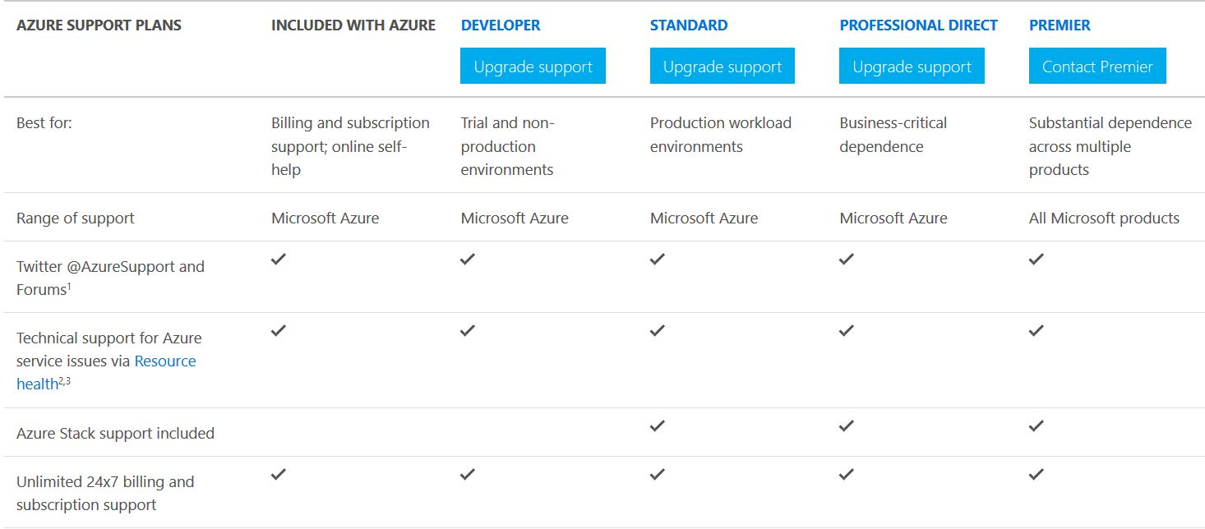

# SPECALITY OF AZURE:

# Security

### Decades of experience

In today’s complex and regulated environment, businesses need to focus on building more secure solutions that deliver value to their customers, partners, and shareholders—both in the cloud and on-premises. Microsoft has decades-long experience building enterprise software and running some of the largest online services in the world. We use this experience to implement and continuously improve security-aware software development, operational management, and threat-mitigation practices that are essential to the strong protection of services and data.

### Assume breach

The guiding principle of our security strategy is to “assume breach.” The Microsoft global incident response team works around the clock to mitigate the effects of any attack against our cloud services. And security is built into Microsoft business products and cloud services from the ground up, starting with the [Security Development Lifecycle](https://www.microsoft.com/en-us/sdl/), a mandatory development process that embeds security requirements into every phase of the development process.

### Commitment to compliance

Microsoft also complies with both international and industry-specific compliance standards and participates in rigorous third-party audits that verify our security controls.

### Security Features Offered by Azure to Secure Data and Application

Depending on the cloud service model, there is variable responsibility for who is responsible for managing the security of the application or service. There are capabilities available in the Azure Platform to assist you in meeting these responsibilities through built-in features, and through partner solutions that can be deployed into an Azure subscription.

## Operations

This section provides additional information regarding key features in security operations and summary information about these capabilities.

* Operations Management Suite Security and Audit Dashboard
* Azure Resource Manager
* Application insights
* Azure nmonitor
* Log analytics
* Azure advisor
* Azure security center

## Applications

The section provides additional information regarding key features in application security and summary information about these capabilities.

* Web application vulnerability
* Penetrating test
* Web application firewall
* Authentication
* Layered structure web and application diagnostics

## Storage

The section provides additional information regarding key features in Azure storage security and summary information about these capabilities.

* Role Based Access Control-RBAC
* Shared Access Signature
* Encryption in transmission and rest

## Networking

The section provides additional information regarding key features in Azure network security and summary information about these capabilities.

* Network layer control
* Network security groups
* Route control
* Virtual network security applications
* VPN gateway,express route and Application gateway
* Web application firewall and azure DNS

## Compute

The section provides additional information regarding key features in this area and summary information about these capabilities.

* Anti malware and anti virus
* Virtual memory backup
* Site recovery

## Identify and access management

Securing systems, applications, and data begins with identity-based access controls. The identity and access management features that are built into Microsoft business products and services help protect your organizational and personal information from unauthorized access while making it available to legitimate users whenever and wherever they need it.

* Security identity
* Secure apps and data

# SELF SERVICE PROVISION:

Virtual Machines (IaaS):

Azure gives you the ability to create VMs simply by specifying the size and the Virtual Hard Disk (VHD) you want to use. The VHD is the virtual version of a hard drive on a conventional computer; it’s the storage unit on which all the files and applications are saved. Microsoft Azure provides access to both Windows and Linux VHDs, so it accommodates developers with expertise in either. And with this service as well, you only pay according to how much time the VM is actually running.

One of the big advantages of VMs is that developers can use them to build and test applications quickly at low cost. You can also use VMs to augment on-site datacenters to boost the power of applications like SharePoint. Since Azure Virtual Machines essentially gives you the computing substrate for your applications through a service subscription, it falls into the category of Infrastructure as a Service (IaaS).

You can make use of virtualization in your on-site datacenters, but if you’re using Azure you’ll definitely be relying on virtual machines to one extent or another. To create virtual servers on physical servers, you use software that sets up divisions between each virtual machine (VM) and allows them all to operate independently. What this does is add a layer of abstraction between your information and the physical infrastructure that hosts it. This in turn gives you more flexibility in how you manage and protect the various elements of your computing environment.

Web Sites:

You can use Azure as a platform for creating and hosting websites and web applications. Web Sites supports several different development tools and content management systems. And it provides a low cost way to make your site available to however many visitors use it without having to maintain or upgrade any on-site servers. Hosting your website on Azure allows you to take advantage of autoscaling, which means your server capacity will be automatically augmented to accommodate spikes in traffic, but it will return to normal once the spike is over. Again, you only pay for the capacity you actually use.

Mobile Services (mBaaS):

Like Cloud Services, Azure’s Mobile Services give you the tools to create and deploy applications, but obviously in this case the apps are targeted for mobile devices. The information that gets accessed by the app running on your device is stored in what’s called a back-end database, and so Mobile Services is referred to as mobile Back-end as a Service (mBaaS). With Azure, you can build apps for Android, iOS, HTML/ JavaScript, and Windows Phone.

You get three basic advantages from using cloud platforms and infrastructure as opposed to on-site machines:

1. Quicker Development

Purchasing new servers, configuring them, and integrating them into your existing environment tends to be both costly and time-consuming. With Azure, you can set up an application and start building it out in minutes.

2. Auto scaling

Demand for your applications may be variable throughout the year (think tax return filing software). Or you may expect a low number of users at first followed by huge growth as your application catches on. You may even expect usage to the decline, maybe because you’re launching another application. Scaling up with your own on-site servers means purchasing and provisioning them to accommodate growth. And once the servers are in place you still have to maintain them even if they’re not being used.

3. Easier Maintenance and Backup

On-site server farms require a lot of regular upkeep: climate control, electricity, disaster recovery, backups, security. Moving to the cloud means freeing up your IT staff so they can focus on new projects instead of routine maintenance.

# USER FLEXIBILITY:

## Interoperability is key

Tomorrow's apps will be built in a fundamentally different way that requires flexible tools and infrastructure. As part of this evolution, it will be important to be able to spin up apps quickly on Linux virtual machines or Docker containers and blend multiple data types. In addition, it’s critical that systems support different storage types and the ability to incorporate big data. The right cloud solution means an infrastructure that's flexible enough to meet developer needs while being available on demand, anytime, anywhere. That flexibility allows developers to focus on development work and use the tools that they want to use, and not be shoehorned into a limited tool set.

## The right tools for the job

To cut down development time, find a cloud provider that offers a rich ecosystem of end-to-end solutions. Developers leveraging open source technologies should be able to work with the tools they love, right out of the box. A cloud service should pack in support for stacks such as Cassandra, MongoDB, MySQL, and Hadoop. But that's just the beginning. It also needs to seamlessly integrate with existing apps and data storage solutions, so devs aren’t wasting valuable development time trying to make things work together that should already work together.

Developers should feel empowered by their cloud solution to program what they want in the way they want. Support for PHP, Java, Python, and Node.js, on iOS, Android, and Windows devices, is a must. Whatever the platform and whatever the tool, developers' productivity should be enhanced by their IT environment, not hindered by it.

## Code, not operations

The last consideration is the ability to streamline development processes, so coders can focus on coding, not operational tasks like building APIs, databases, and connectors. Rapid building, deployment, and management of applications mean devs can do what used to be “the last 10 percent” continuously throughout the development process. Robust cloud solutions provide prebuilt APIs and connectors to automate processes, and work with the tools devs choose, such as Git, Jenkins, Puppet, and Chef, to support their development process. That way, developers stay on the front lines of innovation and creativity instead of spending time on tedious operational tasks.

## Free the developers

Choosing the right cloud solution—one that supports open source collaborative rock stars—will free developers to do what they do best: get to the finish line faster and be creative. It will provide flexible tools and infrastructure, provide a rich ecosystem of end-to-end solutions, and help streamline development processes by automating operational tasks. Soar through all 100 percent with as few bumps as possible, with a cloud solution that sets developers free to be the best they can be.

# HOW AZURE PROVIDES COST EFFICIENCY:

### Most value for every cloud dollar spent

With [Azure Cost Management,](https://azure.microsoft.com/en-us/services/cost-management/) Azure is the only platform that offers an end-to-end cloud cost management and optimization solution to help customers make the most of cloud investment across multiple clouds. Cost Management is free to all customers to manage their Azure spend. Azure is the [most cost-effective cloud](https://azure.microsoft.com/en-us/blog/announcing-general-availability-of-azure-reserved-vm-instances-ris/) for Windows Server workloads. If you are a Windows Server customer with Software Assurance, you can combine Azure Reserved Instances (RIs) with Azure Hybrid Benefits and save up to 82% compared to pay-as-you-go prices, and up to 67% compared to AWS RIs for Windows VMs. In addition, with Azure Hybrid Benefit for SQL Server, customers with Software Assurance will be able to save even more.

Azure provides the broadest set of security and management capabilities built into a public cloud platform. With these capabilities, customers can more easily secure and manage hybrid infrastructure resources while achieving significant cost savings. Activate Security Center, Backup, Log Analytics and Cost Management today to ensure a secure and well-managed cloud infrastructure with optimized efficiency.

# EASE IN MAINTANING SERVERS:

Azure periodically performs updates to improve the reliability, performance, and security of the host infrastructure for virtual machines. These updates range from patching software components in the hosting environment (like operating system, hypervisor, and various agents deployed on the host), upgrading networking components, to hardware decommissioning. The majority of these updates are performed without any impact to the hosted virtual machines. However, there are cases where updates do have an impact:

* If the maintenance does not require a reboot, Azure uses in-place migration to pause the VM while the host is updated.
* If maintenance requires a reboot, you get a notice of when the maintenance is planned. In these cases, you'll also be given a time window where you can start the maintenance yourself, at a time that works for you.

## In-place VM migration

When updates don't require a full reboot, an in-place live migration is used. During the update the virtual machine is paused for about 30 seconds, preserving the memory in RAM, while the hosting environment applies the necessary updates and patches. The virtual machine is then resumed and the clock of the virtual machine is automatically synchronized.

For VMs in availability sets, update domains are updated one at a time. All VMs in one update domain (UD) are paused, updated and then resumed before planned maintenance moves on to the next UD.

Some applications may be impacted by these types of updates. Applications that perform real-time event processing, like media streaming or transcoding, or high throughput networking scenarios, may not be designed to tolerate a 30 second pause.

## Maintenance requiring a reboot

When VMs need to be rebooted for planned maintenance, you are notified in advance. Planned maintenance has two phases: the self-service window and a scheduled maintenance window.

The **self-service window** lets you initiate the maintenance on your VMs. During this time, you can query each VM to see their status and check the result of your last maintenance request.

When you start self-service maintenance, your VM is moved to a node that has already been updated and then powers it back on. Because the VM reboots, the temporary disk is lost and dynamic IP addresses associated with virtual network interface are updated.

If you start self-service maintenance and there is an error during the process, the operation is stopped, the VM is not updated and it is also removed from the planned maintenance iteration. You will be contacted in a later time with a new schedule and offered a new opportunity to do self-service maintenance.

When the self-service window has passed, the **scheduled maintenance window** begins. During this time window, you can still query for the maintenance window, but no longer be able to start the maintenance yourself.

# WORK FROM ANY WHERE WITH THE HELP OF AZURE PORTAL:

ew and manage all of your applications in one unified hub—including web apps, databases, virtual machines, virtual networks, storage, and Visual Studio team projects. Enjoy the flexibility of using the Azure portal's graphical experience or the integrated command-line experience provided by [Cloud Shell](https://azure.microsoft.com/en-in/features/cloud-shell/).

BACKINGUP DATA MADE EASIER:

Backingup the dat has been amde more safe and easier by the following methods in windows azure:

**Automatic storage management** - Hybrid environments often require heterogeneous storage - some on-premises and some in the cloud. With Azure Backup, there is no cost for using on-premises storage devices. Azure Backup automatically allocates and manages backup storage, and it uses a pay-as-you-use model. Pay-as-you-use means that you only pay for the storage that you consume. For more information, see the [Azure pricing article](https://azure.microsoft.com/pricing/details/backup).

**Unlimited scaling** - Azure Backup uses the underlying power and unlimited scale of the Azure cloud to deliver high-availability - with no maintenance or monitoring overhead. You can set up alerts to provide information about events, but you don't need to worry about high-availability for your data in the cloud.

**Multiple storage options** - An aspect of high-availability is storage replication. Azure Backup offers two types of replication: [locally redundant storage](https://docs.microsoft.com/en-us/azure/storage/common/storage-redundancy#locally-redundant-storage) and [geo-redundant storage](https://docs.microsoft.com/en-us/azure/storage/common/storage-redundancy#geo-redundant-storage). Choose the backup storage option based on need:

* Locally redundant storage (LRS) replicates your data three times (it creates three copies of your data) in a paired datacenter in the same region. LRS is a low-cost option for protecting your data from local hardware failures.
* Geo-redundant storage (GRS) replicates your data to a secondary region (hundreds of miles away from the primary location of the source data). GRS costs more than LRS, but GRS provides a higher level of durability for your data, even if there is a regional outage.

**Unlimited data transfer** - Azure Backup does not limit the amount of inbound or outbound data you transfer. Azure Backup also does not charge for the data that is transferred. However, if you use the Azure Import/Export service to import large amounts of data, there is a cost associated with inbound data. For more information about this cost, see [Offline-backup workflow in Azure Backup](https://docs.microsoft.com/en-us/azure/backup/backup-azure-backup-import-export). Outbound data refers to data transferred from a Recovery Services vault during a restore operation.

**Data encryption** - Data encryption allows for secure transmission and storage of your data in the public cloud. You store the encryption passphrase locally, and it is never transmitted or stored in Azure. If it is necessary to restore any of the data, only you have encryption passphrase, or key.

**Application-consistent backup** - Whether backing up a file server, virtual machine, or SQL database, you need to know that a recovery point has all required data to restore the backup copy. Azure Backup provides application-consistent backups, which ensured additional fixes are not needed to restore the data. Restoring application consistent data reduces the restoration time, allowing you to quickly return to a running state.

**Long-term retention** - Instead of switching backup copies from disk to tape and moving the tape to an off-site location, you can use Azure for short-term and long-term retention. Azure doesn't limit the length of time data remains in a Backup or Recovery Services vault. You can keep data in a vault for as long as you like. Azure Backup has a limit of 9999 recovery points per protected instance. See the [Backup and retention](https://docs.microsoft.com/en-us/azure/backup/backup-introduction-to-azure-backup#backup-and-retention) section in this article for an explanation of how this limit may impact your backup needs.

# FILE SHARING IN AZURE:

Azure Files offers fully managed file shares in the cloud that are accessible via the industry standard [Server Message Block (SMB) protocol](https://msdn.microsoft.com/library/windows/desktop/aa365233.aspx) (also known as Common Internet File System or CIFS). Azure File shares can be mounted concurrently by cloud or on-premises deployments of Windows, Linux, and macOS. Additionally, Azure File shares can be cached on Windows Servers with Azure File Sync (preview) for fast access near where the data is being used.

Azure Files can be used to completely replace or supplement traditional on-premises file servers or NAS devices. Popular operating systems such as Windows, macOS, and Linux can directly mount Azure File shares wherever they are in the world. Azure File shares can also be replicated with Azure File Sync to Windows Servers, either on-premises or in the cloud, for performance and distributed caching of the data where it's being used.

A common pattern for distributed applications is to have configuration files in a centralized location where they can be accessed from many application instances. Application instances can load their configuration through the File REST API, and humans can access them as needed by mounting the SMB share locally.

Azure File shares support the industry standard SMB protocol, meaning you can seamlessly replace your on-premises file shares with Azure File shares without worrying about application compatibility. Being able to share a file system across multiple machines, applications/instances is a significant advantage with Azure Files for applications that need shareability.

One cloud service provider -PaaS (Platform as a Service) on "heroku"

**The services offered by them**-

(i) Heroku Runtime

(ii)Data Services and Ecosystem

(iii) Heroku Developer Experience

(iv) Heroku Operational Experience

## pricing of heruko service providers-

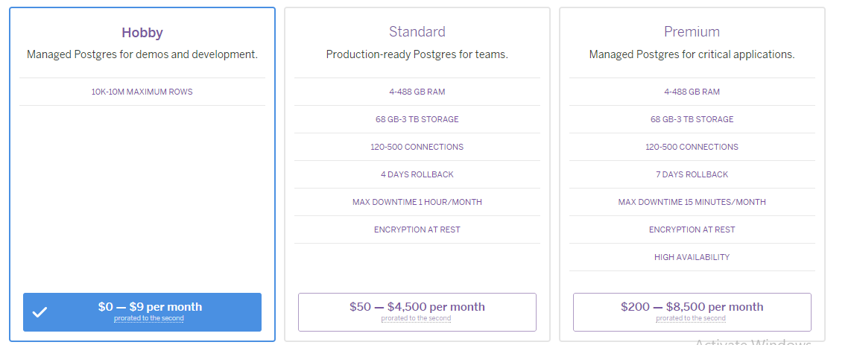

## DATA CENTERS -

European data protection laws are more stringent than those in the U.S., so the two parties have set up a Safe Harbor program for american

services involve the handling of EU citizens’ personal data. Heroku still isn’t part of that program, so technically it’s still not kosher to run services

for EU citizens on the platform, even though it’s now using an EU data center.

“Heroku is not yet a registered participant in the Safe Harbor program,” the post read. “We’ve laid the groundwork for becoming Safe Harbor certified and

expect to have it soon.

CAPABILITIES-

1. Deploy client apps early and often using team-based continuous delivery

types= Continuous delivery

Team support

1. Build innovative client app experiences

types= Polyglot support

heroku elements

Great developer experience for focus and flow

1. Collaborate with clients throughout development and beyond

types= Multiple ways to collaborate

easy client transition

1. Manage client apps with an easy-to-use, integrated experience

types= scalability

Unified app management and monitoring

1. Deliver business applications with seamless Salesforce integration for enterprise clients

year of launch of the service

heroku launched in june 2007'

thier service providers are also launched on same year

## Deployment

The main content of the development are the source code, related dependencies if they exist, and a Procfile for the command.

The application is sent to Heroku using either of the following: Git, GitHub, Dropbox, or via an API.

There are packets which take the application along with all the dependencies, and the language runtime, and produce slugs. These are known as build-packs

and are the means for the slug compilation process.

A slug is a combination/bundle of the source code, built dependencies, the runtime, and compiled/generated output of the build system which is ready

for execution.

Next is the Configvars which contain the customizable configuration data that can be changed independently of the source code.

Add-ons are third party, specialized, value-added cloud services that can be easily attached to an application, extending its functionality.

A release is a combination of a slug (the application), configvars and add-ons.

Heroku maintains a log known as the append-only ledger of releases the developer makes.

## plans=

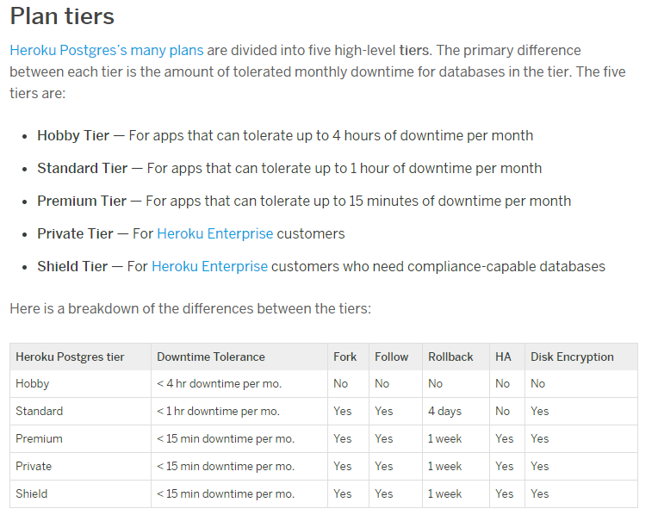

## CHARACTERISTICS=

of service providers-

Collectively, we call these new features Heroku DX—the next evolution in Heroku’s developer experience. Our goal with these new features—Heroku

Button, Heroku Dashboard + Metrics and HerokuPostgresDbX—is to make it faster than ever for developers to build, launch and scale applications.

SECURITY=

Each application on the Heroku platform runs within its own isolated environment and cannot interact with other applications or areas of the

system. This restrictive operating environment is designed to prevent security and stability issues. These self-contained environments isolate processes,

memory, and the file system using LXC while host-based firewalls restrict applications from establishing local network connections.



## Self Service Provisions=

# self.PNG **Flexibility = Improved flexibility in Threshold Autoscaling range settings**

Previously when setting Threshold Autoscaling dyno count ranges one was restricted to range that included the current dyno count. For example, if your current count was 2 you could not set the range as 3 to 5 without first manually adjusting the current count. Now you can set the range outside of your current dyno count. Upon confirming the setting change the current dyno count will adjust to be within the range..

**Pay-per-use = Per-second billing. Dynos cost 5 cents per hour. You get one dyno for free each month (per app). If you use a dyno for 2 seconds, you'll pay 0.16666666666666666 cents**

**Location-free**

. Today we’re releasing [PostGIS 2.0](https://blog.heroku.com/building_location_based_apps_with_postgis" \l "more_about_postgis) into public beta as an extension to Heroku Postgres. Now all Heroku Postgres customers will be able to store and manipulate geospatial data as part of their Postgres database. PostGIS 2.0 capabilities are now available in all [production tier plans](https://devcenter.heroku.com/articles/heroku-postgres-plans#production-plans) at no additional charge—allowing you to add powerful location functionality to your application.

**Backup**

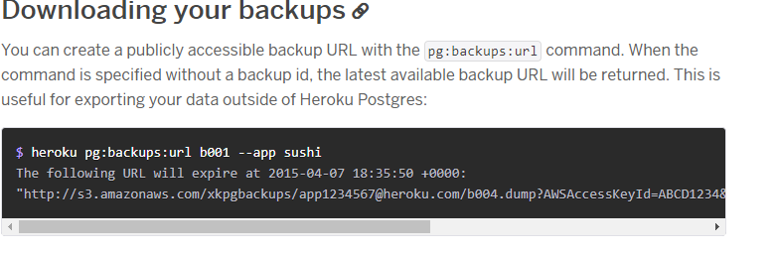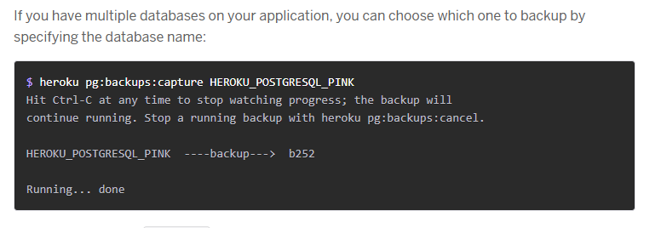

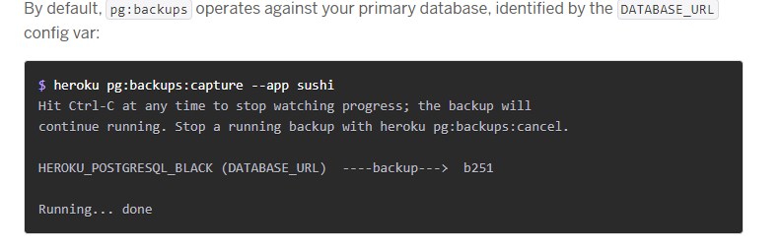

[**SAAS: SOFTWARE AS A SERVICE**](https://apprenda.com/white-papers/saas-hub/?utm_source=library&utm_medium=post&utm_term=saaspaasiaas&utm_campaign=saas-hub) **by GOOGLE**

Cloud application services, or [Software as a Service (SaaS)](https://apprenda.com/white-papers/saas-hub/?utm_source=library&utm_medium=post&utm_term=saaspaasiaas&utm_campaign=saas-hub), represent the largest cloud market and are still growing quickly. SaaS uses the web to deliver applications that are managed by a third-party vendor and whose interface is accessed on the clients’ side. Most SaaS applications can be run directly from a web browser without any downloads or installations required, although some require plugins.

Because of the web delivery model, SaaS eliminates the need to install and run applications on individual computers. [With SaaS, it’s easy for enterprises to streamline their maintenance and support](https://apprenda.com/white-papers/saas-hub/?utm_source=library&utm_medium=post&utm_term=saaspaasiaas&utm_campaign=saas-hub), because everything can be managed by vendors: applications, runtime, data, middleware, OSes, virtualization, servers, storage and networking.

Popular SaaS offering types include email and collaboration, customer relationship management, and healthcare-related applications. Some large enterprises that are not traditionally thought of as software vendors have started building SaaS as an additional source of revenue in order to gain a competitive advantage.

You May Also Like: [The Value of Enterprise Controls in an Open Source Container Platform](https://apprenda.com/white-papers/the-value-of-enterprise-controls-in-an-open-source-container-platform/)

**SaaS Examples**: Google Apps, Salesforce, Workday, Concur, Citrix GoToMeeting, Cisco WebEx  
**Common SaaS Use-Case**: Replaces traditional on-device software  
Technology Analyst Examples: Bill Pray (Gartner), Amy DeMartine (Forrester)

* **SaaS Service Provider:Google**
* [**App Engine**](https://cloud.google.com/appengine/pricing)**(April 7, 2008)**
* **APP ENGINE FEATURES**

A powerful platform to build apps and scale automatically

* **Popular Languages**

Build your application in Node.js, Java, Ruby, C#, Go, Python, or PHP—or bring your own language runtime

* **Open & Flexible**

Custom runtimes allow you to bring any library and framework to App Engine by supplying a Docker container

* **Fully Managed**

A fully managed environment lets you focus on code while App Engine manages infrastructure concerns

* **Application Security**

Help safeguard your application by defining access rules with App Engine firewall and leverage managed SSL/TLS certificates\* by default on your custom domain at no additional cost

* **Services Ecosystem**

Tap a growing ecosystem of GCP services from your app including an excellent suite of [cloud developer tools](https://cloud.google.com/products/tools/)

* **Pricing:**
* **Standard environment instances**
* Applications running in the App Engine standard environment are deployed to instance classes that you specify. This table summarizes the hourly billing rates of the various instance classes.**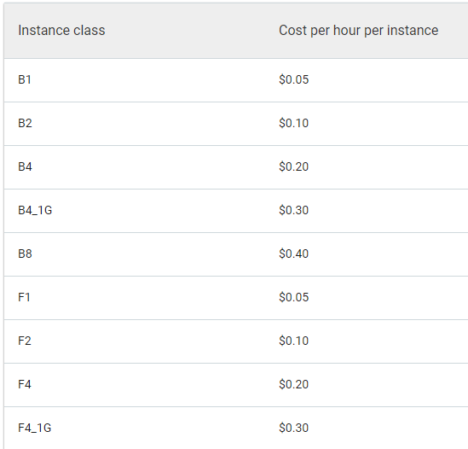**
* **Flexible environment instances**
* Applications running in the App Engine flexible environment are deployed to virtual machine types that you specify. These virtual machine resources are billed on a per-second basis with a 1 minute minimum usage cost.
* This table summarizes the hourly billing rates of the various computing resources:

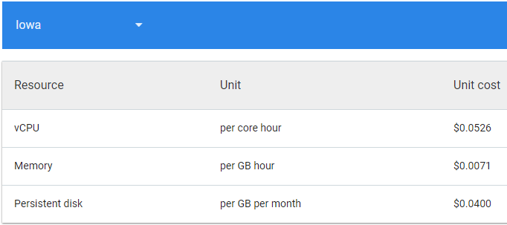

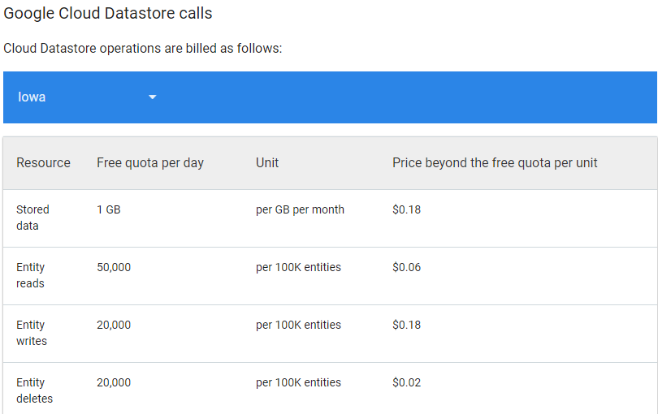

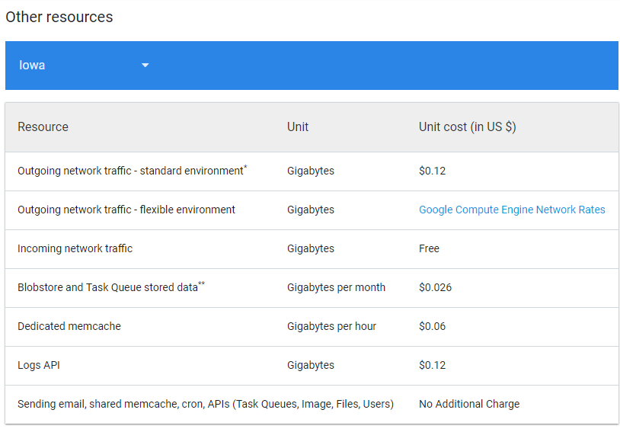

* **Compute Engine(June 28, 2012)**:--
* **High-Performance, Scalable VMs**

Google Compute Engine delivers virtual machines running in Google's innovative data centers and worldwide fiber network. Compute Engine's tooling and workflow support **enable scaling from single instances to global**, load-balanced cloud computing.

Compute Engine's **VMs boot quickly**, come with persistent disk storage, and deliver consistent performance. Our virtual servers are available in many configurations including predefined sizes or the option to **create Custom Machine Types optimized for your specific needs**. Flexible pricing and automatic sustained use discounts make Compute Engine the leader in price/performance.

* **Industry Leading Price & Performance**

Compute Engine VMs boot quickly and are consistently high performance. Compute Engine also offers **industry-leading local SSD performance**. Compare throughput on equivalent IaaS offerings and see the difference our virtual servers can make for your workloads.

* **Low Cost, Automatic Discounts**

Google bills in **second-level increments**, so you only pay for the compute time you use. With sustained use discounts, **we automatically give you discounted prices** for long-running workloads with no up-front commitment required.

//Networking

[Virtual Private Cloud (VPC)](https://cloud.google.com/compute/pricing#network)

[Cloud Load Balancing](https://cloud.google.com/compute/pricing#lb)//

* **Big Data**
* [**BigQuery**](https://cloud.google.com/bigquery/pricing)

BigQuery is a [RESTful](https://en.wikipedia.org/wiki/Restful" \o "Restful) [web service](https://en.wikipedia.org/wiki/Web_service) that enables interactive analysis of massively large datasets working in conjunction with [Google Storage](https://en.wikipedia.org/wiki/Google_Storage). It is an *Infrastructure as a public Service* ([IaaS](https://en.wikipedia.org/wiki/Cloud_computing" \l "Infrastructure_as_a_service_(IaaS)" \o "Cloud computing)) that may be used complementarily with [MapReduce](https://en.wikipedia.org/wiki/MapReduce" \o "MapReduce).

* [**Cloud Dataflow**](https://cloud.google.com/dataflow/pricing)

Cloud Dataflow is a fully-managed service for transforming and enriching data in [stream](https://cloud.google.com/solutions/big-data/stream-analytics/) (real time) and batch (historical) modes with equal reliability and expressiveness -- no more complex workarounds or compromises needed. And with its serverless approach to resource provisioning and management, you have access to virtually limitless capacity to solve your biggest data processing challenges, while paying only for what you use.

Cloud Dataflow unlocks transformational use cases across industries, including:

* Clickstream, Point-of-Sale, and segmentation analysis in retail
* Fraud detection in financial services
* Personalized user experience in gaming
* IoT analytics in manufacturing, healthcare, and logistics
* **Machine Learning**
* [**Cloud Machine Learning Engine**](https://cloud.google.com/ml-engine/pricing)
* **CLOUD MACHINE LEARNING ENGINE FEATURES**

Google services are designed to work together. It works with [Cloud Dataflow](https://cloud.google.com/dataflow/) for feature processing, [Cloud Storage](https://cloud.google.com/storage/) for data storage and[Cloud Datalab](https://cloud.google.com/datalab/) for model creation.

* **Discover and Share Samples**

Discover and share our [Machine Learning Samples](https://cloud.google.com/ml-engine/docs/samples) tailored to your industry use case.

* **HyperTune**

Build better performing models faster by automatically tuning your hyperparameters with HyperTune, instead of spending many hours to manually discover values that work for your model.

* **Managed Service**

Focus on model development and prediction without worrying about the infrastructure. Managed service automates all resource provisioning and monitoring.

* **Scalable Service**

Build models of any data size or type using managed distributed training infrastructure that supports CPUs and GPUs. Accelerate model development, by training across many number of nodes, or running multiple experiments in parallel.

* **Notebook Developer Experience**

Create and analyze models using the familiar Jupyter notebook development experience, with integration to [Cloud Datalab](https://cloud.google.com/datalab/).

* **Portable Models**

Use the open source [TensorFlow SDK](https://www.tensorflow.org/" \t "_blank) to train models locally on sample data sets and use the Google Cloud Platform for training at scale. Models trained using Cloud Machine Learning Engine can be downloaded for local execution or mobile integration.

* **Natural language Apl:**

**CLOUD NATURAL LANGUAGE FEATURES**

* **Syntax Analysis**

Extract tokens and sentences, identify parts of speech (PoS) and create dependency parse trees for each sentence.

* **Entity Recognition**

Identify entities and label by types such as person, organization, location, events, products and media.

* **Content Classification**

Classify documents in predefined 700+ categories.

* **Multi-Language**

Enables you to easily analyze text in multiple languages including English, Spanish, Japanese, Chinese (Simplified and Traditional), French, German, Italian, Korean and Portuguese.

* **Integrated REST API**

Access via REST API. Text can be uploaded in the request or integrated with [Google Cloud Storage.](https://cloud.google.com/storage/)

* **Google drive**:

Google Drive is a [file storage](https://en.wikipedia.org/wiki/File_hosting_service) and [synchronization service](https://en.wikipedia.org/wiki/File_synchronization) developed by [Google](https://en.wikipedia.org/wiki/Google). Launched on April 24, 2012, Google Drive allows users to store files in the cloud, synchronize files across devices, and [share files](https://en.wikipedia.org/wiki/File_sharing). In addition to a [website](https://en.wikipedia.org/wiki/Web_application), Google Drive offers apps with offline capabilities for [Windows](https://en.wikipedia.org/wiki/Microsoft_Windows) and [macOS](https://en.wikipedia.org/wiki/MacOS" \o "MacOS)computers, and [Android](https://en.wikipedia.org/wiki/Android_(operating_system)) and [iOS](https://en.wikipedia.org/wiki/IOS" \o "IOS) smartphones and tablets. Google Drive encompasses [Google Docs, Sheets and Slides](https://en.wikipedia.org/wiki/Google_Docs,_Sheets_and_Slides), an [office suite](https://en.wikipedia.org/wiki/Office_suite) that permits collaborative editing of documents, spreadsheets, presentations, drawings, forms, and more. Files created and edited through the office suite are saved in Google Drive.

* **Google doc:**

Google Docs brings your documents to life with smart editing and styling tools to help you easily format text and paragraphs. Choose from hundreds of fonts, add links, images, and drawings. All for free.

* **Google messaging softwares**:

Google Cloud Messaging (GCM) is a free service that enables developers to send messages between servers and client apps. This includes downstream messages from servers to client apps, and upstream messages from client apps to servers.

* **Google App Engine**:

*Google App Engine*  is a [web framework](https://en.wikipedia.org/wiki/Web_framework) and [cloud computing](https://en.wikipedia.org/wiki/Cloud_computing) platform for developing and hosting [web applications](https://en.wikipedia.org/wiki/Web_application) in Google-managed [data centers](https://en.wikipedia.org/wiki/Data_center). Applications are [sandboxed](https://en.wikipedia.org/wiki/Sandbox_(computer_security)" \o "Sandbox (computer security))and run across multiple servers.[[1]](https://en.wikipedia.org/wiki/Google_App_Engine#cite_note-1) App Engine offers automatic scaling for web applications—as the number of requests increases for an application, App Engine automatically allocates more resources for the web application to handle the additional demand.[[2]](https://en.wikipedia.org/wiki/Google_App_Engine#cite_note-2)