**15CSE337 Cloud Computing and Services**

**Assignment 1**

* **Identify one cloud service provider of each category (IaaS, PaaS, and SaaS)**

**Ans:** SaaS: Cisco WebEx

PaaS: Microsoft Azure

IaaS: AWS

* **Find and list the services offered by them**

**Ans: Cisco WebEx** is a Service is a company that provides on-demand collaboration, online meeting, web conferencing and videoconferencing applications. Amazon Web Services (AWS) is a secure [cloud](https://aws.amazon.com/what-is-cloud-computing/) services platform, offering compute power, database storage, content delivery and other functionality to help businesses scale and grow.

**Azure:** It is a Comprehensive of cloud services that developers and IT professionals use to build, deploy and manage application throughout global networks of datacenters. Integrated tools, Devops and marketplace support efficiently building anything from simple mobile apps to internet-Scale Solution.

* **Identify the pricing of each of them and list against each category**

**AWS:** 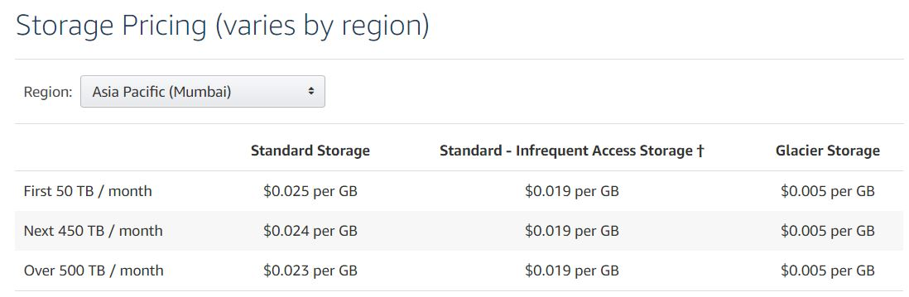

**Azure:**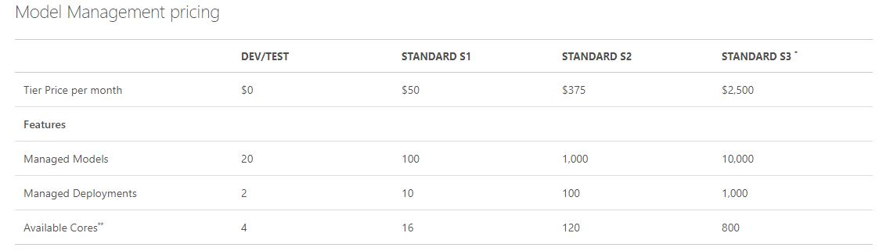

**Cisco WebEx:**

* Do a detailed survey on the location of their data center and their capabilities

**Azure:**

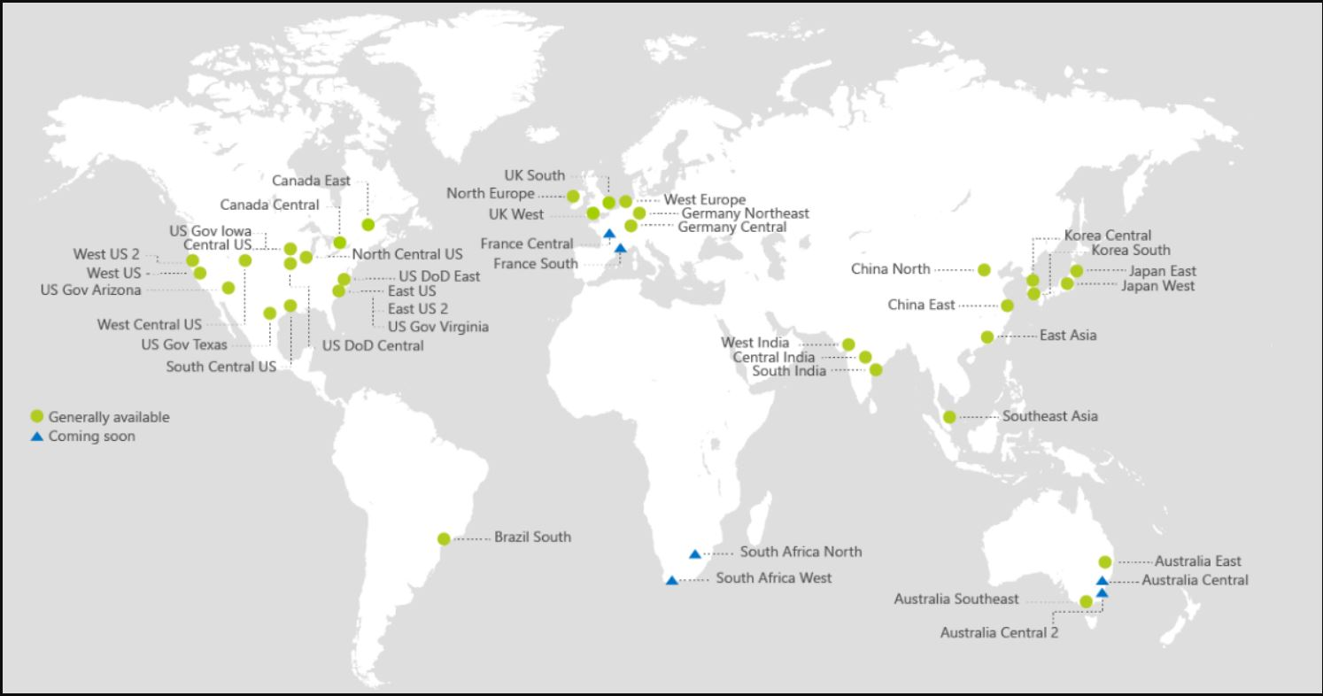

**AWS:**

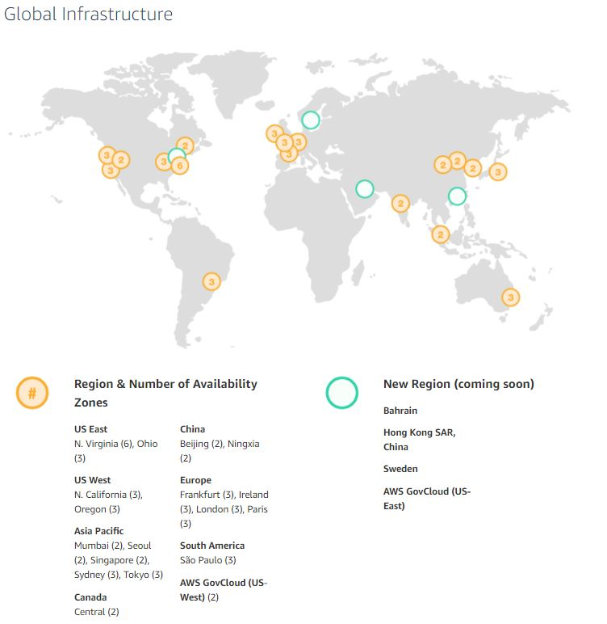

**Cisco WebEx:**

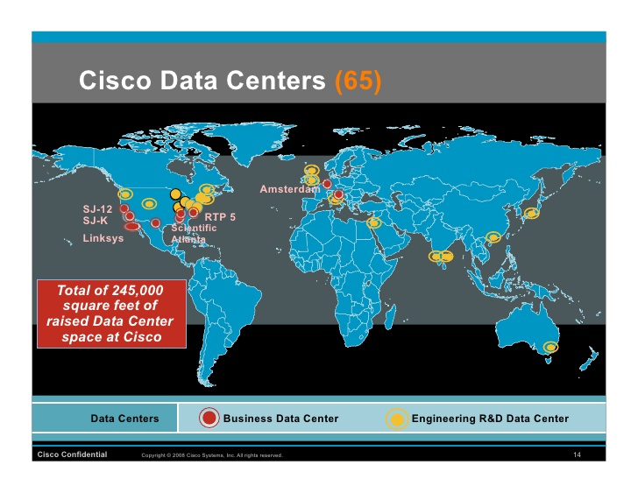

* Find the year of launch of the service

**AWS:** March 2006

**Azure:** 1 February 2010

**Cisco WebEx:** 21st February 2006

* Find their deployment model (Private/Public etc.)

**AWS:**Public,Community models

**Azure:** Private,Public,Community models

**Cisco WebEx:** Community model

* List the various plans offered by the service providers you have identified (if any)

**Azure:**

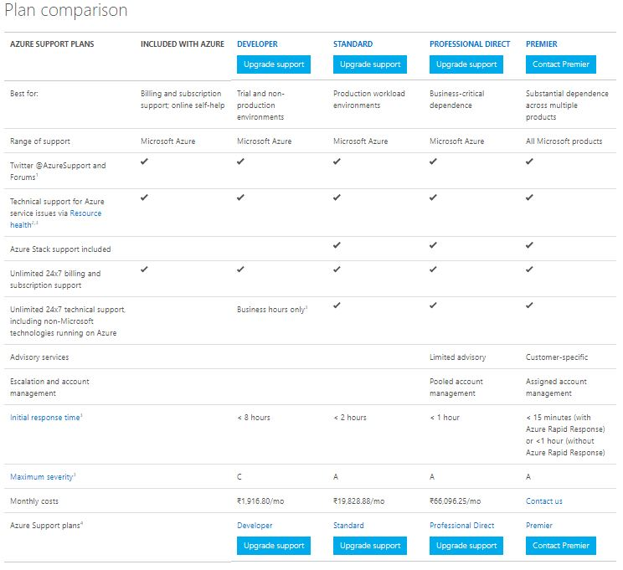

**AWS:**

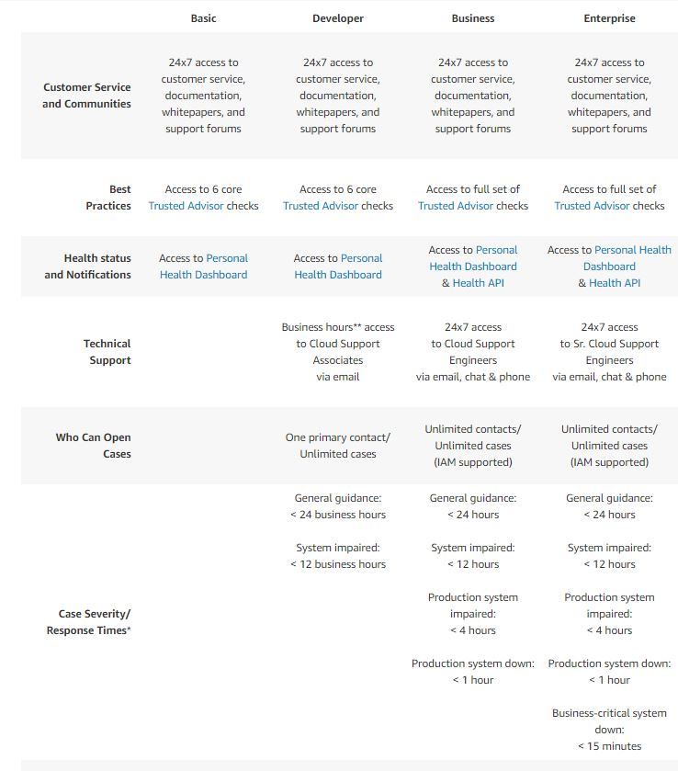

**Cisco WebEx:**

Video conferencing (full-screen, up to 7 video feeds, or split-screen)

Share applications or your whole screen

VoIP or phone call-in

Markup tools and whiteboard

Record meetings (including video)

Free mobile apps

Share the presenter role

* Identify the special characteristics of them and find how they address issues like security, multitenancy etc.

**AWS:**

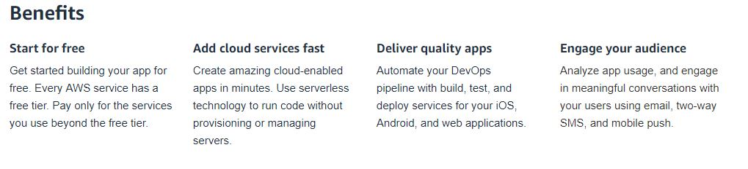

Storage: You can use two methods to encrypt files on instance stores. The first method is disk encryption, in which the entire disk or block within the disk is encrypted by using one or more encryption keys. Disk encryption operates below the file-system level, is operating-system agnostic, and hides directory and file information such as name and size.

**Cisco WebEx:**

CMR Hybrid (WebEx-enabled Telepresence)

Testing and instant grading

Web-based automated call distribution (ACD) routing and queue management

**Azure:**

Special characteristics: Azure Site Recovery, Azure portal, Azure ExpressRoute

Handling Issues:

Storage:   
 To ensure that data to stay durable, Azure Storage has the ability to keep (and manage) multiple copies of your data. This is called replication, or sometimes redundancy

They have locally redundant storage (LRS),Zone redundant storage (ZRS)

Security: Logically segment subnets, Control routing behaviour, enable Forced

Tunnelling, use Virtual network appliances

Multitenancy: Windows Azure can select any instance of the role to handle a particular task. Windows Azure monitors your role instances and automatically restarts any that have failed.

* The benefits of cloud-based computing include the below listed features. Find how these features are addressed by the identified service providers.
  + **Self-service provisioning** means the computing resources are used for almost any kind of work.
  + **Flexibility** refers to changes in usage to increase or decrease as users see their needs change.
  + **Pay-per-use** allows users to pay for only the services and resources they use.
  + **Maintenance of the servers is easy.** Servers are off site, and the providers take care of software updates. There is no need for users to install software on to individual systems and keep up to date with the software as it develops.
  + **Location-free** allows users to work from anywhere. As long as you have an Internet connection you can access the cloud. Many providers often have apps available to multiple devices, so you are not restricted. More and more businesses are now granting employees the ability to work away from the office. This feature allows a work-life balance and maintains productivity rates.
  + **Backup.** Cloud-based backup saves time, avoids larger investments and the need to recruit third-party experts. Choosing cloud backups decrease the size of their data centers. The lowering of the numbers of servers, the software expense, and the staff personnel can significantly reduce IT costs without negatively affecting an organization’s IT capabilities.
  + **Cloud-based workload and file sharing** streamline teamwork collaboration, which allows data to be shared, accessed and edited from anywhere. Updates are visible in real-time and are seen by all teammates.

**AWS:**

**Self Service Provisioning:**

Software vendors that wish to list their products for sale on AWS Marketplace can log in to AMMP to view their existing product listings, create a new free listing, create a new Bring-Your-Own-License (BYOL) listing, or track the status of their submitted listing requests.

**Flexibility:**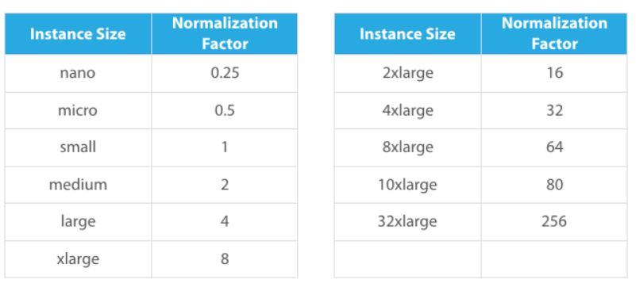

**Pay per Use:**

AWS offers you a pay-as-you-go approach for pricing for over 70 cloud services. With AWS you pay only for the individual services you need, for as long as you use them

**Maintenance of servers is easy:**

 Amazon RDS performs maintenance on Amazon RDS resources. Maintenance most often involves updates to the DB instances or DB cluster's underlying operating system (OS). Updates to the operating system most often occur for security issues

**Location Free:**

Infrastructure provided by Amazon are location independent, can be accessed from anywhere though the datacenters are in fixed places. It facilitates distributed computing within datacenters rather than performing task on individual machines or through remote servers.

**Backup:**

Leverage APN partner offerings to implement secure and efficient backup and recovery solutions that take full advantage of the AWS environment. AWS and APN partner solutions have been designed to provide the scalability and durability needed to implement an effective storage solution.

**Cloud based Workload and file sharing:**

Amazon Elastic File System (Amazon EFS) provides simple, scalable file storage for use with Amazon EC2 instances in the AWS Cloud. Amazon EFS is easy to use and offers a simple interface that allows you to create and configure file systems quickly and easily. With Amazon EFS, storage capacity is elastic, growing and shrinking automatically as you add and remove files, so your applications have the storage they need, when they need it.

**Azure**:

**Self Service Provisioning:**

AZURE self-service users can create and manage their own security groups or Office 365 groups in Azure Active Directory (Azure AD).

**Flexibility:**

Microsoft Azure is an open and flexible cloud platform, providing you the ability to quickly build, deploy and manage applications across a global network of secure, Microsoft-managed data centers.

**Pay per Use:**

The Pay-As-You-Go Dev/Test offer allows you to quickly get your team up and running with dev/test environments in the cloud using pre-configured virtual machines, including Windows 10 and low rates on virtual machines, Cloud Services, HDInsight, App Service and Logic Apps. You have the flexibility to create multiple Azure subscriptions based on this offer, enabling you to maintain isolated environments and a separate bill for different projects or teams.

**Maintenance of servers is easy:**

Azure periodically performs updates to improve the reliability, performance, and security of the host infrastructure for virtual machines. These updates range from patching software components in the hosting environment (like operating system, hypervisor, and various agents deployed on the host), upgrading networking components, to hardware decommissioning.

**Location Free:**

Services provided by Azure are location independent.

**Backup:**

 When the Azure Backup service initiates a backup job at the scheduled time, it triggers the backup extension to take a point-in-time snapshot. The Azure Backup service uses the *VMSnapshot* extension in Windows, and the *VMSnapshotLinux* extension in Linux. The extension is installed during the first VM backup. To install the extension, the VM must be running. If the VM is not running, the Backup service takes a snapshot of the underlying storage (since no application writes occur while the VM is stopped).

**Cloud based Workload and file sharing:**

Azure Files is Microsoft's easy way to use cloud file system. Azure File shares can be mounted in Windows and Windows Server, with the File Explorer UI, via PowerShell, and via the Command Prompt. After mounting in systems,it is easy to share the files.

**Cisco WebEx:**

**Self Service Provisioning:**

 A Care Assistant bot provides assisted service by connecting people together. If you want your bot to offer self-service, you can integrate it with API.AI.

**Flexibility:**

Cisco WebEx is a flexible platform that operates on a variety of devices (including computers, mobile phones, etc.). It can host a large number of collaborators (up to 200 with the highest premium plan)

**Pay per Use:**

WebEx Pay-Per-Use Meetings offer:

* Pricing based per participant, per minute
* Meetings delivered over WebEx’s global MediaTone network
* Access to WebEx advanced features
* Use of the WebEx teleconferencing system or your own
* Estimates provided when the meeting is scheduled
* Payment with a credit card

**Maintenance of servers is easy:**

Location Free: Software is provided online and meetings can be conducted from anywhere, which is location independent.

**Backup:**

Cisco Network Registrar provides a shadow backup utility, cnr_shadow_backup. Once a day, at a configurable time, Cisco Network Registrar takes a snapshot of the critical files. This snapshot   
is guaranteed to be a consistent view of the databases

**Cloud based Workload and file sharing:**

Workload Optimization Manager helps to optimize the workload and files can be shared from one's own computers as a PDF format through their website.

**DONE BY:**

**B Sudheesh Reddy BL.EN.U4CSE15119**

**P V Bhanu Prakash BL.EN.U4CSE15087**

**N Sai Sreenidhi BL.EN.U4CSE15082**