Download the Application : -

From play store and open it

When a new user is downloading this application from playstore, the user must log in to create a profile and password to complete the setup process.

Here’s how to log on/ SignUp for the first time:

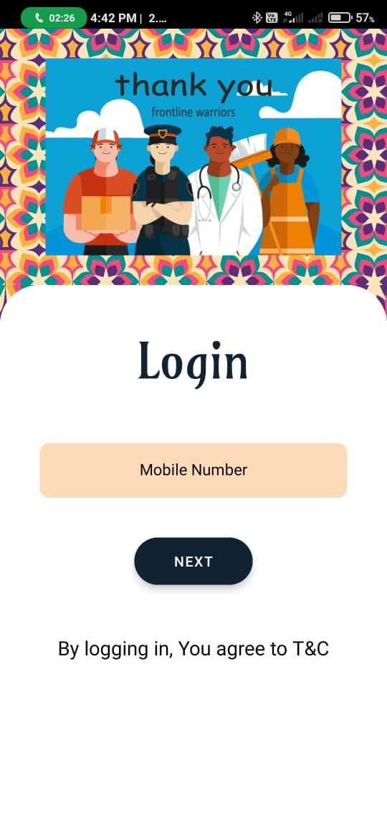

Figure 1

1. Enter your valid phone number in given box.
2. Press next button to goto verification part

Enter your mobile number here

Then press next

1. Check your inbox for the 'Number Verification' or ‘OTP – One Time Password’ in massage box.

This massage contains 6- digit code to complete the setup. Copy the code from the massage box and go to the application and paste in otp verification and press Submit.

Once you login to this application no need to verify your identity again and again.

It will automatically be logged in.

q


Figure 2

Your mobile number is showing here

Enter OTP Here

Press here to resend the OTP

1. You Can resend the OTP with the help of Resend OTP option