

DISTANCE MEASUREMENT AND OBJECT DETECTION

I I

***A*** ***project*** ***report*** ***submitted*** ***in*** ***partial*** ***fulfillment*** ***of*** ***supervision*** ***for*** ***the*** ***award*** ***of*** ***a*** ***degree*** ***of***

**BACHELOR** **OF** **TECHNOLOGY** **IN**

**ELECTRONICS** **AND** **COMMUNICATIONENGINEERING** Submitted by

**P. DAVID**

(PIN – 20551A04A7) **T. SREYANSH**

(PIN – 20551A04B8)

**T. KOUSIK**

(PIN – 20551A04B6) **MD. SHARIEF**

(PIN – 21555A0410)

Under the guidance of

**D.NAVYA** **NARAYANA** **KUMARI**

Professor

Department of Electronics and Communication Engineering.

Godavari Institute of Engineering & Technology (Autonomous). NH-16, Chaitanya Knowledge City,

Rajamahendravaram - 533296.

1



**BONAFIDE** **CERTIFICATE**

This is to certify that the project entitled “LED DISTANCE INDICATOR AND

MEASUREMENT USING ULTRASONIC SENSOR ”is project work by

**“P.DAVID(20551A04A7),T.SREYANSH(20551A04B8),T.KOUSIK(20551A04B6),**

**MD.SHARIEF(21551A0410)”,** who carried out the project work under my supervision during

the academic year 2022 - 2023, towards partial fulfillment of the requirements of the Degree of

Bachelor of technology in Electronics & Communication Engineering as administered under

the Regulation of Godavari Institute of Engineering & Technology, Rajamahendravaram, A.P,

India and award of the Degree from Jawaharlal Nehru Technological University, Kakinada. The

results embodied in this report have not been submitted to any other University for the award

of any degree.

Signature of the supervisor

D.NAVYA NARAYANA KUMARI

Assistant Professor

**PROJECTGUIDE** Date:

Signature of the Head of the Department

D.NAVYA NARAYANA KUMARI

Assistant Professor

External Vivavoce conducted on

**Internal** **Examiner** **External** **Examiner**

**GODAVARIINSTITUTE** **OF** **ENGINEERING** **AND** **TECHNOLOGY** **(An** **Autonomous** **Institution)**

**CHAITANYA** **KNOWLEDGE** **CITY,** **NH** **–** **16,** **RAJAMAHENDRAVARAM** **–** **533295,** **A.P**

2

**CERTIFICATEOF** **AUTHENTICATION**

We solemnly declare that this project report **“LED** **DISTANCE** **INDICATOR** **AND**

**MEASUREMENT** **USING** **ULTRASONIC** **SENSOR**” is bonafide work done purely by

**“P. DAVID (20551A04A7), T. SREYANSH (20551A04B8),T.KOUSIK(20551A04B6),**

**MD.SHARIEF (21555A0410)”** carried out under the supervision of **DR.B. SRINIVASA**

**RAJA** (Professor) towards partial fulfillment of the

**of** **Technology** in **Electronics** **&** **Communication**

requirements of the Degree of **Bachelor**

**Engineering** as administered under the

Regulation of Godavari Institute of Engineering & Technology, Rajamahendravaram, A.P,

India and award of the Degree from Jawaharlal Nehru Technological University, Kakinada

during the year 2022 – 2023.

We also declare that no part of this document has been taken up verbatim from any other source

without permission from the author(s)/publisher(s). Wherever a few sentences, findings,

images, diagrams, or any other information has been used for the sake of completing this work.

We have adequately referred to the document source. If any issue arises hereafter about this

work, we shall be personally responsible.

It is further certified that this work has not been submitted either in part or in full, to any other department of the Jawaharlal Nehru Technological University Kakinada or any other University, institution, or elsewhere, in India or for publication in any form.

**P. DAVID**

**T.SREYANSH**

**T. KOUSIK**

**MD.SHARIEF**

**Date:**

**Signature** **of** **the** **students**

**20551A04A7**

**20551A04B8**

**20551A04B6**

**215551A0410**

3

**DECLARATION**

We hereby declare that this submission is our work and that, to the best of our knowledge and

belief, it contains no material previously published or written by another person nor material

which to a substantial extent has been accepted for the award of any other degree or diploma of

the university or other institute of higher learning, except were a due acknowledgment.

**P. DAVID**

**T. SREYANSH**

**T. KOUSIK**

**MD.SHARIEF**

**20551A04A7**

**20551A04B8**

**20551A04B6**

**21555A0410**

4

**ACKNOWLEDGEMENT**

We are grateful to our guide Mrs D. NAVYA NARAYANA KUMARI, Asst.proffessor

(E.C.E) for having allowed carrying out this project work. We take this opportunity to

express my profound and whole heartful thanks to my guide, who with his patience support,

and sincere guidance helped me in the successful completion of the project. We are

particularly indebted to him for his innovative ideas, valuable suggestions, and guidance

during the entire period of work, and without his unfathomable energy and enthusiasm, this

project would not have been completed.

We would like to thank Mrs D. NAVYA NARAYANA KUMARI (Asst.Professor) for

valuable suggestions throughout my project which have helped in giving a defined shape to

this work.

We like to express our deep gratitude to Dr. P. M. M. S. SHARMA, Principal of

GODAVARI INSTITUTE OF ENGINEERING AND TECHNOLOGY (A), for providing us

with a chance to undergo the course at the prestigious institute.

We would like to thank all the faculty members and non–teaching staff of the Department of Electronics and Communication Engineering, GIET (A) for their direct and indirect help during the project work.

We owe our specialthanksto the management of our college for providing the necessary arrangements to carry out this project.

The euphoria and satisfaction of completing this project will not be completed until we thank all the people who have helped me complete this enthusiastic task.

Lately, we thank our parents for their ever-kind blessings.

**P. DAVID**

**T.SREYANSH**

**T. KOUSIK**

**MD.SHARIEF**

**20551A04A7**

**20551A04B8**

**20551A04B6**

**21555A0410**

**ABSTRACT**

Motion detection has become one of the great areas of research in the world. Many activities are carried out in the presence of motion. One of the research foci has been the use of Arduino Uno microcontroller, Ultrasonic sensor, passive infrared sensor and many others to sense and measure distances.

The project is designed to develop distance measurement system using ultrasonic waves and interfaced with Arduino. The distance of an obstacle from the sensor is measured through ultrasonic sensor. After knowing the speed of sound, the distance can be calculated.

The device can be used in many different fields and categories like distance calculation in construction field, robots, car sensor to avoid obstacles and many other applications.

6

**TABLEOF** **CONTENT**

**CHAPTER** **NO.**

**1**

**2**

**3**

**4**

**TITLE**

**INTRODUCTION** 1.1 DESCRIPTION

1.2 OBJECTIVE

**LITERATURE** **REVIEW**

**AND** **PROBLEM** **IDENTIFICATION**

2.1 LITERATURE REVIEW AND PROBLEM IDENTIFICATION

**METHODOLOGY**

1. DESIGN METHODOLOGY 2. PROPOSED SYSTEM

**IMPLEMENTATION** 1. BLOCK DIAGRAM

2. BLOCK DIAGRAM EXPLINATION 3. COMPONENTS USED

4. COMPONENTS DISCRIPTION

**PAGENO.**

**1-2**

**2** **-** **3**

**04**

**5** **-** **15**

1. ARDUINOUNOATmega328P 2. ULTRASONIC SENSOR

3. LIQUID CRYSTAL DISPLAY 4 LIGHT EMITTING DIODE

5. LIGHT EMITTING DIODE 1. JUMPERWIRES

1. WORKING PROCEDURE

1. ARDUINO CODE

**5** **RESULTS** **ANALYSIS** **CONCLUSION** **15** **-** **19** **AND** **FUTURE** **WORK** **REFERENCE**

1. EXPERIMENT RESULTS

2. ADVANTAGES AND APPLICATIONS 3. LIMITATIONS AND FUTURE SCOPE 4. CONCLUSION

5. REFERENCE

7

**LIST** **OF** **FIGURES**

|  |  |  |
| --- | --- | --- |
| **FIGURE** | **FIGURE** **CONTAIN** | **PAGE.NO** |
| FIG 4.1 | BLOCK DIAGRAM | 5 |
| FIG 4.4.1 | ARDUINO BOARD | 6 |
| FIG 4.4.2(a) | IR SENSOR CIRCUIT | 9 |
| FIG 4.4.2(b) | IR SENSOR | 10 |
| FIG 4.4.3(a) | LDR CIRCUIT | 12 |
| FIG 4.4.3(b) | LDR | 12 |
| FIG 4.4.4(a) | RESISTOR | 12 |
| FIG 4.4.4(b) | RESISTOR SYMBOL | 12 |
| FIG 4.4.5(a) | LED STRUCTURE | 13 |
| FIG 4.4.5(b) | LED | 14 |
| FIG 4.4.6 | JUMPER WIRES | 15 |
| FIG 5.1 | CIRCUIT DIAGRAM DISTANCE MEASUREMENT AND OBJECT DETECTION | 16 |
| FIG 5.1 | EXPERIMENT RESULT | 21 |

8

**LIST** **OF** **TABLES**

|  |  |  |
| --- | --- | --- |
| **TABLE** | **TABLE** **CONTAIN** | **PAGE.NO** |
| **TABLE:1** | **SPECIFICATIONS** **OF** **ARDUNIO** | **7** |
| **TABLE:2** | **SPECIFICATIONS** **OF** **IR** **SENSOR** | **10** |
| **TABLE:3** | **SPECIFICATIONS** **OF** **LED** | **14** |

9

**LIST** **OF** **ABBREVIATIONS**

|  |  |
| --- | --- |
| **IR** | INFRARED |
| **LCD** | LIQUID CRYSTAL DISPALY |
| **LED** | LIGHT EMITTING DIODE |
| **AC** | ALTERNATING CURRENT |
| **DC** | DIGITAL CURRENT |
| **IC** | INTEGRATED CIRCUIT |
| **VCC** | VOLTAGE AT THE COMMON COLLECTOR |
| **EEPROM** | ELECTRICALLY ERASABLE PROGRAMMING READ -ONLY-  MEMORY |
| **TX** | TRANSMITTER |
| **RX** | RECIEVER |
| **GND** | GROUND |

10

**1.** **INTRODUCTION**

The development of "smart cars" requires new sensors that can measure distances in the range of a few centimeters to a few meters. Parking aids, obstacle detection, as well as intelligent suspensions and headlight leveling, are some examples of features that require a distance measurement to be performed with contactless sensors The sensor performance is better than many commercial devices, the sensors have evaluated the environmental conditions and then self-adapting to these conditions. The sensor has been designed to satisfy typical requirements in the automotive field: measured distance in the range of 0.1-0.3m and standard uncertainty of 1mm in the temperature range of 0°C to 40°c.Population increase, lifestyle changes and economic development has led to increase in human activity and hence high demand of manpower and especially in cities all over the world.

**1.1** **DESCRIPTION:**

The system can calculate the distance of the obstruction with sufficient accuracy. In earlier days the measurements are generally occur through measuring devices. But now a day’s digitalization as is on height. Therefore, we use a proper display unit for measurement of distance. An ultrasonic sensor houses a transducer that emits high-frequency, inaudible acoustic waves in one direction when the transducer element vibrates. If the waves strike and bounce off an object, the transducer receives the echoed signal. The sensor then determines its distance from the object based on the length of time between the initial sound burst and the echo's return. Ultrasonic sensors require fairly accurate timing circuitry, so acoustic sensors really require a processor of some sort to drive them. Ultrasonic sensors should be a first choice for detecting clear objects, liquids, dense materials of any surface type (rough, smooth, shiny) and irregular shaped objects

1

**1.2** **OBJECTIVE:**

**2.** **LITERATURE** **SURVEY** **AND** **POBLEM** **IDENTIFICATION**

**1.** **LITERATURESURVEY:**

Measurements has always been essential to humans. We use it to interpret certain phenomena that can be quantified into numbers such as time which can be measured through seconds, mass through kilograms, or distance through meters.

Although these measurements can be done unaided, it is much more effective to use devices that can provide accurate information. This is especially true in the field of engineering or science where any error can be consequential.

That is why experts in these fields require special devices. They use measuring tapes, thermometers, or even weighing scales to obtain precise measurements. Through these devices, they can effectively do tasks that require as such while preventing any error to occur as much as possible.

1

Thus, the researchers want to come up with a device that will be relatively simple to use and can acquire the measurements accurately in a very short time. During the 18th century, the electro-optical distance meter’s development has evolved through the techniques of determining the velocity of light. Fizeau, who determined the velocity of light in 1840s, and a lot more inventions; E. Berg strand was then inspired to design the first “Geodimeter” in 1940s. This works has developed and evolved throughout the history by aspiring Scientists. Moreover, recent scientists first patent application for an electromagnetic distance meter, this was made by Lowy in 1923.The use of this ultrasonic distance measuring device is useful in measuring the distance between two objects. Instead of using devices such as a measuring tape, an ultrasonic device can determine the length between two points of up to 4 meters.

The researchers have decided to conduct this study to create a prototype of and ultrasonic distance measuring device and study and understand the basic concepts of

using ultrasonic as a method of measuring distance. The concepts on how coding

works when using Arduino UNO, ultrasonic distance measurement, Sonar, etc., This

project will be useful in measuring two points; this device uses the concept of a sonar

to determine the distance of an object.

**PROBLEMS** **FACED**

reasonable adjustment according to the latitude, longitude, and seasonal variation. Also,

this system can run in controlled mode. In this mode, we can take the initiative to control

streetlights through PC monitor terminal. In addition, the system integrates a digital

temperature-humidity sensor, not only monitoring the street light real-time but also

temperature and humidity. The system is equipped with the high-power relay output and

can be widely applied in all places which need timely control such as streets, stations,

mining, schools, and electricity sectors and so on. But in this work a wireless network

for street light remote control is discussed. In particular, the novelty of the proposal is

in the location awareness of nodes, which cannot self-localize themselves.

**IDENTIFIED** **PROBLEM:**

Prototypes have been built using costly hardware. The capability of the ranging measurements, the basis for localization, is not characterized and showing some problems on the order of one meter. In near future, location aware routing algorithms will develop that will improve the efficiency of the network.

3. S.H. Jeong describes about the development of Zigbee based Street Light Control System which control and monitor status of streetlights installed alongside load. Lights are switched to ON/OFF by this system's control command. Its local status information is also monitored by control system via communication channel. Status information which is monitored are on/off status information, energy saving mode status, control group status information and safety related information, etc. To transfer control command and status information between streetlight control system and remote street light control terminals which installed at each light pole, various communication media and communication protocols are using. As communication media, wireless or power lines are used generally. Various frequency bands from tens of MHz to Rebrands are used for wireless case. This Street light control system can save maintenance time and costs and which can improve safety level.

**IDENTIFIED** **PROBLEM:**

• The researcher didn’t tell us about the working principle of the Single chip micro computer system.

• Use of fault detection circuit will create a problem which when it is damaged.

• It is not a real time set up Experiments, only it shows simulation result and theoretical proof.

3

**3.** **METHODOLOGY**

**1.** **DESIGN** **METHODOLOGY:**

This paper proposes an effective scheme for controlling the wastage of electricity due to streetlights. It reduces the manual effort by automation of street light on the basis of light intensity. The electricity wastage can be reduced by glowing the light on the basis of movement detection. Here three parts have been included under the topic for completed this study . Design architecture is the main block function for the proposed design. While, the hard ware specification will detail out the components involved in the design from the sensor components until the controller section. Software development based on the proposed design will detail out in software part where the flow of system operation will be detailed out elaborated.

**2.** **PROPOSED** **SYSTEM:**

Street lights are doing more than ever in today’s smart cities. With digital networks and embedded sensors, they collect and transmit information that help cities monitor and respond to any circumstance, from traffic and air quality to crowds and noise. They can detect traffic congestion and track available parking spaces. Those very same networks can remotely control LED lights to turn on and off, flash, dim and more, offering cities a chance to maximize low-energy lighting benefits while also improving pedestrian and bicyclist safety. With street lights creating a network canopy, those networks of data can be used by more than just lighting departments, empowering even schools and businesses via a lighting infrastructure that brightens the future of the digital city.

Smart lighting helps cities save energy, lower costs, reduce maintenance all while better serving citizens and reducing energy use and CO2 emissions. Automation and networked control can further increase your energy savings and reduce maintenance spending. Networked street lighting built on a scalable platform can reduce crime up to10% and make roadways safer through improved visibility. Leveraging intelligent control systems can rapidly increase lighting efficiencies and traffic management.

4

**4.** **IMPLEMENTATION**

**4.1** **BLOCK** **DIAGRAM:**

**LDR**

A

R



**IR** **SENSOR** D **LED**

U

I

N

O

**2.** **BLOCK** **DIAGRAM** **EXPLINATION**

• When Ldr detect the low light intensity in the environment then it switches on the system. • Ir sensor detect the vehicle movement and send the response to the Arduino.

• Arduino execute the programme and switch on the led with respect to the vehicle position.

**3.** **COMPONENTS** **USED:** • **Arduino** **uno**

• **Infrared** **sensor**

• **Light** **dependent** **resistor** • **Resistor**

• **Light** **emitting** **diode**

5

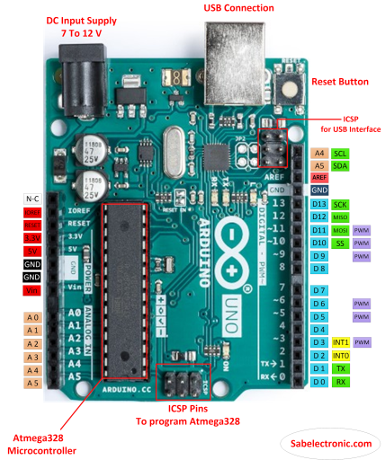

**4.** **COMPONENT** **DESCRIPTION:**

**1.** **ARDUINO** **UNO**

It is a microcontroller board based on the ATmega328. Arduino is an open-source, prototyping platform and its simplicity makes it ideal for hobbyists or novice to use as well as professionals. The Arduino Uno has 14 digital input/output pins (of which 6 can be used as PWM outputs), 6 analog inputs, a 16 MHz crystal oscillator, a USB connection, a power jack, an ICSP header, and a reset button. It contains everything needed to support the microcontroller; simply connect it to a computer with a USB cable or power it with AC to DC adapter or battery to get started. The Arduino Uno R3 uses an ATmega16U2 instead of the 8U2 found on the Uno (or the FTDI found on previous generations). This allows for faster transfer rates and more memory. No drivers needed for Linux or Mac (in file for Windows is needed and included in the Arduino IDE), and the ability to have the Uno show up as a keyboard, mouse, joystick, etc. The Arduino Uno differs from all preceding boards in that it does not use the FTDI USB-to-serial driver chip. Instead, it features the Atmega8U2 microcontroller chip programmed as a USB-to-serial converter. The Uno R3 also adds SDA and SCL pins next to the AREF. In addition, there are two new pins placed near the RESET pin. One is the IOREF that allow the shields to adapt to the voltage provided from the board. The other is a not connected and is reserved for future purposes. The Uno R3 works with all existing shields but can adapt to new shields which use these additional pins. "Uno" means one in Italian and is named to mark the upcoming release of Arduino 1.0. Preferred quality and originals are made in Italy.

**Fig** **4.4.1:** **ARDUINO** **UNO** **ATmega328P**

6

• **SPECIFICATIONSOF** **ARDUINO** **UNO**

|  |  |
| --- | --- |
| **Microcontroller** | ATmega328p |
| **Operating** **voltage** | 5v |
| **Input** **voltage** **(recommended)** | 7v-12v |
| **Input** **voltage** **(limits)** | 6-18v |
| **Analog** **input** **pins** | 6 |
| **Digital** **input/output** **pin** | 14 |
| **Dc** **current** **per** **input/output** **pin** | 40ma |
| **Dc** **current** **for** **3.3v** **pin** | 50ma |

**TABLE** **4.4.1:** **SPECIFICATION** **TABLE** **OF** **ARDUINO** **UNO** **ATRmea328P**

7

**2.** **IR** **SENSOR**

An infrared sensor is an electronic device that emits in order to sense some aspects of the surroundings. An IR sensor can measure the heat of an object as well as detects the motion as well as the presence of an object due to intervention or interruption. These type of sensors measure only infrared radiation, rather than emitting it that is called as a passive IR sensor. Usually in the infrared spectrum, all the objects radiate some form of thermal radiations. These types of radiations are invisible to our eyes that can be detected by an infrared sensor. The emitter is simply an IR LED (Light Emitting Diode) and the detector is simply an IR photodiode which is sensitive to IR light of the same wavelength as that emitted by the IR LED. When IR light falls on the photodiode, the resistances and these output voltages, change in proportion to the magnitude of the IR light received.

An IR sensor is a device which detects IR radiation falling on it. There are numerous types of IR sensors that are built and can be built depending on the application. Proximity sensors (Used in Touch Screen phones and Edge Avoiding Robots), contrast sensors (Used in Line Following Robots) and obstruction counters/sensors (Used for counting goods and in Burglar Alarms) are some examples, which use IR sensors.

• **WORKING** **MECHANISM:**

An IR sensor is basically a device which consists of a pair of an IR LED and a photodiode which are collectively called a photo-coupler or an opto-coupler. The IR LED emits IR radiation, reception and/or intensity of reception of which by the photodiode dictates the output of the sensor. Now, there are so many ways by which the radiation may or may not be able to reach the photodiode.

• **DIRECT** **INCIDENCE:**

We may hold the IR LED directly in front of the photodiode, such that almost all the radiation emitted, reaches the photodiode. This creates an invisible line of IR radiation between the IR LED and the photodiode. Now, if an opaque object is placed obstructing this line, the radiation will not reach the photodiode and will get either reflected or absorbed by the obstructing object. This mechanism is used in object counters and burglar alarms.

•  **INDIRECT** **INCIDENCE:**

High school physics taught us that black color absorbs all radiation, and the color white reflects all radiation. We use this very knowledge to build our IR sensor. If we place the IR LED and the photodiode side by side, close together, the radiation from the IR LED will get emitted straight in the direction to which the IR LED is pointing towards, and so is the photodiode, and hence there will be no incidence of the radiation on the photodiode. Please refer to the right part of the illustration given below for better understanding. But, if we place an opaque object in front the two, two cases occur.

8

• **REFLECTIVE** **SURFACE:**

If the object is reflective, (White or some other light color), then most of the radiation will get reflected by it, and will get incident on the photodiode. For further understanding, please refer to the left part of the illustration below.

• **NON** **REFLECTIVE** **SURFACE:**

If the object is non-reflective, (Black or some other dark color), then most of the radiation will get absorbed by it, and will not become incident on the photodiode. It is similar to there being no surface (object) at all, for the sensor, as in both the cases, it does not receive any radiation.

2

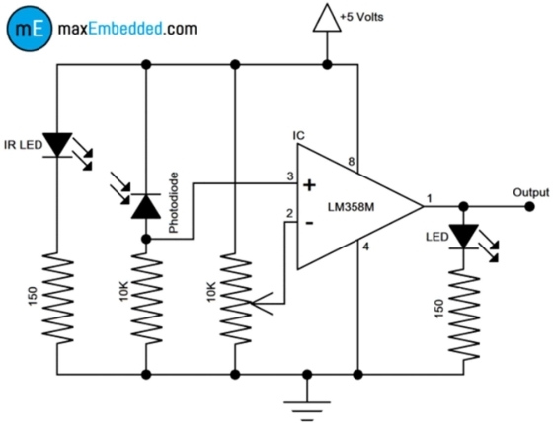

Fig 4.4.2(a) IR SENSOR CIRCUIT DIAGRAM

9

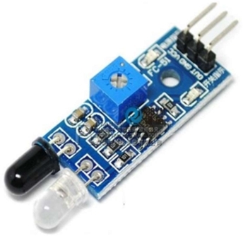

• **SPECIFICATIONSOF** **IR** **SENSOR**

|  |  |
| --- | --- |
| **Main** **chip** | LM393 |
| **Operating** **voltage** | 3.3-5vdc |
| **Distance** **measuring** **range** | 2-30 cm |

Fig 4.4.2(b) IR SENSOR

10

**4.4.3** **LIGHT** **DEPENDENT** **RESISTOR** **CIRCUIT**:

LDRs or Light Dependent Resistors are very useful especially in light/dark sensor circuits. Normally the resistance of an LDR is very high, sometimes as high as 1000000 ohms, but when they are illuminated with light resistance drops dramatically. Electronic onto sensors are the devices that alter their electrical characteristics, in the presences of visible or invisible light. The best-known devices of this type are the light dependent resistor (LDR), the photo diode and the phototransistors. Light dependent resistor as the name suggests depends on light for the variation of resistance. LDR are made by depositing a film of cadmium sulphide or cadmium selenide on a substrate of ceramic containing no or very few free electrons when not illuminated .The longer the strip the more the value of resistance. When light falls on the strip, the resistance decreases. In the absence of light, the resistance can be in the order of 10K ohm to 15K ohm and is called the dark resistance. Depending on the exposure of light the resistance can fall down to value of 500 ohms. The power ratings are usually smaller and are in the range 50mw to 5w.

Though very sensitive to light, the switching time is very high and hence cannot be used for high frequency applications. They are used in chopper amplifiers. Light dependent resistors are available as discs 0.5cm to 2.5cm. The resistance rises to several Mega ohms under dark conditions. The device consists of a pair of metal film contacts separated by a snakelike track of cadmium sulphide film, designed to provide the maximum possible contact area with the two metal films. The structure is housed in a clear plastic or resin case, to provide free access to external light. Practical LDRs are available in variety of sizes and packages styles, the most popular size having a face diameter of roughly 10mm.

When an LDR is brought from a certain illuminating level into total darkness, the resistance does not increase immediately to the dark value. The recovery rate is specified in k ohm/second and for current LDR types it is more than 200k ohm/second. The recovery rate is much greater in the reverse direction, e.g., going from darkness to illumination level of 300 lux, it takes less than 10ms to reach a resistance which corresponds with a light level of 400 lux. A LDR may be connected either way round and no special precautions are required during the time of soldering.

**Darkness:** Maximum resistance, about 1Mega ohm.

**Very** **bright** **light**:

Minimum resistance, about 100 ohm. The LDR is a variable resistor whose resistance decreases with the increase in light intensity. Two cadmium photoconductive cells with spectral response are very similar to that of the human eye. The cell resistance falls with increasing light intensity. Some of its

11

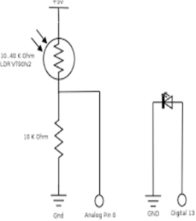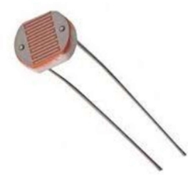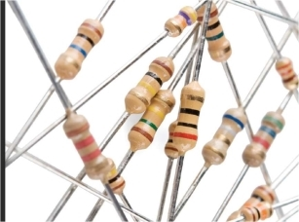

features: 1) High reliability. 2) Light weight. 3) Wide spectral response. 4) Wide ambient temperature range.

Fig 4.4.3(a) LDR CIRCUIT DIAGRAM Fig 4.4.3(b) LDR

• **4.4.4** **RESISTOR:**

A resistor is a passive two terminal electrical component that implements electrical resistance as a circuit element. In electronic circuit, resistors are used to limit current flow, to adjust signal levels. bias active elements, and terminate transmission line among other uses. High power resistors, that can dissipate many watts of electrical power as heat, may be used as part of motor controls, in power distribution systems, or as test loads for generators. Fixed resistors have resistances that only change slightly with temperature, time or operating voltage. Variable resistors can be used to adjust circuit elements (such as a volume control or a lamp dimmer), or as sensing devices for heat, light, humidity, force, or chemical activity.

12

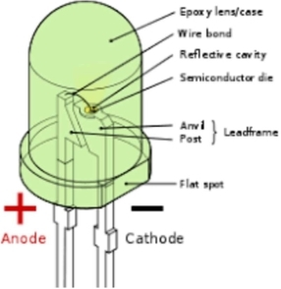

Fig 4.4.4(a) RESISTOR Fig 4.4.4(b) RESISTOR SYMBOL • **4.4.5** **LIGHT** **EMITTING** **DIODE:**

A light-emitting diode (LED) is a two-lead semiconductor light source. It is p-n junction diode that emits light when activated. The long terminal is positive, and the short terminal is negative. When a suitable current is applied to the leads, electrons can recombine with electron holes within the device, releasing energy in the form of photons. This effect is called electroluminescence, and the color of the light (corresponding to the energy of the photon) is determined by the energy band gap of the semiconductor. LEDs are typically small (less than 1 mm2 ) and integrated optical components may be used to shape the radiation pattern.

LEDs are versatile semiconductor with several attributes which make them perfect for most applications. Their features include:

• Long Life: LEDs can last over 100,000 hours (10+ years) if used at rated current No annoying flicker as we experience with fluorescent lamps.

• LEDs are impervious to heat, cold, shock and vibration. • LEDs do not contain breakable glass.

• Solid-State, high shock and vibration resistant • Extremely fast turn on/off times.

• Low power consumption puts less load on the electrical systems increasing battery life.

Here we have used the most common 5mm white light. White LEDs are perfect for replacing inefficient incandescent bulbs in night lights and path lights.

Fig 4.4.5(a) LED STRUCTURE

13

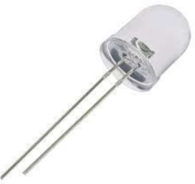

• **SPECIFICATIONS**

|  |  |
| --- | --- |
| **Intensity** | 28,500mcd |
| **Color** **frequency** | x=31 y=32 |
| **Viewing** **angle** | 48º |
| **Lens** | Water Clear |
| **Voltage** | 3.0v-3.3v |
| **Typical** | 3.1v |
| **Current** | 20mA |

**CAUTIONS:**

LEDs produce a focused light source and extra care should be used for your eyes ,though intensity is not very high. While testing the LEDs a resistance must be applied to It . Also, being a semiconductor device, they are sensitive to static charges.

Fig 4.4.5(b)LED

14

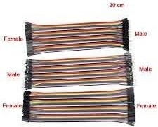

**4.4.6** **JUMPER** **WIRES:**

Fig 4.4.6:JUMPER WIRES

Cabling RF *jumper* cables - *Jumper* cables are smaller and more bendable corrugated cable which is used to connect antennas and other components to the network.

**4.5** **working** **procedure:**

The working procedure of the Smart street light using IR sensors is explained

below. The following are the different steps included in building a Smart street

light:

i Output of the LDR pin is connected to A0 (analog) port of Arduino Uno board.

ii Connect all output of the IR sensors to port numbers A1, A2, A3, A4 and A5

respectively (analog) which is the input signal to the Arduino board.

iii Connect the ground of all the IR sensors to GND port.

iv. The output signals from LED are connected to port number 5, 6, 9, 10 and 11 respectively.

v.Again, connect all the negative terminals of LED’s to GND port. vi Power is passed to the Arduino (7-12V).

15

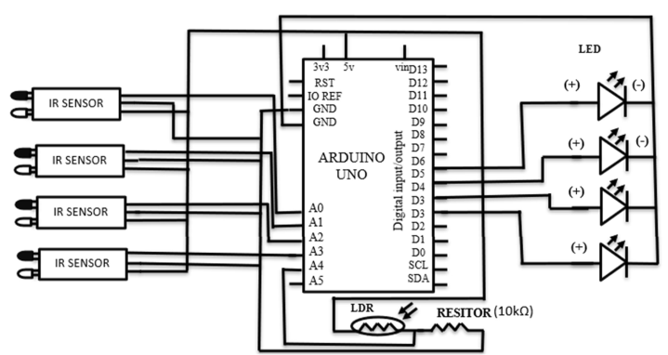

Fig 4.5 CIRCUIT DIAGRAM

Above diagram is the circuit diagram of the Smart streetlight. It works in

accordance with the varying sunlight. Whenever there is sufficient sunlight in

surroundings, LDR exhibits high resistance and acts as an insulator, while in darkness this

LDR behaves as low resistance path and allows the flows of electricity, this LDR’s operates

with the help of IR sensors, these sensors are activated under low illumination conditions

and these are controlled by an AT89C51 micro controller, every basic electronic circuit

will operate under regulated 5v DC. When any object comes in the range of IR sensors, as

IR LED emits the radiations and reflected back to IR photodiode by the object. Hence,

object is detected. The heart of Arduino circuit is the low power, high performance Arduino

micro controller is programmed by embedded assembly programming language for

implementing these tasks; this program is stored and operated by means of storage device

EPROM.

The intensity of LED’s is remained at low initially (when no object is detected,

at no natural light condition) by Arduino using Pulse Width Modulation (PWM) technique

where analog signal is converted to digital signal, ON-OFF process of LEDs take place so

16

rapidly in such a way, the LEDs seem to glow dimly when seen by naked eye. Hence,

intensity of LEDs are controlled by varying duty cycle. While coming to the functional

block i.e., LDR, LEDs, IR sensors, these components are in expensive, smaller in size, less

complexity, highly reliable, low power applications, minimum risk with greater accuracy.

The project is successfully implemented in many areas based on the experimental

verification proving that it can save the electrical power to greater extent removing the

manual work completely; the system became the origin for upcoming advanced intelligent

systems in saving both human and electrical power. The switching of the LEDs are

operated through coding applied in Arduino using Arduino software.

**4.6** **ARDUINO** **NANO** **IDE** **OR** **SOURCE** **CODE:**

**Arduino** **code:**

**int** **led** **=** **2;**

**int** **led1** **=** **12;**

**int** **led2** **=** **4;**

**int** **led3** **=** **13;**

**int** **ldr** **=** **A5;**

**int** **ir** **=** **A0;**

**int** **ir1** **=** **A1;**

**int** **ir2** **=** **A2;**

**int** **ir3** **=** **A3;**

**void** **setup()**

**{**

**Serial.begin** **(9600);**

**pinMode** **(led,OUTPUT);**

**pinMode** **(led1,OUTPUT);**

**pinMode** **(led2,OUTPUT);**

**pinMode** **(led3,OUTPUT);**

17

**pinMode** **(ldr,INPUT);**

**pinMode** **(ir,INPUT);**

**pinMode** **(ir1,INPUT);**

**pinMode** **(ir2,INPUT);**

**pinMode** **(ir3,INPUT);**

**}**

**void** **loop()**

**{** **Serial.println(analogRead(A5));**

**int** **ldrStatus** **=** **analogRead** **(ldr);** **if** **(ldrStatus** **<=500)**

**{**

**digitalWrite(led,** **HIGH);**

**analogWrite(led,255/5);**

**digitalWrite(led1,** **HIGH);**

**analogWrite(led1,255/5);**

**digitalWrite(led2,** **HIGH);**

**analogWrite(led2,255/5);**

**digitalWrite(led3,** **HIGH);**

**analogWrite(led3,255/5);**

18

**if** **(analogRead(A0)<300)** **//** **IR** **1** **CODE**

**{** **digitalWrite(led,HIGH);** **analogWrite(led,255);**

**delay(0.0001);//** **micro** **second**

**}**

**else**

**{**

**digitalWrite(led,HIGH);**

**analogWrite(led,255/5);**

**}**

**if** **(analogRead(A1)<300)** **//** **IR** **2** **CODE**

**{** **digitalWrite(led1,HIGH);** **analogWrite(led1,255);**

**delay(0.0001);//** **micro** **second**

**}**

**else**

**{**

**digitalWrite(led1,HIGH);**

**analogWrite(led1,255/5);**

**}**

**if** **(analogRead(A2)<300)** **//** **IR** **3** **CODE**

**{** **digitalWrite(led2,HIGH);**

**analogWrite(led2,255);**

**delay(0.0001);//** **micro** **second**

**}**

19

**else**

**{**

**digitalWrite(led2,HIGH);**

**analogWrite(led2,255/5);**

**}**

**if** **(analogRead(A3)<300)** **//** **IR** **4** **CODE**

**{** **digitalWrite(led3,HIGH);** **analogWrite(led3,255);**

**delay(0.0001);//** **micro** **second**

**}**

**else**

**{** **digitalWrite(led3,HIGH);**

**analogWrite(led3,255/5);**

**}**

**}**

**else**

**{**

**digitalWrite(led,** **LOW);**

**digitalWrite(led1,LOW);**

**digitalWrite(led2,LOW);**

**digitalWrite(led3,LOW);**

**}**

**}**

20

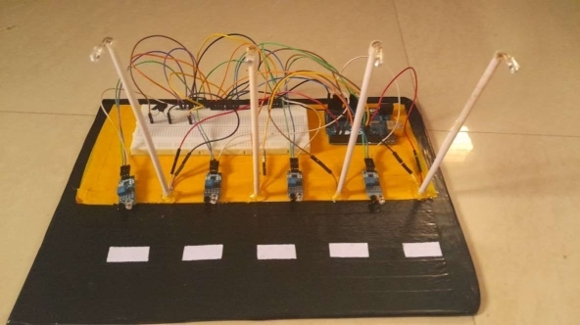

**5** **RESULTFROM** **ANALYSIS** **CONCLUSION** **AND** **FUTURE** **WORK** **REFERENCES**

**1.** **:** **EXPERIMENT** **RESULTS:**

As a team, we have successfully assembled the system, All the components are in accordance to other component. The four IR sensors are placed next to each other. The Arduino board is about to be mounted and connected to the external power supply for the flow of current. All the four IR sensors are going to be connected to the Arduino board. All the wirings with the breadboard are installed. . All the connections are completed, as soon as the 5V power supply is fed to the input Arduino, circuit will start to work perfectly.

**Fig** **5.1:** **EXPERIMENT** **RESULTS**

The Fig. 5.1 shows the initial operation when power is supplied to the Arduino at the 24 natural lighting condition. Thus, LDR circuit detects light and LDR works as an insulator, does not allow the current to pass through the circuit. Hence, LEDs are remained turn off. ,LDR is hidden by finger tip, to create natural dark condition. Due to no light, the resistance of LDR becomes very low, allowing current to pass through the LDR circuit. Thus, LEDs glow dimly. when any object is detected by the first sensor first two adjacent LEDs glow with its full intensity keeping rest of the LEDs lit dimly. IR sensor detects the object and glows the corresponding LED and the successive LED with full intensity keeping rest of LEDs lit dimly.

**Output:** This is the drive link for our project output

21

**2.** **APPLICATIONS** **AND** **ADVANTAGES:**

• The street light control circuit can be used in normal roads, highways, express ways etc.

• The project can also be used in parking areas of malls, hotels, industrial lighting, etc.

• If the lighting system implements all LED lights, the cost of the maintenance can be reduced as the life span and durability of LEDs is higher than Neon based lights which are normally used as street lights.

• As the lights are automaticallyturned ON or OFF, huge amount of energy can be saved.

• This system less costly, less installation and maintenance cost and more efficient as compared to the others system.

22

**3.** **LIMITATIONS** **AND** **FUTURE** **WORK:**

**LIMITATIONS:**

* Some common disadvantages of conventional ultrasonic sensors include limited testing distance, inaccurate readings, and inflexible scanning methods. All these drawbacks, however, can be mitigated and even overcome with the right NDT tools and techniques.

23

**5.** **CONCLUSION:**

* The objective of this project was to design and implement a wireless distance measurement device using ultrasonic sensor. By using the system, we can not only calculate the distance of the object, but we can also locate the object.
* The following can be concluded from the above project-:

1.The system can calculate the distance of the object without errors.

2.The system can locate the object.

3.The system provides low cost and efficient solution.

* A low-cost distance measurement system using ultrasonic sensor which works good in different light condition and has the capability to detect both distance and location of the object.

24

**6.** **REFERENCES**:

1.Tarek Mohammad, “Using Ultrasonic and Infrared Sensors for Distance Measurement” World Academy of Science, Engineering and Technology, Volume 3, March 2009.

2. S.P. Bhumkar, V.V.Deotare, R.V.Babar “Accident avoidance and detection on highways”, International journal of engineering trends and technology-volume-3, Issue-2, pp.247-252, 2012.

3. http://www.makeitortakeit.in/projects/aurduino/distance-measurement-using-ultrasonic/

25