INTERNSPARK TASK 1 REPORT

Build a RESTful API using Node.js, Express.js, and MongoDB
Name: Gunapalli Chandra Sai Sri
Task: Task 1
Internship: InternSpark MERN Stack Internship
GitHub Repository: https://github.com/saisri202/internspark-task1-api

Objective
To develop a RESTful CRUD API using Node.js, Express.js, and MongoDB Atlas with Mongoose validation, error handling middleware, logging, and GitHub integration.

Technologies Used
• Node.js
• Express.js
• MongoDB Atlas
• Mongoose
• Postman
• Git
• GitHub
• VS Code
• Morgan
• Dotenv

Commands Used
- npm init -y
- npm install express mongoose dotenv cors morgan
- npm install nodemon --save-dev
- npm run dev
- git init
- git add .
- git commit -m "Completed InternSpark Task 1 CRUD API"
- git branch -M main
- git push -u origin main

API Endpoints
Method | Endpoint | Description
POST | /api/products | Create Product
GET | /api/products | Get All Products
GET | /api/products/:id | Get Product By ID
PUT | /api/products/:id | Update Product
DELETE | /api/products/:id | Delete Product

Implementation Screenshots

Package Installation and Initial Setup
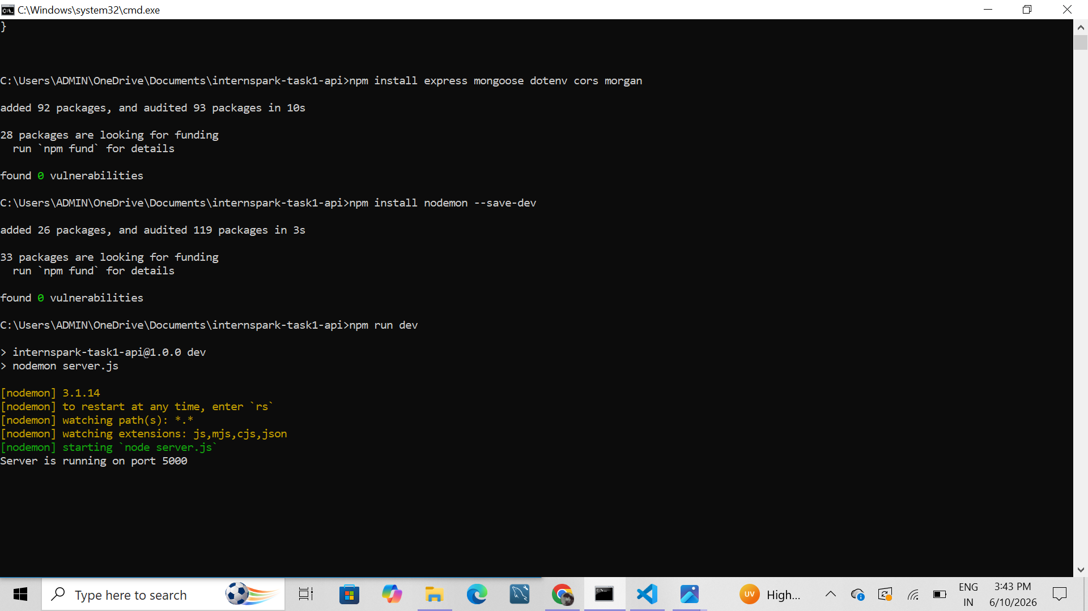
Figure: Package Installation and Initial Setup

API Running in Browser
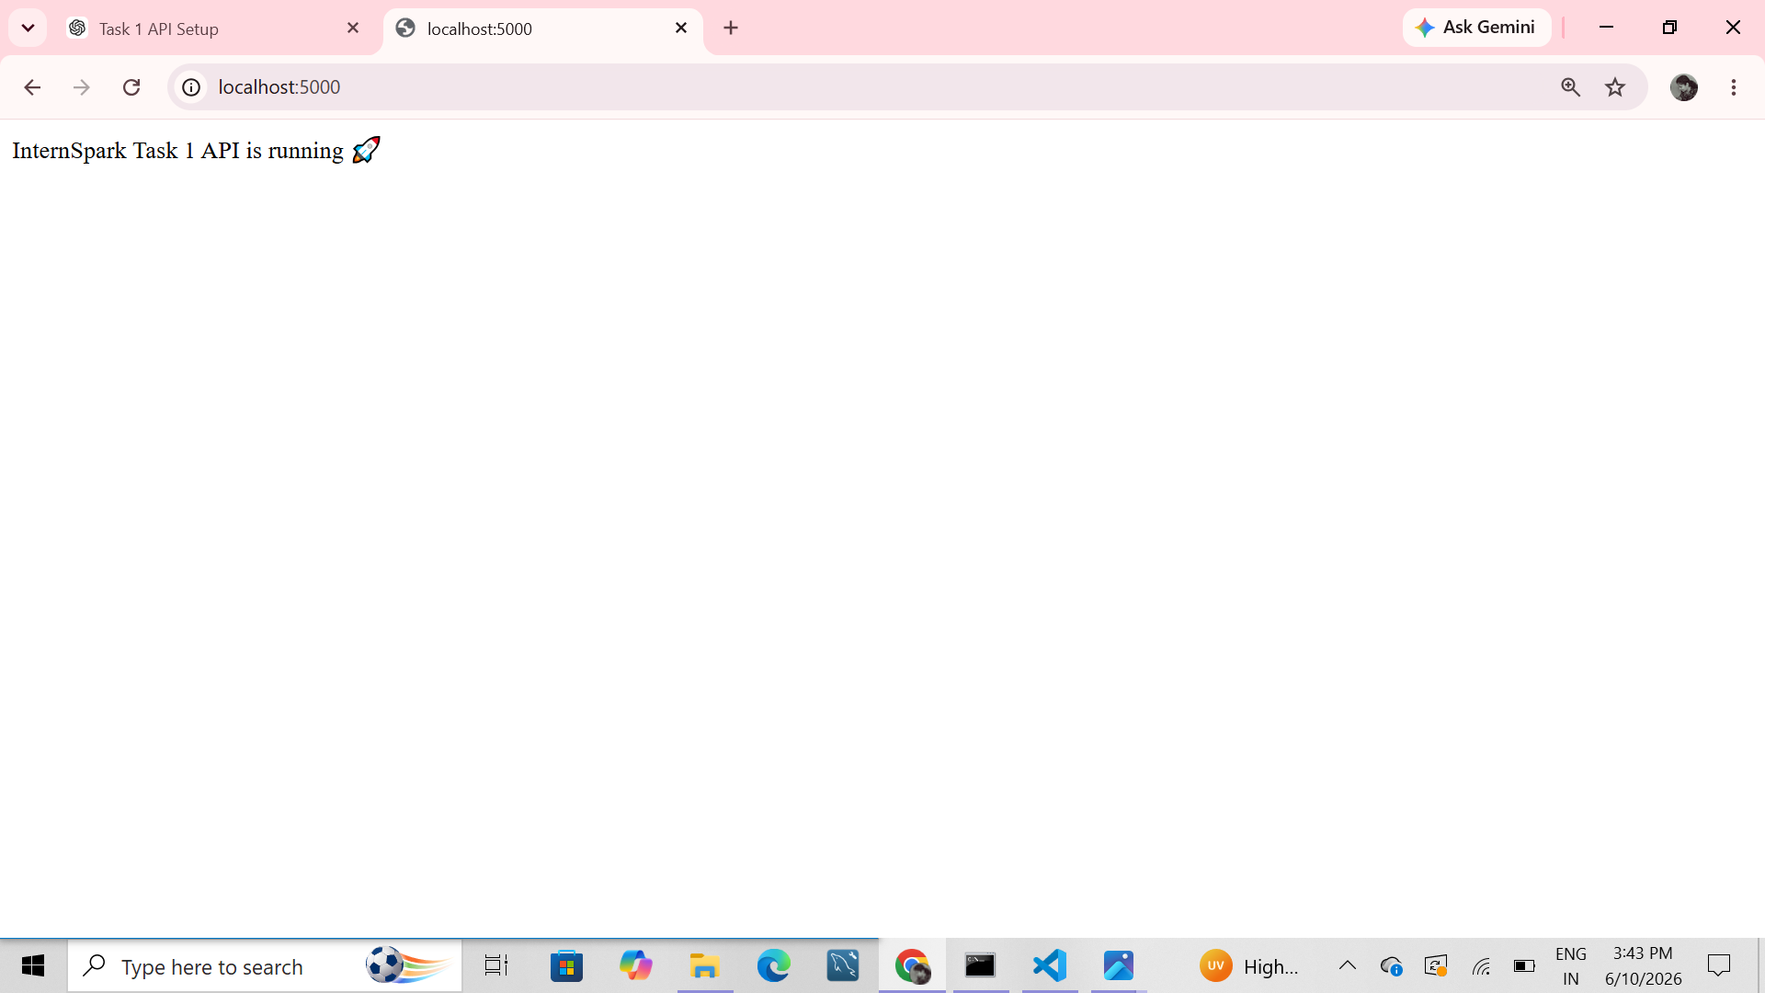
Figure: API Running in Browser

MongoDB Connection Successful
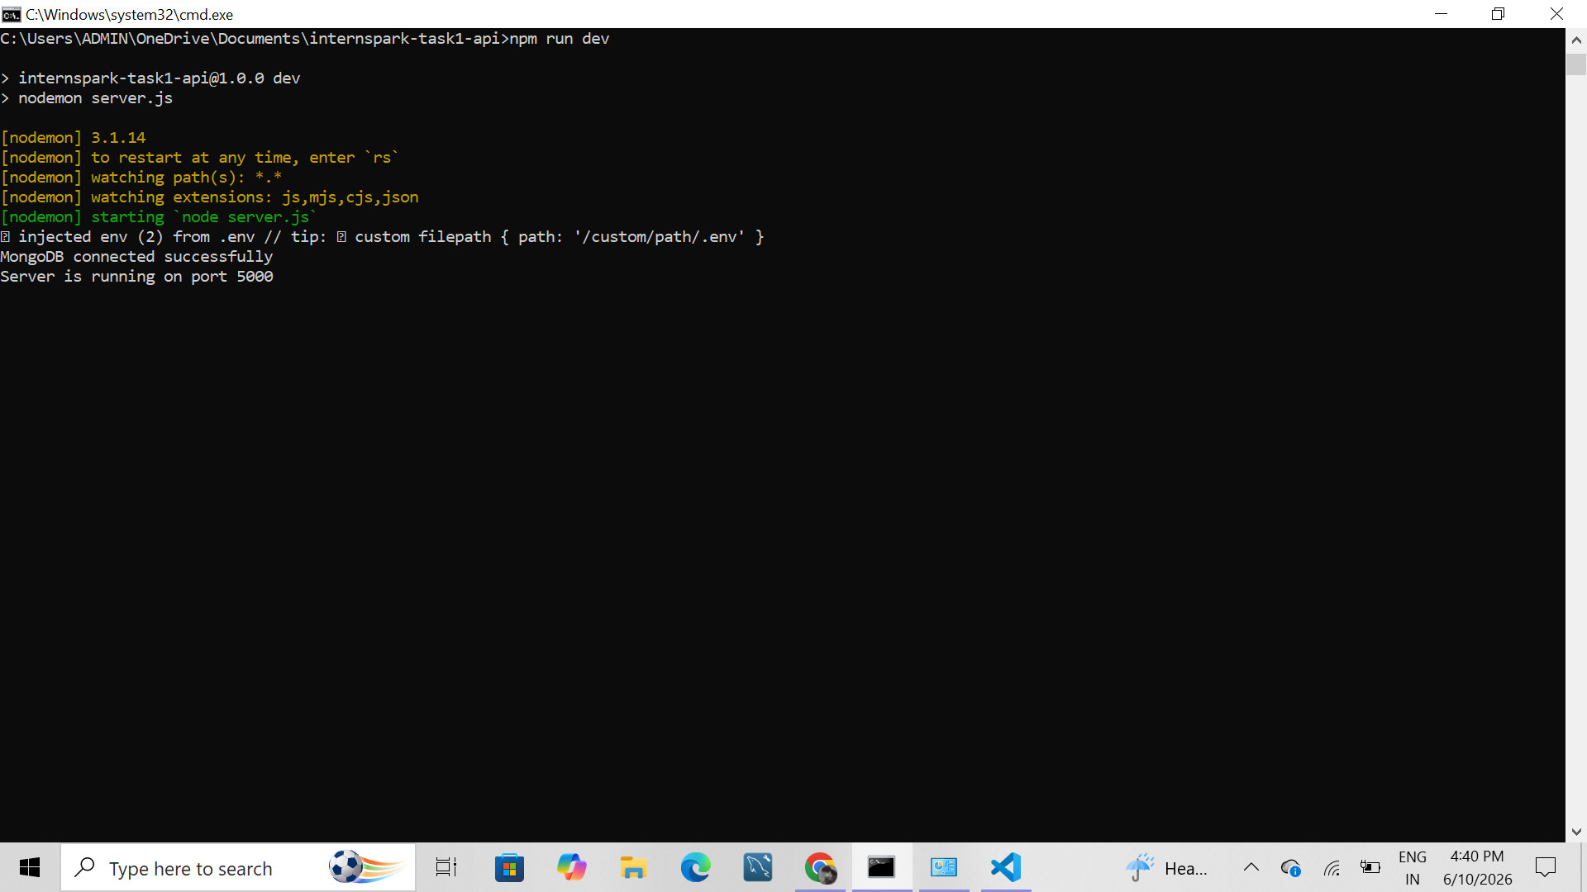
Figure: MongoDB Connection Successful

POST Request - Create Product
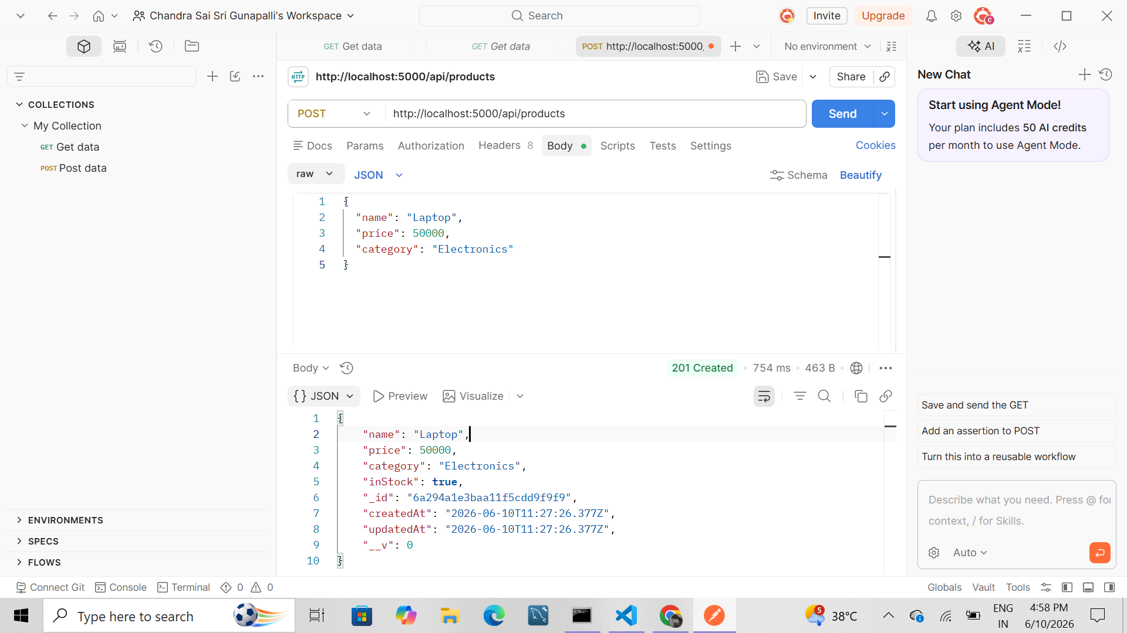
Figure: POST Request - Create Product

PUT Request - Update Product
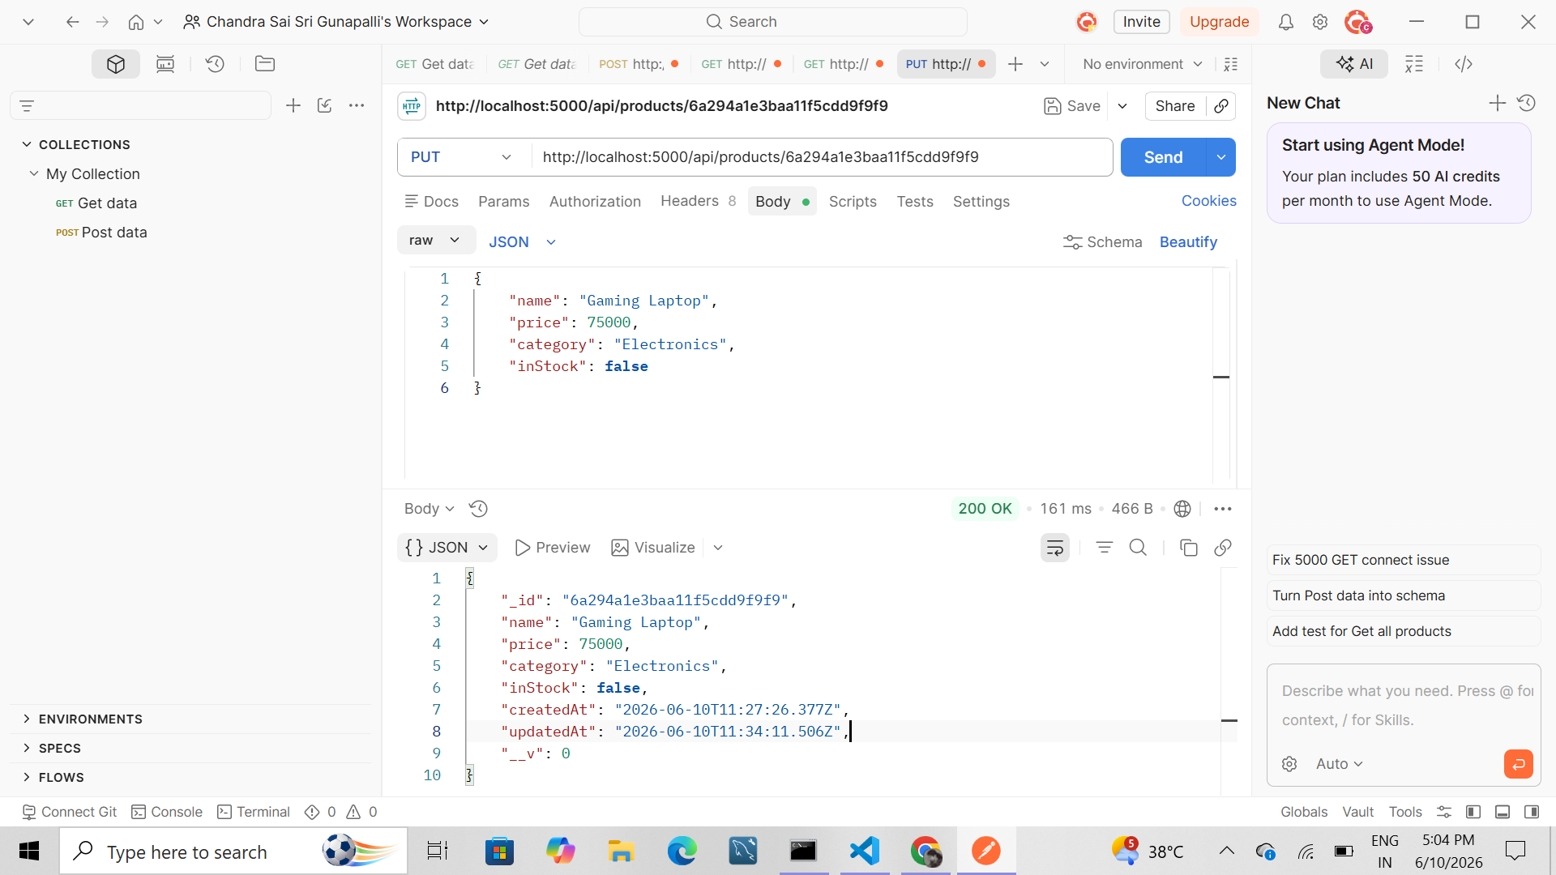
Figure: PUT Request - Update Product

DELETE Request - Delete Product
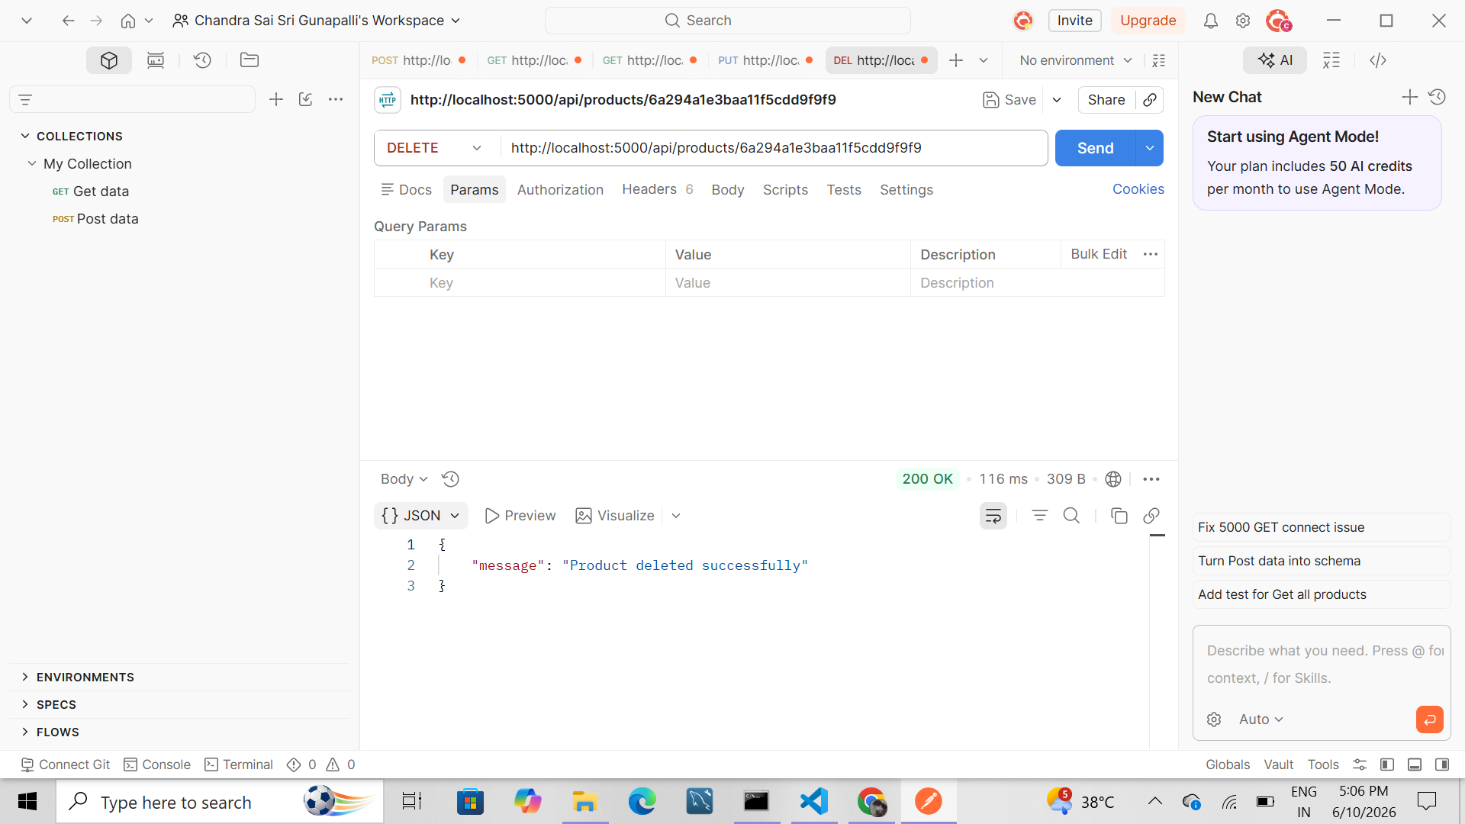
Figure: DELETE Request - Delete Product

GET Request - Fetch Products
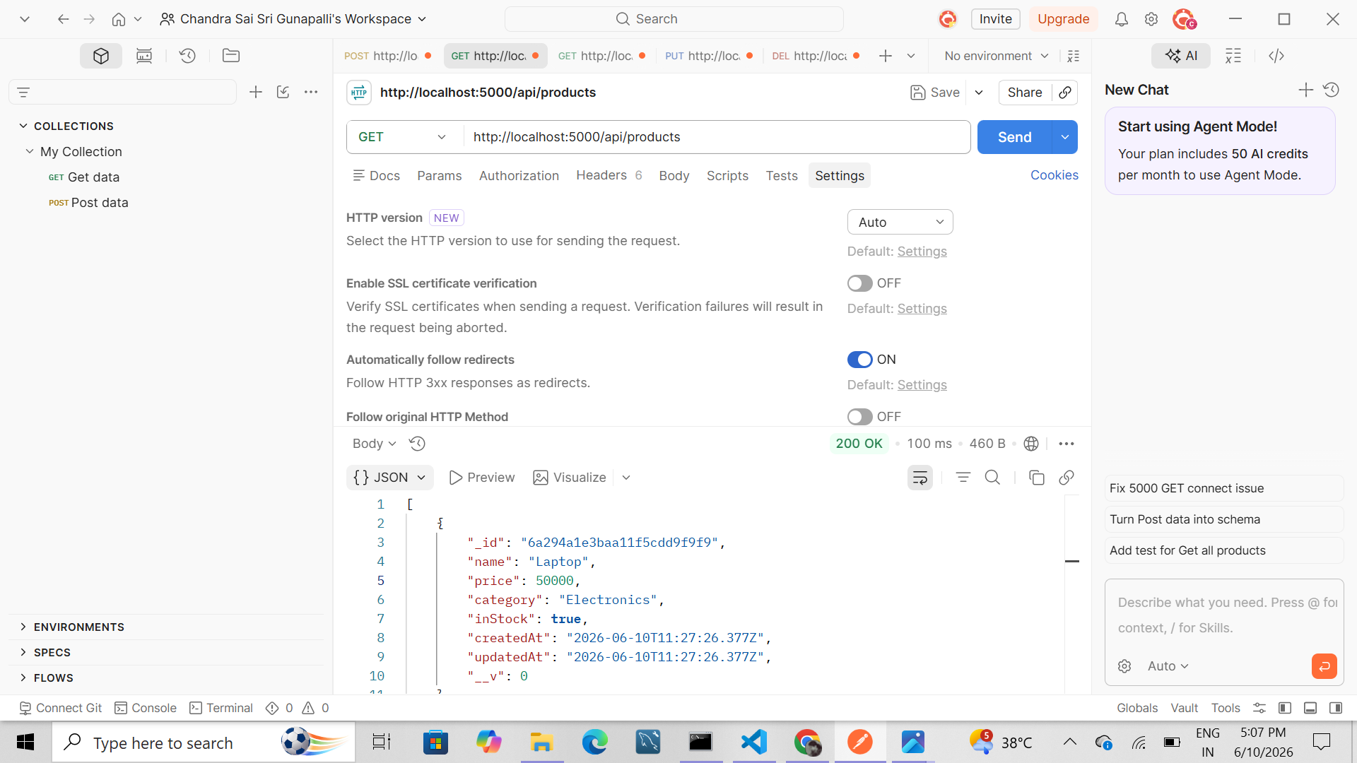
Figure: GET Request - Fetch Products

GET Request After Deletion
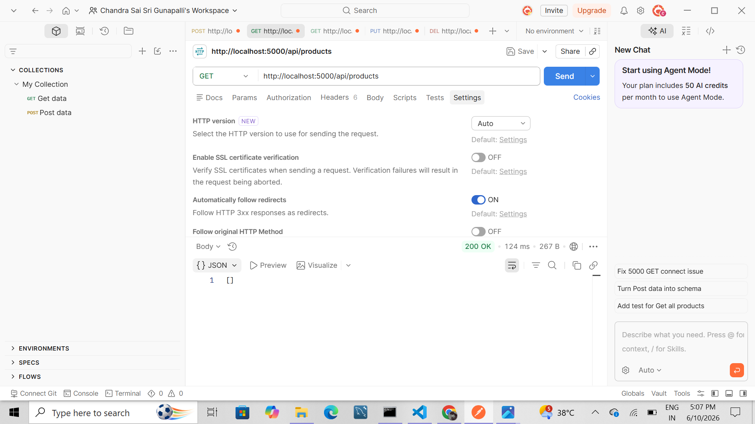
Figure: GET Request After Deletion

VS Code Project Structure
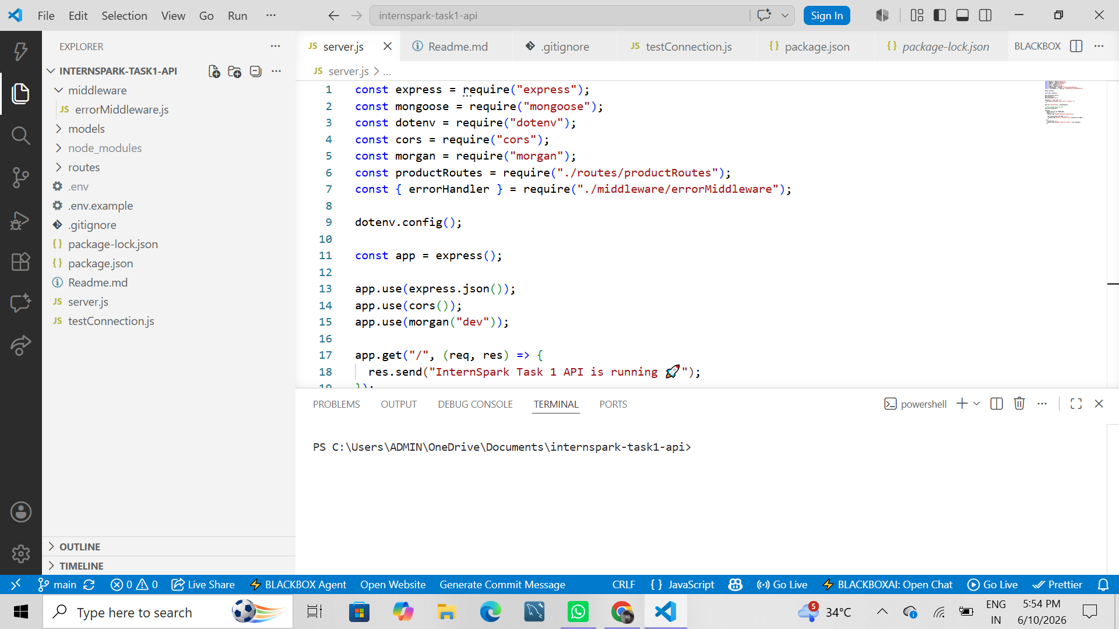
Figure: VS Code Project Structure

GitHub Repository
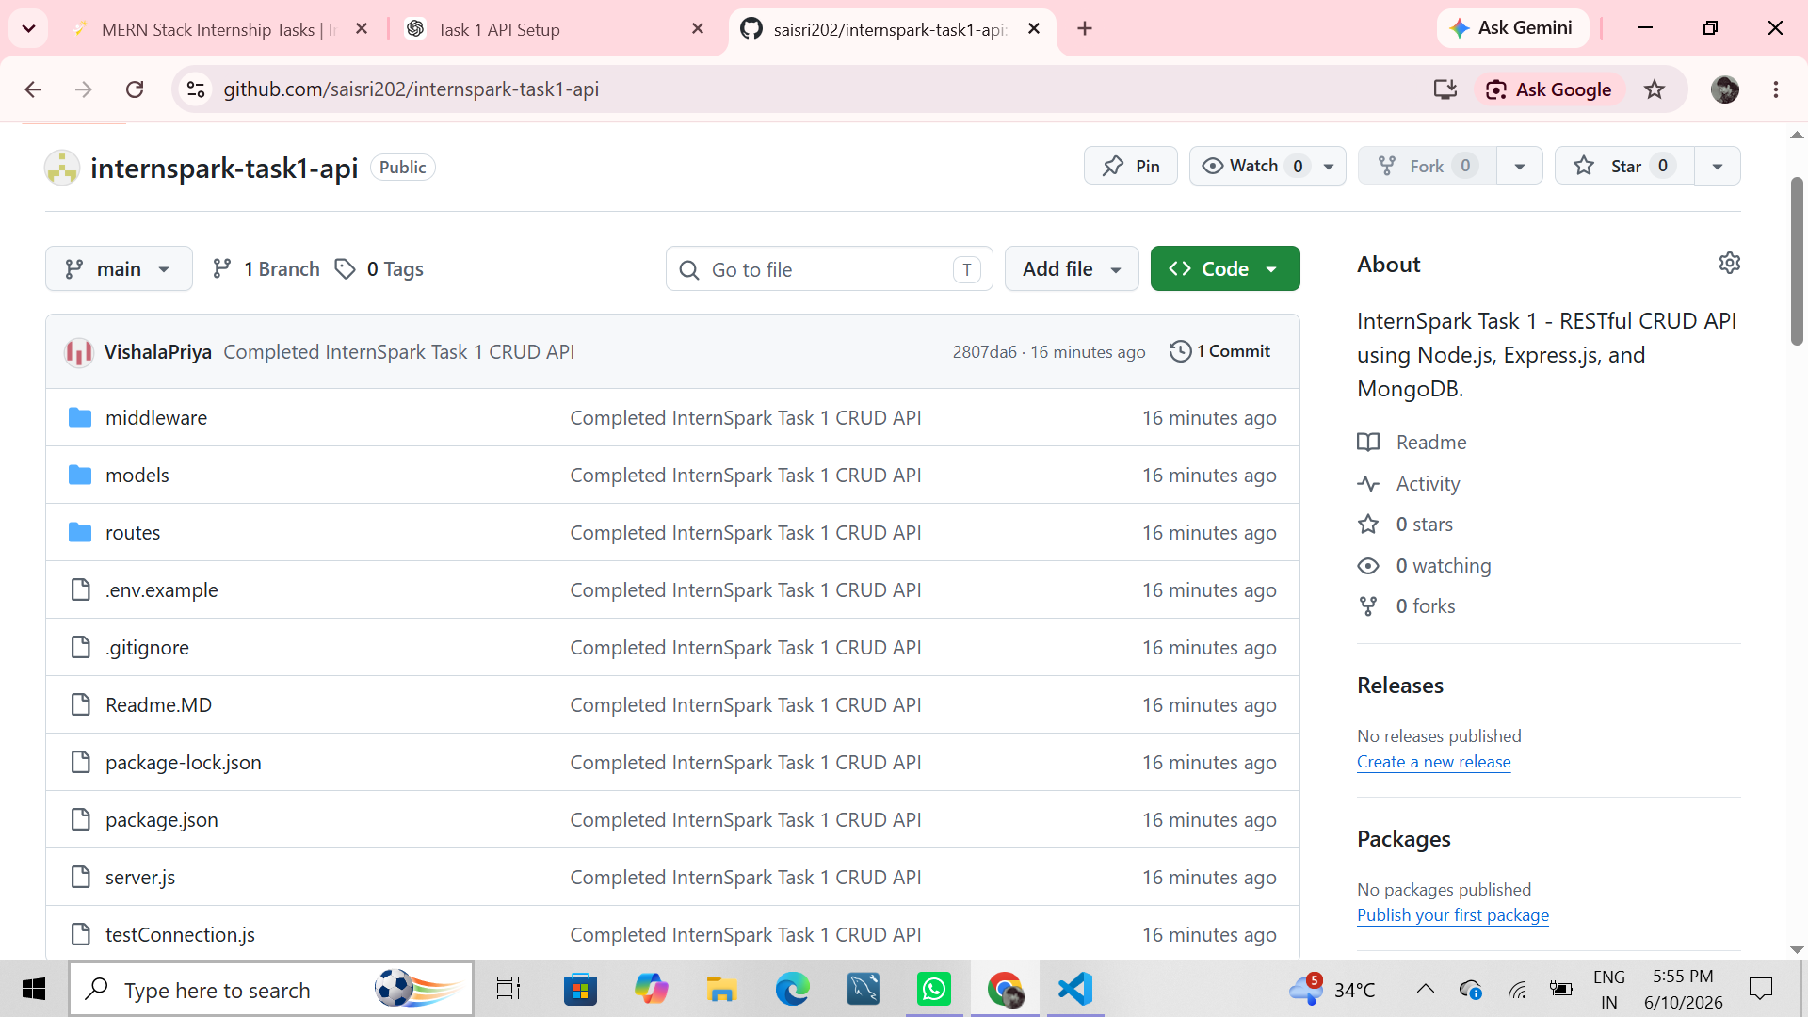
Figure: GitHub Repository

Conclusion
The RESTful CRUD API was successfully designed and implemented using Node.js, Express.js, and MongoDB Atlas. All CRUD operations were tested using Postman, and the project was version controlled using Git and published to GitHub successfully.

