InternSpark Task 2 Report

Frontend SPA with React

Submitted By: Gunapalli Chandra Sai Sri
GitHub Repository:
https://github.com/saisri202/internspark-task2-react

Objective
To build a React Single Page Application (SPA) that consumes the REST API developed in Task 1 and provides a user interface to perform CRUD operations.

Technologies Used
• React
• Vite
• React Router DOM
• Axios
• Node.js REST API

Features Implemented
• View Products
• Add Products
• Edit Products
• Delete Products
• Routing
• Axios Integration

Home Page
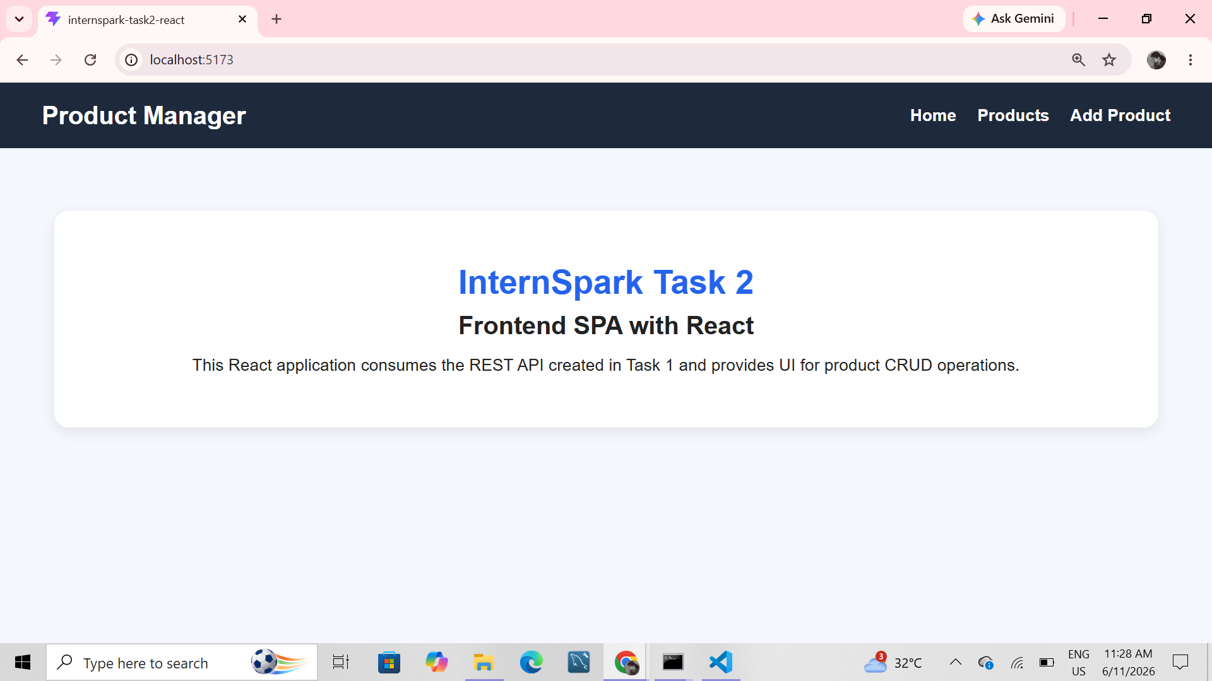

Products Page
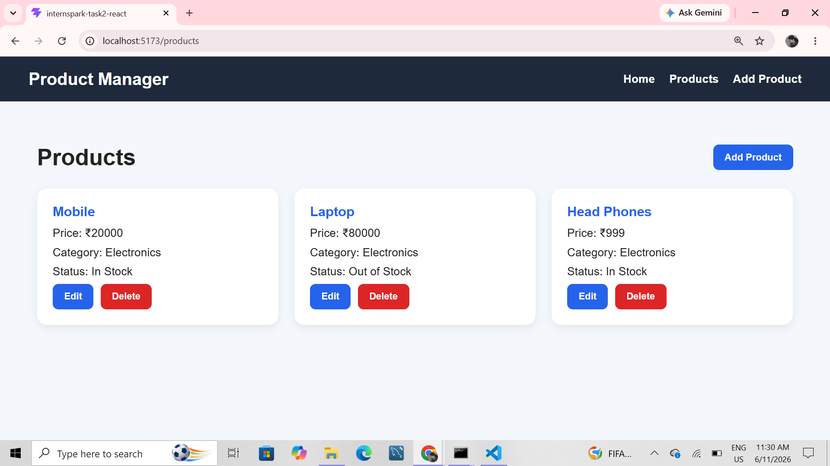

Add Product Form
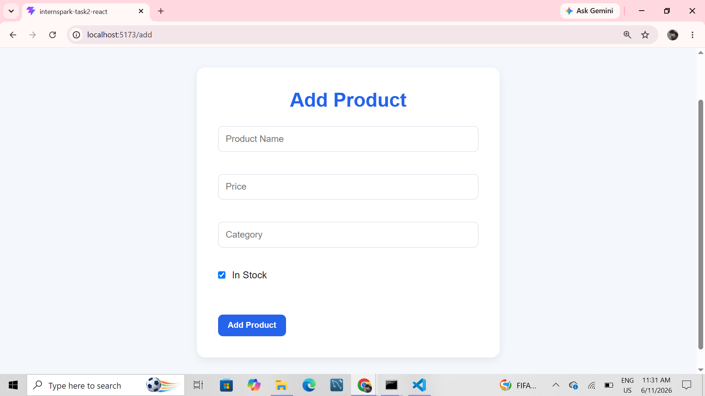

Product Added Successfully
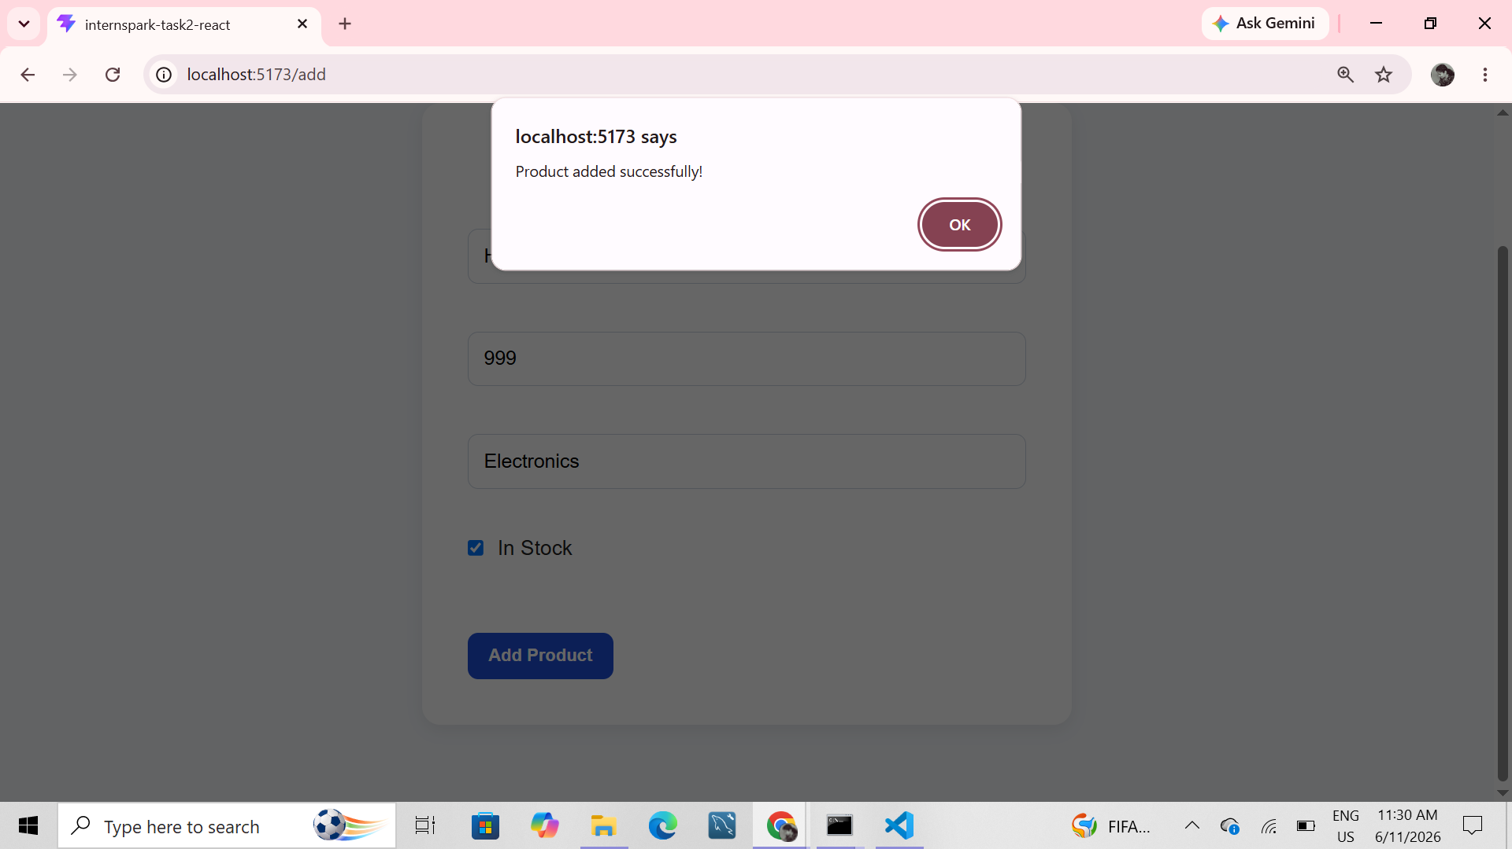

Edit Product Form
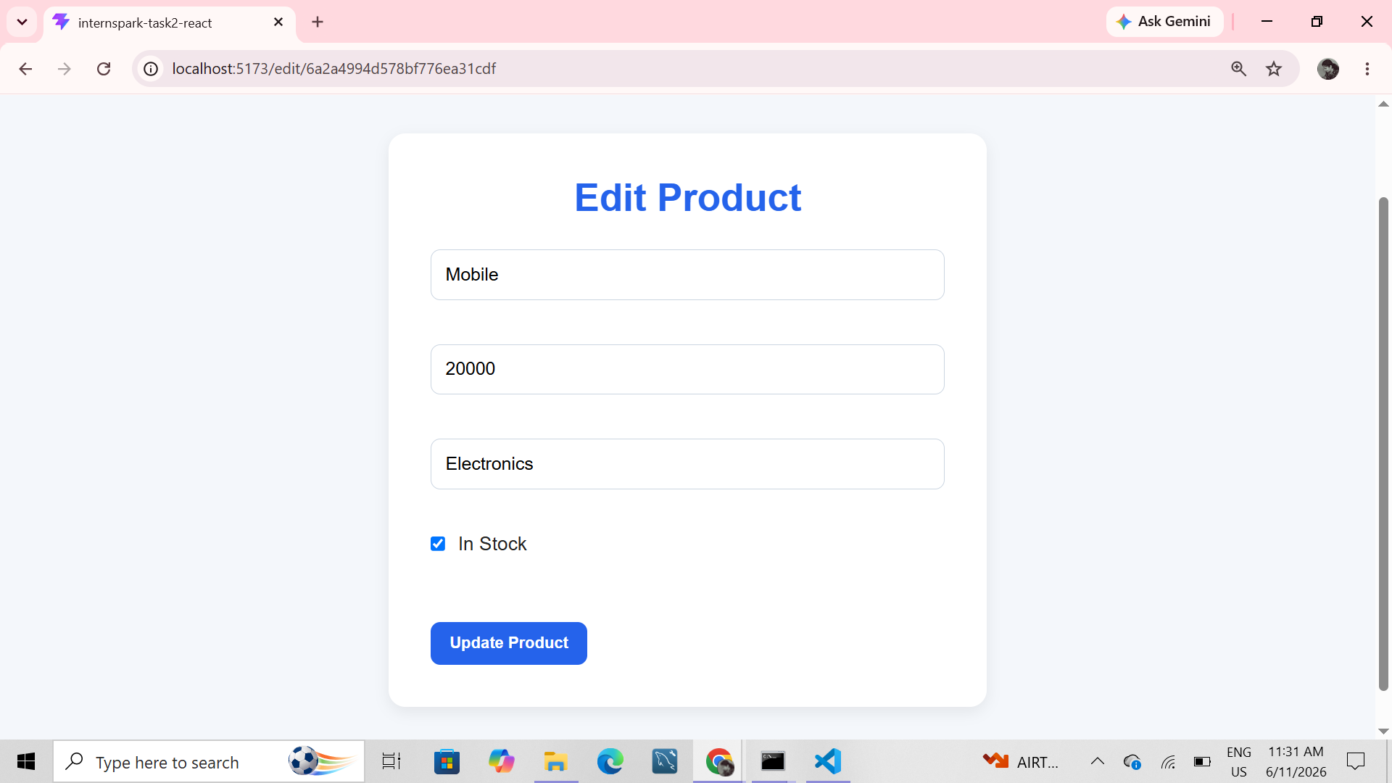

Product Updated Successfully
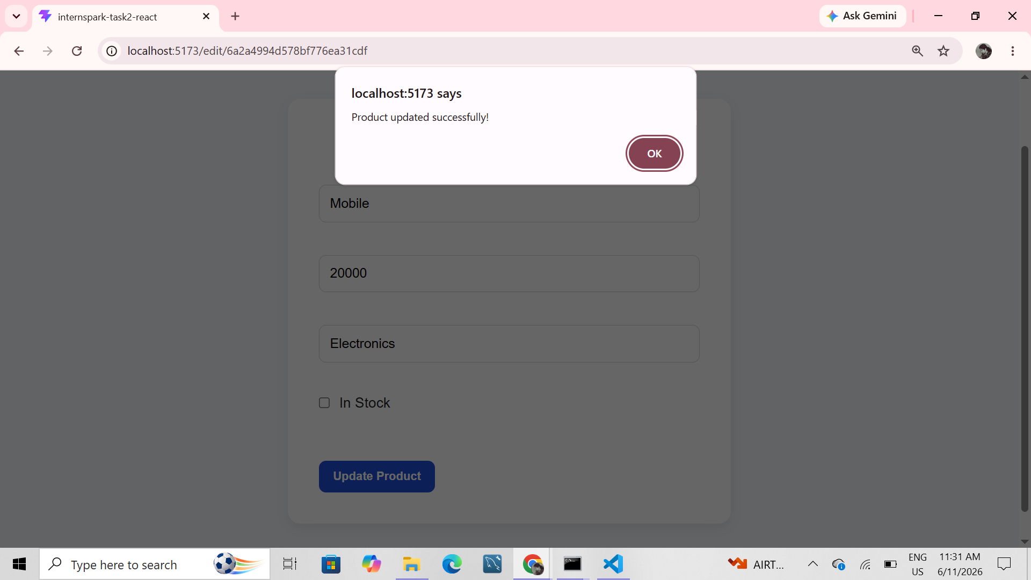

Product Deleted Successfully
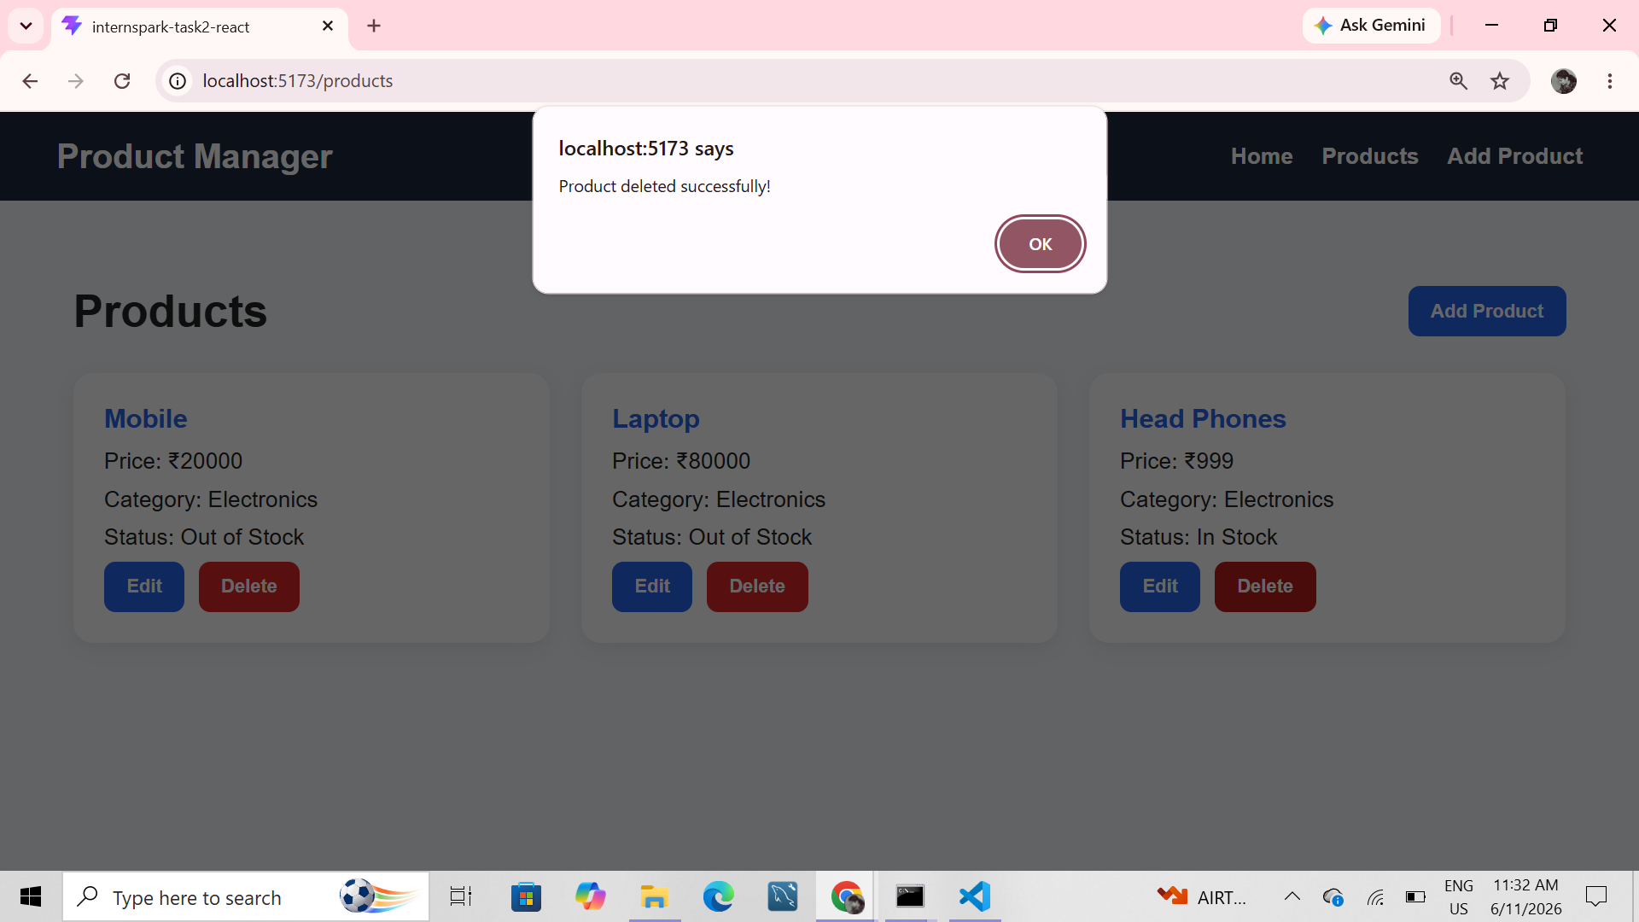

Products After Deletion
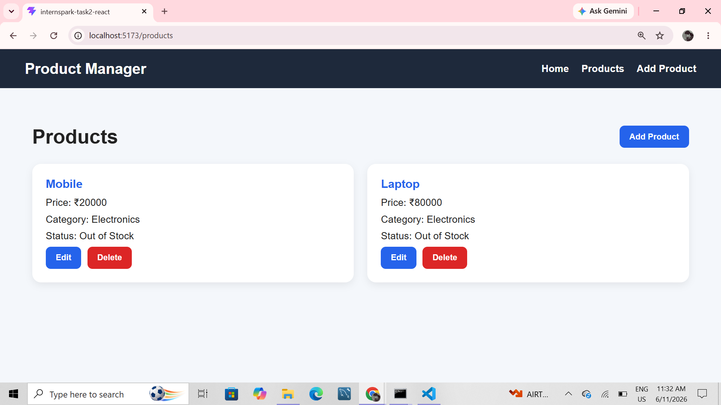

VS Code Structure
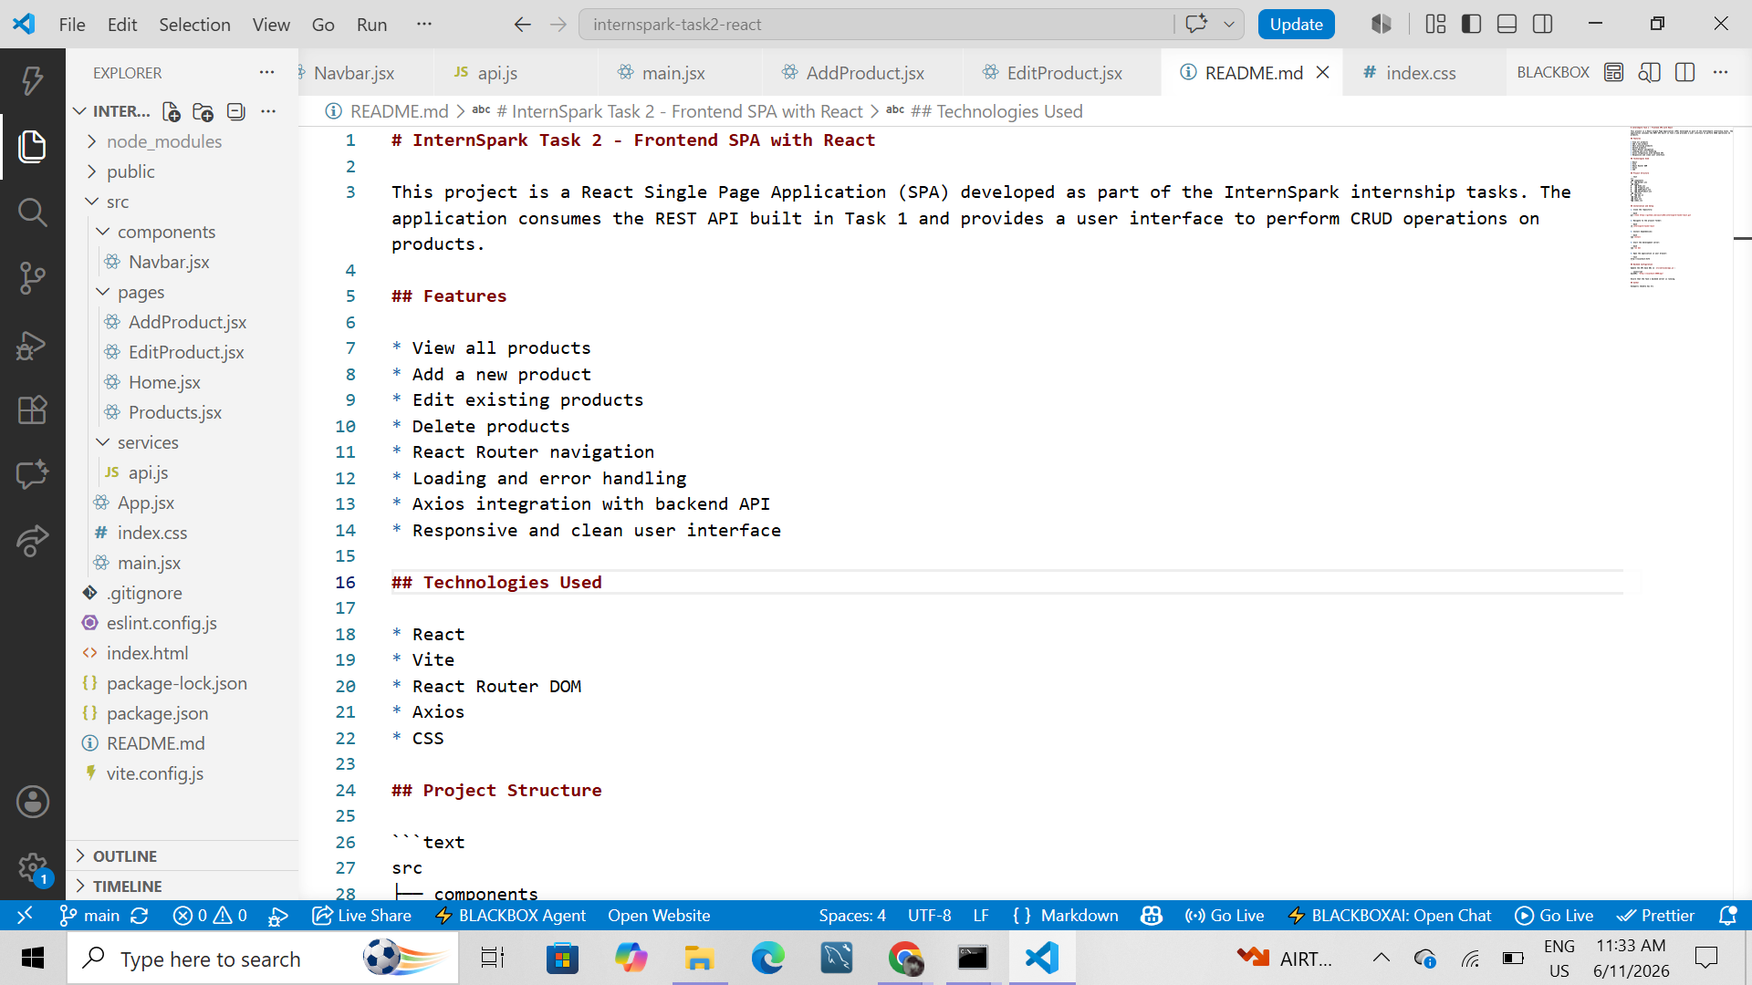

Vite Development Server
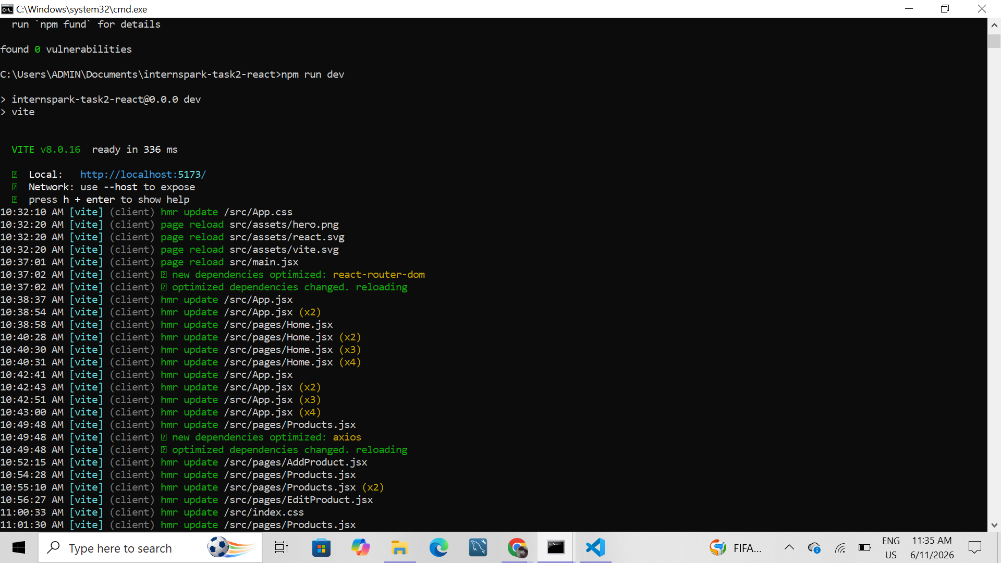

Conclusion
The React SPA was successfully developed using functional components and hooks. The application integrates with the backend REST API and supports complete CRUD operations.

