* **Display**
* **There are four types of displays available**

1. **display: inline;**
2. **display: block;**
3. **display: inline-block;**
4. **display: none;**
5. **display: flex;**

* **The display inline property allows next element to sit beside the current element and height and width property do not affect the space occupied the border the enough space only get occupied.**
* **The display block property do not allow the next element next to current element the next element starts from new line and width and height properties get affected.**
* **The display inline-block is combination of the display block and display inline here it allows element next to it and height and width properties affects.**
* **Display: inline;**

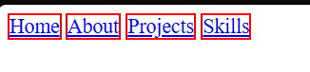

* **Display: block;**

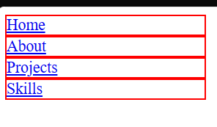

* **Display: inline-block;**



* **Wire Frame**
* **A wireframe is skeletal outline of web page. It contains of horizontal or vertical lines that form boxes denoting containers that further contain different elements of the web page.**
* **We should draw wireframes as much as detail as possible**
* **Key to design any website is to draw an wireframe.**
* **Different ways to create wire frames**
* **Display: inline-block;**
* **Float**
* **Flexbox**
* **Flexbox**
* **It deals with alignment of elements inside parent element**
* **In flexbox layout we call the parent as flex container and their children as flex items.**
* **To create the flex children and flex container we need to set display property of the parent to display: flex;**
* **There are two axis in the flexbox**

1. **Main axis**
2. **Cross axis**

* **There are two terminals in the flexbox start and the end**
* **The direction of the flex items in the container using flex-direction and the**

**Flex-direction property get applied to only the parent element no child element**

* **Flex direction has values**

1. **row (items aligned from the left to right)**
2. **row reverse (items aligned from right to left)**
3. **column (items aligned from the top to bottom)**
4. **column reverse (items aligned from bottom to top)**

* **Creating the responsive website**