# Phase 2: Org Setup & Configuration (Education Project)

## Create a New Lightning App

App Manager → New Lightning App.  
  
Smart Education CRM  
  
“A Salesforce solution for Student Enrollment & Engagement Management.”

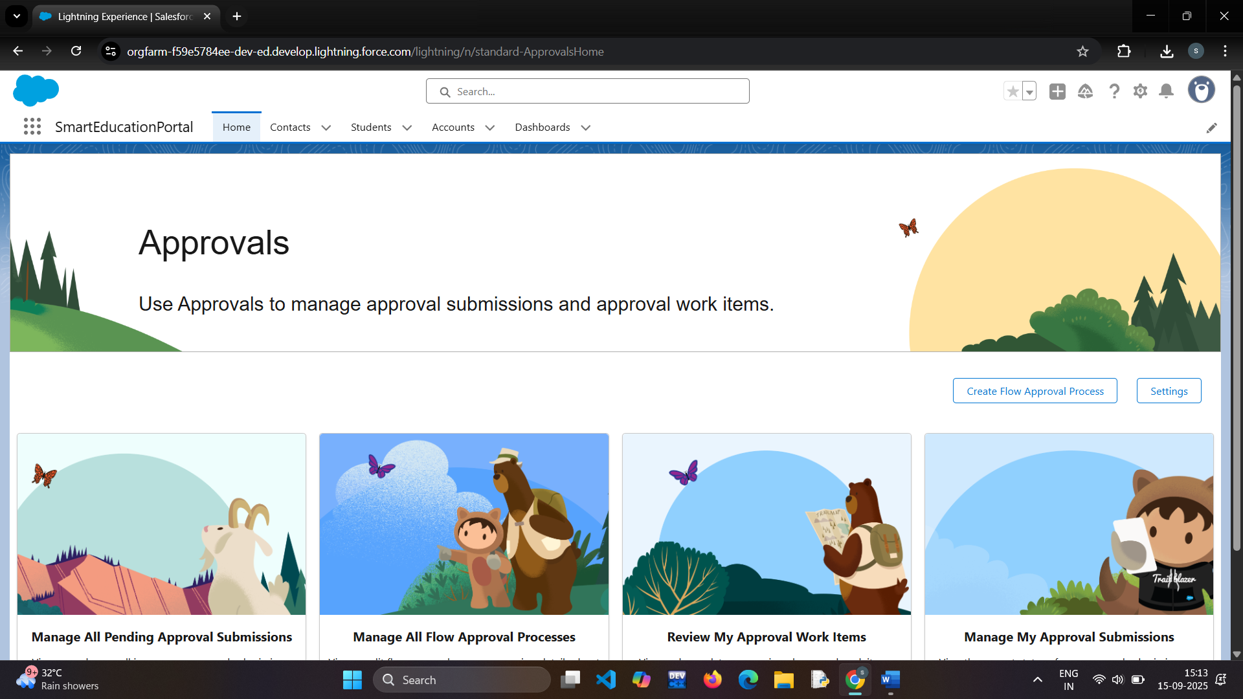

## Custom Objects

Student__c  
Application__c  
Course__c  
Faculty__c  
Counseling_Session__c  
Transcript__c  
Support_Case__c

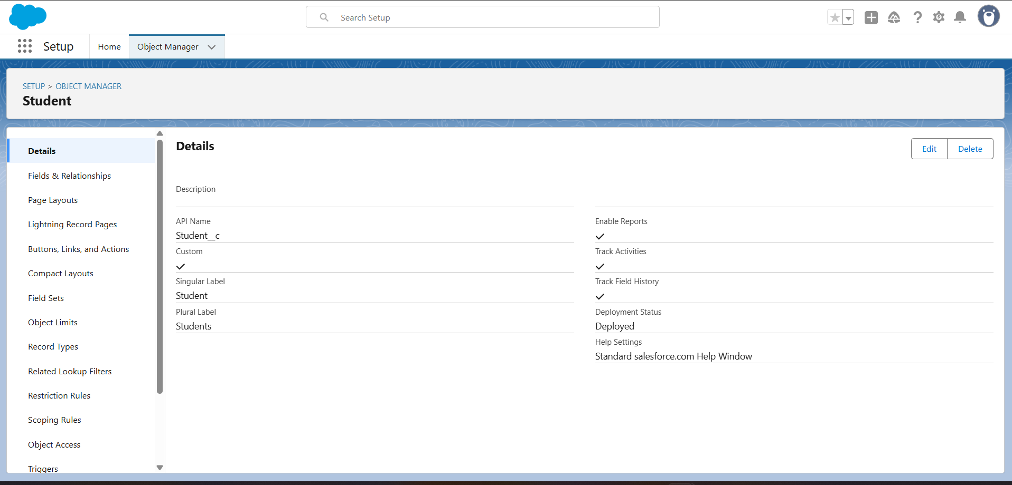

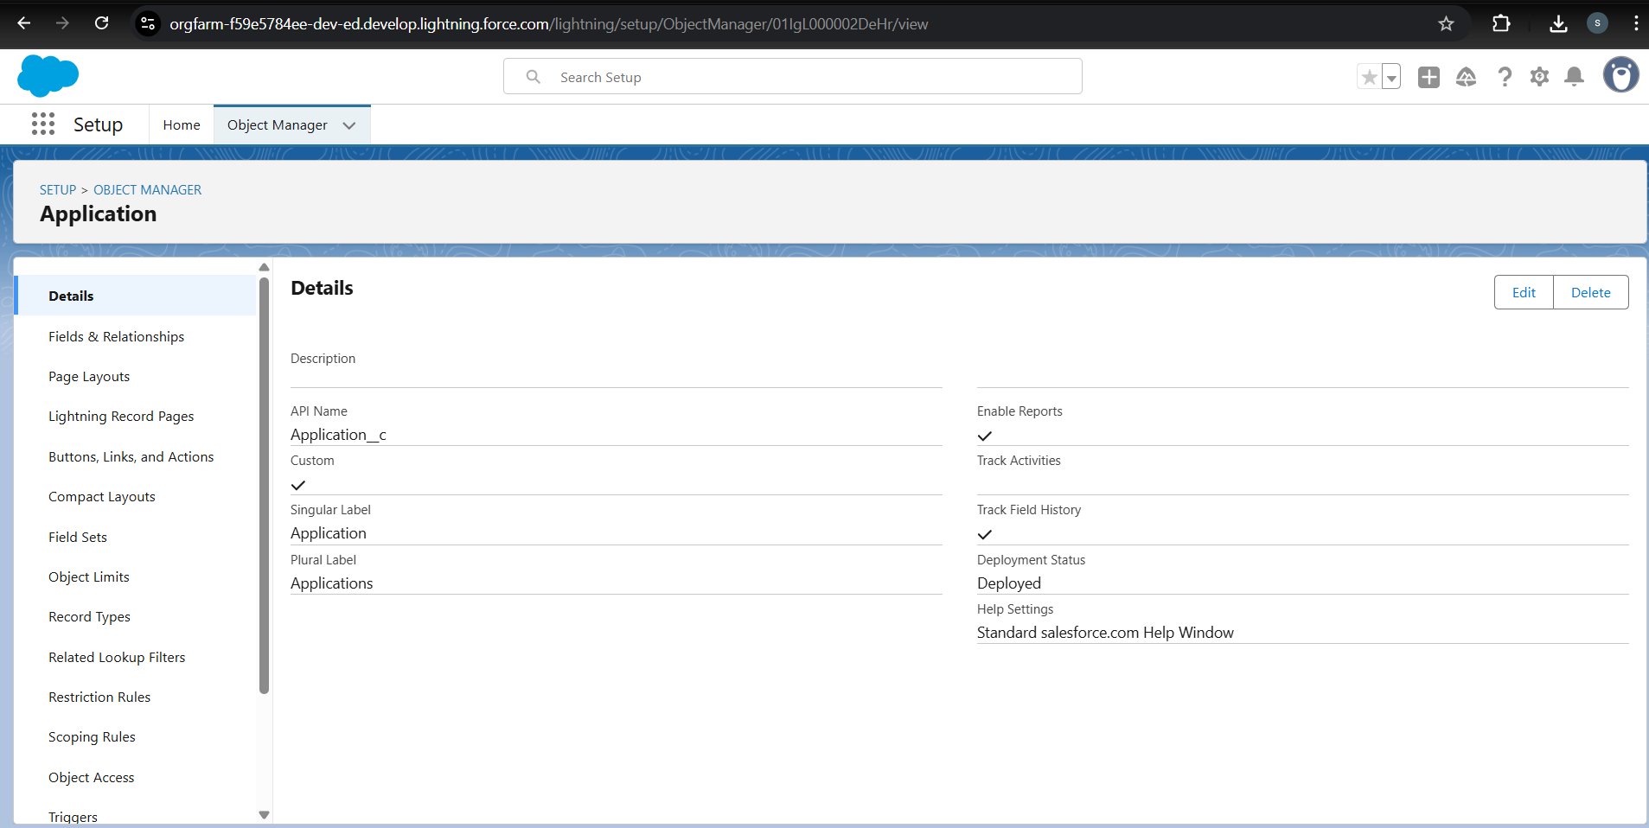

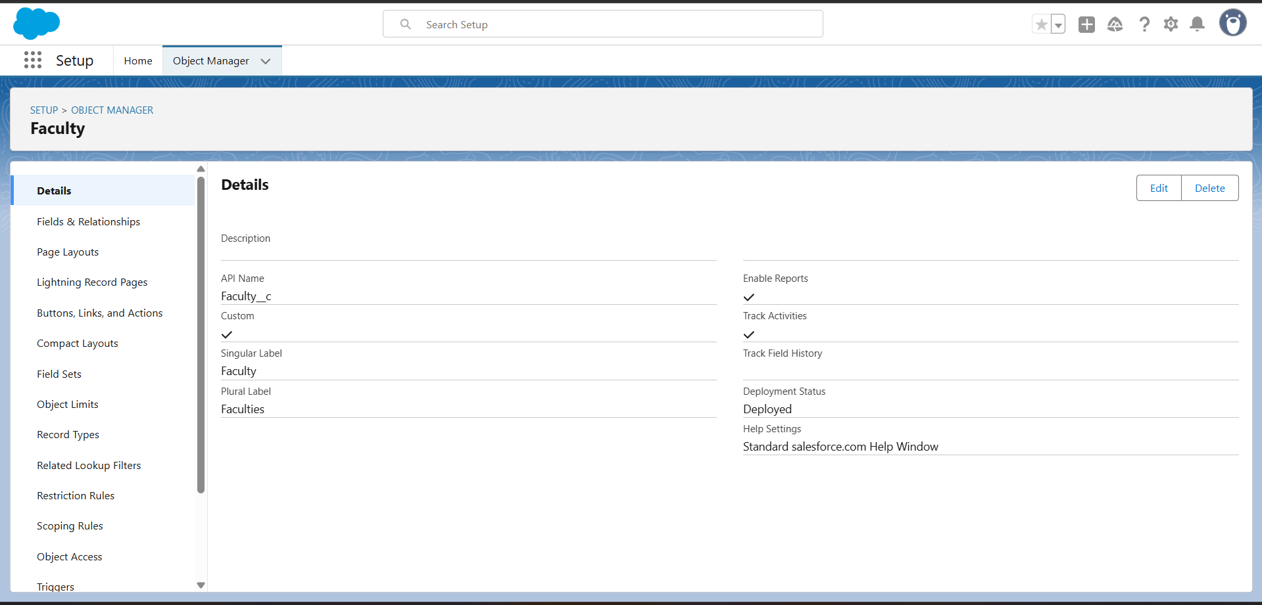

## Custom Fields

**Student_c**

Student_ID__c → Auto Number (STU-{0000})

Name__c → Text (80)

Email__c → Email

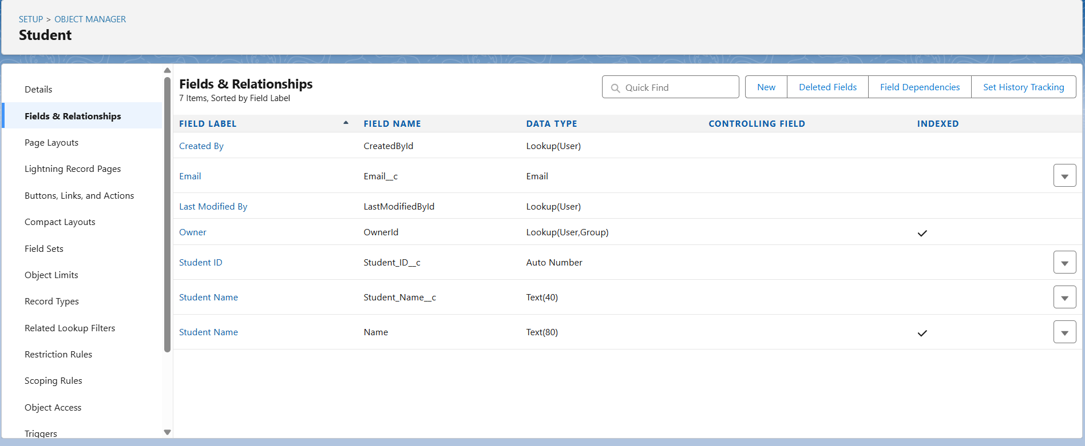

**Application__c**  
  
Application_Date__c (Date)  
Status__c (Picklist: Applied, Shortlisted, Admitted, Enrolled)  
Student__c (Lookup → Student/Contact)  
Faculty_Assigned__c (Lookup → Faculty__c)  
Interview_Date__c (Date/Time)

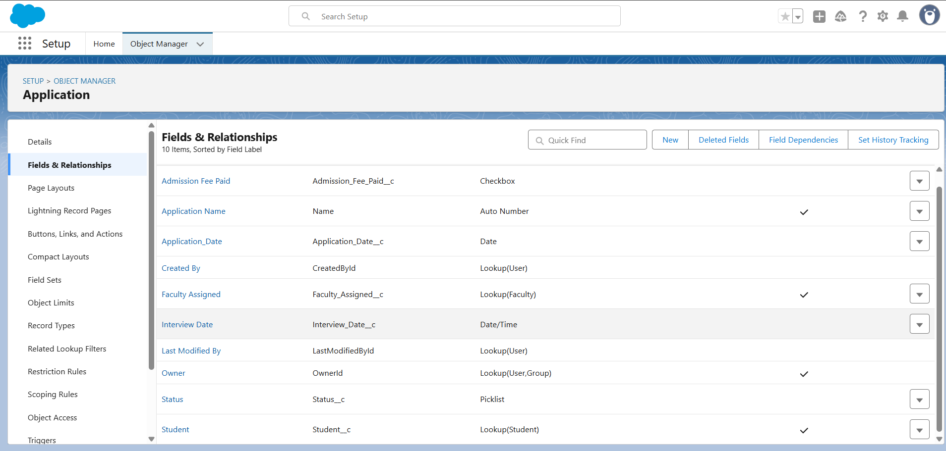

## Tabs for Custom Objects

Student, Application, Course, Faculty, Counseling Session, Transcript, Support Case

