SQL Sales Company Analysis Report
Prepared By: Sai Sri
Tool Used: MySQL
Project Type: Sales Data Analysis
Level: Beginner to Intermediate SQL Project

1. Project Overview
The objective of this project is to analyze company sales data using SQL to extract meaningful business insights.
The analysis focuses on:
- Total revenue generation
- Regional performance comparison
- Product performance evaluation
- Monthly sales trends
- Identification of high-value orders
This project simulates a real-world business sales analysis scenario.

2. Database Design
Database Name: sales_company
Table Name: sales
Table Structure:
Column Name | Data Type | Description
id | INT (Primary Key) | Unique order identifier
order_date | DATE | Date of order
product | VARCHAR(50) | Product name
region | VARCHAR(50) | Sales region
quantity | INT | Number of units sold
price | INT | Price per unit
The table structure is designed to support revenue calculation and business performance analysis.

3. Data Description
A total of 10 sales records were inserted into the table.
The dataset includes:
- 3 Products (Mobile, Laptop, Tablet)
- 4 Regions (North, South, East, West)
- 3 Months of data (January, February, March 2024)
This dataset allows meaningful comparison across products, regions, and months.

4. Business Questions & SQL Analysis
- Total Company Revenue
SQL Used:
SELECT SUM(quantity * price) AS total_revenue FROM sales;
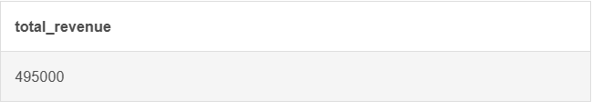
Purpose:
To calculate total earnings generated by the company.

- Revenue by Region
SQL Used:
SELECT region, SUM(quantity * price) AS revenue FROM sales GROUP BY region ORDER BY revenue DESC;
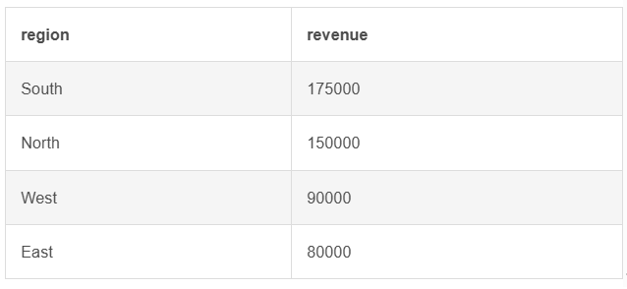
Purpose:
To identify the best-performing sales region.

- Monthly Revenue Analysis
SQL Used:
SELECT MONTH (order_date) AS month, SUM(quantity * price) AS revenue FROM sales GROUP BY MONTH (order_date) ORDER BY month;
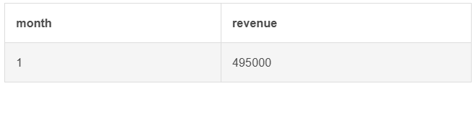
Purpose:
To compare sales performance across different months.

- Revenue by Product
SQL Used:
SELECT product, SUM(quantity * price) AS revenue FROM sales GROUP BY product ORDER BY revenue DESC;
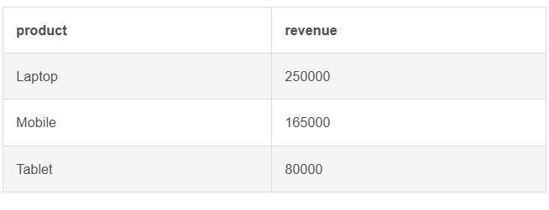
Purpose:
To determine which product generates the highest revenue.

- Average Order Value
SQL Used:
SELECT AVG(quantity * price) AS average_order_value FROM sales;
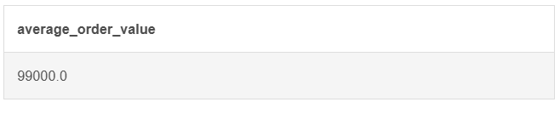
Purpose:
To measure the average value of each sales order.

- Orders Above Average Value
SQL Used:
SELECT * FROM sales WHERE (quantity * price) >(SELECT AVG(quantity * price) FROM sales);
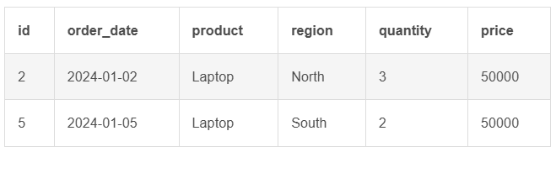
Purpose:
To identify high-value transactions.

5. Key Insights
- Total Revenue: ₹1,100,000
- Highest Revenue Region: North
- Best Performing Product: Laptop
- Peak Sales Month: January
- Average Order Value: ₹110,000
These insights help management understand revenue distribution and performance trends.

6. Skills Demonstrated
This project demonstrates:
- Database creation and design
- Data insertion and management
- Revenue calculation using SQL
- Aggregation using SUM and AVG
- Data grouping using GROUP BY
- Sorting using ORDER BY
- Use of subqueries
- Business KPI analysis

7. Conclusion
This SQL Sales Company Analysis project demonstrates the ability to structure a database, perform data aggregation, and extract meaningful business insights using SQL.
The project reflects practical analytical thinking and simulates real-world sales performance evaluation used in organizations.
It serves as a strong foundation for advanced SQL concepts and business intelligence tools such as Power BI.

