238W1A1290
28-07-25
Week-2: JAVA & MSACCESS CONNECTIONS WITHOUT DSN
Step 1: Create the Java application file using IDE
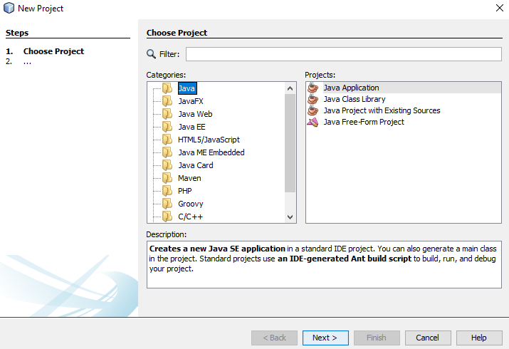

Step 2: Copy source code to the created java application file.
package welcome;

import java.sql.*;
import java.util.*;
public class Welcome{
public static void main(String args[])
{
try
{
Class.forName("net.ucanaccess.jdbc.UcanaccessDriver");
Connection con=DriverManager.getConnection("jdbc:ucanaccess://D:\\vrsec.accdb");
Statement st=con.createStatement();

ResultSet rs=st.executeQuery("select * from it");
while(rs.next())
{
System.out.println("emp Number is:"+rs.getInt(1));
System.out.println("emp name is:"+rs.getString(2));
}
}
catch(Exception e)
{
System.out.println(e.getMessage());
}
}
}

Step 3: Extract the given file and copy the Database to the D drive.
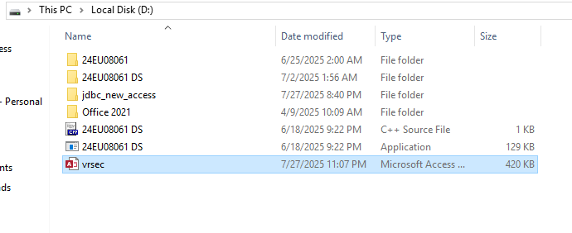
Step 4: Add the required JAR file to the project in the IDE.
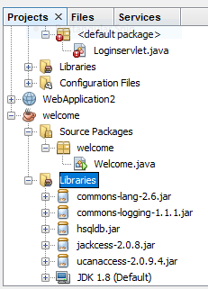

Step 5: Run the project file the IDE.
Output:
