238W1A1290
Week-7
AIM:To develop a Java Servlet program that demonstrates the concept of cookies by creating, setting, and reading cookies from the client’s browser to maintain user-specific information across multiple requests.

Code:

clearCookieServlet.java:
package com.example.cookies; import java.io.*;
import javax.servlet.*;
import javax.servlet.annotation.WebServlet; import javax.servlet.http.*; @WebServlet("/clear")
public class ClearCookieServlet extends HttpServlet { @Override
protected void doGet(HttpServletRequest request, HttpServletResponse response) throws ServletException, IOException {
Cookie cookie = new Cookie("username", ""); cookie.setMaxAge(0);
cookie.setPath(request.getContextPath().isEmpty() ? "/" : request.getContextPath()); response.addCookie(cookie);
response.sendRedirect(request.getContextPath() + "/");
}
}

readCookiesServlet.java: package com.example.cookies; import java.io.*;
import java.net.URLDecoder; import javax.servlet.*;

import javax.servlet.annotation.WebServlet; import javax.servlet.http.*; @WebServlet("/read")
public class ReadCookieServlet extends HttpServlet { @Override
protected void doGet(HttpServletRequest request, HttpServletResponse response) throws ServletException, IOException {
String username = null;
Cookie[] cookies = request.getCookies(); if (cookies != null) {
for (Cookie c : cookies) {
if ("username".equals(c.getName())) {
username = URLDecoder.decode(c.getValue(), "UTF-8"); break;
}
}
}
response.setContentType("text/html;charset=UTF-8"); try (PrintWriter out = response.getWriter()) {
out.println("<html><body>"); if (username != null) {
out.println("<h3>Found cookie! username = " + username + "</h3>");
} else {
out.println("<h3>No 'username' cookie found</h3>");
}
out.println("<p><a href=\"" + request.getContextPath() + "/\">Back</a></p>"); out.println("</body></html>");
}
}
@Override
protected void doPost(HttpServletRequest req, HttpServletResponse resp) throws ServletException, IOException {

doGet(req, resp);
}
}

setCookieServlet.java:
package com.example.cookies; import java.io.*;
import java.net.URLEncoder; import javax.servlet.*;
import javax.servlet.annotation.WebServlet; import javax.servlet.http.*; @WebServlet("/set")
public class SetCookieServlet extends HttpServlet { @Override
protected void doGet(HttpServletRequest request, HttpServletResponse response) throws ServletException, IOException {
String user = request.getParameter("username"); if (user == null || user.trim().isEmpty()) {
user = "Guest";
}
String value = URLEncoder.encode(user, "UTF-8"); Cookie cookie = new Cookie("username", value); cookie.setMaxAge(60 * 60 * 24);
cookie.setPath(request.getContextPath().isEmpty() ? "/" : request.getContextPath()); cookie.setHttpOnly(true);
// cookie.setSecure(true); response.addCookie(cookie); response.setContentType("text/html;charset=UTF-8"); try (PrintWriter out = response.getWriter()) {
out.println("<html><body>");
out.println("<h3>Cookie created for user: " + user + "</h3>");

out.println("<p><a href=\"" + request.getContextPath() + "/read\">Read cookie</a></p>");
out.println("</body></html>");
}
}
@Override
protected void doPost(HttpServletRequest req, HttpServletResponse resp) throws ServletException, IOException {
doGet(req, resp);
}
}

index.html:
<!doctype html>
<html>
<head>
<meta charset="utf-8" />
<title>CookieDemo</title>
</head>
<body>
<h2>Cookie demo</h2>
<form action="set" method="get"> Name: <input name="username" />
<button type="submit">Set cookie</button>
</form>
<p><a href="read">Read cookie</a></p>
<p><a href="clear">Clear cookie</a></p>
</body>
</html>
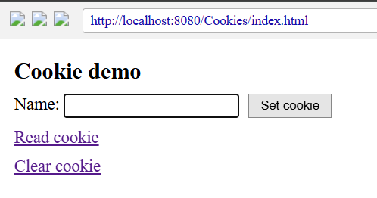
Output:

