CS 643 Cloud Computing Assignment

Wine Quality Prediction Model
1. Project Introduction
This project implements a scalable machine learning pipeline to predict wine quality using Apache Spark’s MLlib. Designed for parallel execution on AWS EC2 clusters, the solution leverages Spark’s distributed computing capabilities, integrates with Amazon S3 for data storage and model persistence, and is containerized with Docker for portability and deployment ease.
2. Project Components Overview
- Parallel Model Training: Leveraging Spark MLlib on a 4-node EC2 cluster
- Prediction Application: Java-based standalone application for model inference
- Dockerized Deployment: Containerized version of the prediction application
- S3 Integration: Storage for training/validation datasets and trained model artifacts
3. Prerequisites
- AWS Account with EC2 and S3 permissions
- Java 8 or higher
- Maven 3.8.4 or higher
- Docker installed
- Git

4. Dataset Overview
File Name | Description
TrainingDataset.csv | Used for training the model
ValidationDataset.csv | Used for validation and hyperparameter tuning
TestDataset.csv | Used for final testing and predictions

5. AWS EC2 Cluster Setup

Step 1: Launch EC2 Instances
- Number of instances: 4
- Instance type: t2.medium
- Operating system: Ubuntu 22.04 o

Step 2: Configure Security Groups
- Allow:
  - SSH (port 22)
  - Spark Master (port 7077)
  - Spark UI (port 8080)
  - Internal EC2 communication

Step 3: Set IAM Role (Optional but Recommended)
- Permissions:
  - s3:GetObject
  - s3:PutObject
  - s3:ListBucket

Step 4: Install Required Software
sudo apt update
sudo apt install -y openjdk-8-jdk maven

6. Project Setup
1. Clone Repository
git clone :- https://github.com/saisrinivas194/CS_643-wine-quality-prediction.git
cd CS_643-wine-quality-prediction
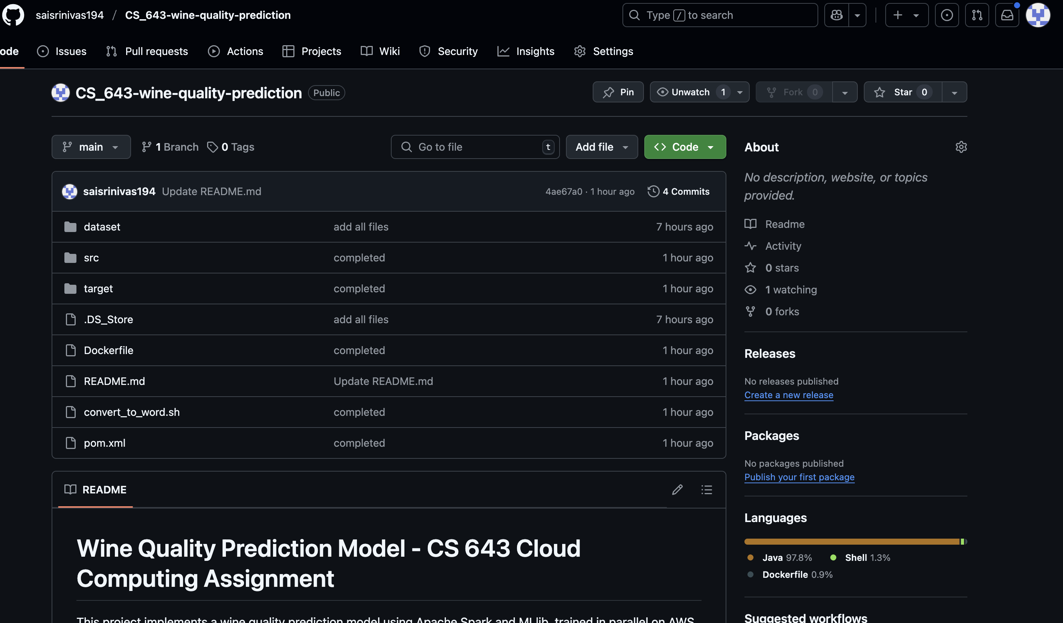
2. Build the Application
mvn clean package

7. Parallel Model Training with Spark
1. Copy JAR to All EC2 Nodes
2. Start Spark Master (on master node)
/usr/local/spark/sbin/start-master.sh
3. Start Spark Workers (on all nodes)
/usr/local/spark/sbin/start-worker.sh spark://<MASTER-IP>:7077
4. Run the Training Job
spark-submit \
--master spark://<MASTER-IP>:7077 \
--class com.mlearning.spark.WineModel \
target/wine-prediction-1.0-SNAPSHOT.jar

8. Prediction Application
Without Docker:
1. Copy JAR to a single EC2 instance
2. Run the app with test data:
java -jar target/wine-prediction-1.0-SNAPSHOT.jar
With Docker:
1. Build Docker Image
docker build -t wine-prediction .
2. Run the Container
docker run -v /path/to/test/data:/data wine-prediction
9. Model Details & Performance
- Algorithm: Linear Regression with L2 regularization
- Feature Scaling: StandardScaler
- Cross-validation: 5-fold
- Training RMSE: 0.5515
- Validation RMSE: 0.5515
- Model saved to: s3://<yo ur-bucket>/models/wine-model

10. Docker Image Summary
- Docker Hub Repo: https://hub.docker.com/repository/docker/saisrinivas194/wine-prediction/general
- Image Size: ~500 MB
- Build Time: ~5 minutes
- Memory Requirement: 2 GB minimum
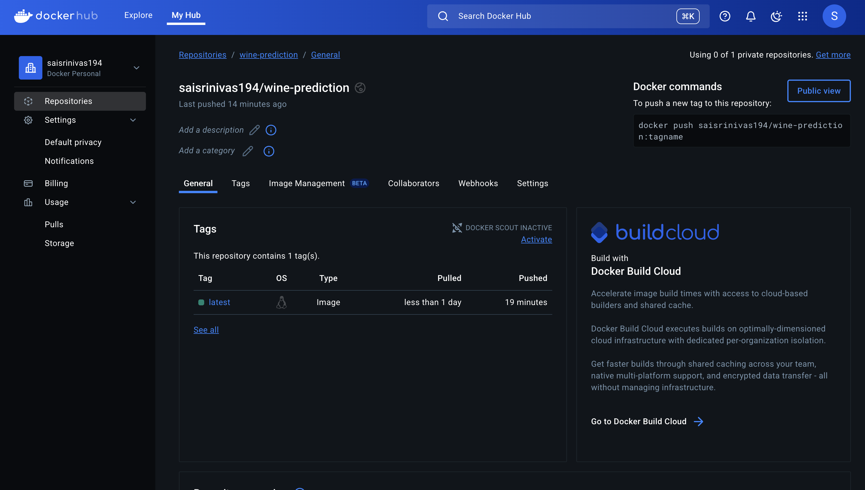

11. Project Structure
CS_643-wine-quality-prediction/
├── src/
│ └── main/java/com/mlearning/spark/
│ ├── WineModel.java # Spark training application
│ └── WinePrediction.java # Prediction logic
├── dataset/
│ ├── TrainingDataset.csv
│ ├── ValidationDataset.csv
│ └── TestDataset.csv
├── Dockerfile
├── pom.xml

12. Testing & Validation
- Model evaluated using ValidationDataset.csv
- Prediction app tested with CSV and JSON input formats
- Docker container verified with:
  - Mounted volumes
  - Environment variable support
- S3 read/write validated for model and data integration

