**Introduction**

Snakes and ladders is an ancient Indian board game that’s regarded today as a worldwide classic. It requires two or more players and takes place on a board with numbered, gridded squares. Throughout the board, there are snakes and ladders which connect different squares. Players roll a die and navigate the board. Landing on a ladder advances a player to a square further up the board, while landing on a snake means they have to go back to a previous square.The aim of the game is to reach the final square. The game is a race that’s based on sheer luck, and is popular with children

**Research**

History:-

The history of snakes and ladders can be traced back to ancient India, where it was known as Mokshapat or Moksha Patamu. Snakes and ladders originated as part of a family of Indian dice board games that included gyan chauper and pachisi known in English as Ludo and Parcheesi. It made its way to England and was sold as "Snakes and Ladders",then the basic concept was introduced in the United States as Chutes and Ladders

Equipment:-

The size of the grid varies, but is most commonly 8×8, 10×10 or 12×12 squares. Boards have snakes and ladders starting and ending on different squares; both factors affect the duration of play. Each player is represented by a distinct game piece token. A single die is rolled to determine random movement of a player's token in the traditional form of play; two dice may be used for a shorter game.

Variations

Variants exists where a player must roll the exact number to reach the final square. Depending on the variation, if the die roll is too large, the token either remains in place or goes off the final square and back again. For example, if a player requiring a 3 to win rolls a 5, the token moves forward three spaces, then back two spaces.

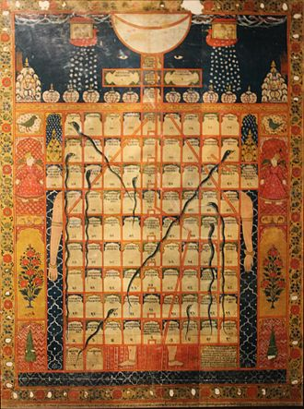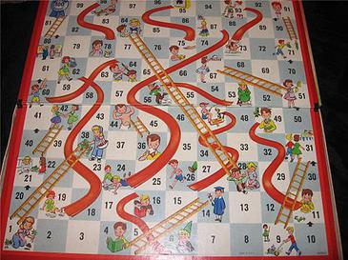

**4w's and 1H:-**

Who

This game can be played by people of all age groups.

when

while having free time we can play with family or friends, to reduce stress and pressure and in learning stages for children.

what

It's an digital form of an ancient game snake and ladders

where

At any place where availability to keep the board and space to roll the dice.

How

1.Each player puts their counter on the space that says 'start here'.

2.Take it in turns to roll the dice. Move your counter forward the number of spaces shown on the dice.

3.If your counter lands at the bottom of a ladder, you can move up to the top of the ladder.

4.If your counter lands on the head of a snake, you must slide down to the bottom of the snake.

5.The first player to get to the space that says 'home' is the winner.

**SWORT:-**

strengths

1.A very quick and simple game.

2) Can be played by people of any age group.

3) Helps children practice counting and adding.

4) Easy to design.

weekness

1)Can lead to addiction in children.

2) With increase in number of players, the time delay increases.

3) The design of the board with too many snakes leads to increase in the chances of a player encountering a snake multiple times making the game long.

4). Waiting for the occurence of 1 on the dice to win a game can be very irritating.

Opportunities

1.The game can be further developed to make it more fun and interesting.

Threats

Due to development of many digital games, ancient board games like "snakes and ladder" face the threat of extinction.

**High level requirements**

User should be able to read data from file

User should be able to modify the data in the file

If the game is not working properly, should raise an issue

If the game is working properly, selecting number of players

When a player wins, The game should print a message and exit the program

The game should correctly calculate and update the position values based on the roll

**Low level requirements**

Good readability of the code

The messages printed by the game should be catchy and encourage the players to play another round

The game code should be open for development

Implementing more than 5 players in one game