# SETUP

First connect PC to the Bluetooth module HC-05, Go to Bluetooth settings to add new device.

Search for HC-05.

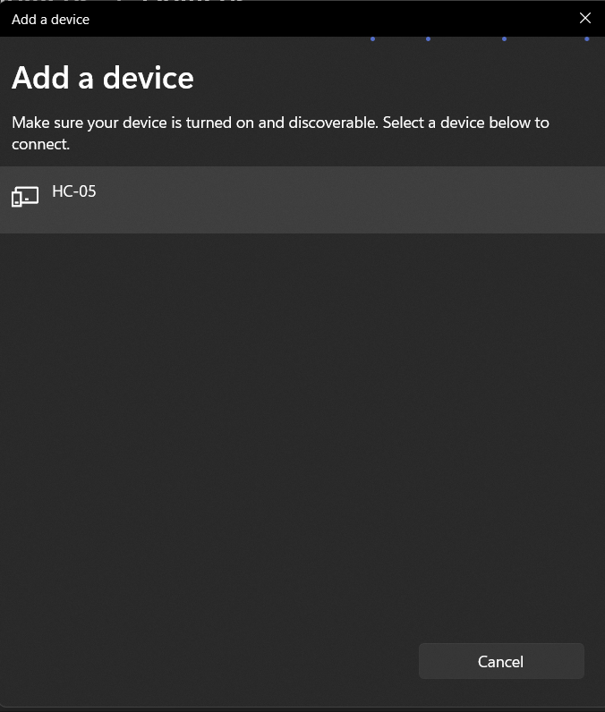

Figure 12. add device

Connect PC to HC-05 by selecting. Then we need to provide password. The default password will either be 0000 or 1234.

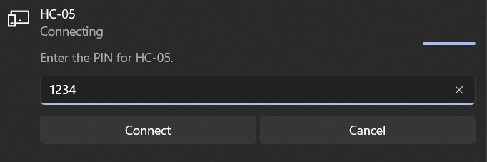

Figure 13. Password

Once our PC is connected to Bluetooth module we need to find the COM port assigned to it.

Go to More Bluetooth settings and COM ports. HC-05 Serial port will be visible. The port which is outgoing should be used.

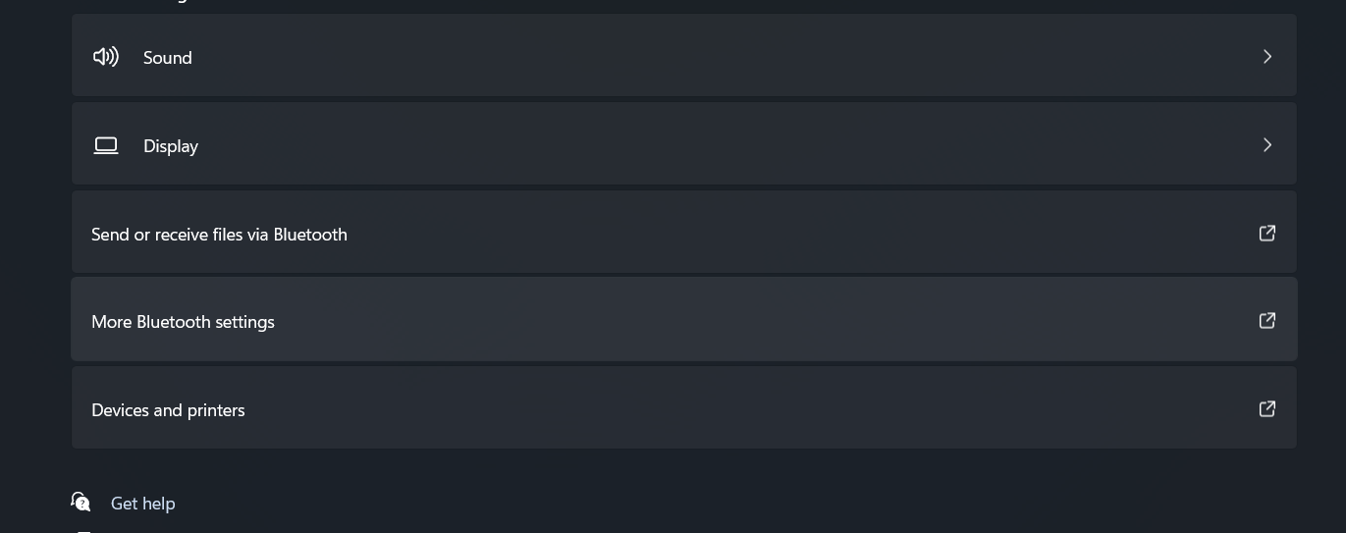

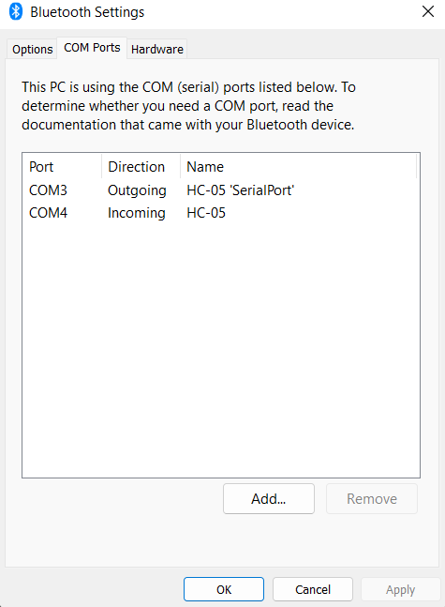

Figure 14. COM ports

The outgoing COM port should be mentioned at the line 9 inside SerialObject and the Baud rate should be 9600 which is ideal for Arduino.

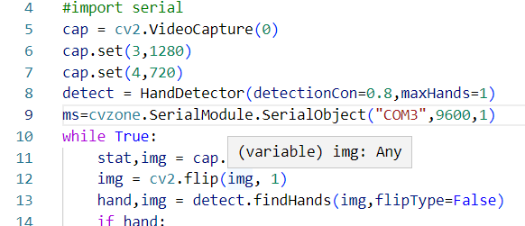

The blinking frequency will change if the Bluetooth module is connected to the PC.