Early Detection of Cancer using AI

In this project we are implementing Artificial Intelligence algorithm called as Neural Networks with various optimizer techniques such as ADAM, SGD and Gradient Descent Mini Batch to predict cancer disease. To train AI algorithms we have used images given by you and this images contains 3 different types of cancer or stages and below screen showing such cancer details

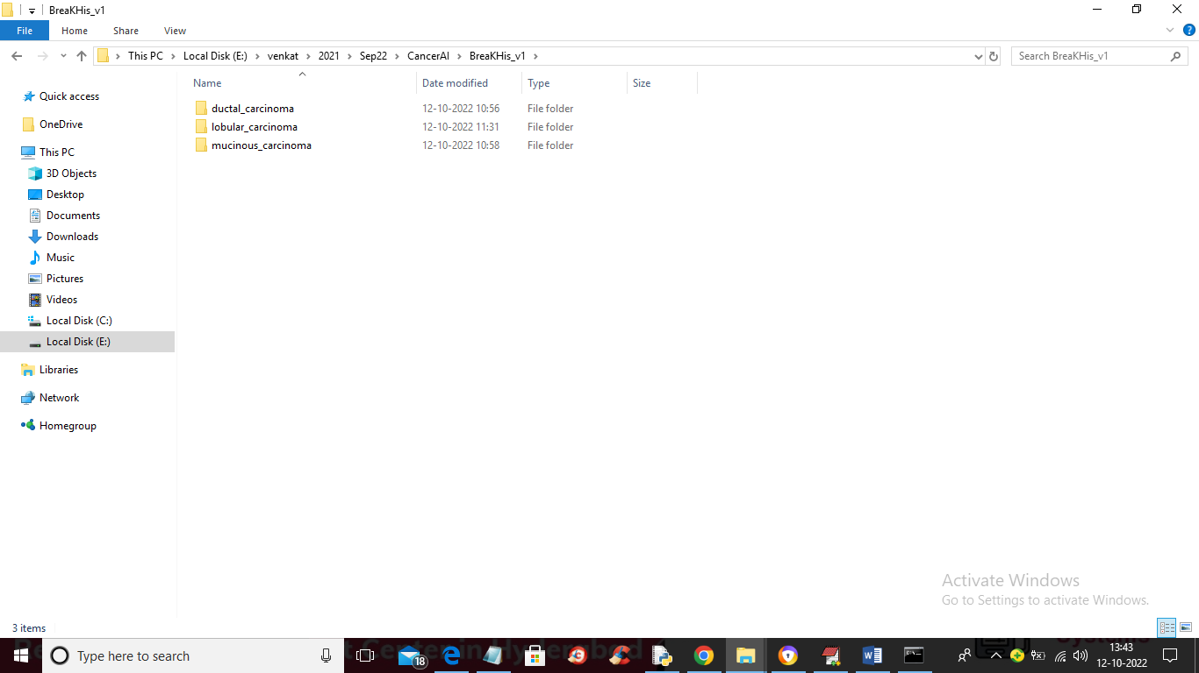

In above screen you can see dataset contains 3 different types of cancers and just go inside any folder to view those images

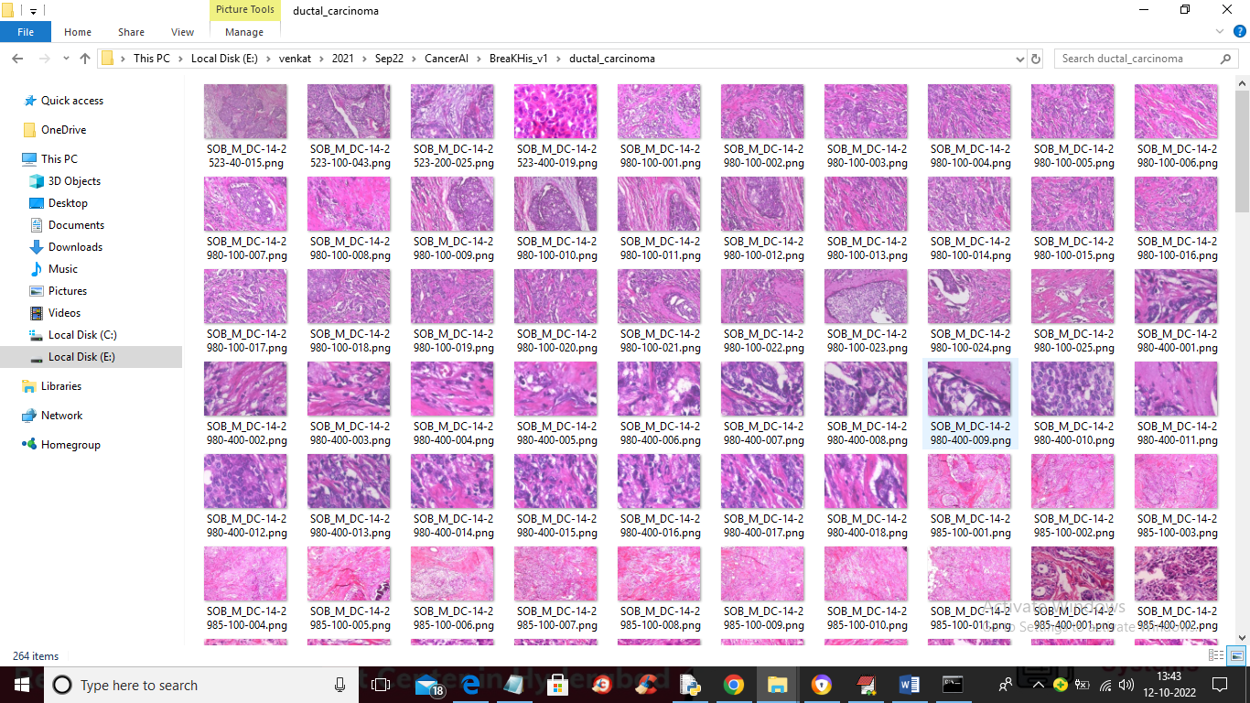

So by using above images we are training AI with 3 different optimizers.

To implement this project we have designed following modules

1. Upload Histopathological Images Dataset: using this module we will upload dataset to application
2. Preprocess Dataset: using this module we will read all images and then resize all images to equal size and then normalize pixel values. After processing we will split dataset into train and test
3. Train AI with ADAM: using this module we will feed Training Data to AI algorithm with optimizer as ADAM. After training we will apply test data in trained model to calculate prediction accuracy
4. Train AI with SGD: using this module we will feed Training Data to AI algorithm with optimizer as SGD. After training we will apply test data in trained model to calculate prediction accuracy
5. Train AI with MiniBatch: using this module we will feed Training Data to AI algorithm with optimizer as MiniBatch. After training we will apply test data in trained model to calculate prediction accuracy
6. Comparison Table: using this module we will plot all algorithm accuracy and show performance in tabular format

SCREEN SHOTS

To run project double click on ‘run.bat’ file to get below screen

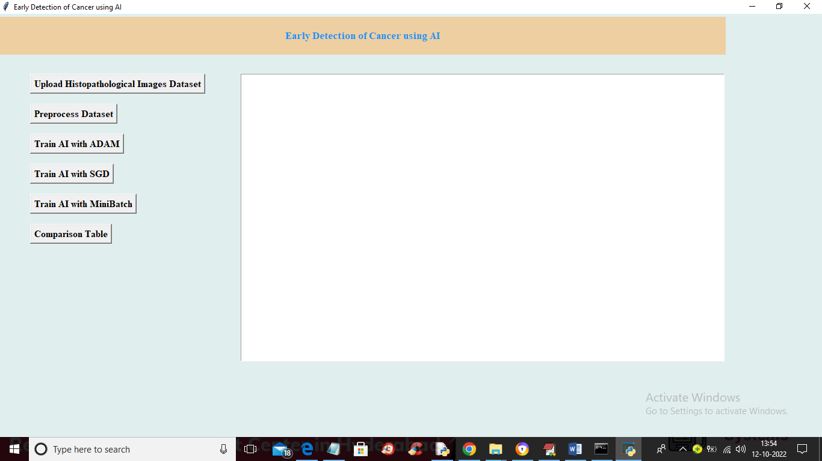

In above screen click on ‘Upload Histopathological Images Dataset’ button o upload dataset and get below output

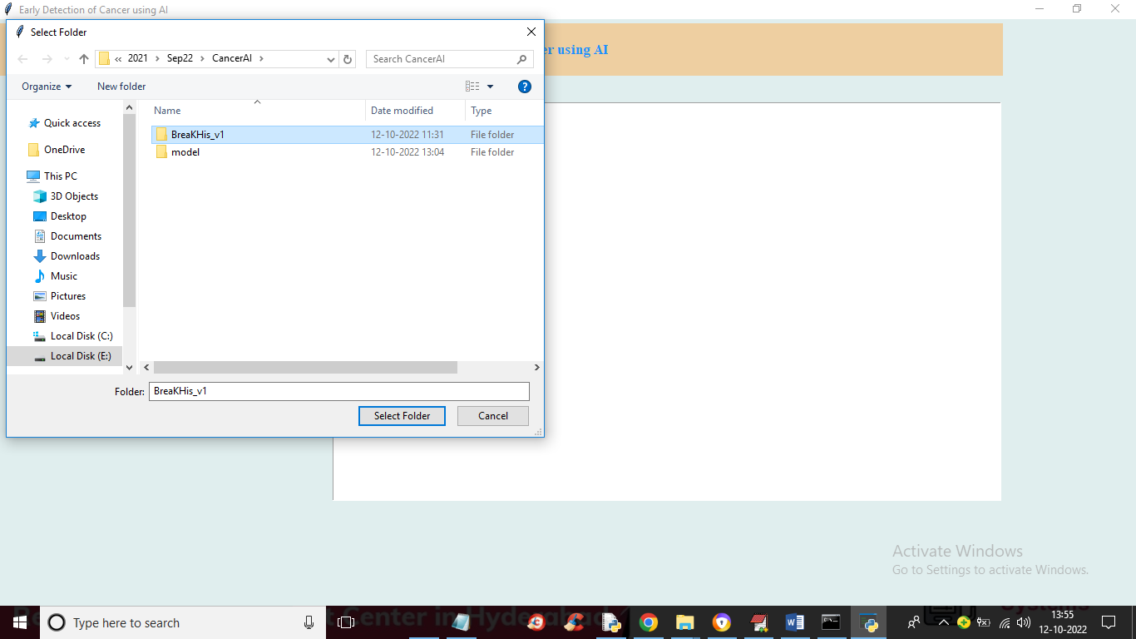

In above screen selecting and uploading entire ‘Dataset’ folder and then click on ‘Select Folder’ button to load dataset and get below output

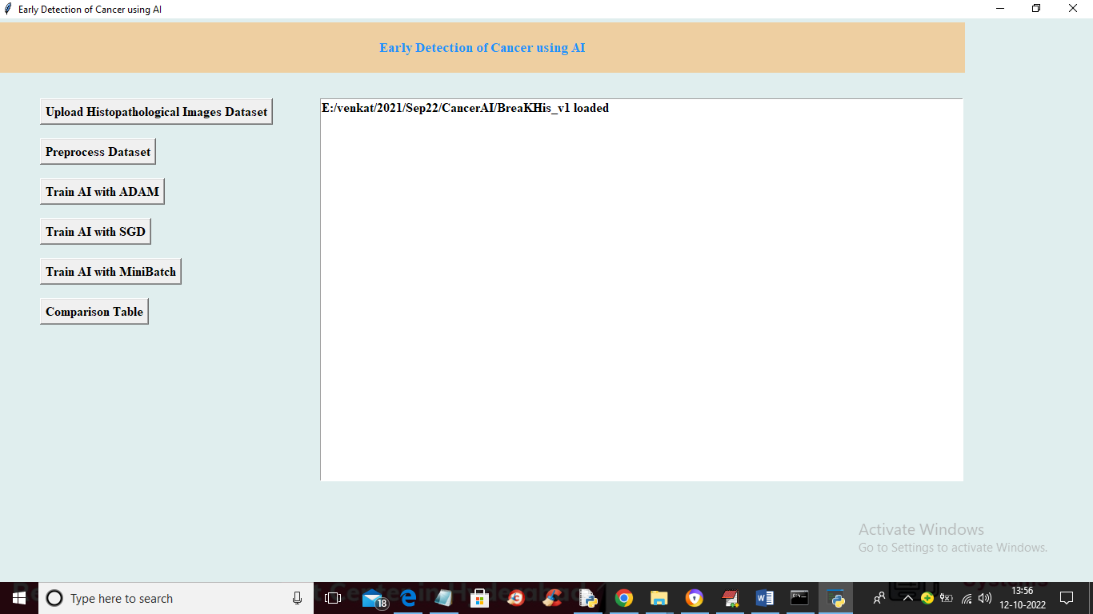

In above screen dataset loaded and now click on ‘Preprocess Dataset’ button to read and process images and get below output

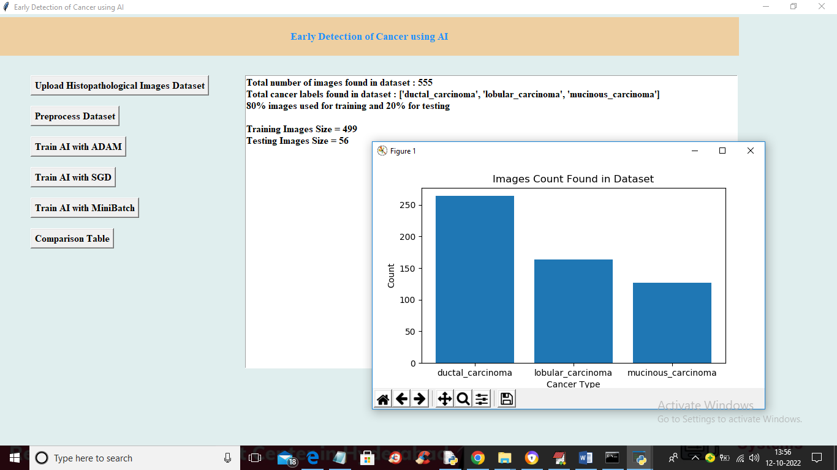

In above screen we can see dataset contains 555 images and then showing train and test data size and in graph x-axis represents ‘Cancer’ type and y-axis represents number of images of that cancer type and now close above image and then click on ‘Train AI with ADAM’ button to train AI and get below output

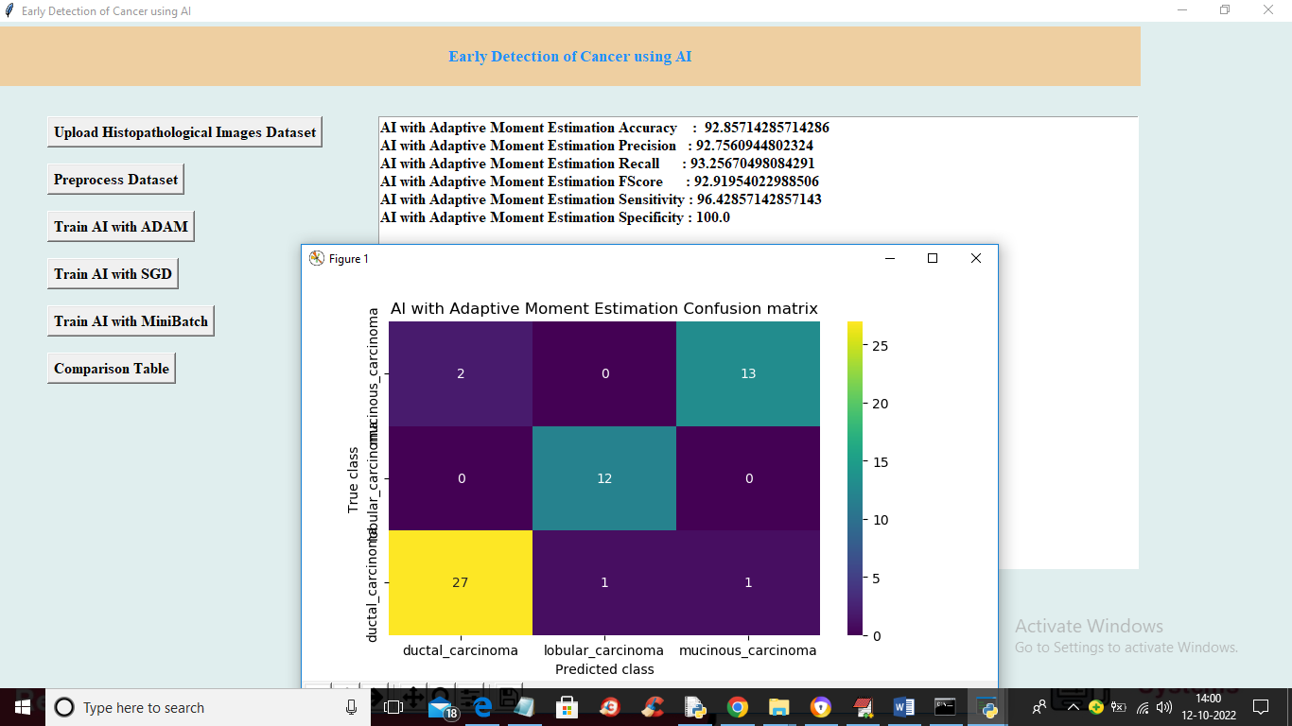

In above screen AI with ADAM got 92% accuracy and in confusion matrix graph x-axis represents Predicted Labels and y-axis represents TRUE labels and different colour boxes represents CORRECT Prediction count and same blue colour boxes represents incorrect prediction count. Now close above and then click on ‘Train with SGD’ button to train with SGD and get below output

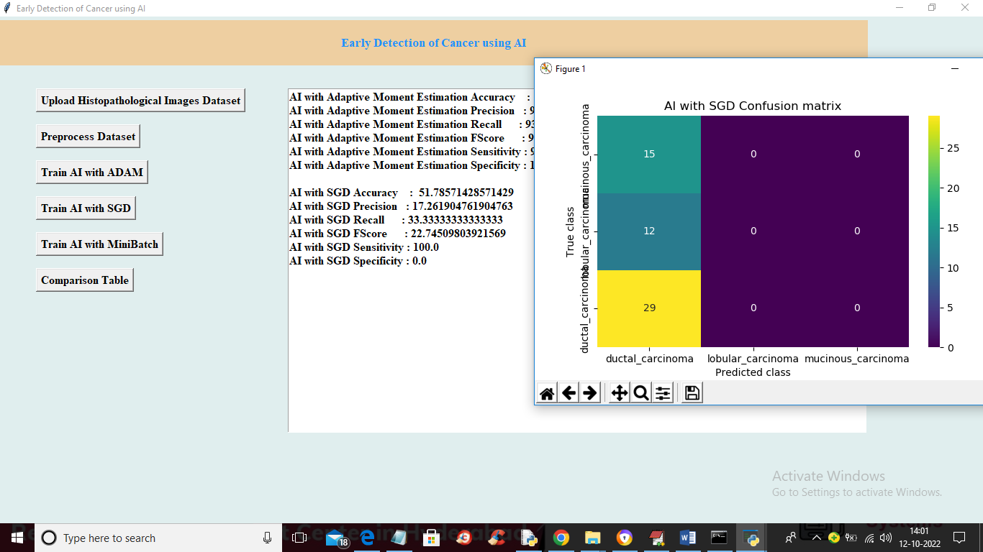

In above screen AI with SGD we got 51% accuracy and now close above graph and then click on ‘Train with MiniBatch’ button to train AI and get below output

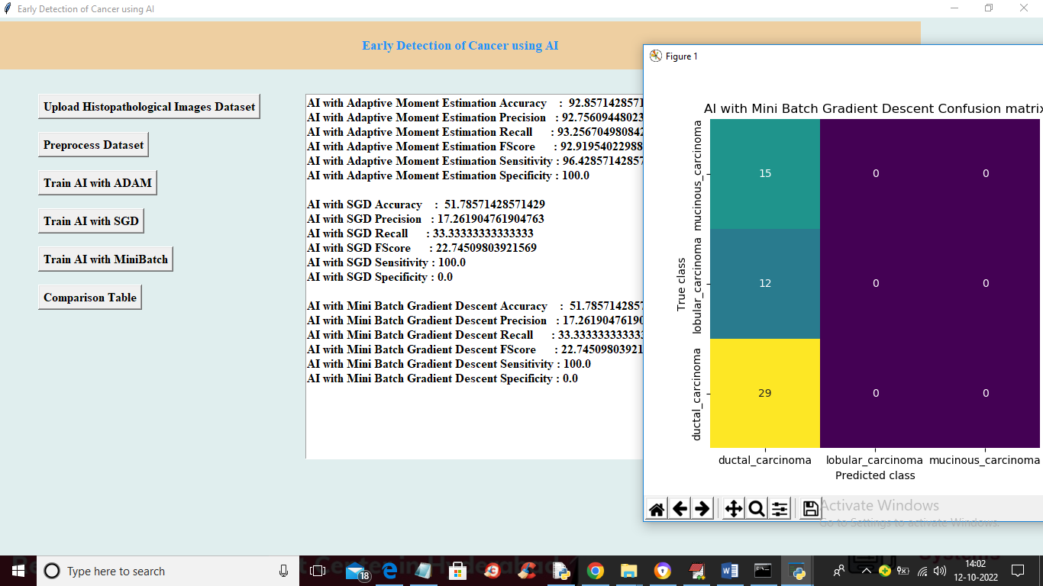

In above screen with Mini Batch also we got 51% accuracy and now close above graph and then click on ‘Comparison Table’ button to get below output

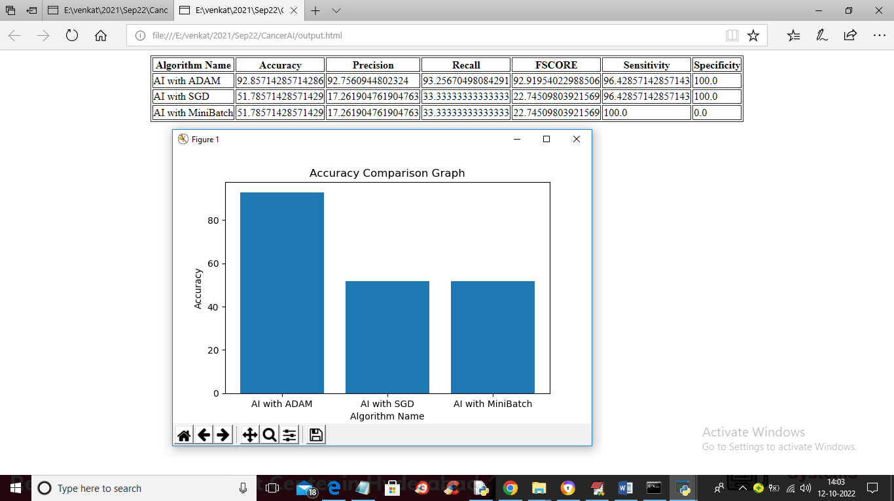

In above screen we can see all algorithm performance in tabular and graphical format and in all algorithms ‘AI with ADAM’ got high performance or accuracy