In this project you ask to choose best performing model and then task sentence from user and then process that text to predict as sarcastic or non-sarcastic and in all algorithms Random Forest is giving high accuracy so we choose random forest for prediction. Below are the JUPYTER code and output screens.

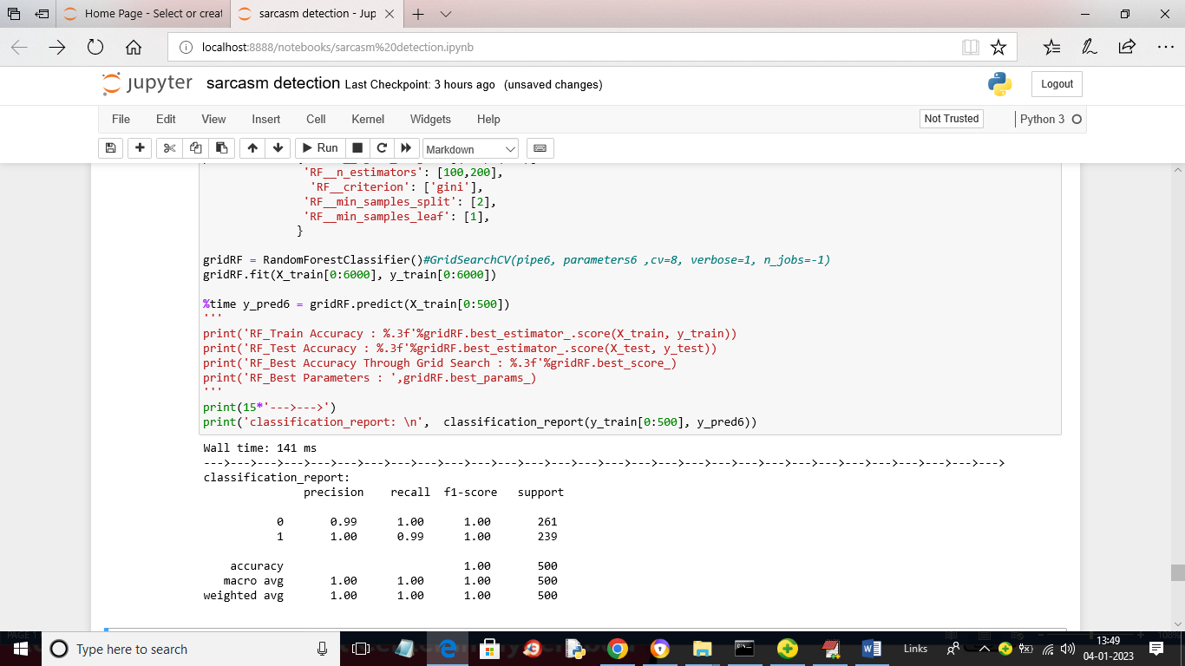

In above screen random forest giving precision between 0.99 to 1. In below screen we are reading text from user

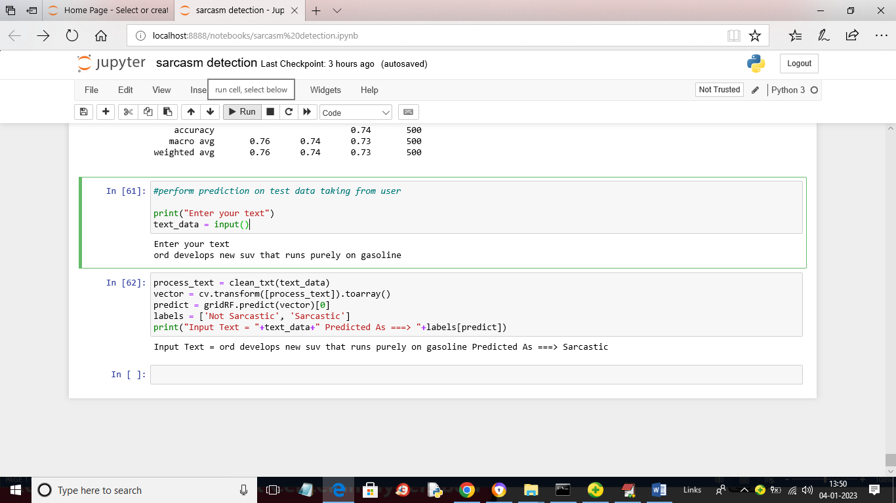

In above screen just run the block with ‘input()’ line to get below text field

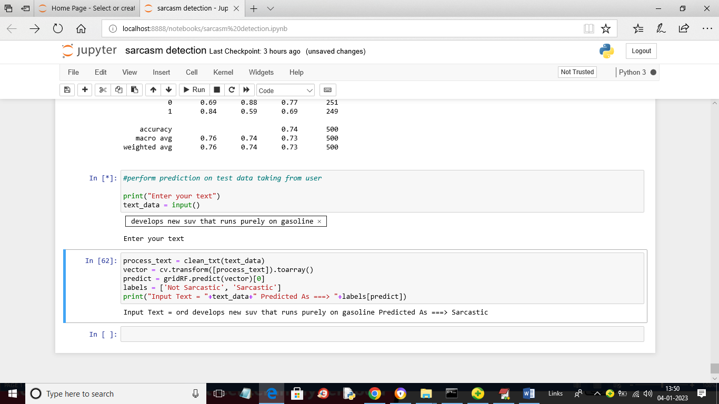

In above text field just enter some text and then run last block to get below prediction output

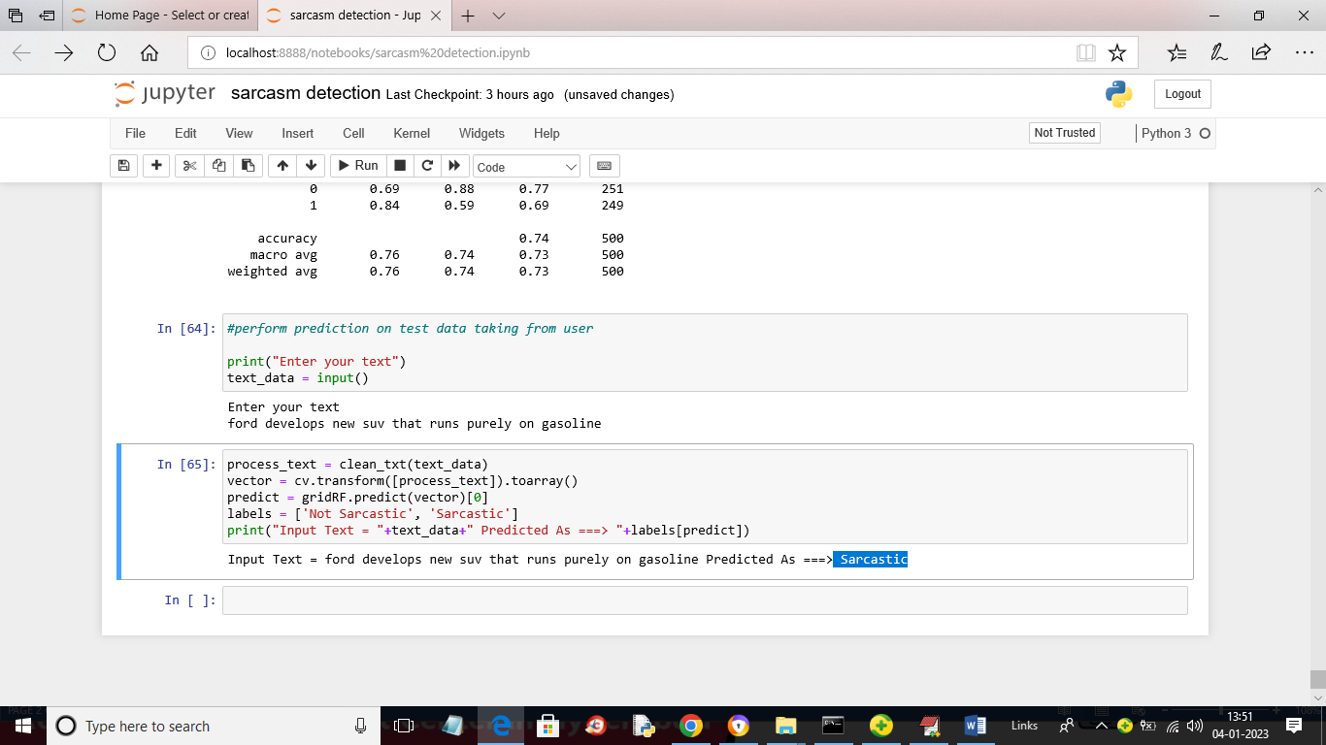

In above screen in last line we can see the input text as ‘ford develops new suv that runs purely on gasoline’ and after =🡺 symbol we can see predicted output as ‘Sarcastic’ and similarly run last 2 blocks to get prediction output. In below screen showing another example

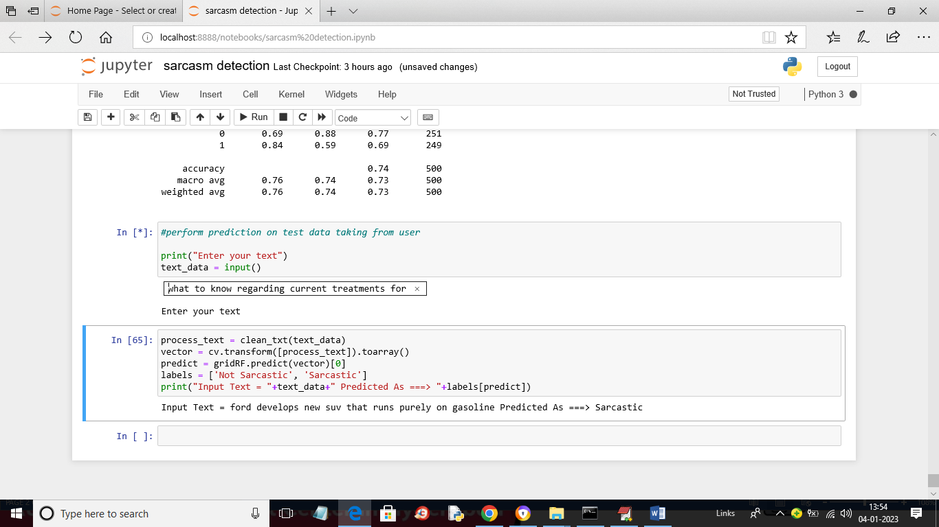

In above screen in text field I entered some other message and the press enter key and then run last block to get below output

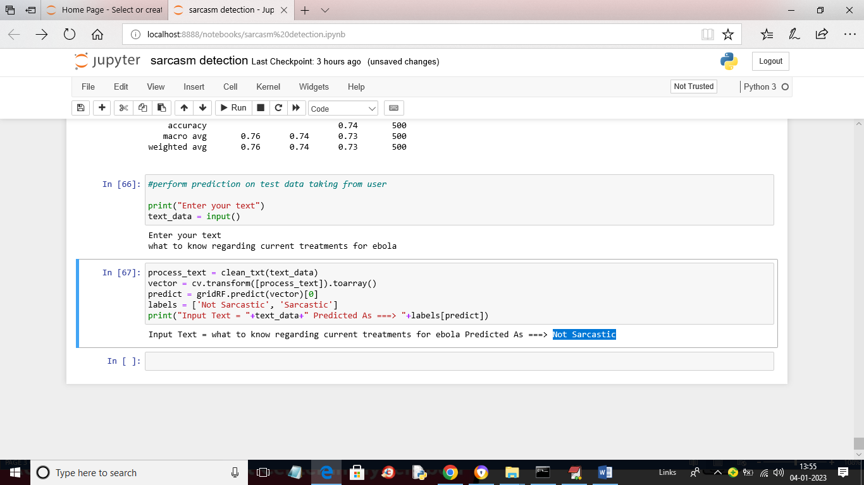

In above screen in last line we can see predicted output as ‘Not Sarcastic’

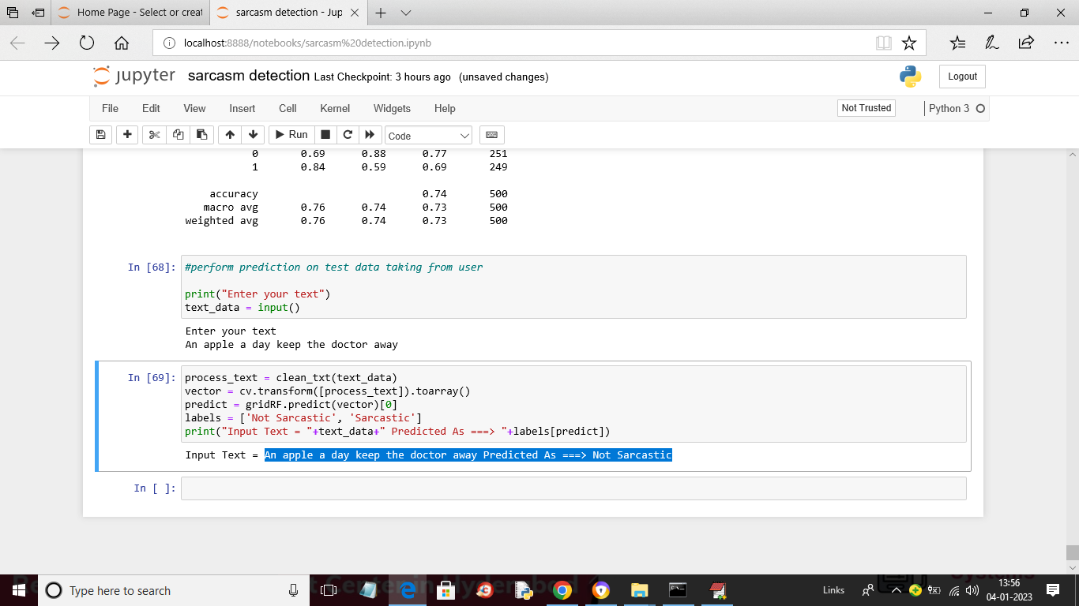

In above screen I entered message as ‘An apple a day keep the doctor away’ and this sentence Predicted As ===> Not Sarcastic