1. Create RFC for the stack admin access.
2. Logon to any EC2 server.

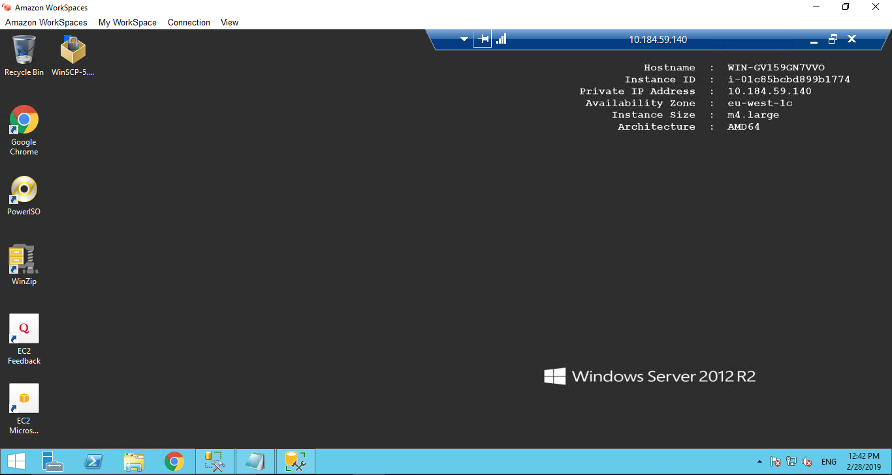

1. Open SSMS and connect to Target RDS instance using SQL Authentication. (User Master user credentials to access DB server).

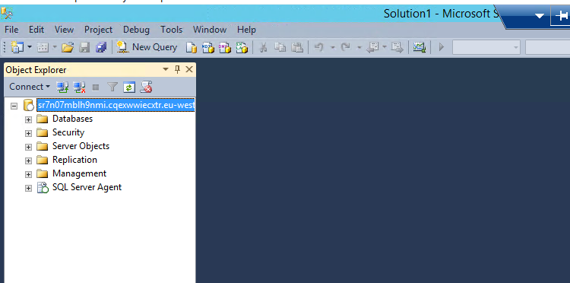

1. Check the backup file in the S3 bucket and copy the path in the Restore command.

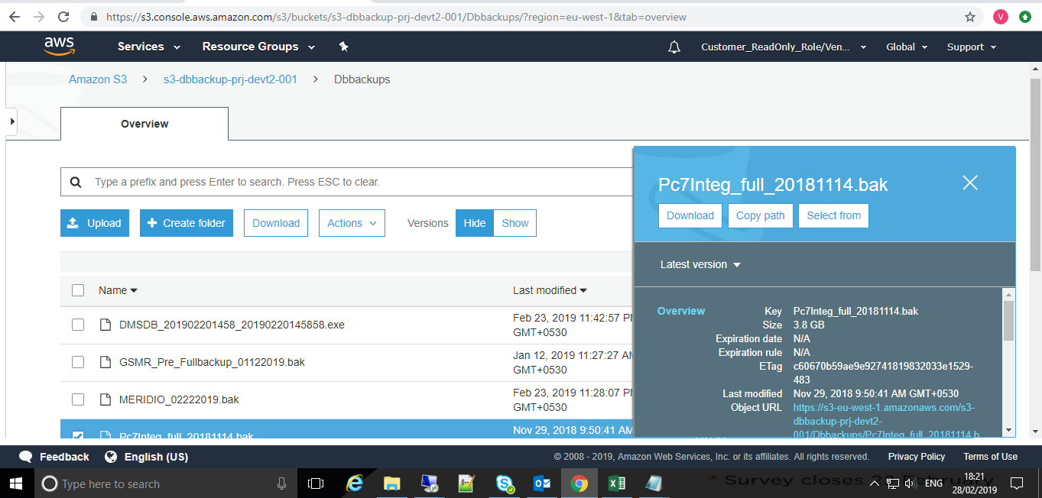

1. Execute Restore command for the DB import.

exec msdb.dbo.rds_restore_database

@restore_db_name='PC7integ',

@s3_arn_to_restore_from='arn:aws:s3:::s3-dbbackup-prj-devt201/Dbbackups/Pc7Integ_full_20181114.bak';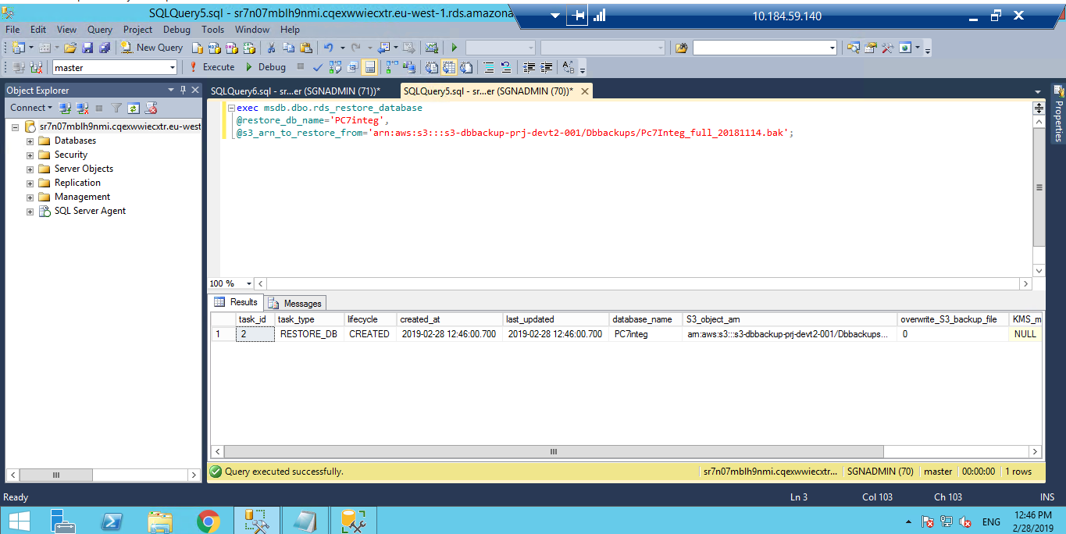

1. Track DB restore status using below SQL query

exec msdb.dbo.rds_task_status @db_name='PC7integ';

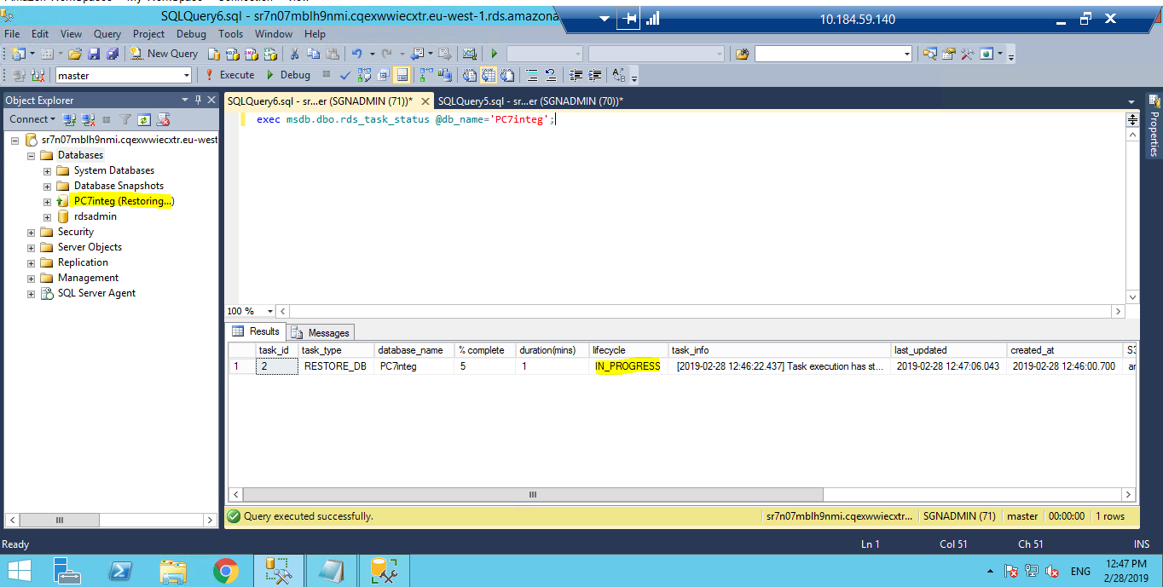

1. Restore has been completed.

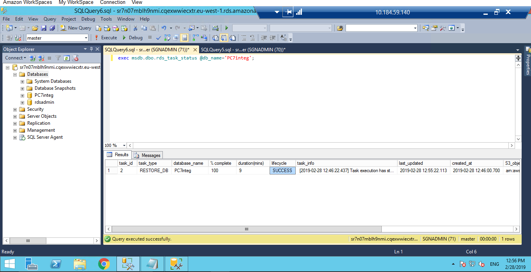

1. Check and fix the orphan users .

User Name: integ

