StandardScaler, MinMaxScaler, MaxAbsScaler
There are three popular approaches to scaling the data:
- MinMaxScaler - scales features to a [0, 1] range;
- MaxAbsScaler – scales features such as the maximum absolute value is 1 (so the data is guaranteed to be in a [-1, 1] range);
- StandardScaler – standardize features making the mean equal to 0 and variance equal to 1.
- MinMaxScaler
- The MinMaxScaler works by subtracting the minimum value (to make values start from zero) and then dividing by (x_max - x_min) to make it less or equal to 1.
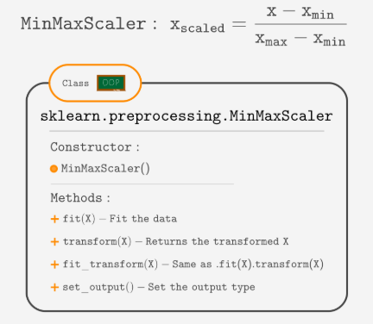
MaxAbsScaler
The MaxAbsScaler works by finding the maximum absolute value and dividing each value by it. This ensures that the maximum absolute value is 1.
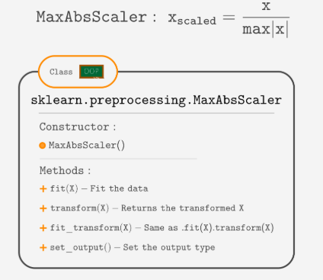

StandardScaler
The idea of StandardScaler comes from statistics. It works by subtracting the mean (to center around zero) and dividing by the standard deviation (to make the variance equal to 1).
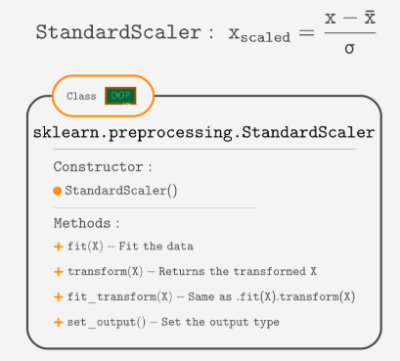
Which scaler to use?
A StandardScaler is less sensitive to outliers, so it is a good default scaler.
If you don't like to use the StandardScaler, between MinMaxScaler and MaxAbsScaler, it comes down to personal preferences, scaling data to the [0,1] range or to [-1,1].

# Importing necessary libraries
from sklearn.preprocessing import MinMaxScaler, StandardScaler, MaxAbsScaler
import numpy as np

# Sample dataset
data = np.array([[1, -1, 2],
[2, 0, 0],
[0, 1, -1]])

# 1. MinMaxScaler
# Scales features to a range, typically [0, 1]
min_max_scaler = MinMaxScaler()
data_minmax = min_max_scaler.fit_transform(data)

print("Original Data:")
print(data)
print("\nMinMax Scaled Data (Range [0, 1]):")
print(data_minmax)

# 2. StandardScaler
# Scales features to have zero mean and unit variance
standard_scaler = StandardScaler()
data_standard = standard_scaler.fit_transform(data)

print("\nStandard Scaled Data (Zero mean, unit variance):")
print(data_standard)

# 3. MaxAbsScaler
# Scales features to the range [-1, 1] by dividing by the maximum absolute value
max_abs_scaler = MaxAbsScaler()
data_maxabs = max_abs_scaler.fit_transform(data)

print("\nMaxAbs Scaled Data (Range [-1, 1]):")
print(data_maxabs)
