* ABSTRACT: Paying fee has become more3 difficult these days because it is done manually but here we are doing everything online let it the subjects u want to pay or the fee no need to stand in long queues just you are a click away from all these problems

INTRODUCTION:

* 1. .Aims and Objective: The main objective of the application is to automate the existing system of manually maintain the records of student information, subjects, fee of exam also to make online payment and get the acknowledge to students.

1. The application should provide quick access to the records maintained and must reveal the subjects to register and pay through online for convenience of students.

1.2. Background

The basic pre-requisite required for this project are basic knowledge of php , mysql ,html.

This also includes embedding sql queries in php scripts , basic html tags and formatting tags , css styling for web pages , bootstrap for a graphical-user friendly interface and the prerequisites of a simple time table building algorithm. The data of the various institutions is to be gathered by the administrator.

2.System Analysis:

2.1 Software Requirement:

The software requirements are

Front End:

1.HTML

2.JAVASCRIPT

3.PHP

Backend:

MYSQLDB

2.2 SOFTWARE TOOLS:

The tools used are

1. Notepad or Notepad++

<https://notepad-plus-plus.org>

2.Xampp

<https://www.apachefriends.org/download.html>

2.3 OPERATION ENVIRONMENT:

The operation environment we use in this project is XAMPP.

PLEASE FOLLOW THE FOLLOWING GUIDELINES TO RUN OUR PROJECT IN XAMPP

1. Download the xampp using the link provided above.
2. The files that has to be executed should be saved in htcdocs of xampp folder.
3. Now go to Xampp control panel.
4. After opening control panel click on the start of apache now the server started.
5. If the server not started there is clash on port number go to config and change the port number.
6. Now click start on the Mysql and click admin yow will get homepage of phpMyadmin where you can create new database and tables.
7. Click on the create where you can create new DATABASE.
8. After creating new DB click on it where you can create the tables for DB.
9. After this and making connections with php our project can be executed on the sever by giving localhost\project name.

3.System Design:

DESCRIPTION AND SRS

1. The main objective is students should get everything automated instead of doing it manually by records and paying challan in bank .
2. U can get everything online the subjects the fee and paying online also.

ER diagram:

ER diagram: An entity relationship diagram(ERD) shows the relationships of entity sets stored in a database. An entity in this context is a component of data .In other words ,ER diagrams illustrate the logical structure of database.It acts like Flow chart.

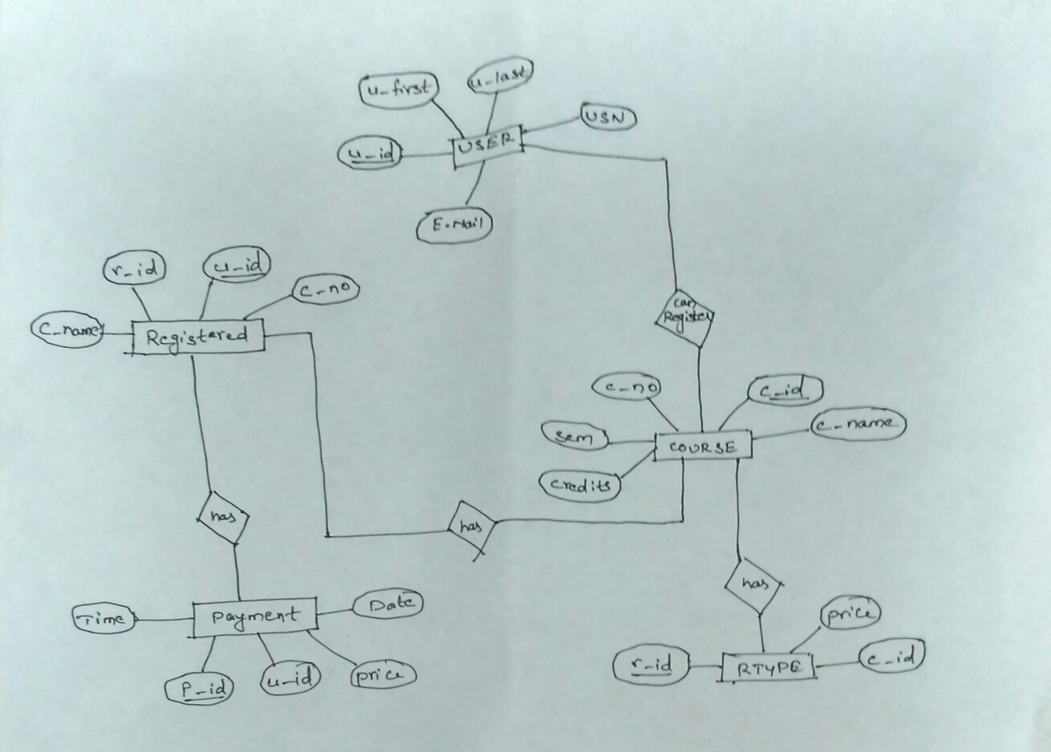

SCHEMA:

In DBMS, a schema is the organization or structure for a database. The activity of data modeling leads to schema .The term is used in discussing both relational databases and object-oriented database. The term sometimes seems to refer to a visualization of a structure some times to a formal text-oriented description.

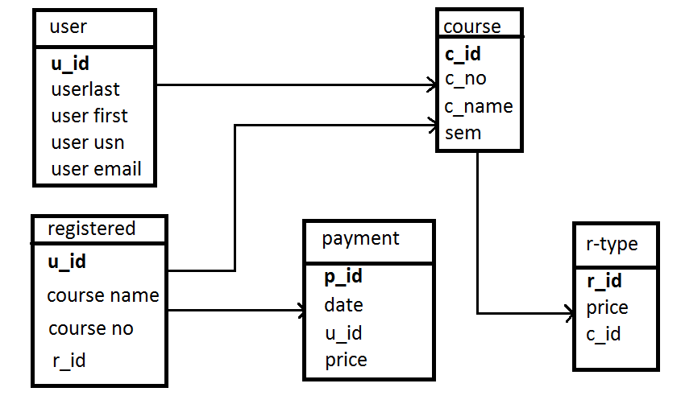

TABLE DESCRIPTION:

1. USER (U_ID PRIMARY KEY)
2. COURSE (C_ID PRIMARY KEY U_ID FOREIGN KEY)
3. RTYPE (R_ID PRIMARY KEY C_ID FOREIGN KEY)
4. REGISTERED (U-ID PRIMARY KEY (C_NAME,C_NO,R_ID) FOREIGN KEY)
5. PAYMENT (P_ID PRIMARY KEY U_ID FOREIGN KEY)

RESULTS AND SNAPSHOTS:

