**JS - Assignment**

Rules and Regulations

1. Use proper Grammar for declaring variables.
2. Embed the external javascript externally as described in the below link.

<http://www.w3schools.com/js/js_whereto.asp>

1. Comment your code to describe what its functionality is.

Exercises

1. Write a JavaScript program to calculate multiplication and division of two numbers (input from user).

Refer the image below for the expected output. Please use the above rules for completing the work. Write individual function for handling the click of multiply and divide(Refer attached image below.)

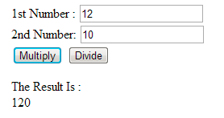

1. Write a JavaScript program to display the current day and time in the following format.  
   Sample Output : Today is : Friday.   
   Current time is : 4 PM : 50 : 22