SAI SURYA D
1NT19IS137
ISE 6 SEM C-1 BATCH

Queries

1. Populate the database with atleast 15 documents

db.employee1NT19IS137.insertMany([
... {
... Firstname: "sai",
... Middlename: "surya",
... Lastname: "d",
... Age: 25,
... Salary: 75000,
... Designation: "Employee",
... Role: ["Software developer","Tester"],
... },
... {
... Firstname: "Vinayak",
... Middlename: "P",
... Lastname: "Bhupal",
... Age: 26,
... Salary: 75000,
... Designation: "HR",
... Role: ["Manager","UI Designer"],
... },
... {
... Firstname: "venky",
... Middlename: "ch",
... Lastname: "Reddy",
... Age: 27,
... Salary: 45000,
... Designation: "Employee",
... Role: ["Tester","Software Developer"],
... },
... {
... Firstname: "M",
... Middlename: "Kumar",
... Lastname: "Babu",
... Age: 27,
... Salary: 70000,
... Designation: "Researcher",
... Role: ["Team Lead","Tester", "UI Designer"],
... },
... {
... Firstname: "Rajesh",
... Middlename: "Patil",
... Lastname: "N",
... Age: 36,
... Salary: 50000,
... Designation: "Scientist",
... Role: ["UI Designer","Tester"],
... },
... {
... Firstname: "Ullaas",
... Lastname: "M",
... Age: 36,
... Salary: 50000,
... Designation: "Scientist",
... Role: ["UI Designer","Team Lead"]
... },
... ]);
db.employee1NT19IS137.insertMany([
... {
... Firstname: "suri",
... Middlename: "raju",
... Lastname: "R",
... Age: 25,
... Salary: 25000,
... Designation: "Employee",
... Role: ["Junior Lead","Junior Architect"],
... },
... {
... Firstname: "Sohan",
... Middlename: "M",
... Lastname: "N",
... Age: 33,
... Salary: 60000,
... Designation: "Employee",
... Role: ["Junior Engineer","Software developer"],
... },
... {
... Firstname: "Praneeth",
... Middlename: "M",
... Lastname: "V L S S S",
... Age: 28,
... Salary: 75000,
... Designation: "Employee",
... Role: ["Software developer","UI Designer"],
... },
... {
... Firstname: "ajay",
... Middlename: "kumar",
... Lastname: "A",
... Age: 29,
... Salary: 50000,
... Designation: "Scientist",
... Role: ["Research and Developer","UI Designer"],
... },
... {
... Firstname: "Randheer",
... Middlename: "Prasad",
... Lastname: "B",
... Age: 30,
... Salary: 20000,
... Designation: "System Engineer",
... Role: ["Intern","Software developer"],
... },
... ]);

2. List all the records having salary in the range of 20000 – 35000(Exclusive)
db.Employee1NT19IS184.find({$and:[{Salary:{$gt:20000}},{Salary:{$lt:35000}}]}).pretty()

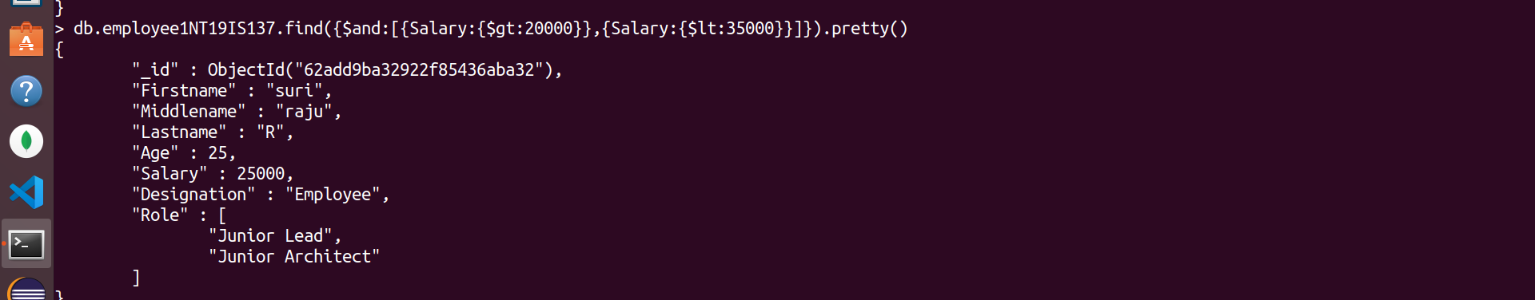

3. List all the Employee whose Middle name is "Kumar"

db.employee1NT19IS137.find({Middlename:"Kumar"}).pretty()
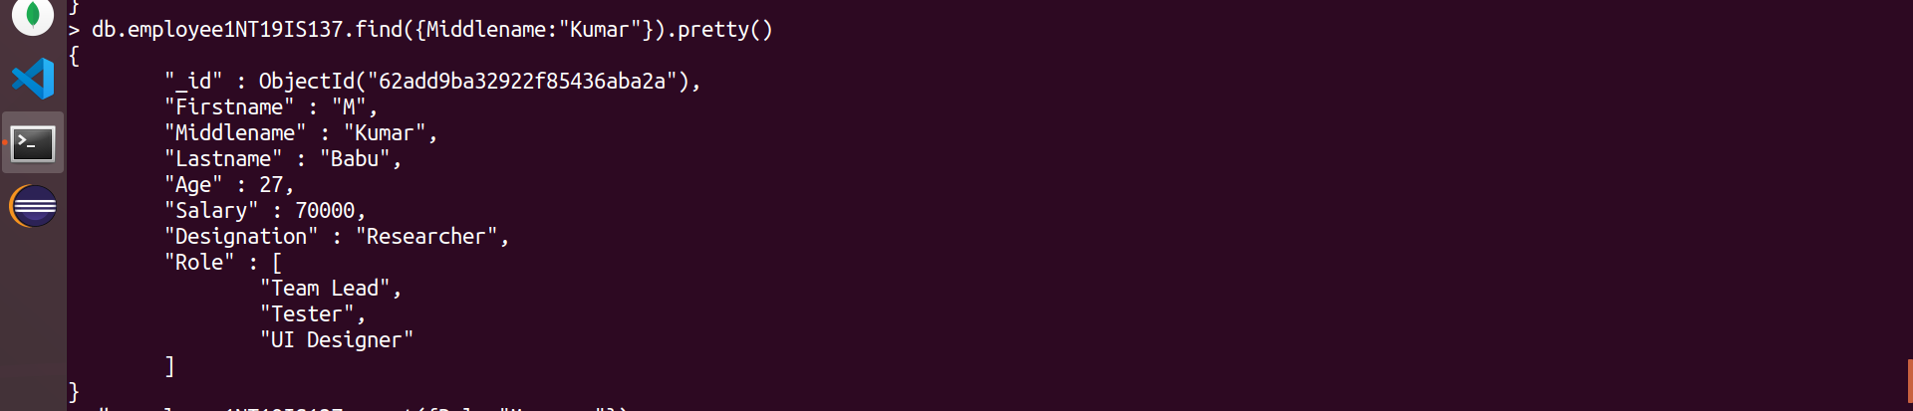

4. Count the number of Employees who has a role "Manager" in the Role field
db.Employee1NT19IS184.count({Role:"Manager"}).pretty
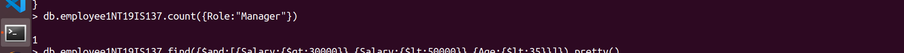

5. Find out all the documents who have age < 35 and salary in the range of 30000-50000

db.employee1NT19IS137.find({$and:[{Salary:{$gt:30000}},{Salary:{$lt:50000}},{Age:{$lt:35}}]}).pretty()
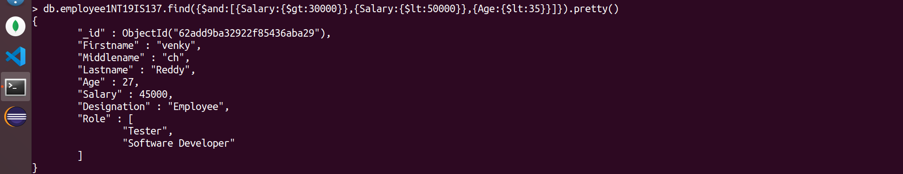

6. Delete an Employee whose "Firstname" is "Rajesh" and having the designation as "Scientist"

db.employee1NT19IS137.deleteOne({$and:[{Firstname:"Rajesh"},{Designation:"Scientist"}]})

db.employee1NT19IS137.find()
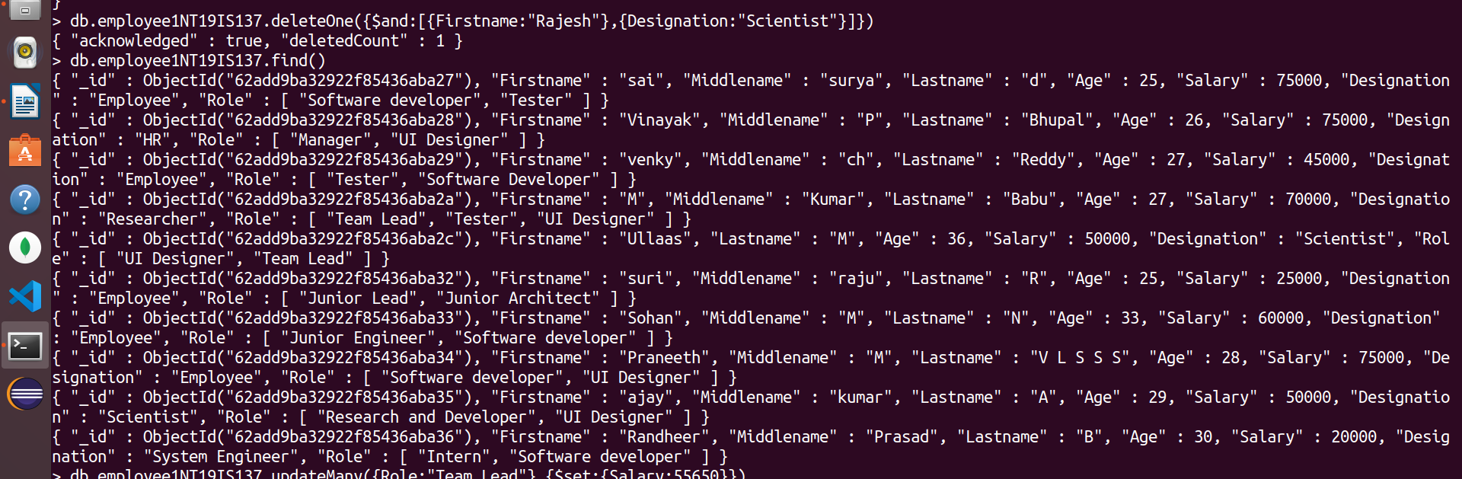

7. Update all the Employees whose role is "Team Lead" with a salary of 55650 INR
db.employee1NT19IS137.updateMany({Role:"Team Lead"},{$set:{Salary:55650}})
db.employee1NT19IS137.find()
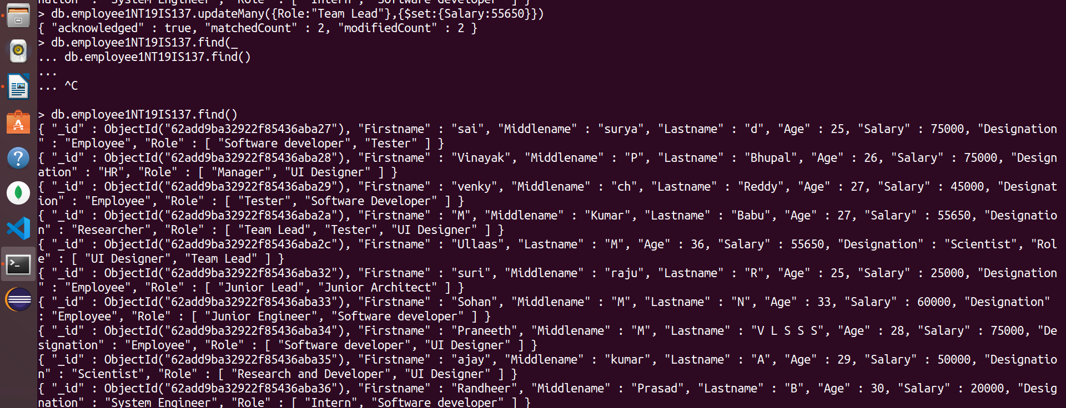

8. Group all the Employees by their age(common age should be there) and calculate the average salary obtained in the each group

db.employee1NT19IS137.aggregate([{$group:{_id:"$Age",Average:{$avg:"$Salary"}}}])

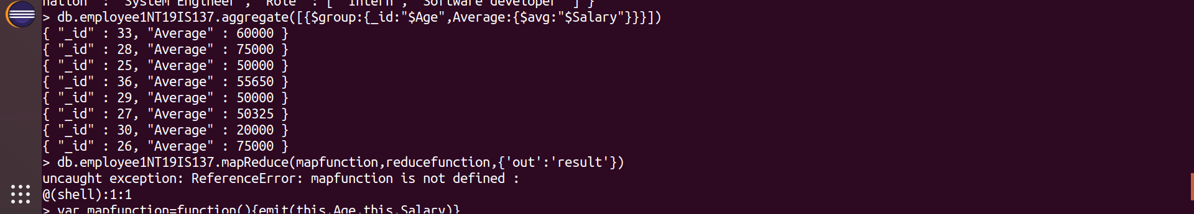
9. Apply the map-reduce to perform the above operation and obtain the results

var mapfunction=function(){emit(this.Age,this.Salary)}
var reducefunction=function(key,values){return Array.avg(values)}
db.Employee1NT19IS184.mapReduce(mapfunction,reducefunction,{'out':'result'})

db.result.find()

