Update with unset

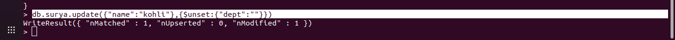
cmd:db.surya.update({"name":"kohli"},{$unset:{"dept":""}})

update with set
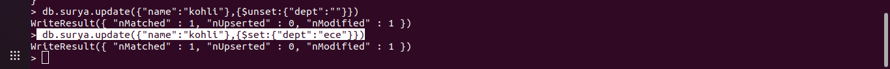
cmd: db.surya.update({"name":"kohli"},{$set:{"dept":"ece"}})

db.surya.find().pretty()
{ "_id" : ObjectId("624bbce4c303cb05449b08cf"), "name" : "sai" }
{
"_id" : ObjectId("624bbce4c303cb05449b08d0"),
"name" : "surya",
"dept" : "cse"
}
{
"_id" : ObjectId("626769278ac7d1046075b38b"),
"name" : "abd",
"dept" : "ise",
"marks" : "90"
}
{
"_id" : ObjectId("626769278ac7d1046075b38c"),
"name" : "kohli",
"marks" : "70",
"dept" : "ece"
}
{
"_id" : ObjectId("62676e99ce719d84d2ac7b6a"),
"name" : "dk",
"dept" : "ise",
"marks" : "95"
}
{
"_id" : ObjectId("62676e99ce719d84d2ac7b6b"),
"name" : "virat",
"dept" : "ise",
"marks" : "69"
}

or operation in find():
db.surya.find({$or:[{"dept":"ise"},{"dept":"cse"}]}).pretty()
{
"_id" : ObjectId("624bbce4c303cb05449b08d0"),
"name" : "surya",
"dept" : "cse"
}
{
"_id" : ObjectId("626769278ac7d1046075b38b"),
"name" : "abd",
"dept" : "ise",
"marks" : "90"
}
{
"_id" : ObjectId("62676e99ce719d84d2ac7b6a"),
"name" : "dk",
"dept" : "ise",
"marks" : "95"
}
{
"_id" : ObjectId("62676e99ce719d84d2ac7b6b"),
"name" : "virat",
"dept" : "ise",
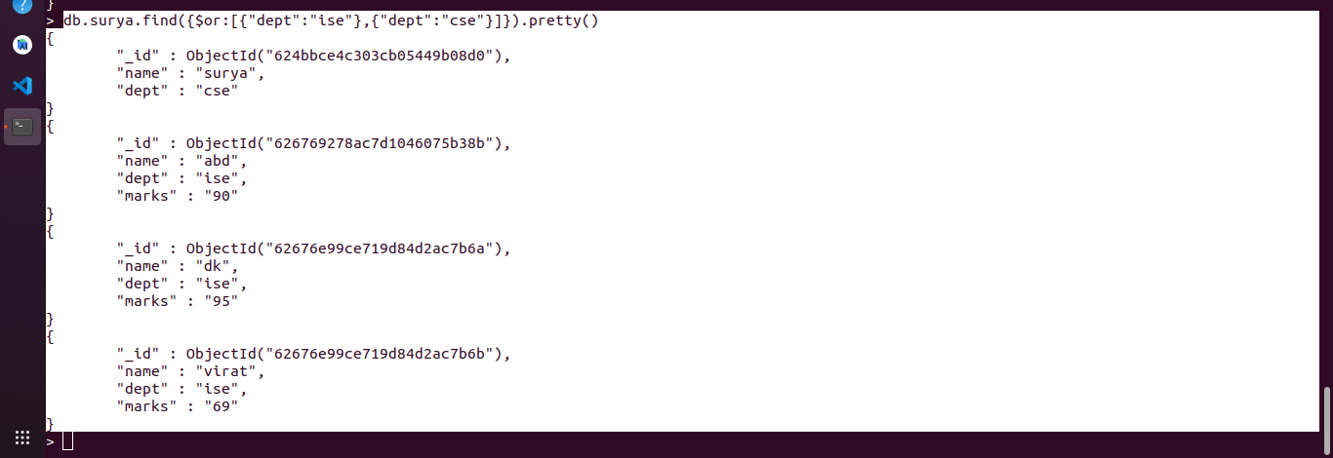
"marks" : "69"
}

AND OPERATION
CMD:db.surya.find({$and:[{"dept":"ise"}]}).pretty()
{
"_id" : ObjectId("626769278ac7d1046075b38b"),
"name" : "abd",
"dept" : "ise",
"marks" : "90"
}
{
"_id" : ObjectId("62676e99ce719d84d2ac7b6a"),
"name" : "dk",
"dept" : "ise",
"marks" : "95"
}
{
"_id" : ObjectId("62676e99ce719d84d2ac7b6b"),
"name" : "virat",
"dept" : "ise",
"marks" : "69"
}

